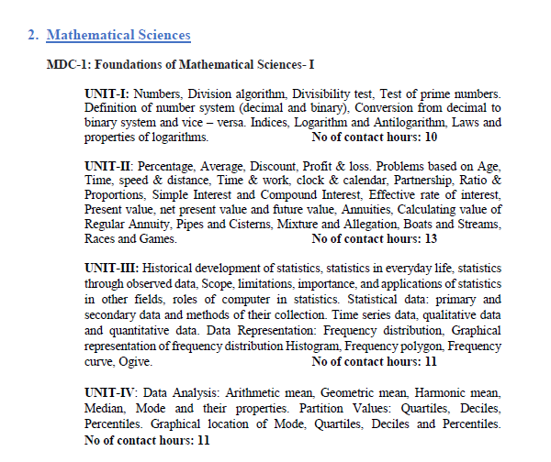
Gauhati University FYUGP Syllabus
B.A 1st Semester (MDC Course)
Sub: Mathematical Science
Full Marks: (45 + 30) = 75

