DEPARTMENT OF ASSAMESE
Pramathesh Barua College, Gauripur
PO- GAURIPUR, DIST- DHUBRI, ASSAM ,PIN NO- 783331
Ref….. Date: 12-08-2024
In connection with ‘Late Amal Kumar Choudhury Memorial Lecture-1’ to be held on 27 august, 2024, the Department of Assamese is pleased to announce an essay writing competition for the students of the college on -
‘TOURISM IN UNDEVIDED GOALPARA DISTRICT: PROBLEMS AND PROSPECTS.’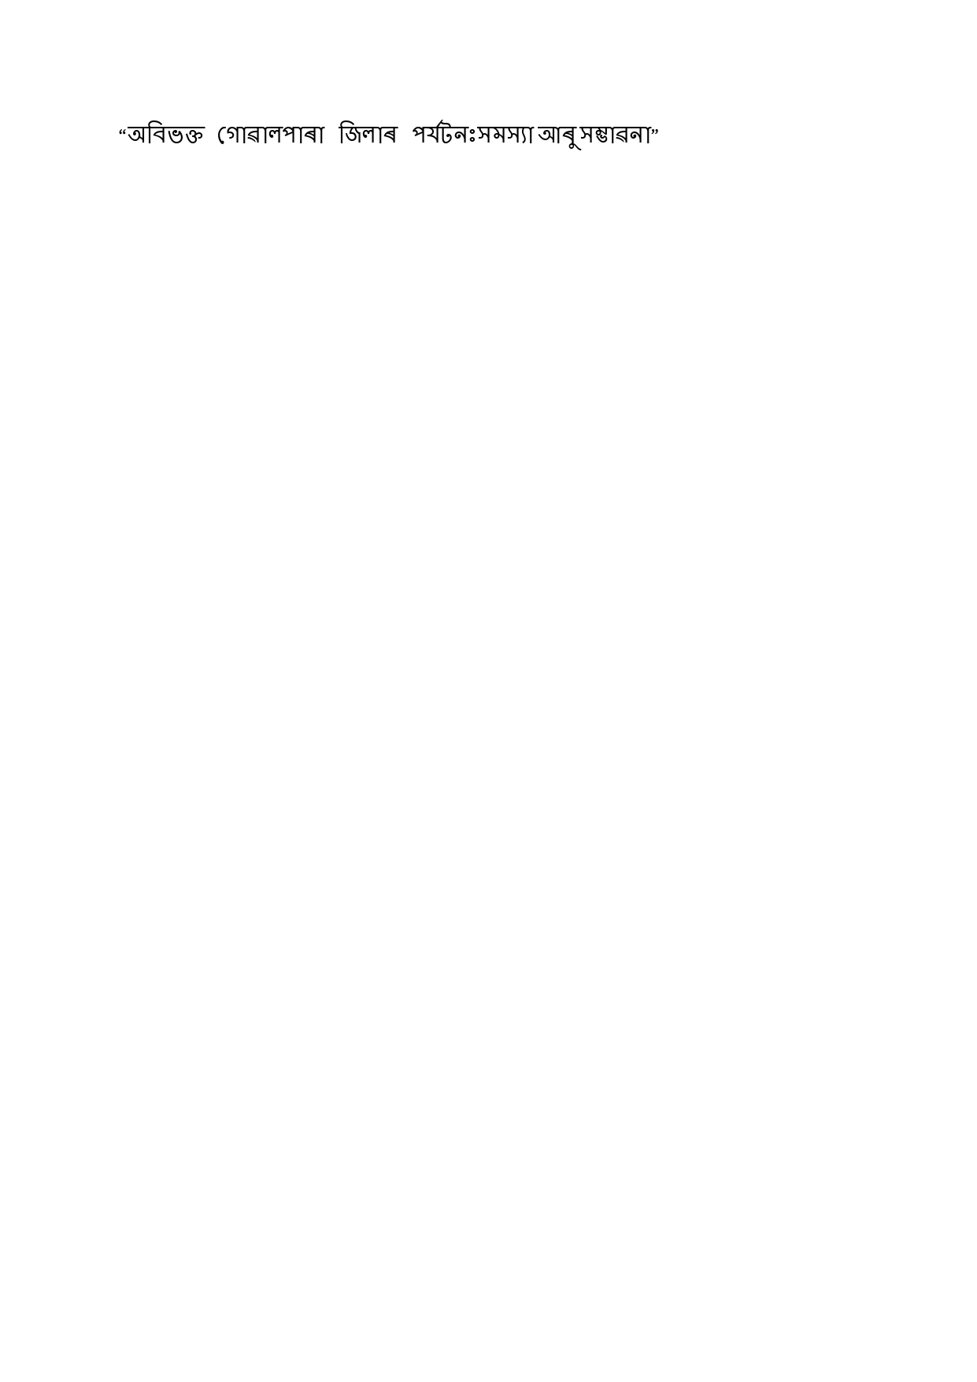

Guidelines for submission of the essay:
- The essay to be completed within 1000-1500 words.
- Essay may be typed or in clear handwriting in one side of the A-4 paper.
- Name, class, roll no to be written on the cover page.
- Last date of submission of essay 24 August, 2024.
- Declaration of result and distribution of prizes will be held on 27 August, 2024.
- Essay to be submitted to Dr. Jyotsna Devi, Assistant Professor, Department of Assamese on or before the last date.

Counter Signed by

(DR KALAYAN DAS) (Dr. AKHTARUL ISLAM)
Principal, P.B. College HOD, Assamese,P.B.College

