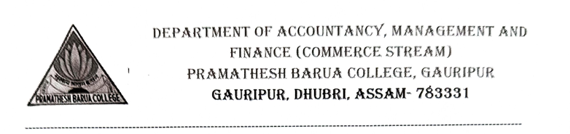
No.PBC/Commerce/Notice/2024-2025 Date: 2/09/2024
Notice
Date: 2/09/2024
This is for general information to all the 5th Semester students of P.B College, Gauripur (B.A &B.COM) that a certified course on “Life skills” will be offered by Department of Accountancy, Management and Finance (Commerce Stream) tentatively from 16th of September, 2024. Hence, interested students are asked to collect the Application form from the Commerce Department and to get enrolled before 12th of September,2024. Considering the limited seats available, students will be selected on the basis of first come first serve. The detailed schedule of the course will be published shortly. For further details contact:

Mr. Diganta Biswas
Course Co-ordinator
Contact No: 9101418232

Principal/Convenor, Academic Council Mr. Diganta Biswas
P.B College, Gauripur Head, Accountancy Department
P.B College, Gauripur

