REPORT ON OBSERVANCE OF SOK DIVAS
Vanue: Pramathesh Barua College, Gauripur
Date: 16th August 2025

Pramathesh Barua College, Gauripur observed Sok Divas on 16th August 2025 at 12:50 PM in the digital classroom as per the DHE’s letter no E Comp.No. 689904/2025/1 dtd 14-08-2025. The college observed condolence of one minute silence in memory of the children and other persons who lost their lives in bomb blast while attending the Independence Day celebration at Dhemaji and also other victims of Militant Violence. The college also took a pledge against all acts of terrorism and militant violence after half mast hoisting of National Flag in our Institution.
All employees and students were present in the programme. It ended successfully.
Some of the visuals of the observation are enclosed herewith.
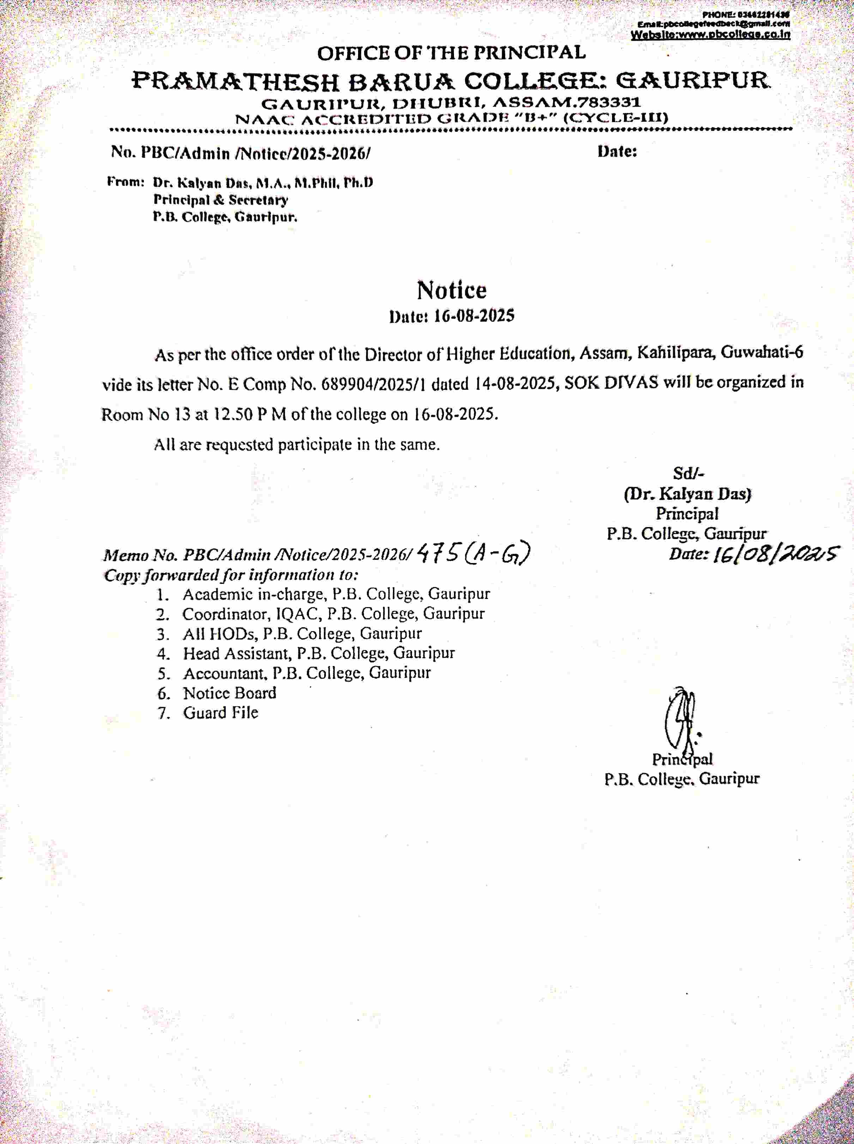
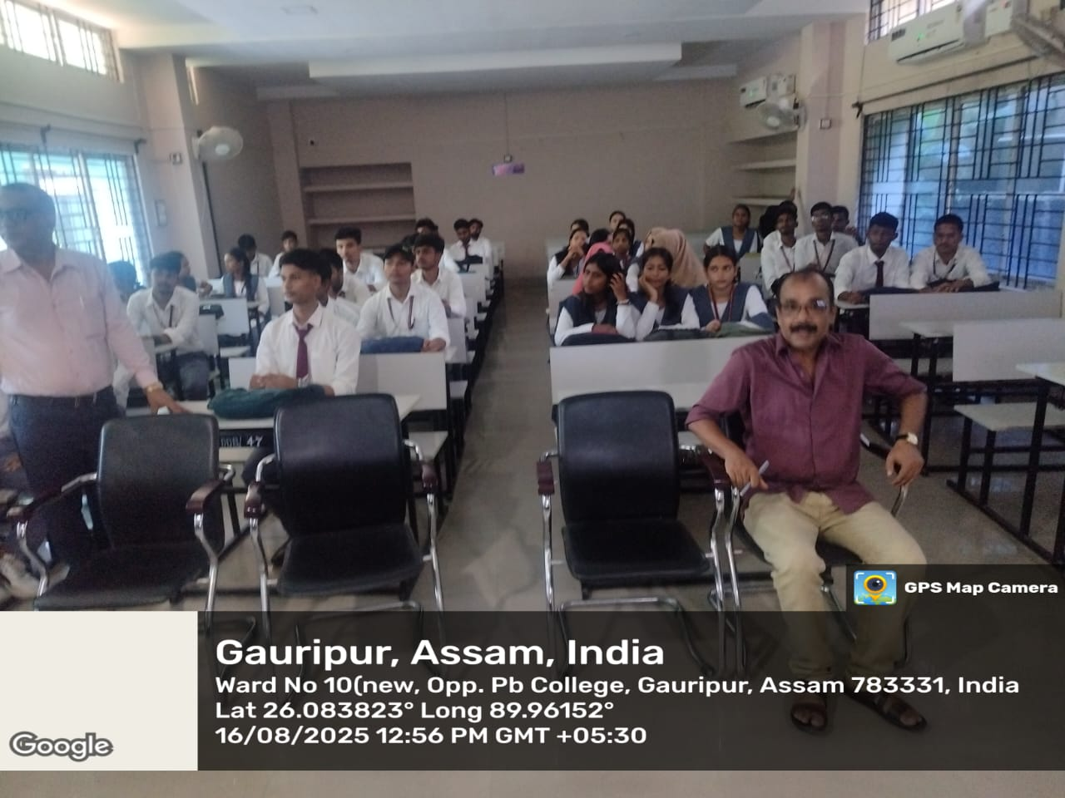
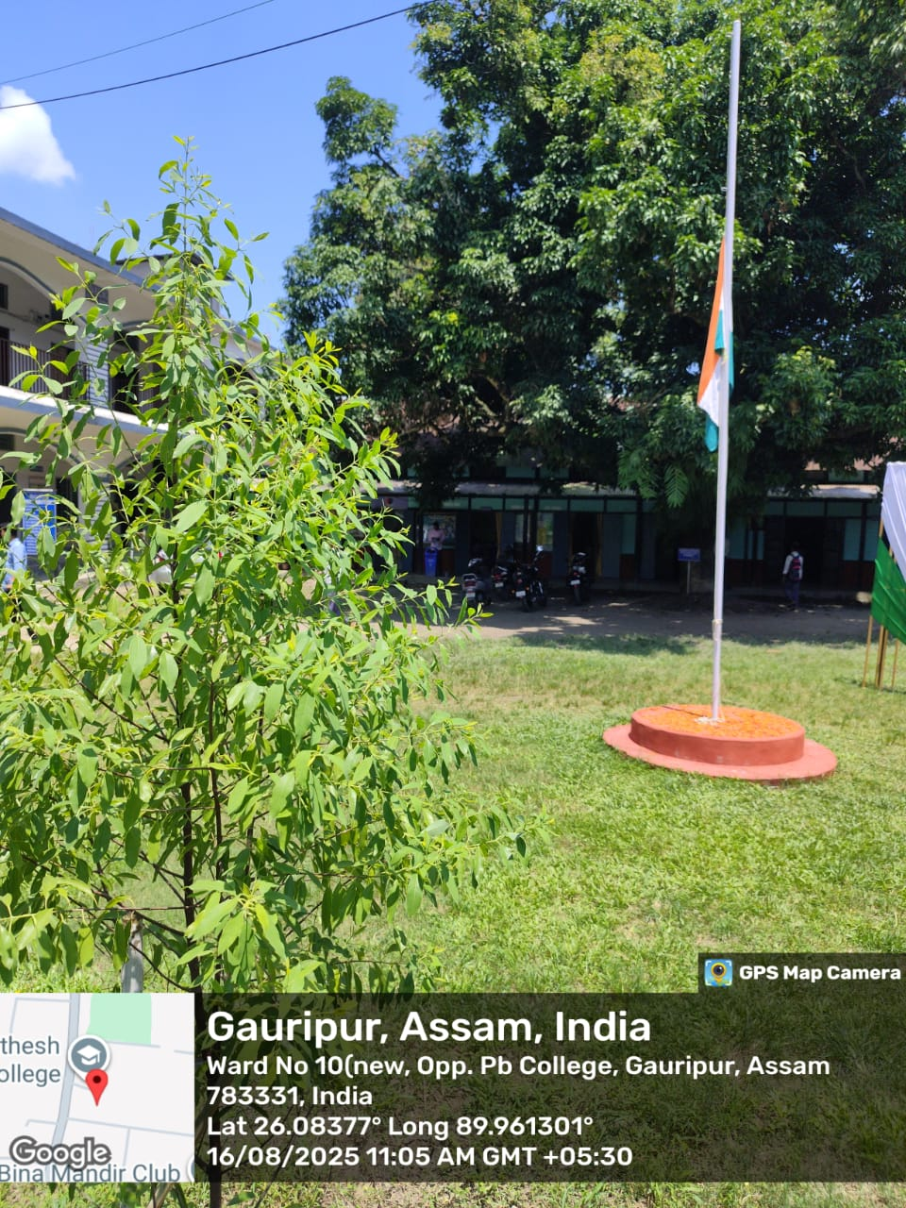

Principal
P.B.College, Gauripur

