REPORT ON -EPLEDGE ON DRUG ABUSE & TRAFFICKING

Pramathesh Barua College, Gauripur observed International Day against Drug Abuse & Trafficking on 26th June 2025 at 11 AM in Room no 13 as per the DHE’s letter no ECF no. 668554/1 dtd 25-06-2025. All employees and students were present in the programme and took the pledge heartily. It ended successfully.
Some of the visuals of the observation are enclosed herewith.
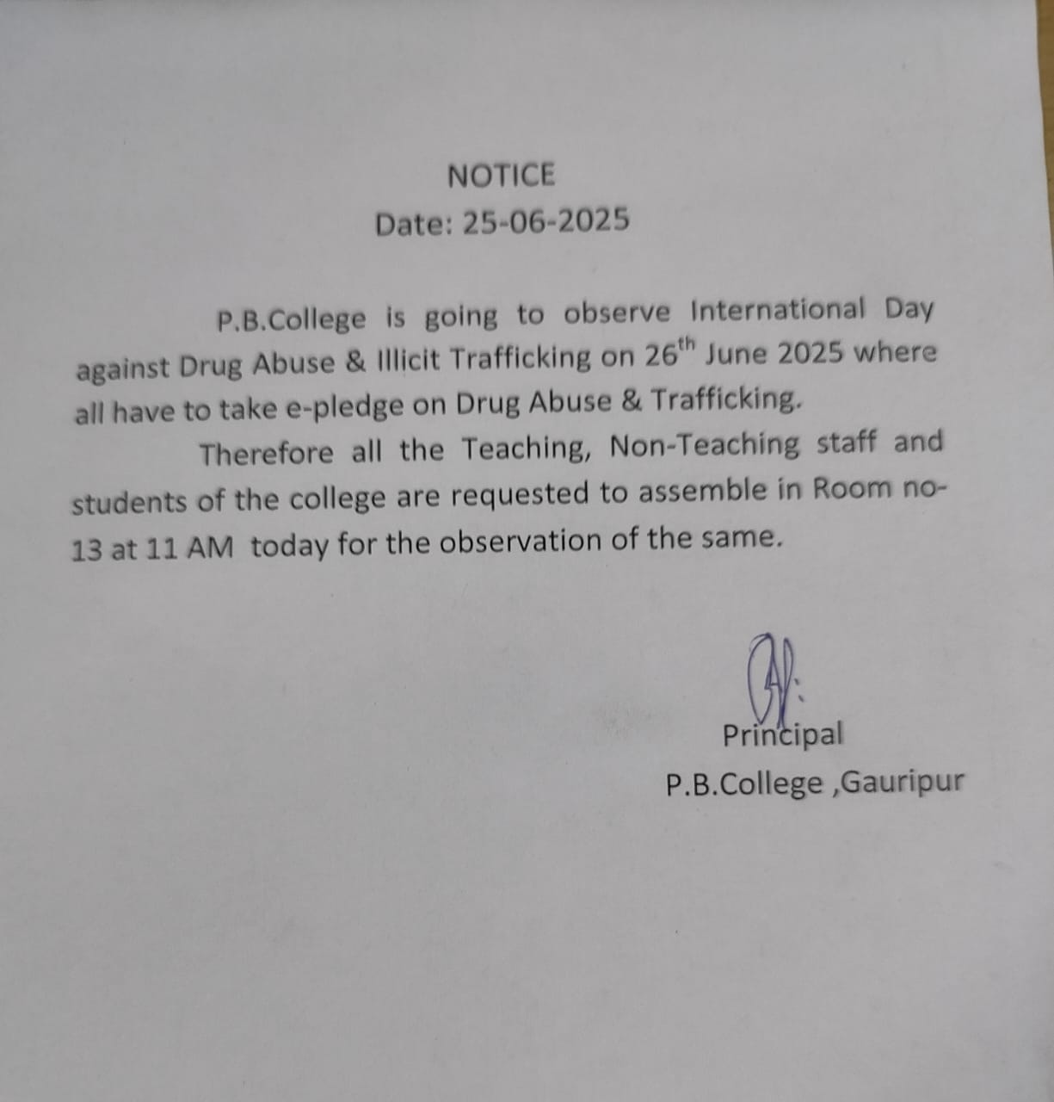

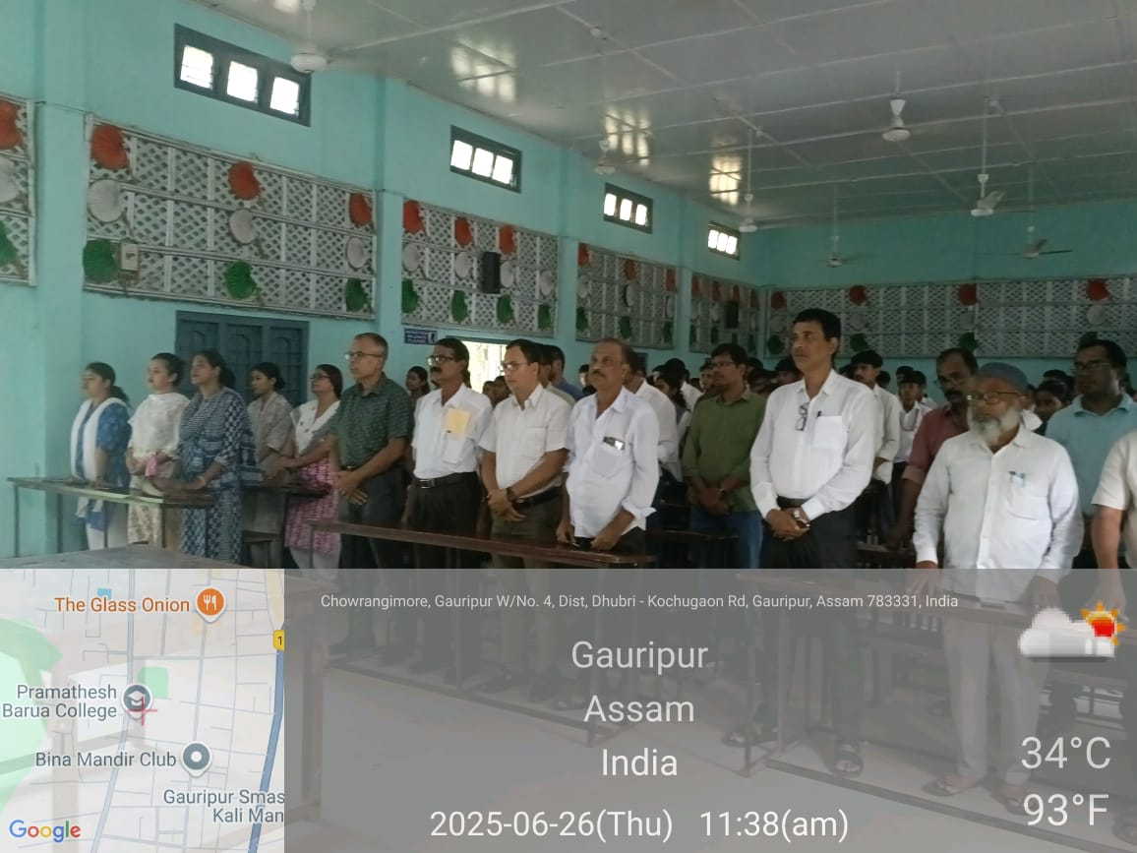
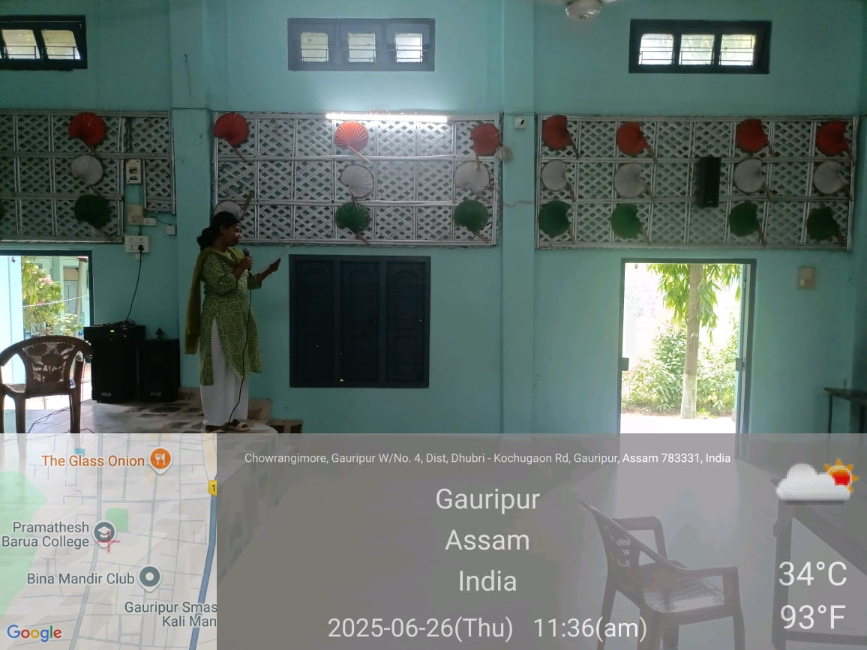
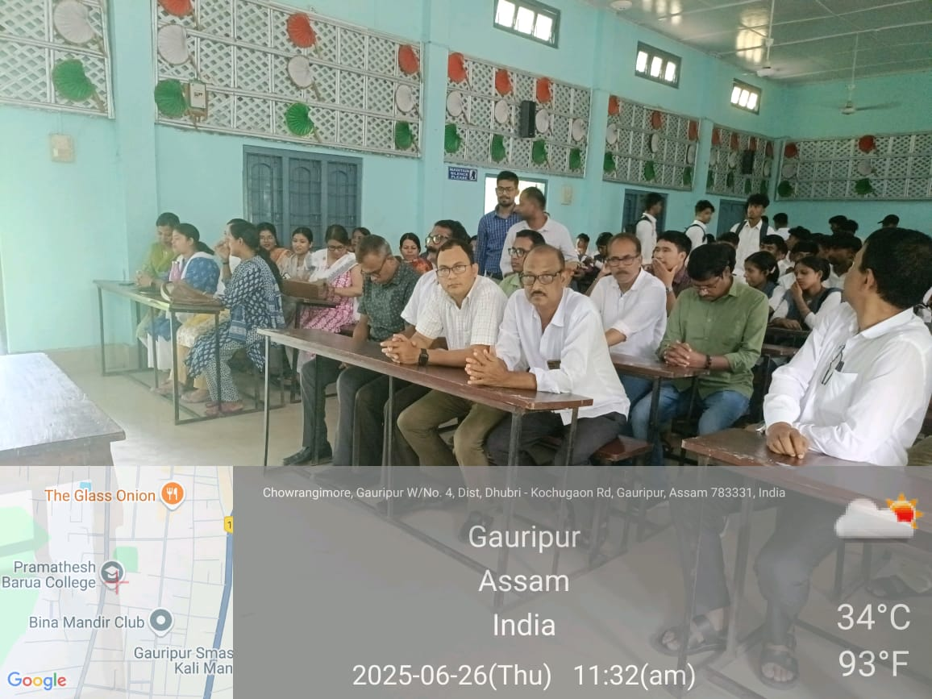
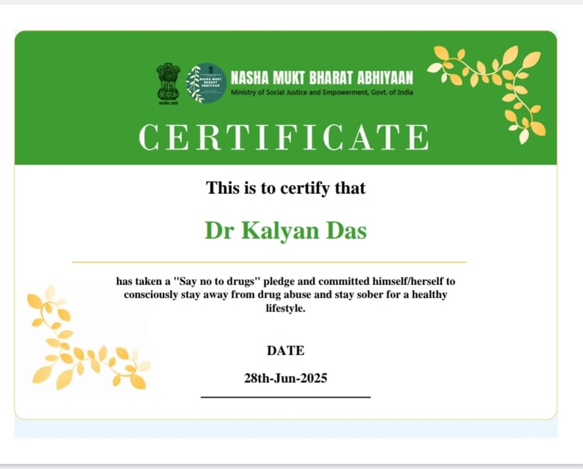
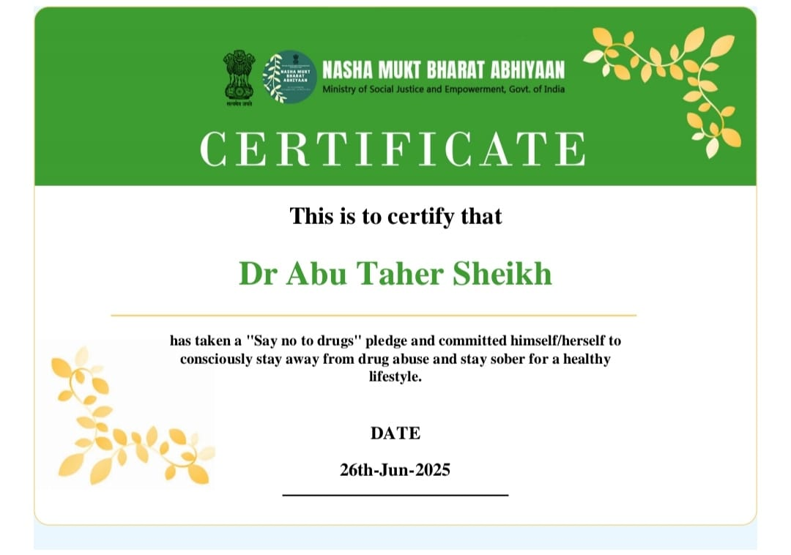

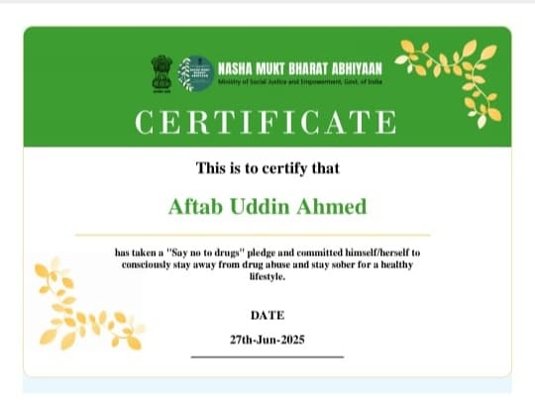

Principal
P.B.College, Gauripur

