REPORT ON MASS E-PLEDGE TAKING PROGRAMME ON DRUG
Vanue: Pramathesh Barua College, Gauripur
Date: 13th August 2025

Pramathesh Barua College, Gauripur observed Mass e-pledge Takng programme against drugs on 13th August 2025 at 12 Noon in Room no 13 as per the DHE’s letter no E Comp.No. 689155/2025/1 dtd 13-08-2025. All employees and students were present in the programme and took the pledge heartily. It ended successfully.
Some of the visuals of the observation are enclosed herewith.
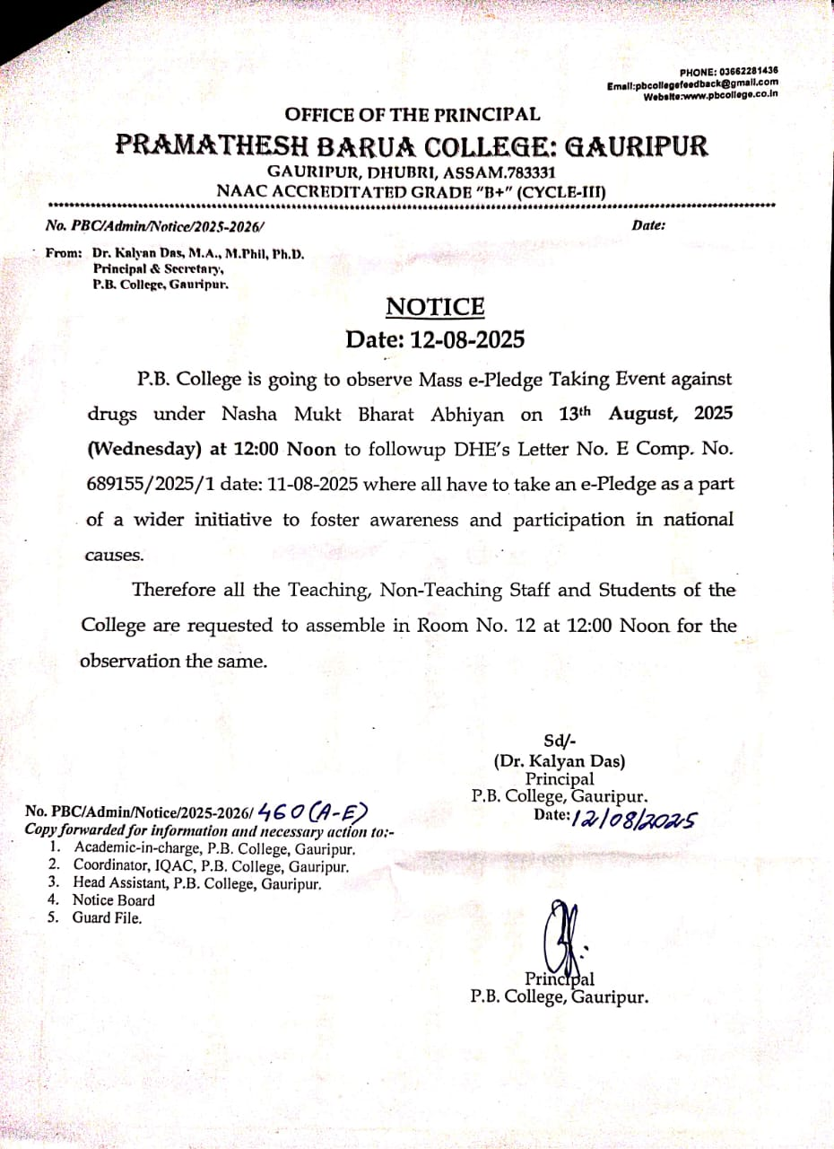
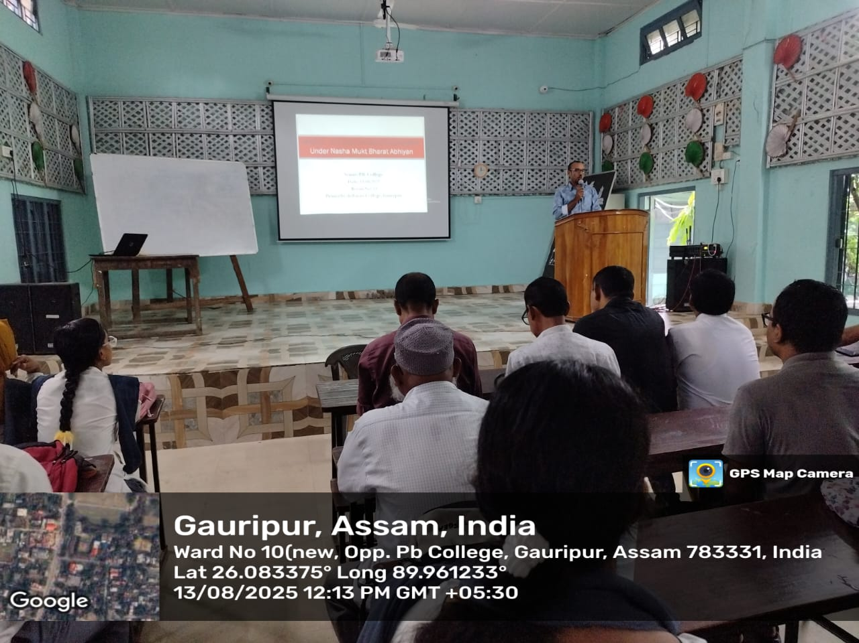
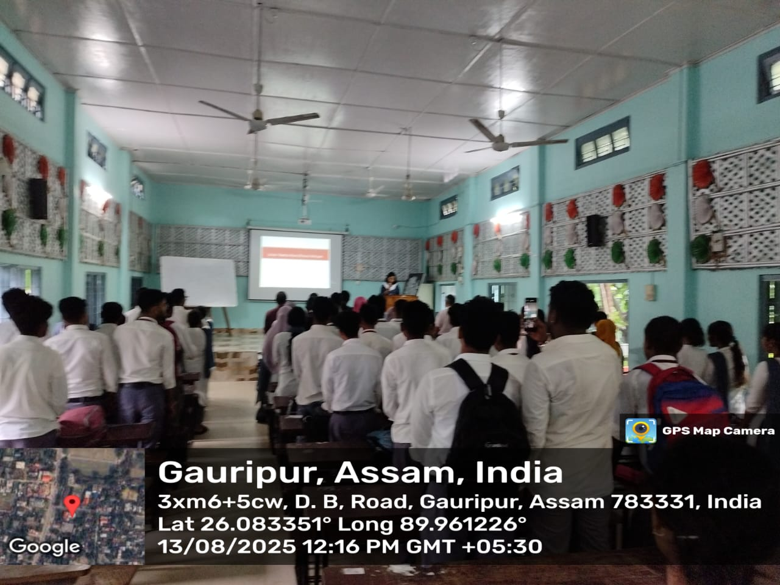
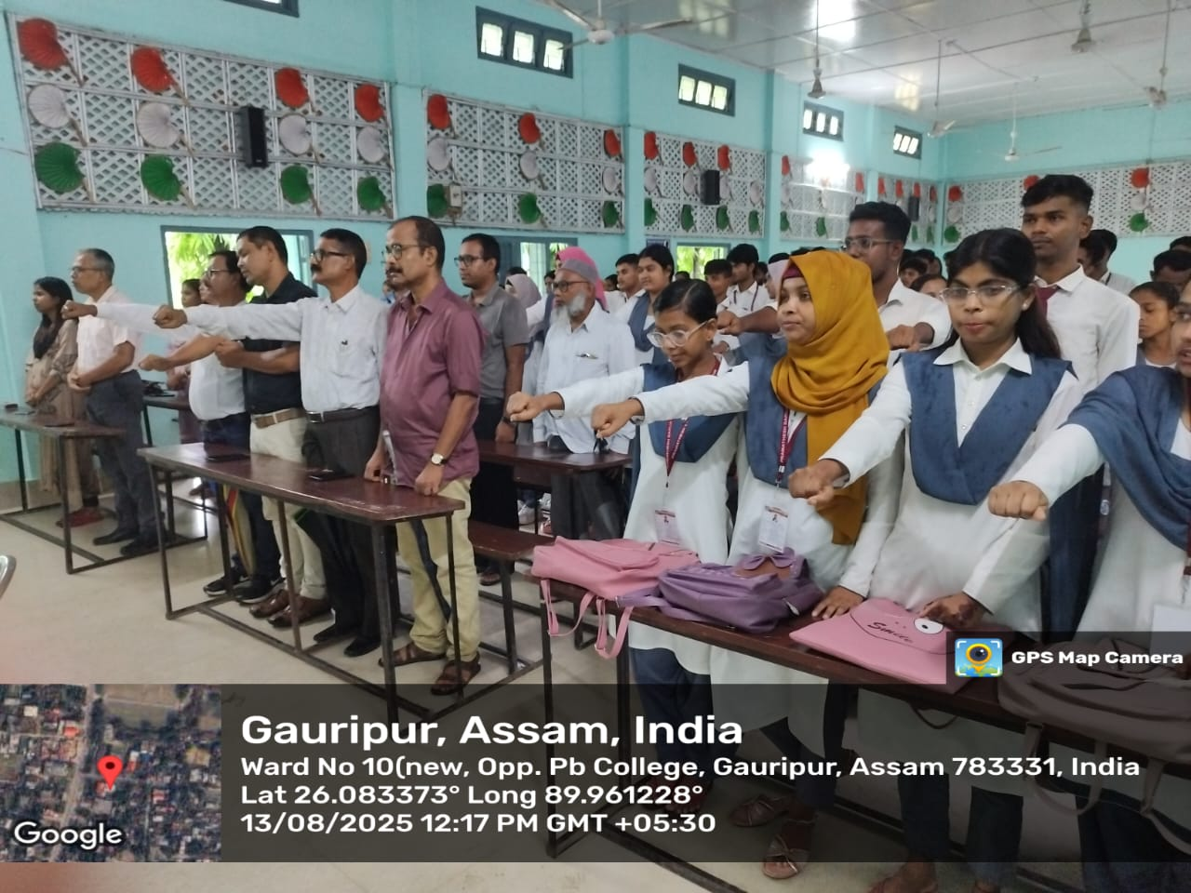

Principal
P.B.College, Gauripur

