Report of inaugural session of the Add-on Course on “Rural Development” by the Department of Economics, Pramathesh Barua College
Date: 20 Aug, 2025

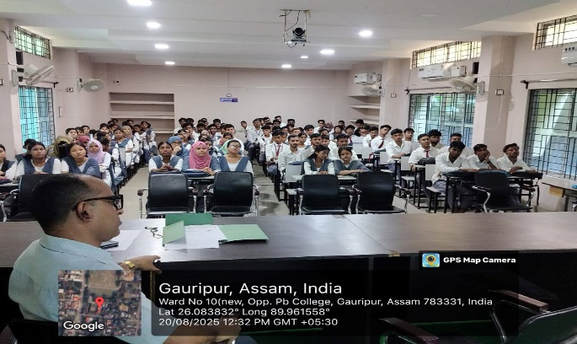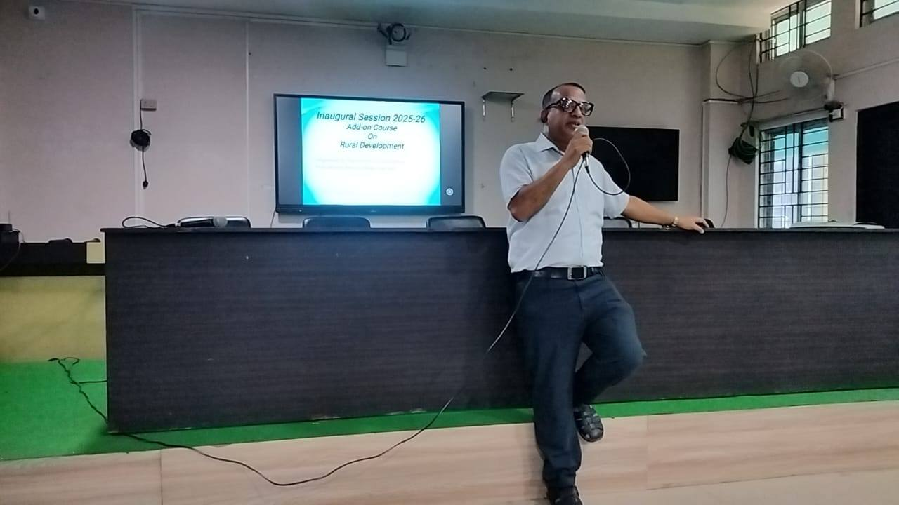
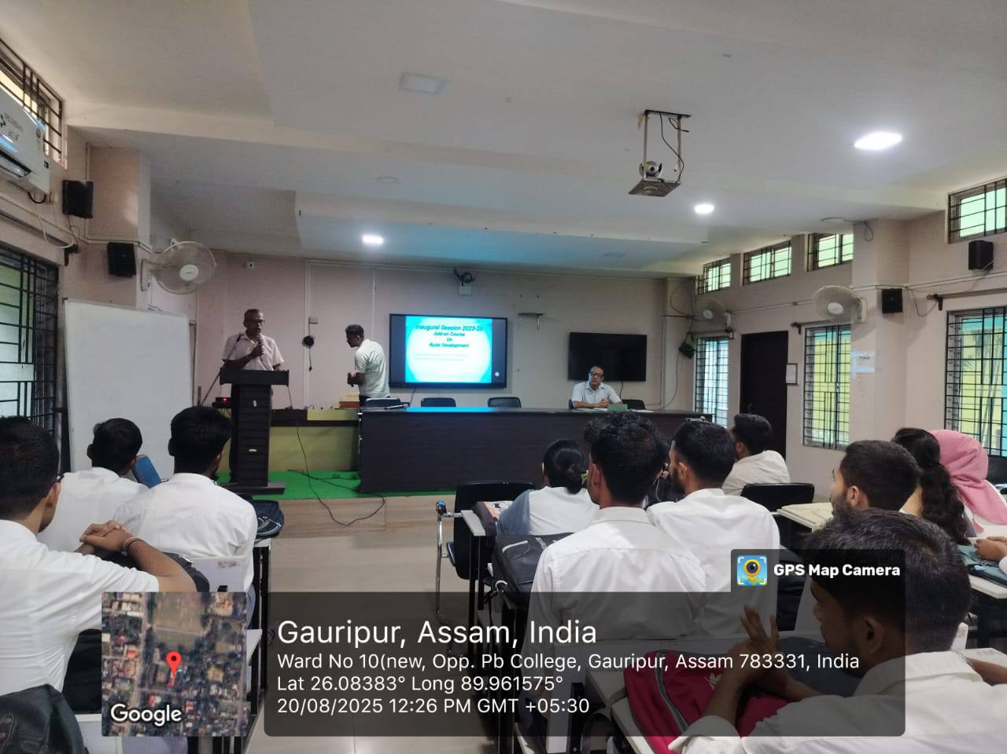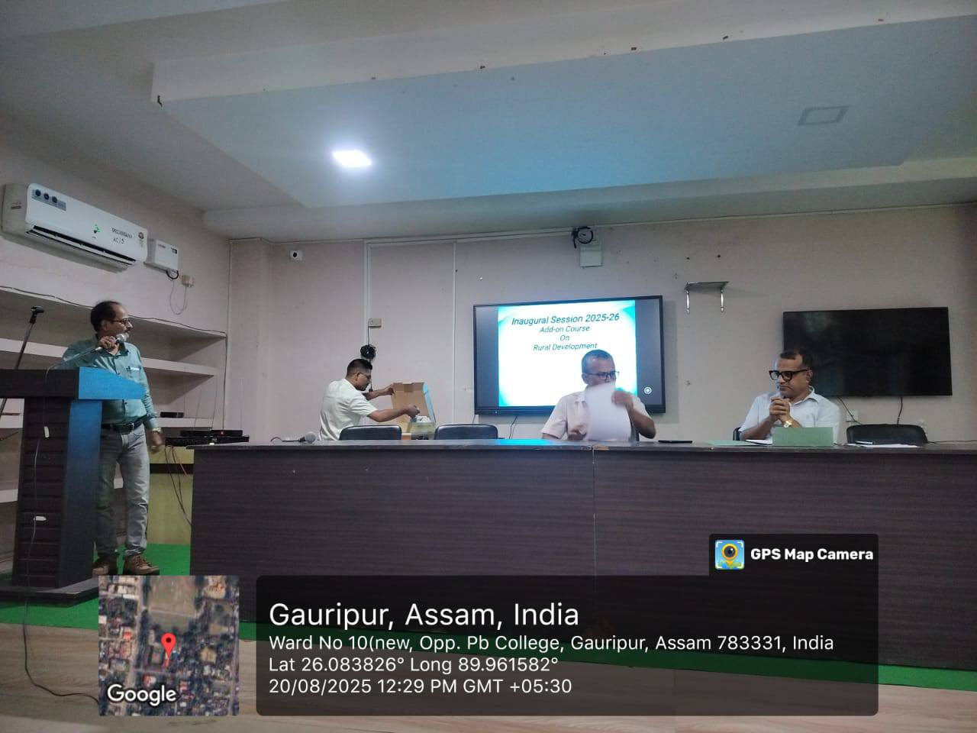
The Department of Economics, Pramathesh Barua College, Gauripur in collaboration with the Internal Quality Assurance Cell (IQAC) of the College, organised the inaugural session of the Add-on Course on “Certificate course on Rural Development” for the session 2025-26 in Digital Classroom at 12 PM on 20th August 2025. The event started with the lecture by Professor Hasib Md Iqbal, he highlighted the importance of rural economy and in context of present economic scenario. The session aimed to include the degree level students of the College.
Dr Kalyan Das, Principal, who highlighted the importance of such courses parallel to a normal degree in current academic landscape and how this type of course helps the students to get the opportunity of employability both in the private and public sector. More than 100 students from Odd semester collected the registration form from Mr Homang Chetri and Maikel Swargoiry, Assistant Professor, Deptt of Economics.
The program ended with the vote of thanks by Dulal Chandra Karmakar, HOD Economics.

