Report of Quiz Competition on the occasion of Independence Day, 2025 organised by the Department of Economics, Pramathesh Barua College
Date: 15 Aug, 2025

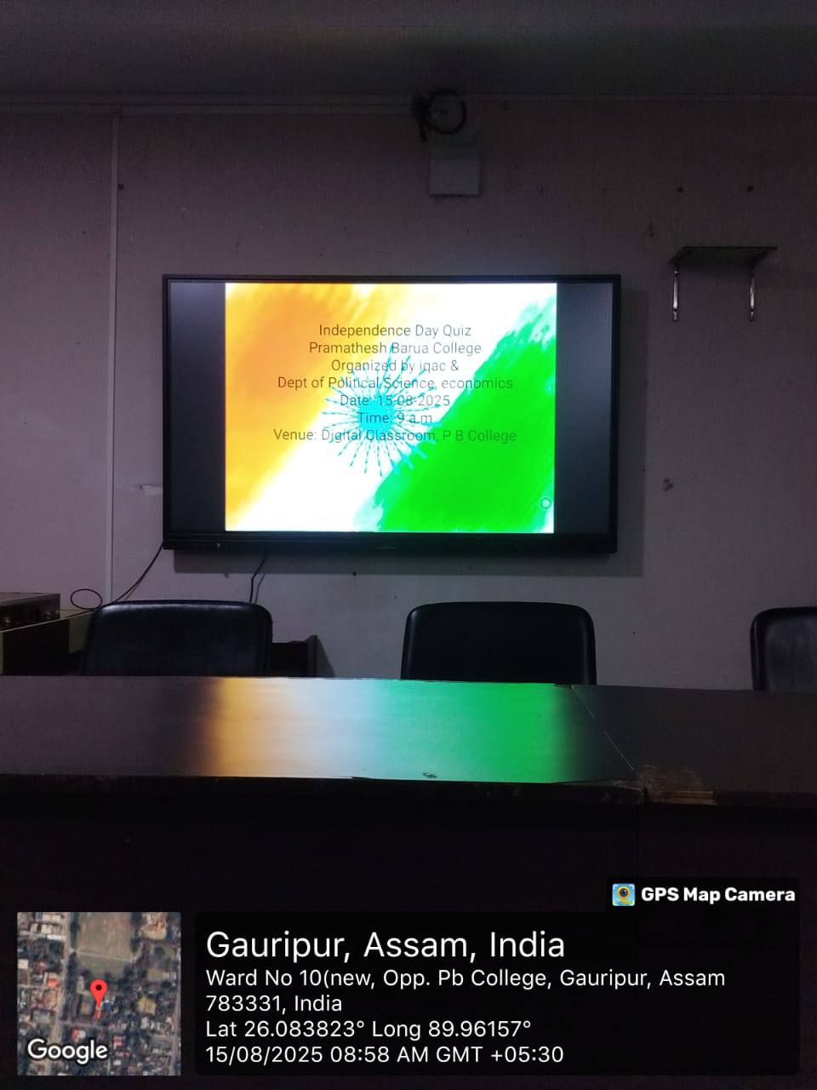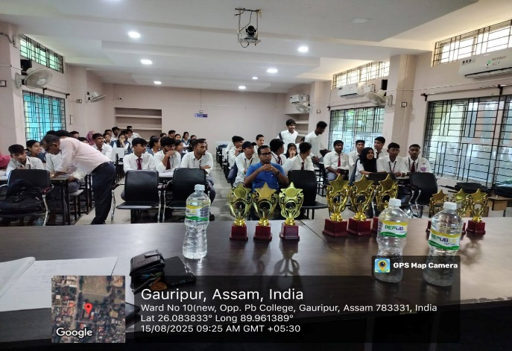
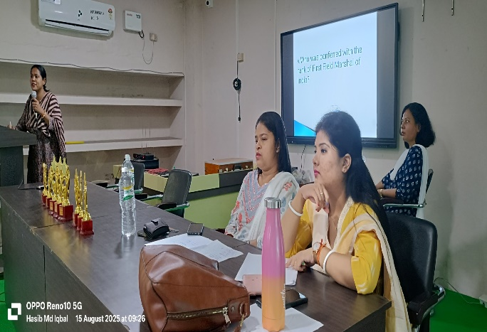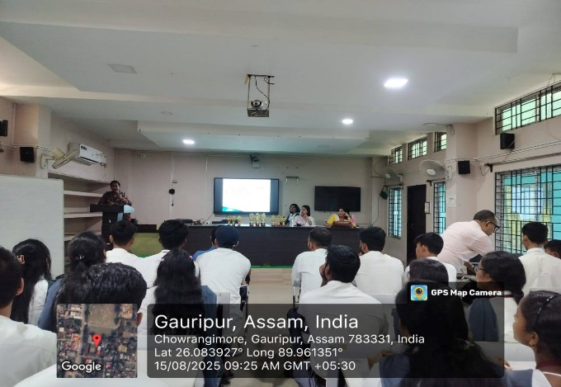
Internal Quality Assurance Cell, Department of Political science and Departments of Economics, Pramathesh Barua College organised a Quiz competition in the Digital classroom of the college on 15th August 2025, on the occasion of 79th Independence Day for the under graduate students. In this competition, eleven different groups, having three participants in each group participated. Before starting the competition Dr. Kalyan Das, Principal of the college explained the importance of competitive atmosphere in the educational institutions and he stressed that involvement of students in different events will enhance the learning habits, boosting the confidence and also improve academic performance.
Rules and regulations of the quiz were explained by Mrs Parvin Sultana, Convener Quiz and Debating Society, P. B. College. All the winners of the quiz competition awarded momento and certificates at the end of Programme. Faculty members Mr Dulal Chandra Karmakar, Coordinator IQAC, Dr Gopal Barman, Mr H. M. Iqbal, Dr Jyotsna Devi, Mrs Pinky Gogoi, Miss Nikumani Das, Himen Das were present in the program. The competition was concluded with the vote of thanks given by the Mrs. Parvin Sultana.

