Report on “Khel Maharan 2023”
Office of the Principal, P.B.College, Gauripur arranged LAC level Chess competition of Golakganj constituency with reference to the vide letter no: GCDC.13/Khel Maharan 2.0/2024/14 dtd Golakganj 7/12/2024 in connection with Khel Maharan 2.0 at P.B.College, Gauripur on 15/12/2024 at 9:30 AM onwards. As a Nodal Officer of Khel Maharan 2.0, 2024 P.B.College, Gauripur Dr. Abu Taher Sheikh made an arrangement of accommodation for performing the above mentioned event.
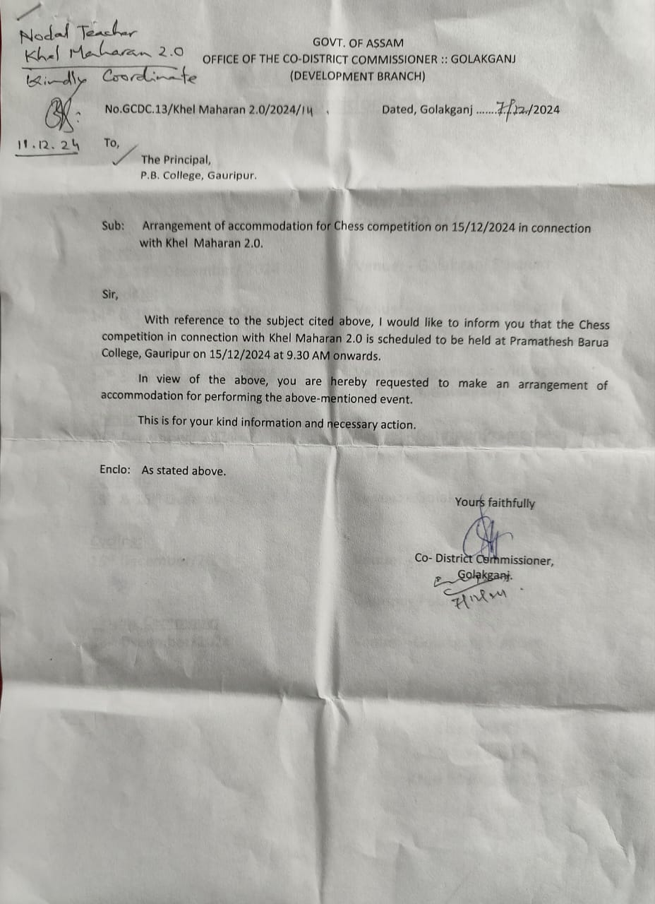
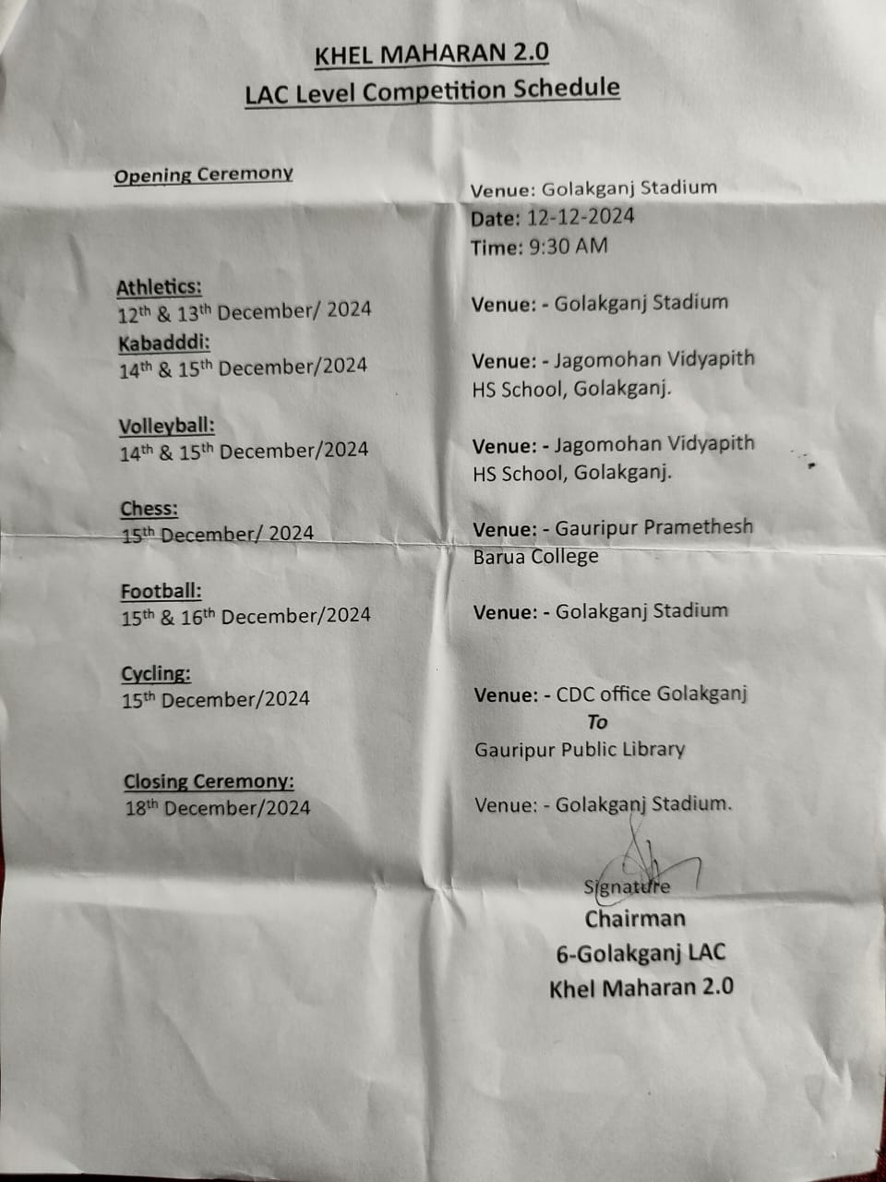
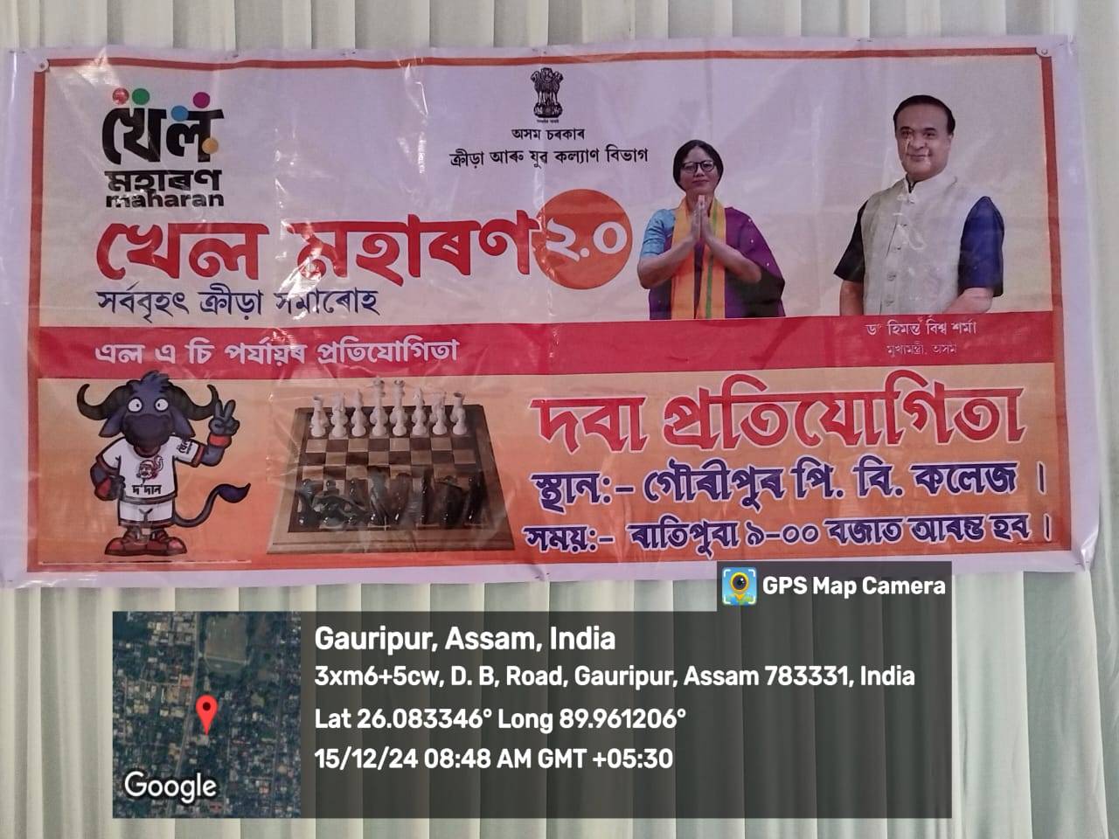
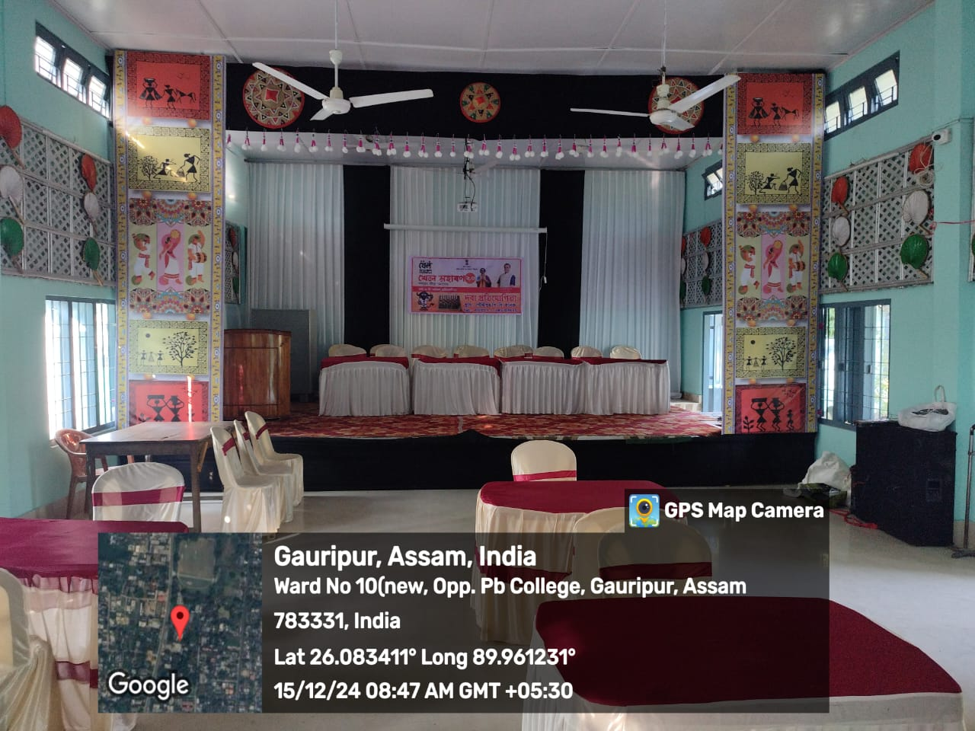
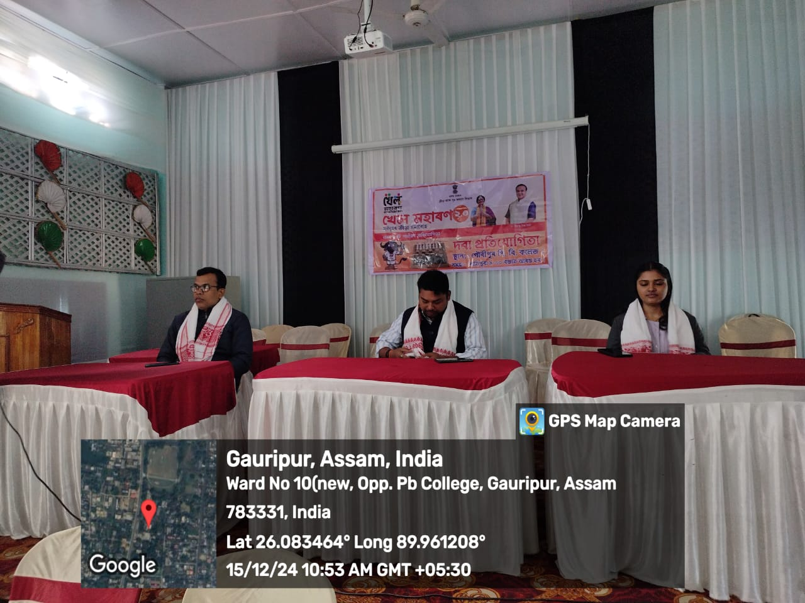
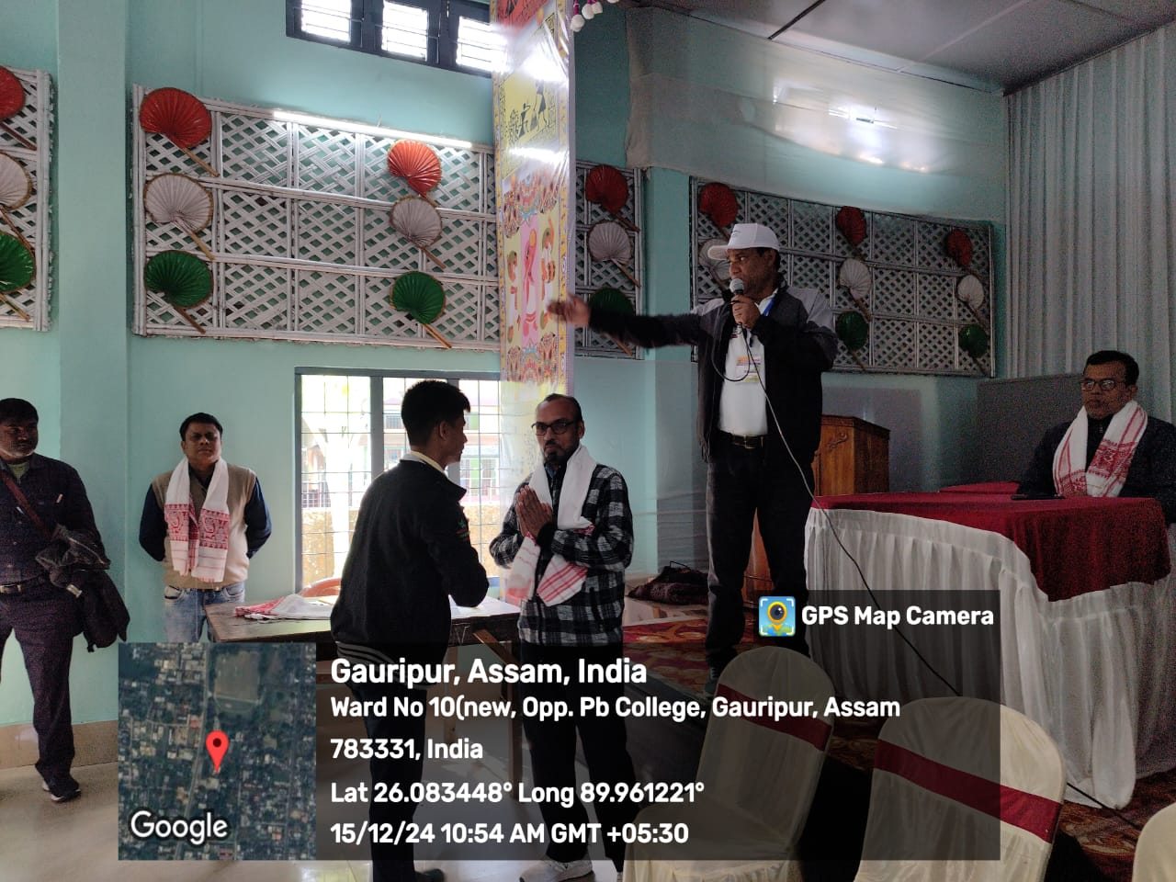
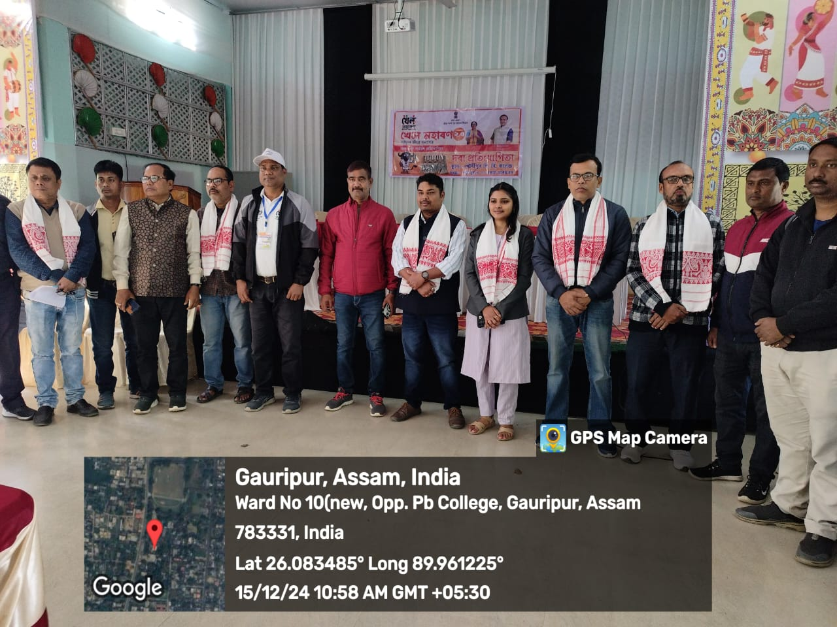
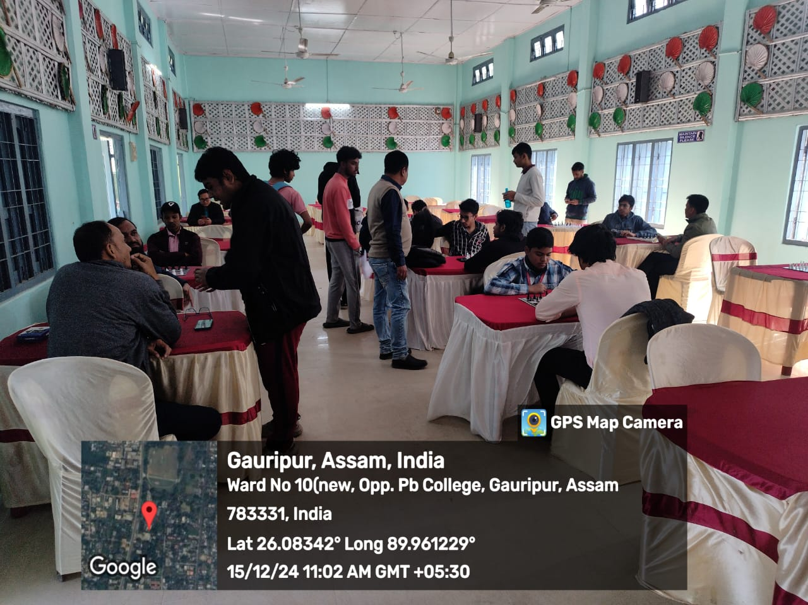

Dr. Kalyan Das Dr. Abu Taher Sheikh
Principal Nodal Teacher, Khel Maharan 2.0
P.B.College, Gauripur P.B.College, Gauripur

