Report on Remedial Class of BA 1st Semester (FYUGP)
A remedial class of Arabic Subject of BA 1st semester (FYUGP) is held on 04-12-2024 at 11:30 am in the department of Arabic…
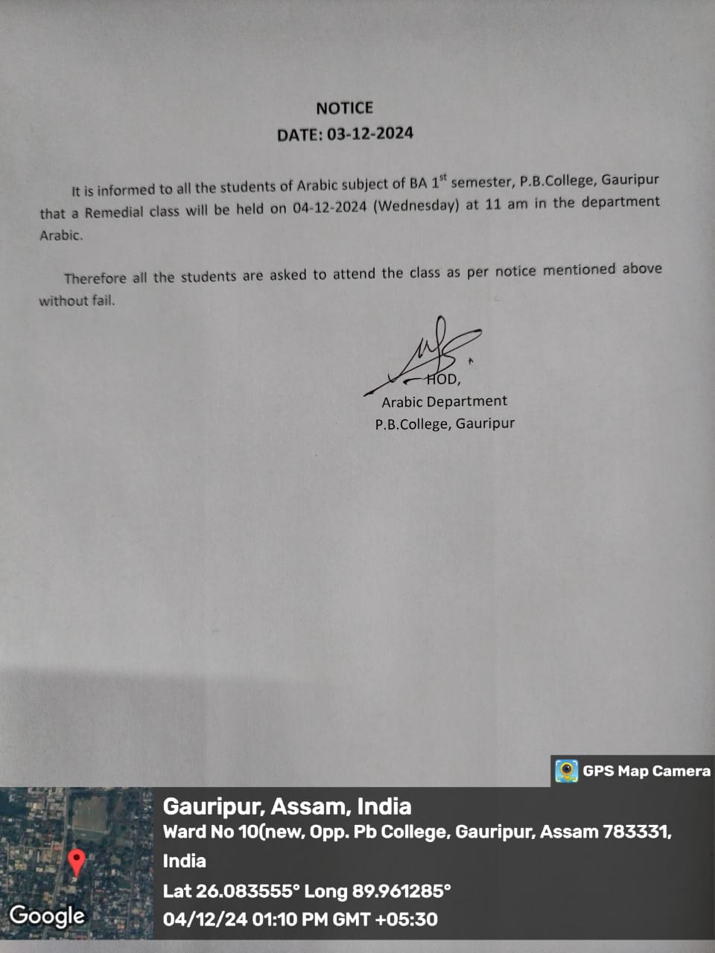
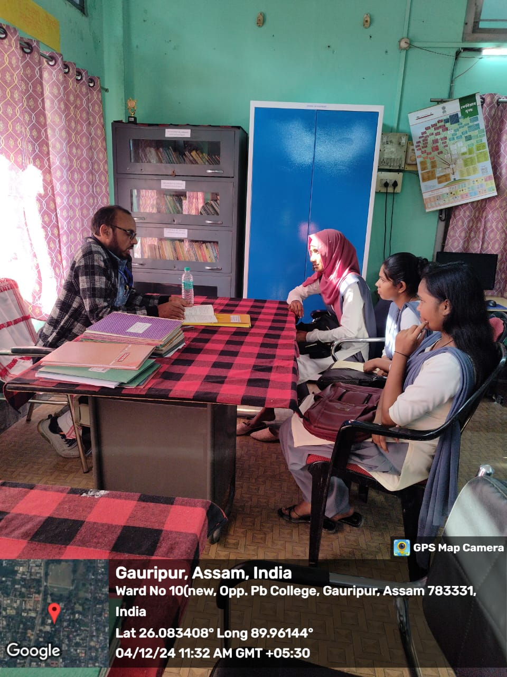

HOD
Department of Arabic
P.B.College, Gauripur

