Report of Remedial class
Depart of Sanskrit
P.B.College, Gauripur

Report on remedial class done by Sanskrit department on 25th Nov/2024 in Room no- 12 at 11 am
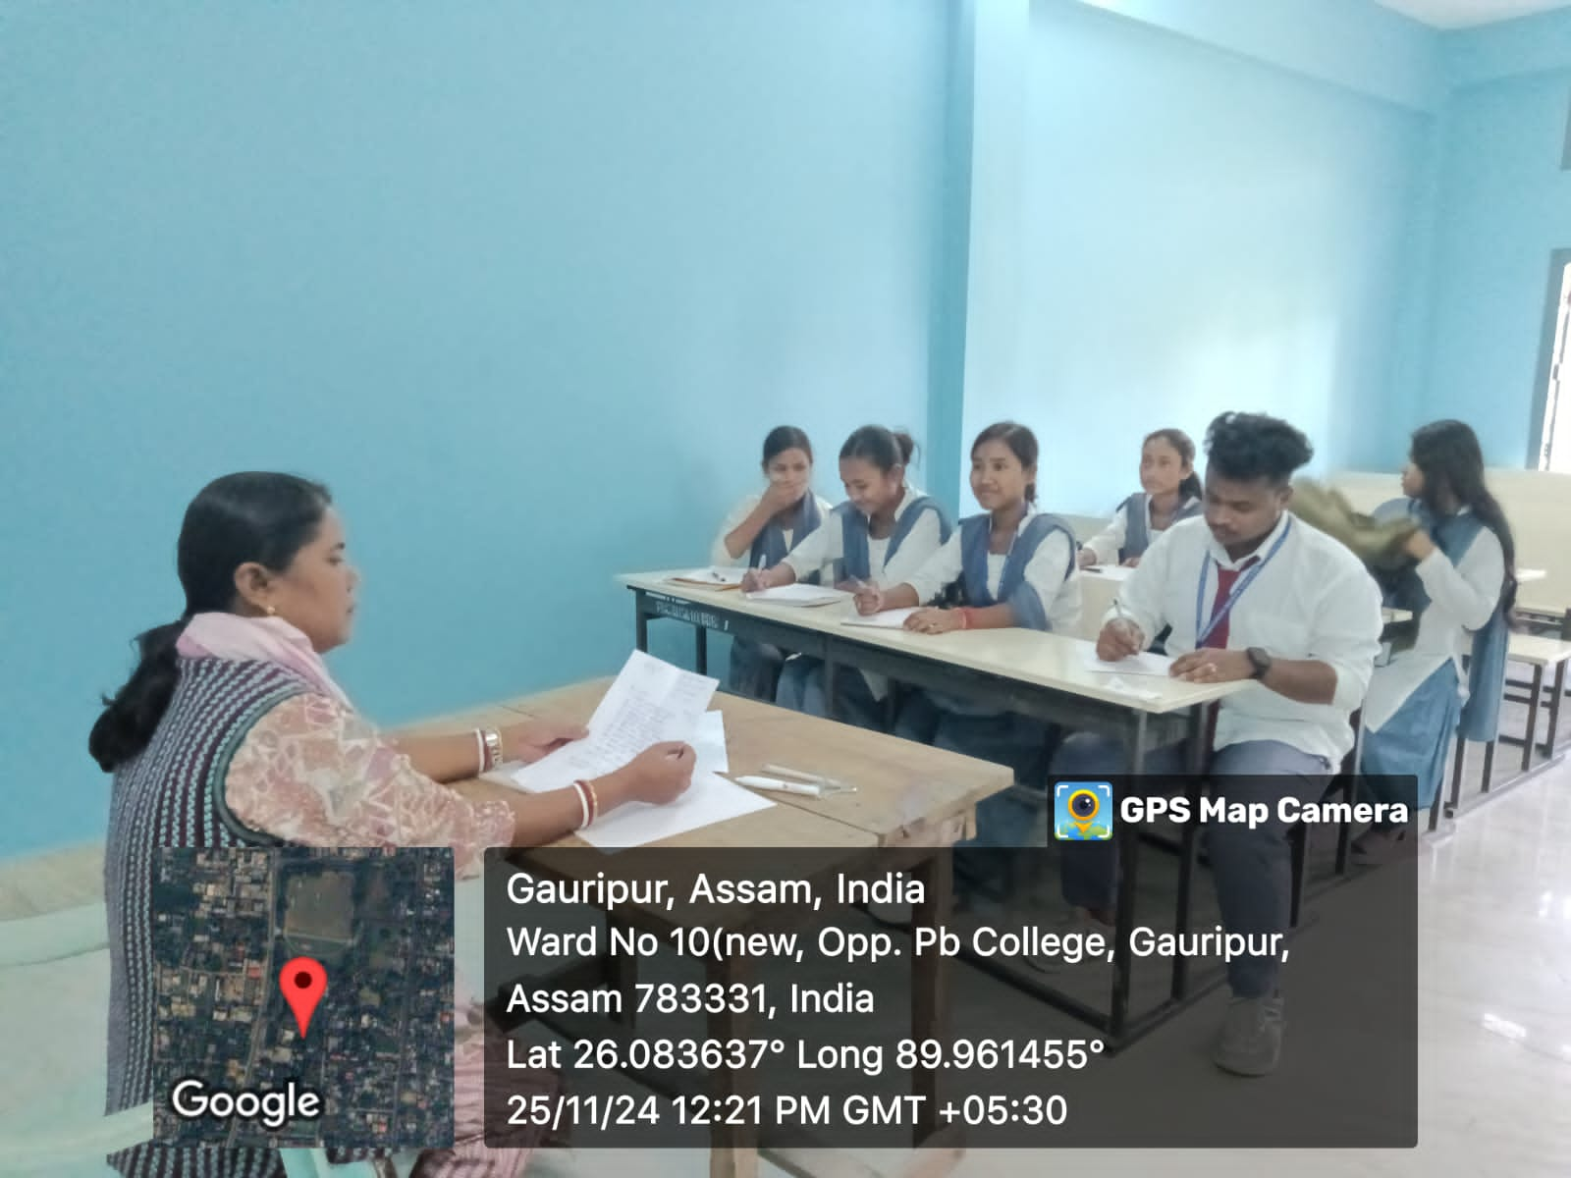
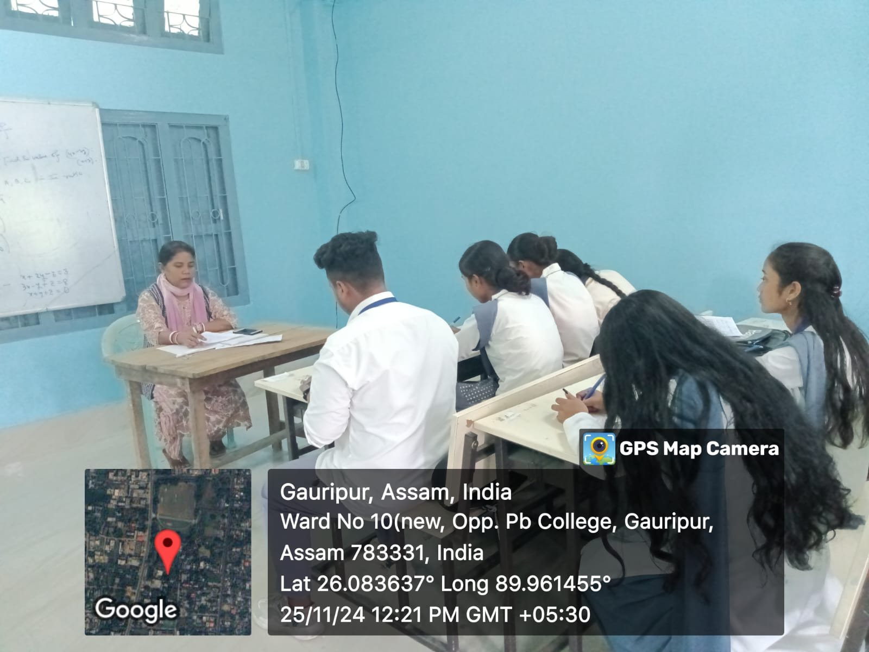

HOD
Department of Sanskrit

