REPORT
ON
“A MOCKDRILL CAMP ON EARTHQUAKE AND FIRE”

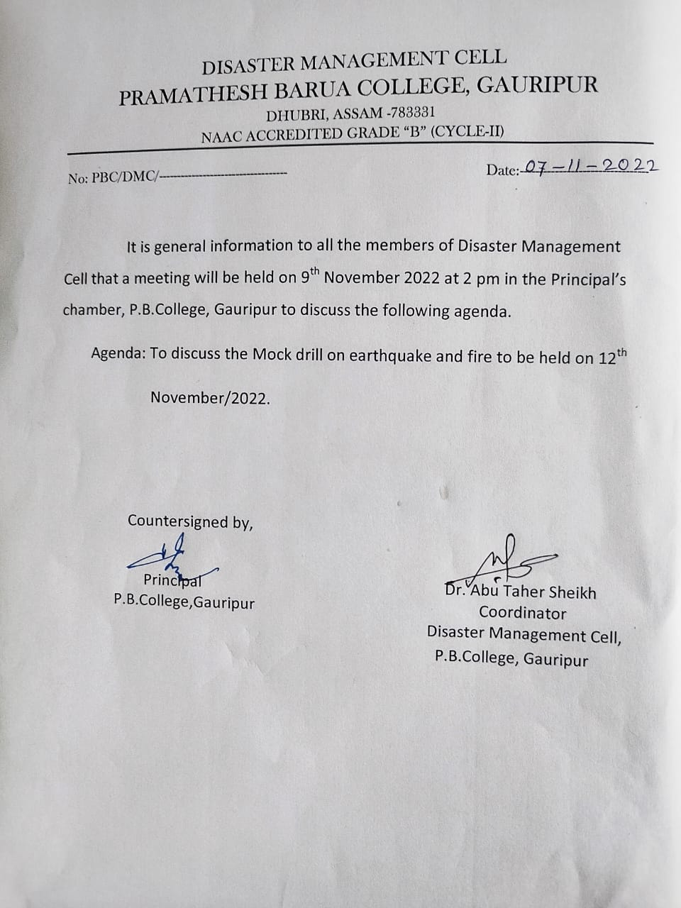
Call letter for meeting to Maembers of DMC

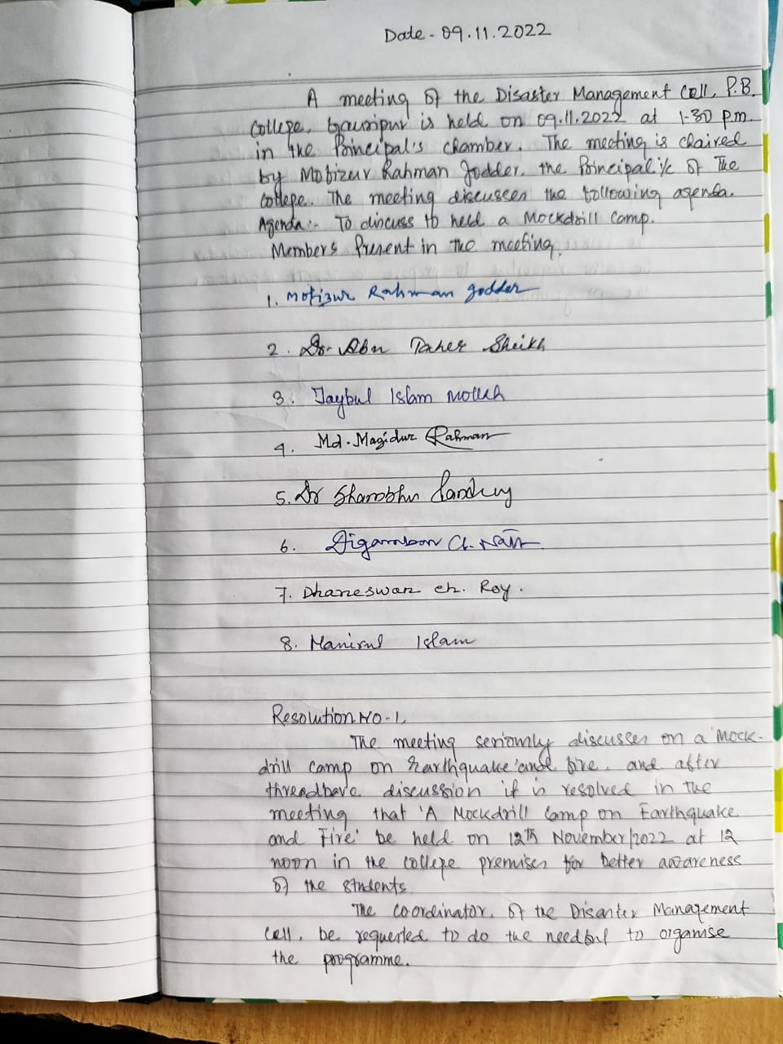
Resolution of the Meeting of DMC
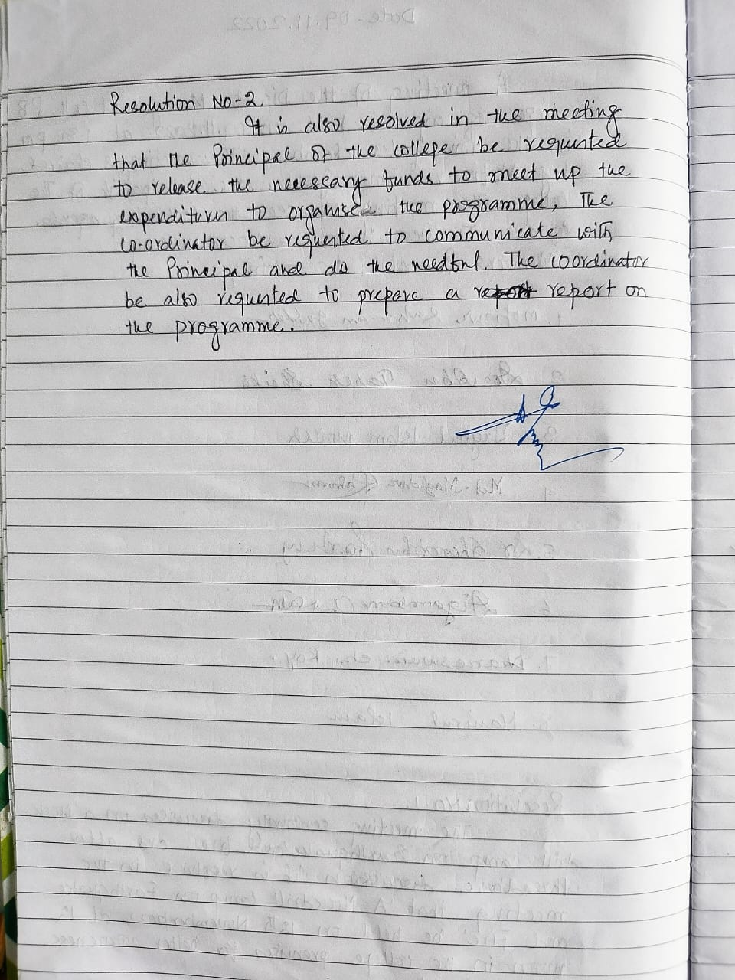
Resolution of the Meeting of DMC

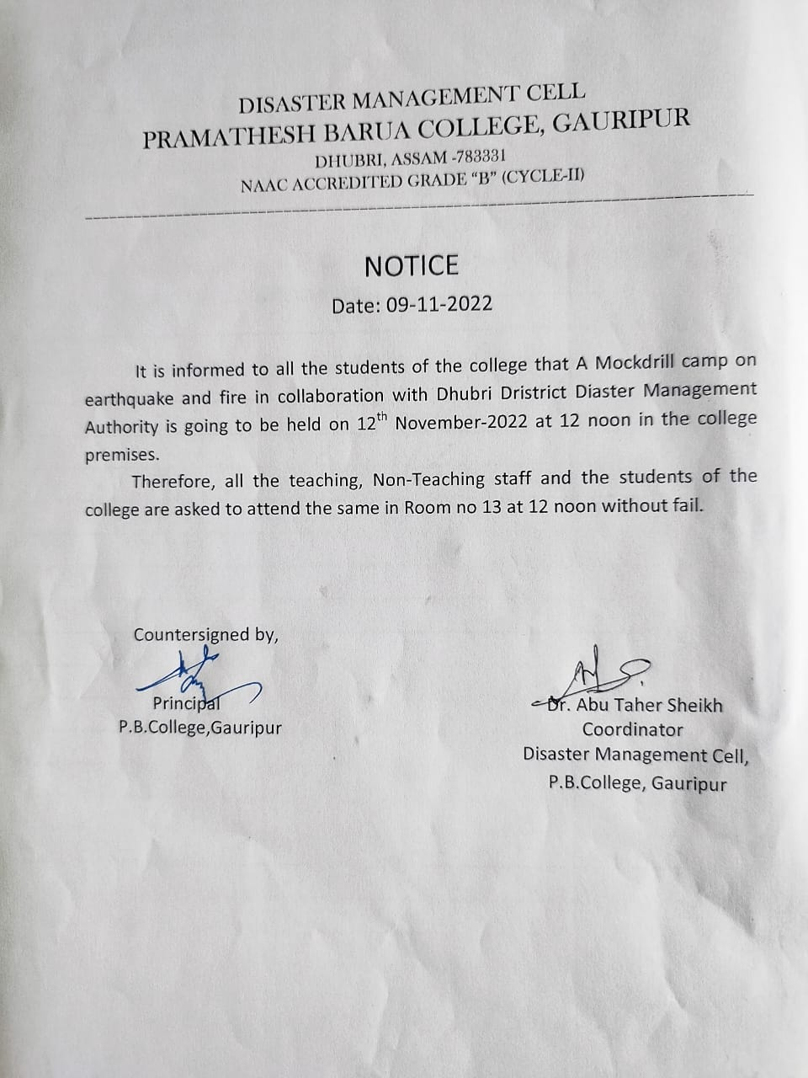
Notice for Students & Staff to attend the programme

Disaster Management Cell, NSS & NCC Units of P.B.College jointly organized “A Mockdrill camp on Earthquake and Fire” with collaboration of Dhubri District Disaster Management Authority at P.B.College campus on 12th November 2022 at 12 noon. The programme started with the inaugural speech of Sri Mofizur Rahman Jotder, Principal i/c, P. B. College, Gauripur. The programme successfully ended with many demonstrations to the students of the college to protect themselves from sudden disaster given by officials from Dhubri District Disaster Management Authority.
The students of the college were shown many important tips to save and protect themselves from the awareness cum training program on disaster management. The programme has immensely benefitted the students of the college.

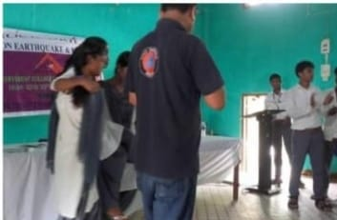

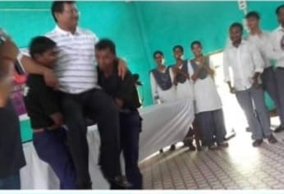

Coordinator,
Disaster Management Cell
P.B.College, gauripur

