Report on “Khel Maharan 2023”
Office of the Mission Co-ordinator, Sarba Siksha Abhijan, Dhubri arranged a “Mega Sports Events” competition from GP to LAC to District level. Some the students of our college participate in the competition. As a Nodal Officer of Khel Maharan 2023 from P.B.College, Gauripur Dr. Abu Taher Sheikh Guides the students so that they can show their talent in the competition.
It is our proud to say that one of our students, Mofizur Rahman of BA 2nd semester bearing Roll no- 23036 secured 3rd position in 800 Meter Race in district level competition.
Admission Roll:
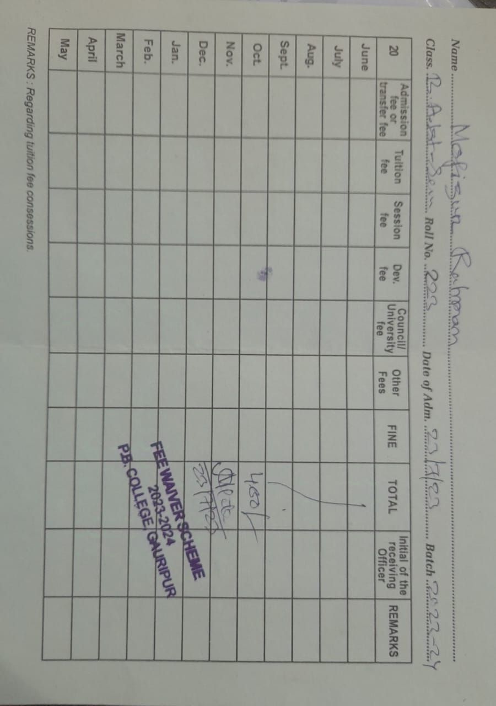
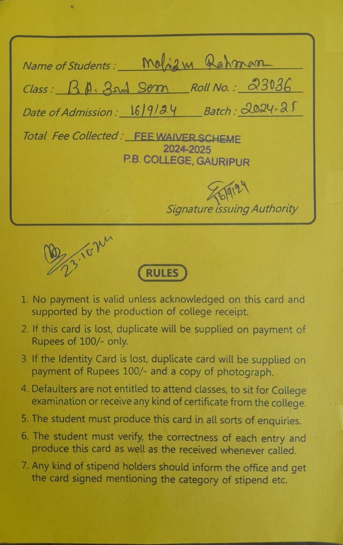
ID card:
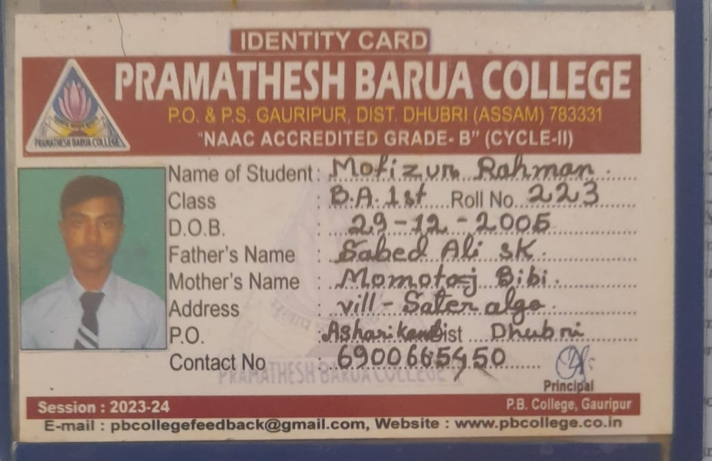
Moment Of Playing in District Level:
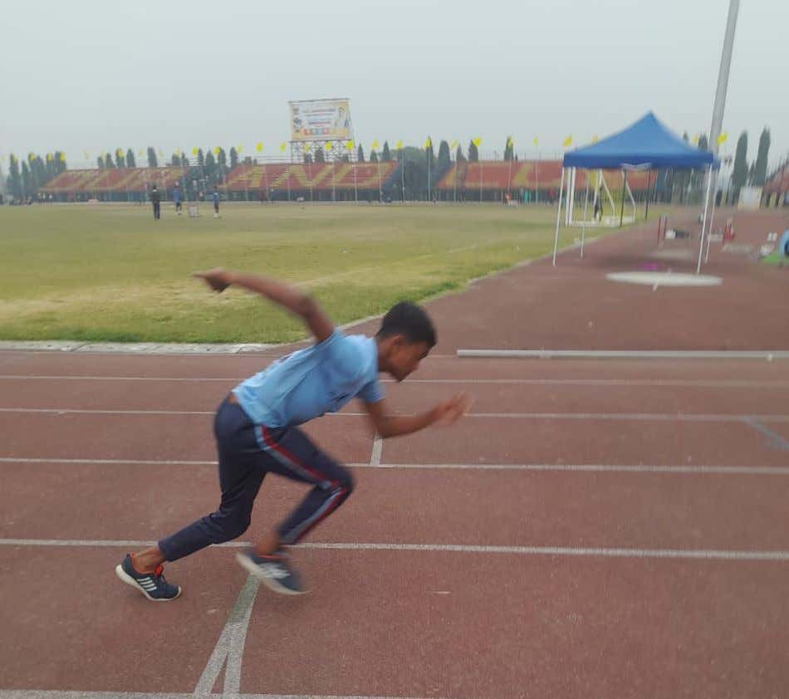

Moment of Playing in District Level:
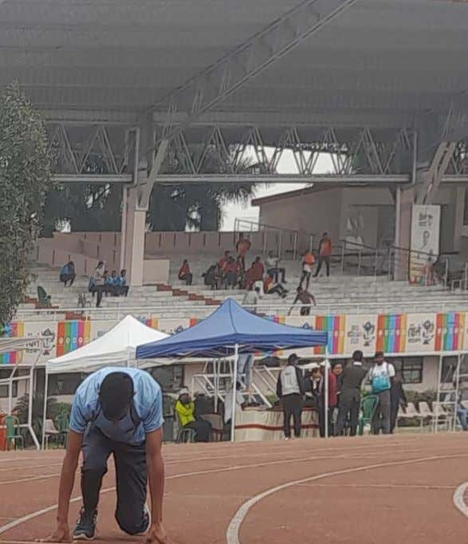
During receiving Prize in District Level:

Certificate of Merit in 800M Race in District Level:
