REPORT
ON
“AWARENESS AND TRAINING PROGRAMME ON DISASTER MANAGEMENT”

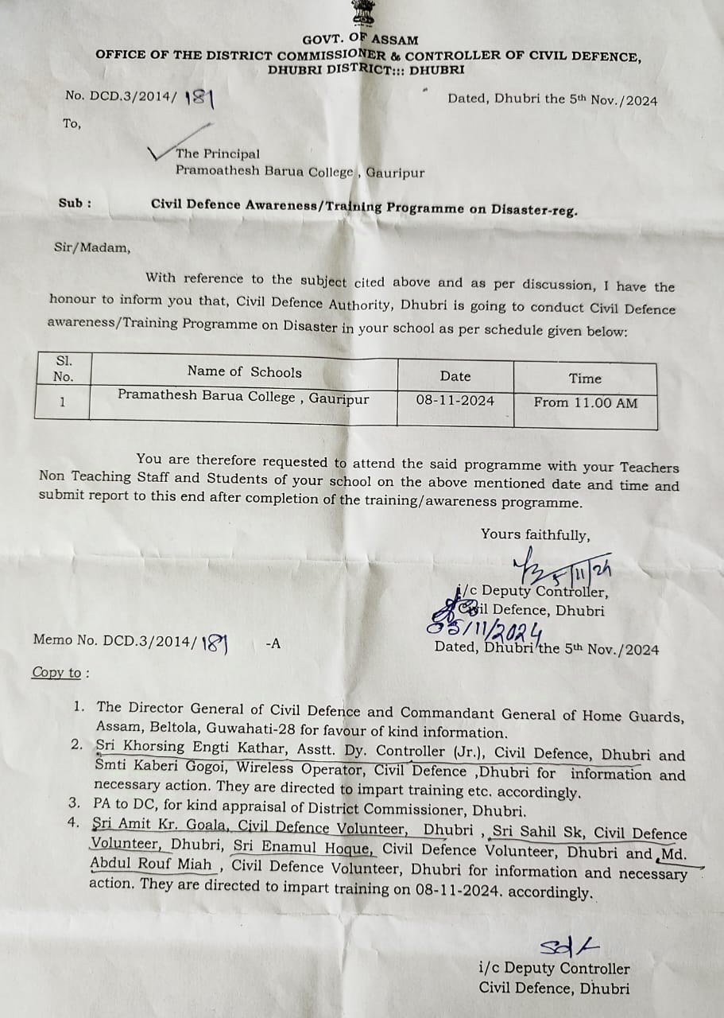
Letter from Civil Defence Office
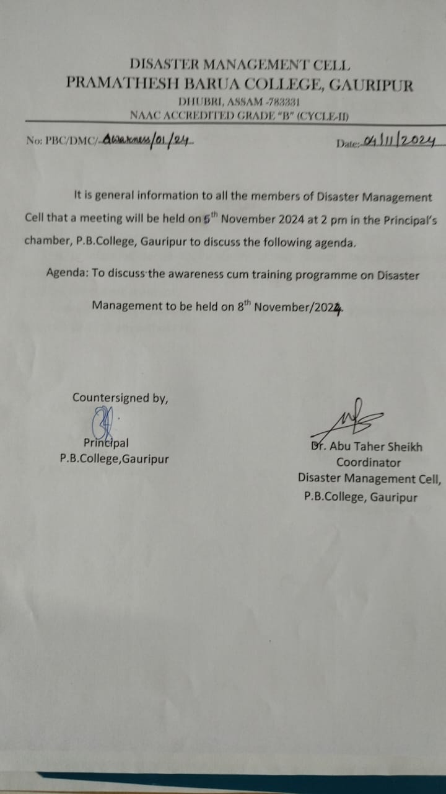
Call letter to Members of DMC for meeting
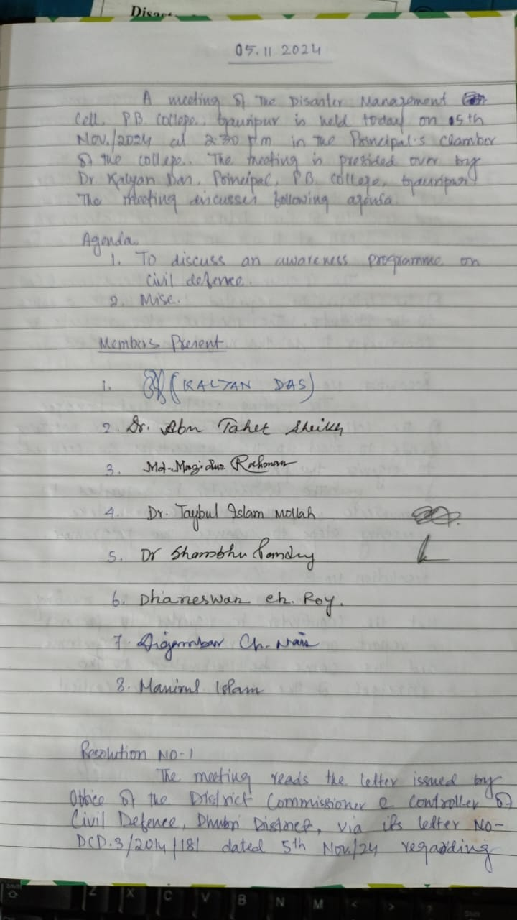
Meeting‘s Resolution
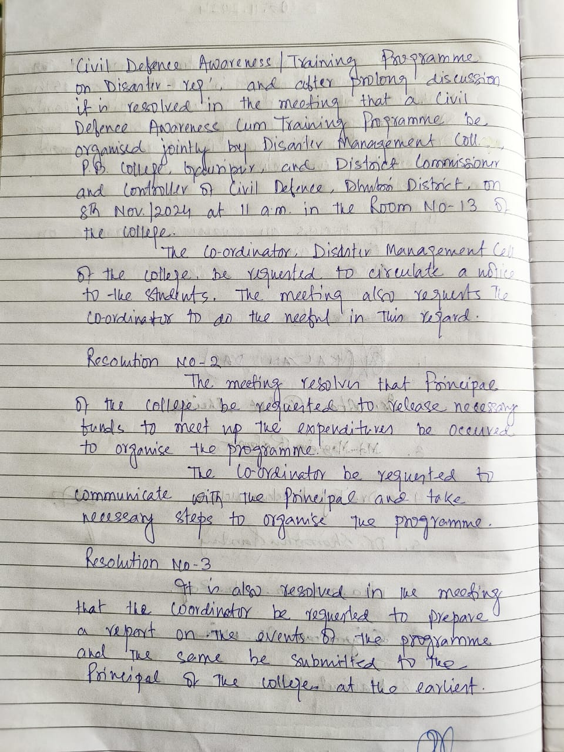
Meeting‘s Resolution
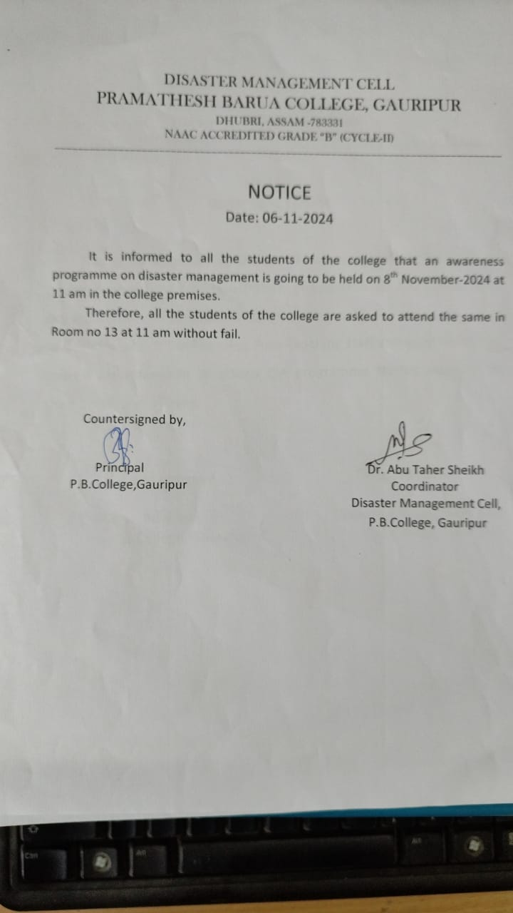
Notice for students & staff
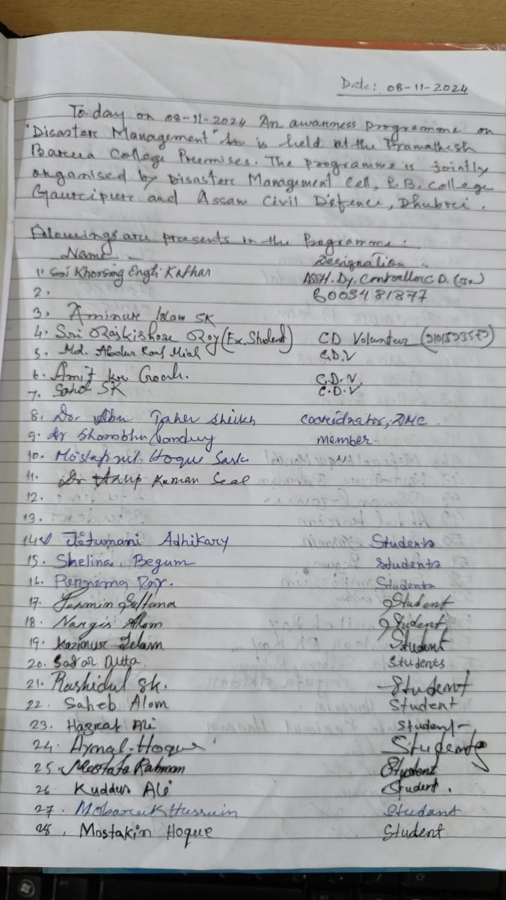
Attendants of Programme
Disaster Management Cell, P. B. College, Gauripur and Office of the District Commissioner & Controller of Civil Defense, Dhubri jointly organized Awareness cum Training Programme on Disaster Management on 8th November 2024 at 11 am. The programme started with the inaugural speech of Dr. Kalyan Das, Principal, P. B. College, Gauripur. Dr Aminur Islam Sk, Associate Professor in Philosophy, P. B. College, Gauripur felicitated the guests and volunteers. The programme successfully ended with many demonstrations to the students of the college to protect themselves from some sudden disaster given by officials from Civil Defence, Dhubri
As a chief quest Sri Khorsing Engti Kather, Asstt. Dy. Controller (Jr), Civil Defence, Dhubri, delivered his valuable speech on disaster management and also instructed the students with demonstrations how we can face and protect us from disaster. Some Volunteers from Civil Defense department performed disaster management demonstration before the students. They are Sri Amit Kr. Goala, Sri Sahil Sk, Sri Enamul Hoque, Md. Abdul Rouf Miah, and Sri Raj Kishore Roy, Civil Defence Volunteers.
The students of the college were shown many important tips to save and protect themselves from the awareness cum training program on disaster management. The programme has immensely benefitted the students of the college.
Some Clicks of the programme:
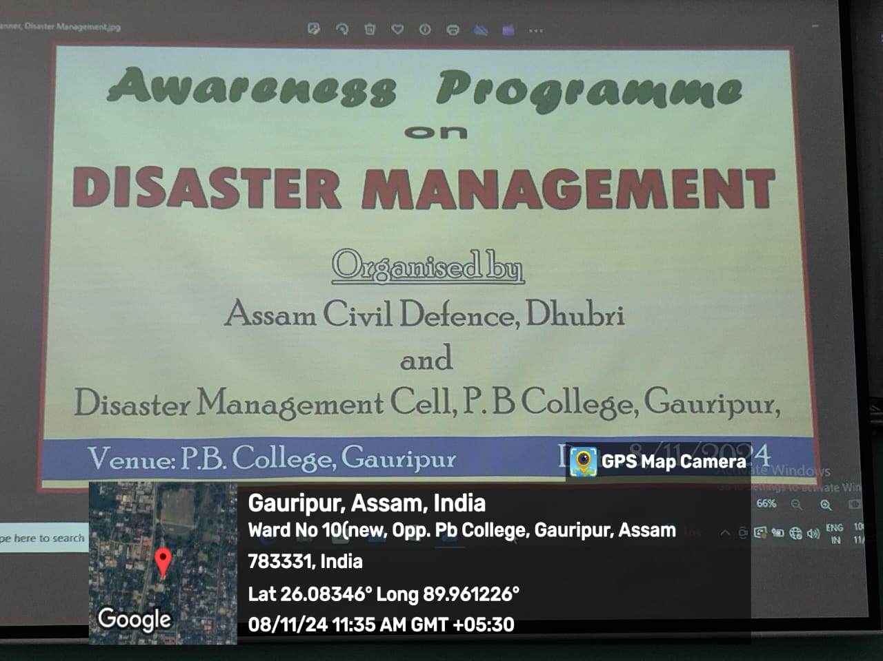
Banner of the programme

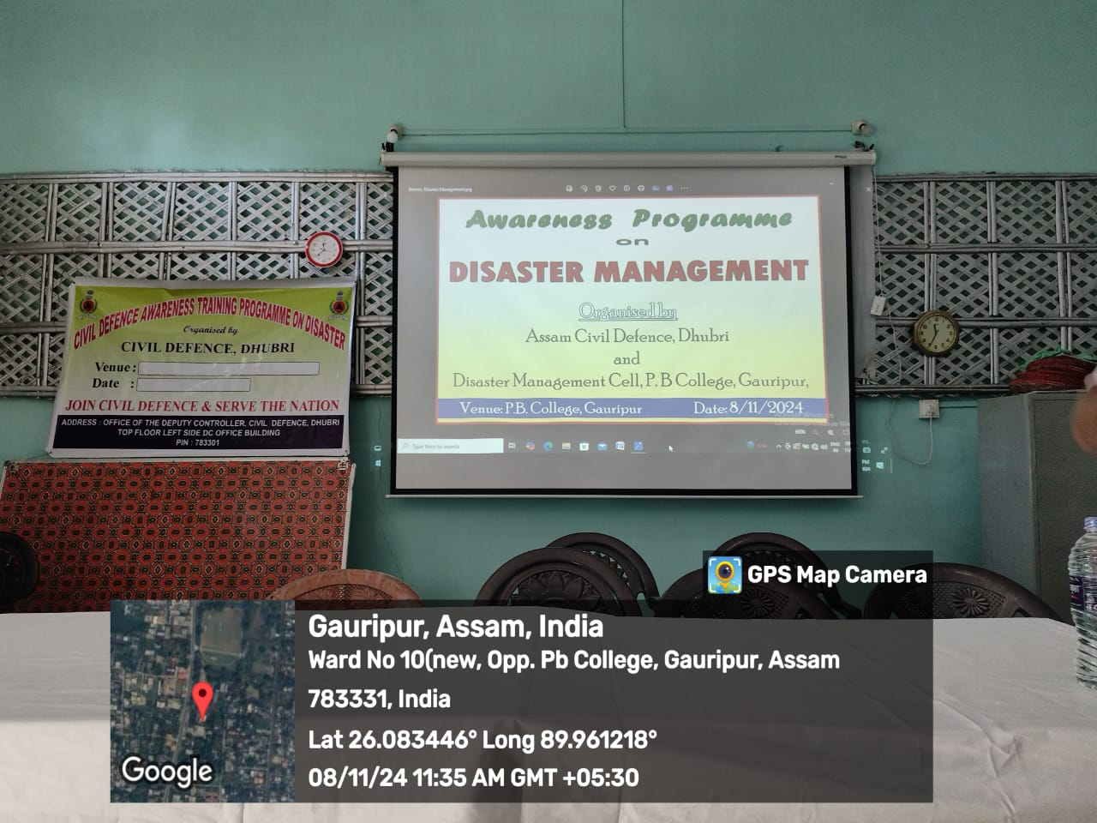

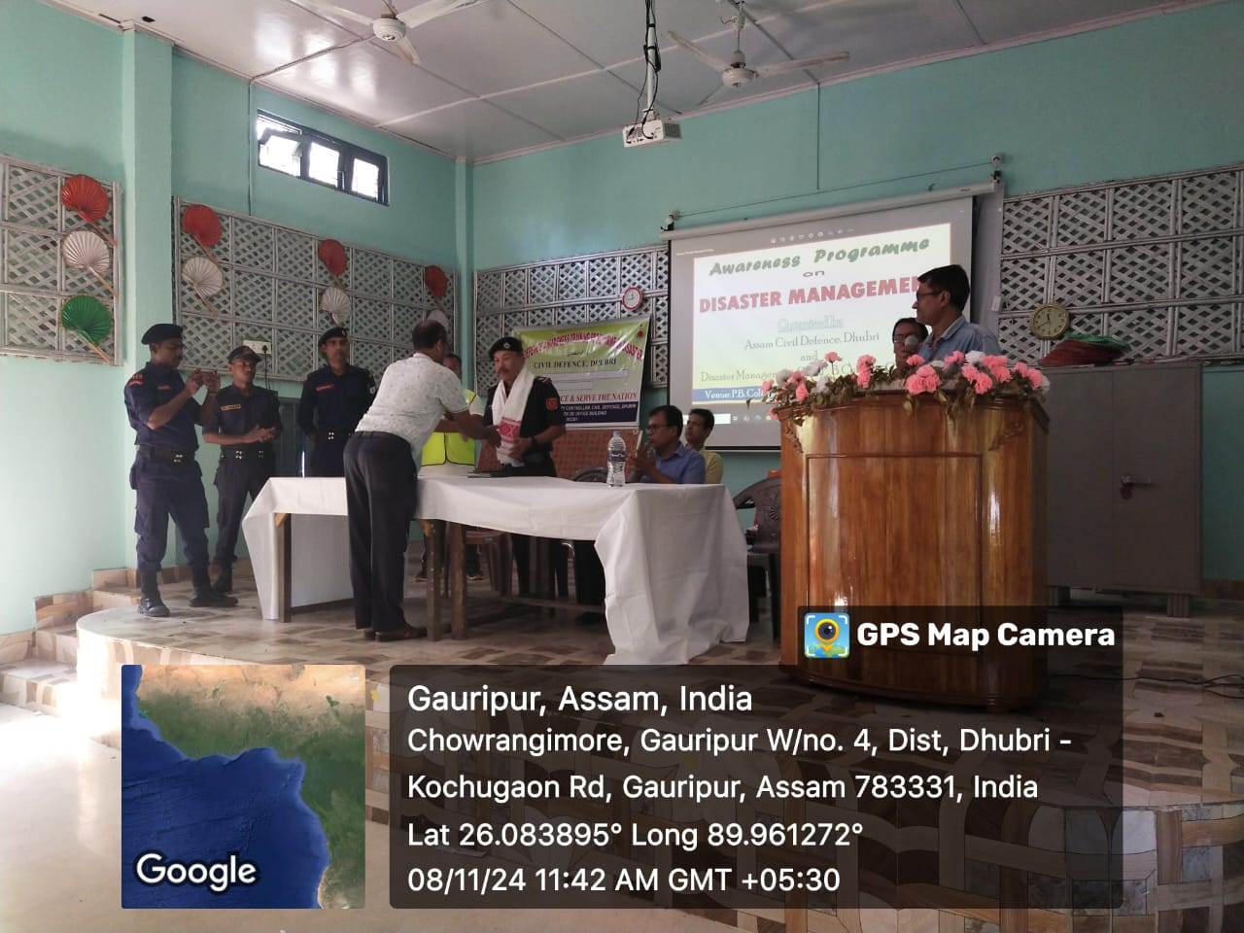
Felicitation to Sri Khorsing Engti Kathar, Asstt.Dy. Controller (Jr.), Civil Defence
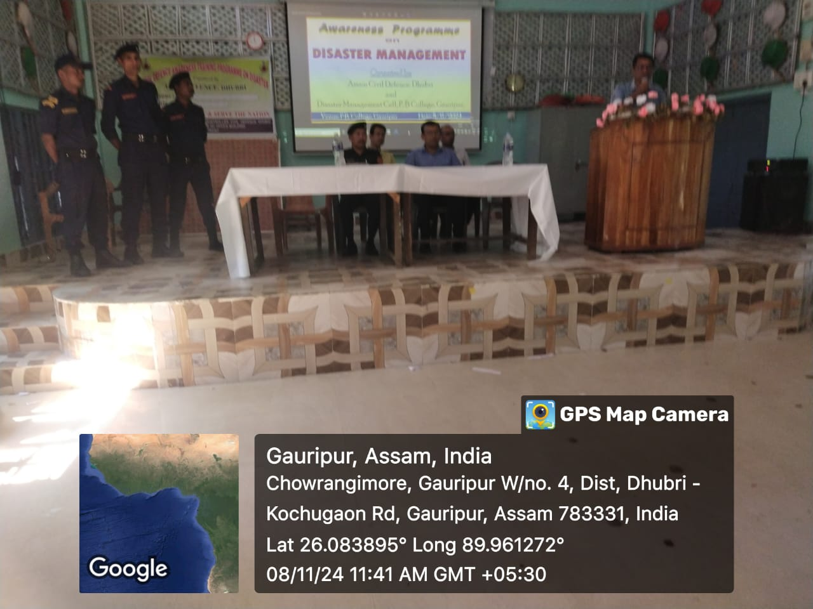
Principal andTeam of Civil Defence, Dhubri

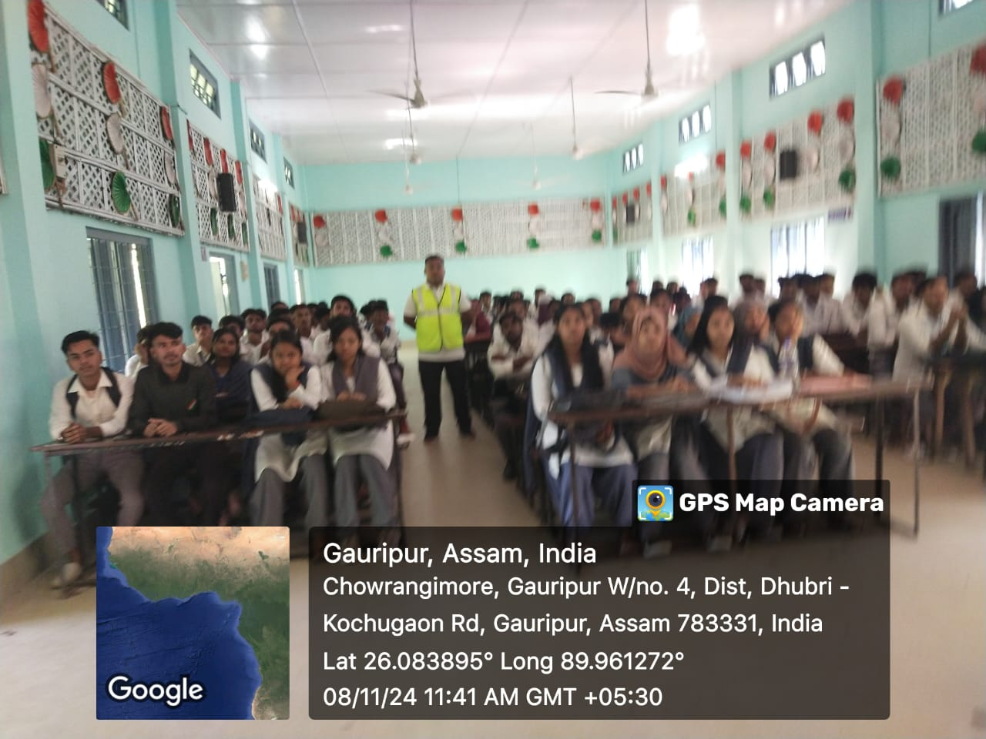
Sri Raj Kishore CDV in the midst of students

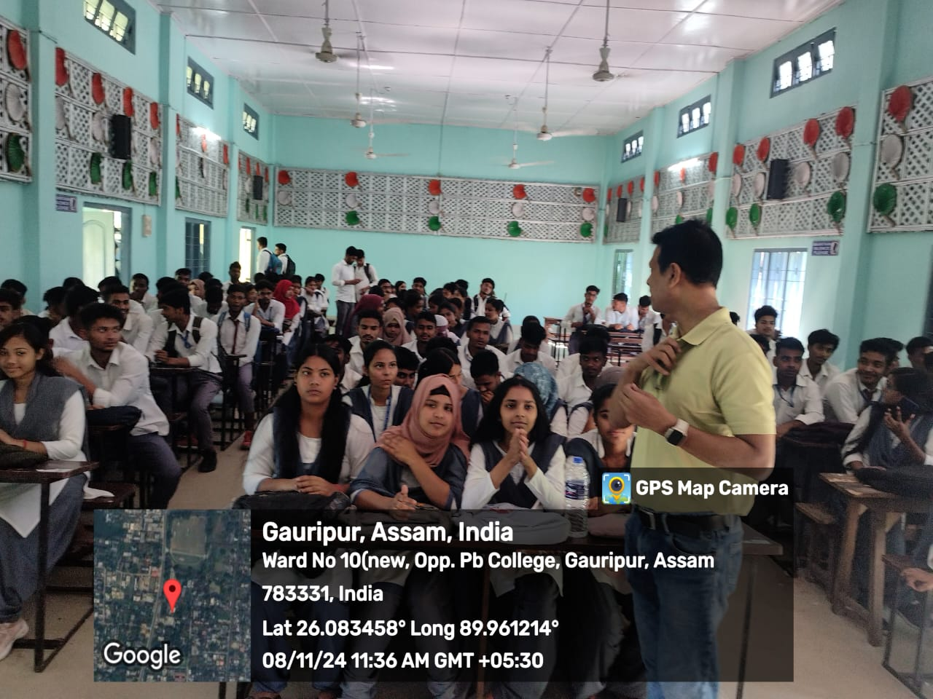
Students as audience
Demonstrations:
No-I:
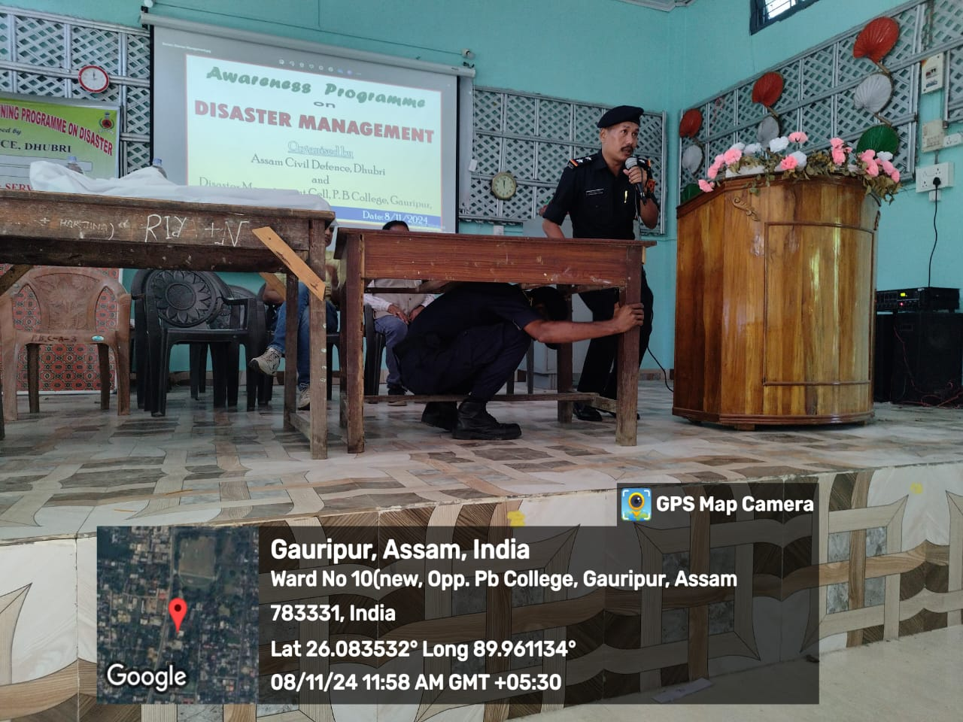
Tip for self protection at the time earthquake

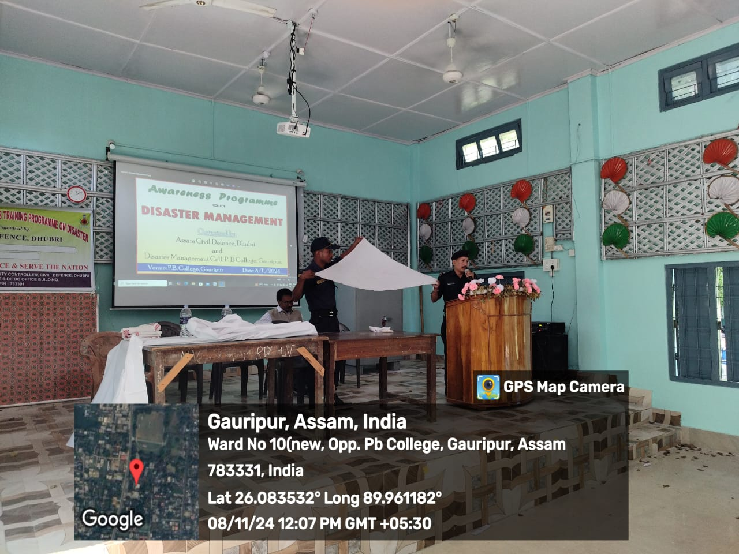
Homemade triangular Bandage for using at fractured hand at the time of Disaster

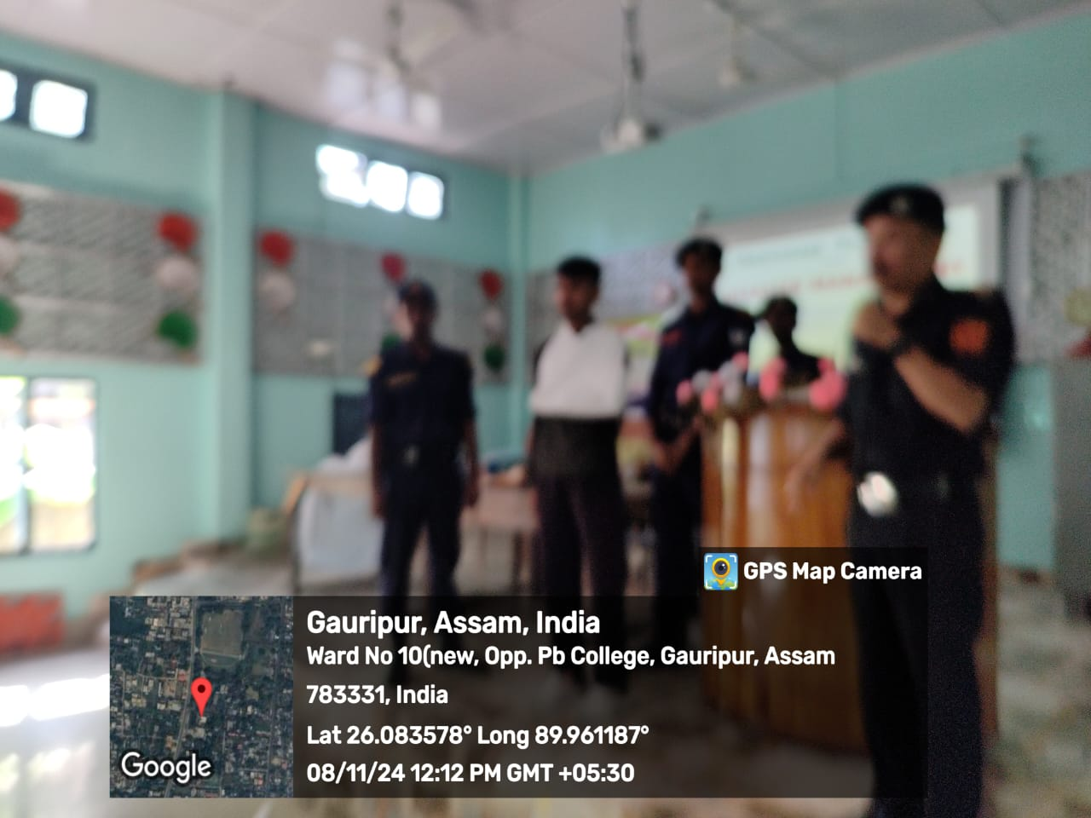
Tip for bandaged at fractured hand with homemade triangular bandage
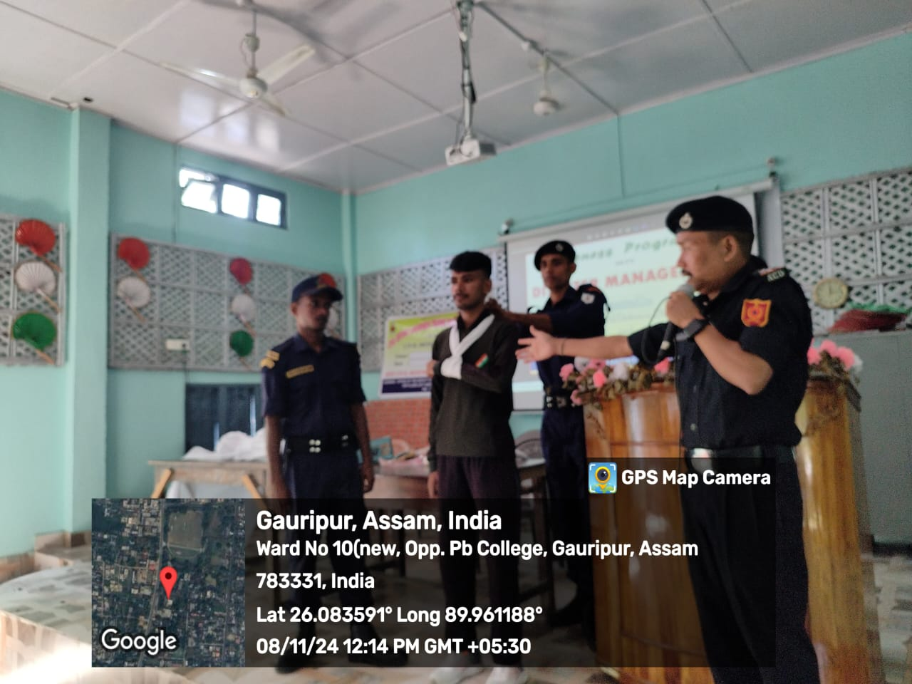
Another Tip for bandaged at fractured hand with homemade triangular bandage

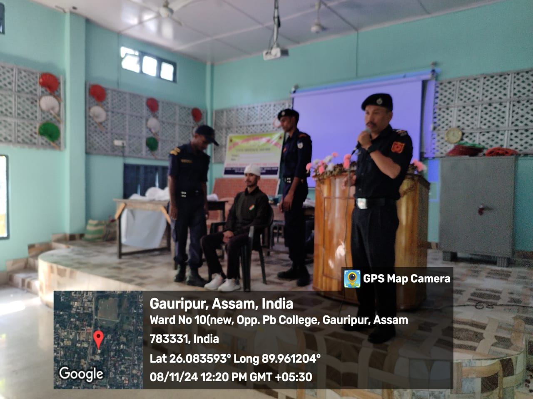
Tip for bandaged at wounded head with homemade triangular bandage

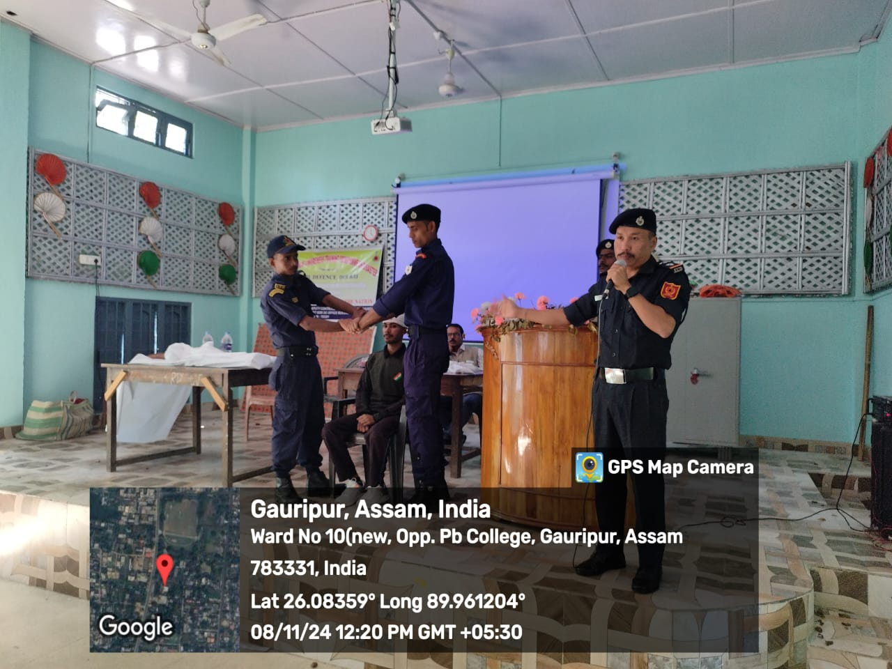
Tip for carrying an injured person with hands of two persons

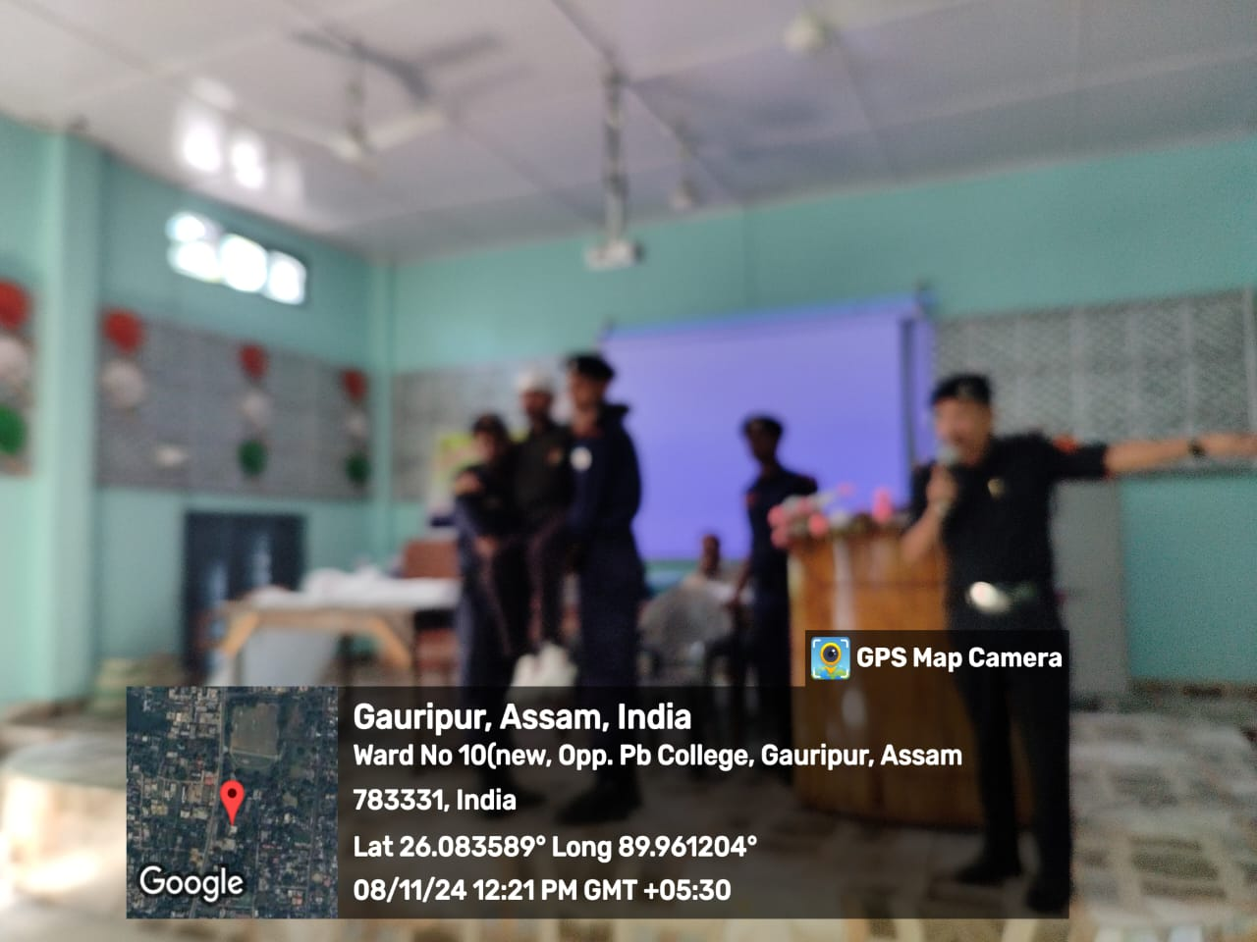
Tip for carrying an injured person with hands of two persons

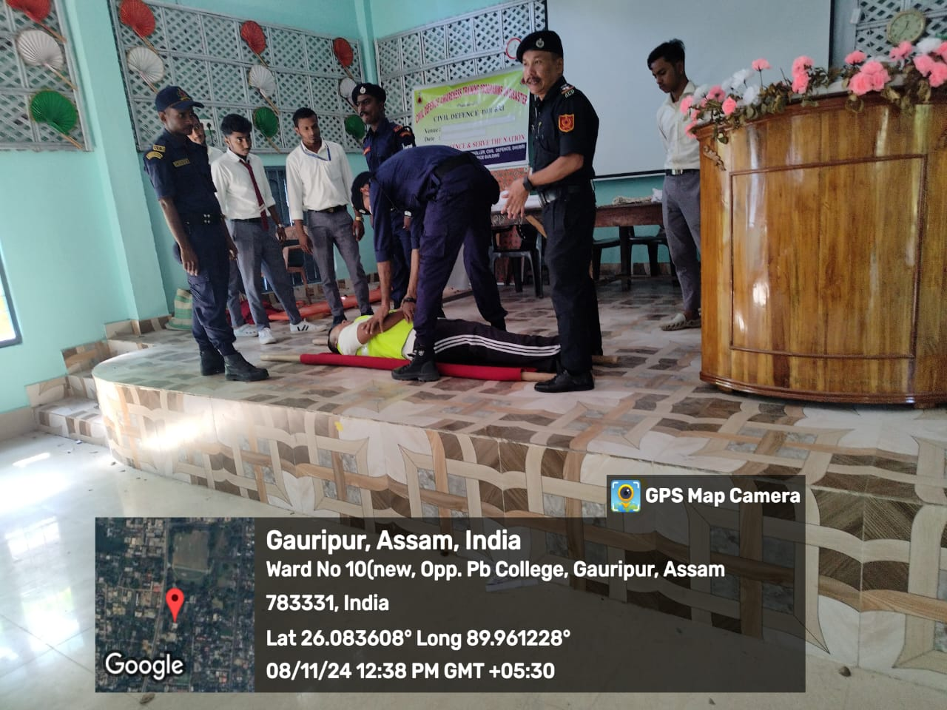
Tip for making homemade stretcher with two pieces of bamboo and a blanket to carry an injured person

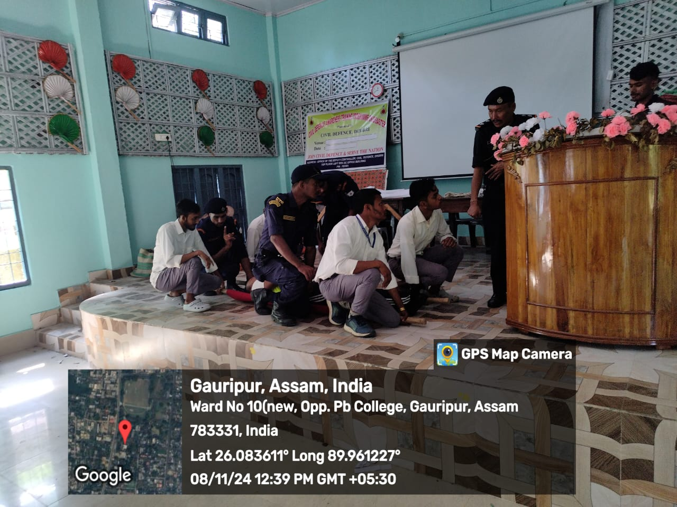
Tip for carrying an injured person with homemade stretcher with two pieces of bamboo and a blanket
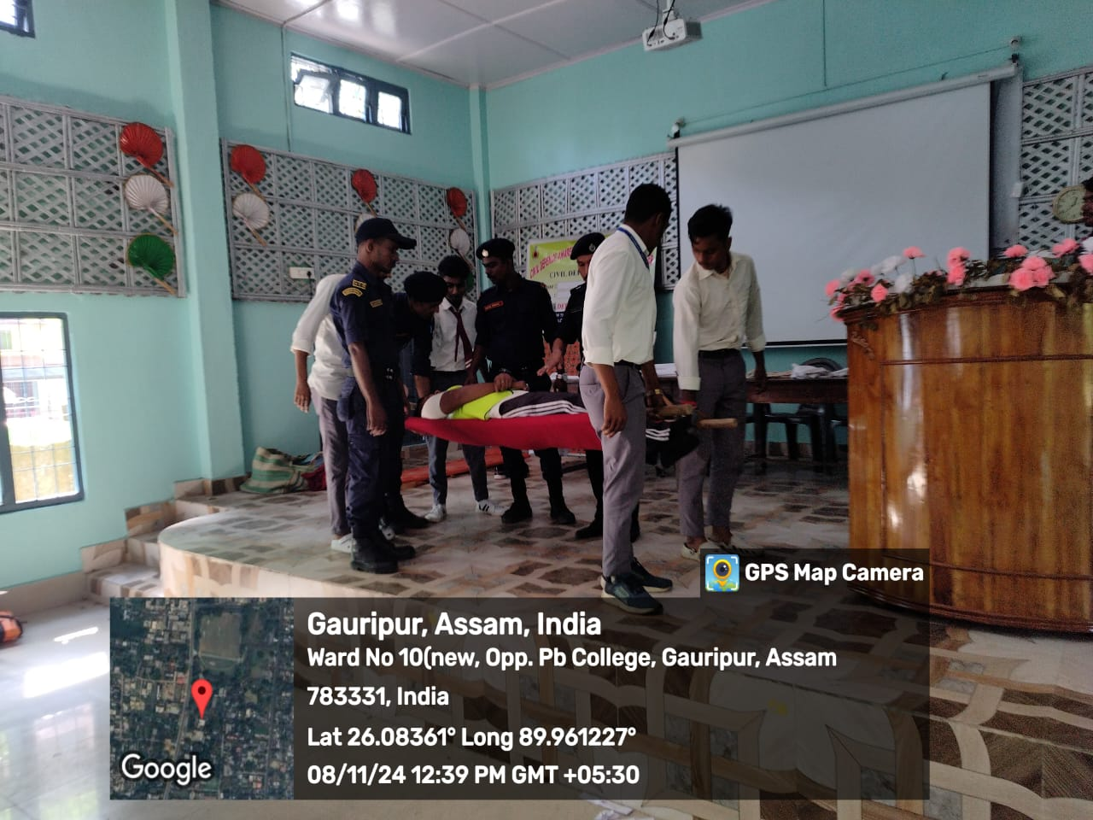
Tip for how to carry homemade stretcher with two pieces of bamboo and a blanket

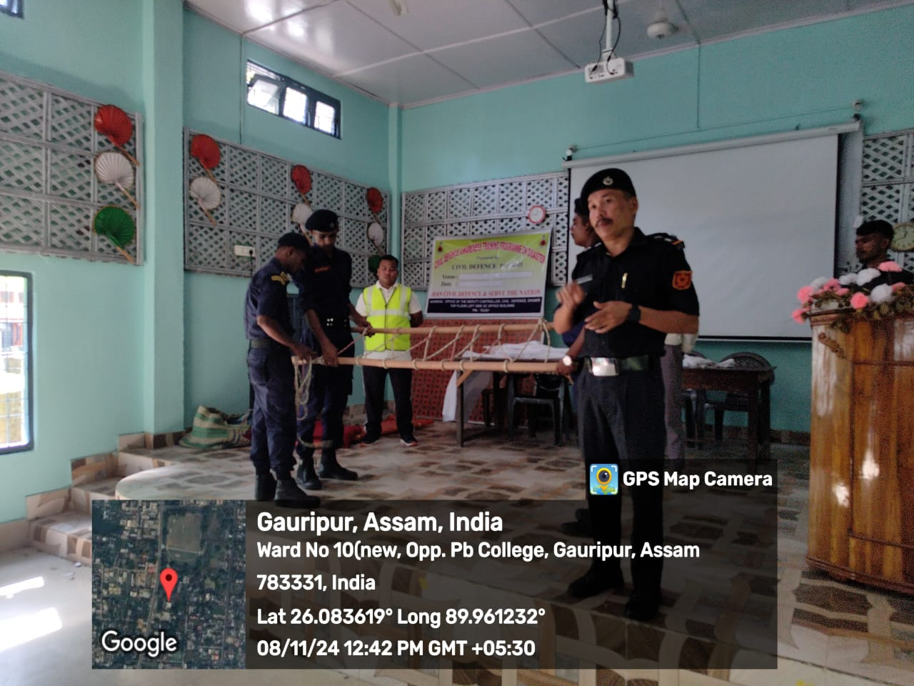
Tip for making stretcher with rope and two pieces of bamboo to carry an injured person

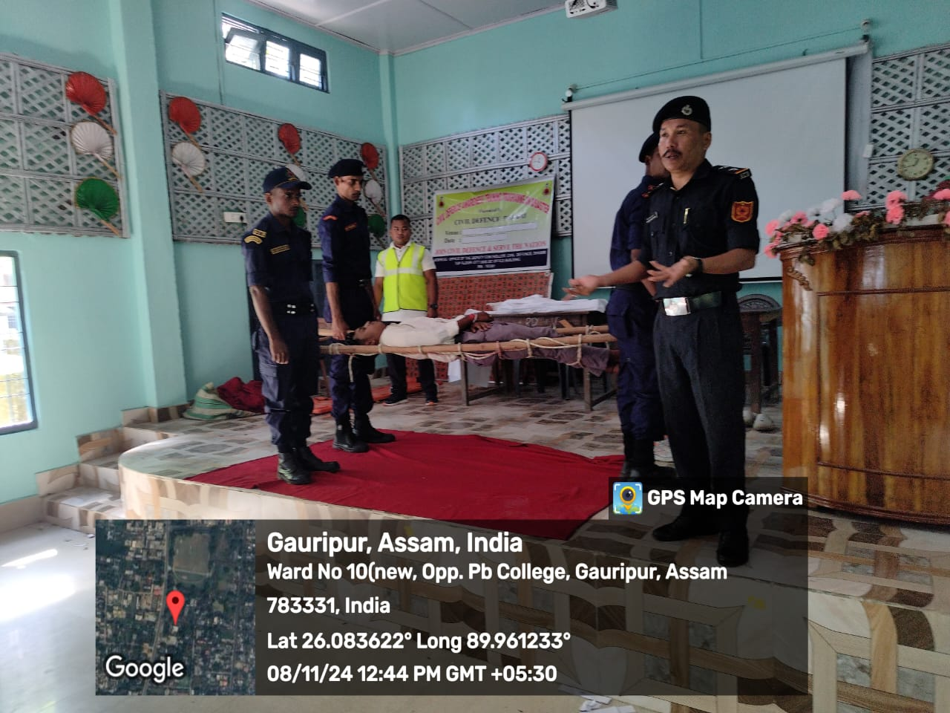
Tip for carrying an injured person with homemade stretcher with rope and two pieces of bamboo
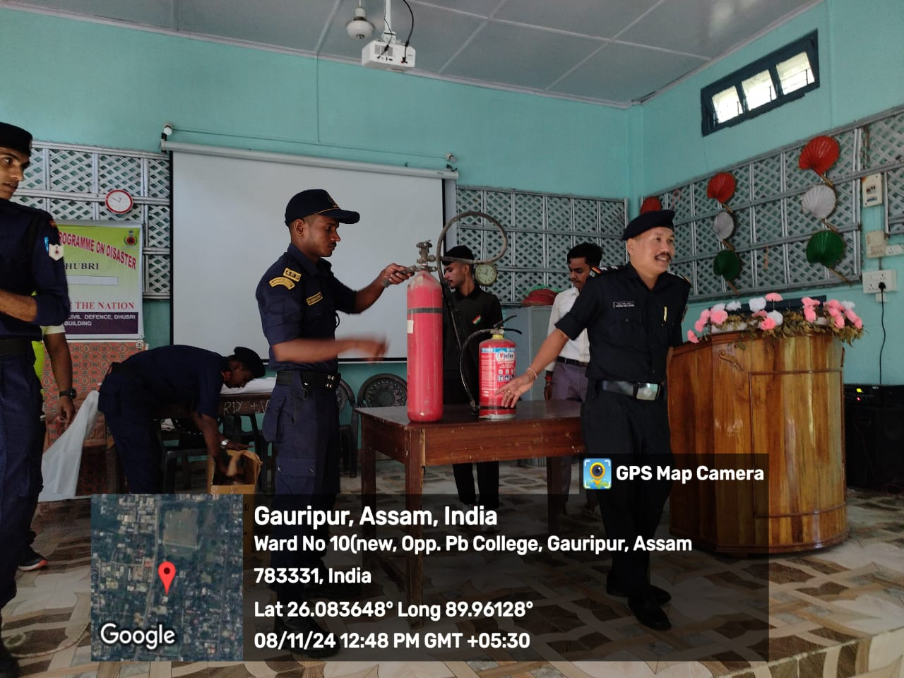
Tip for use extinguisher while caught fire in liquid

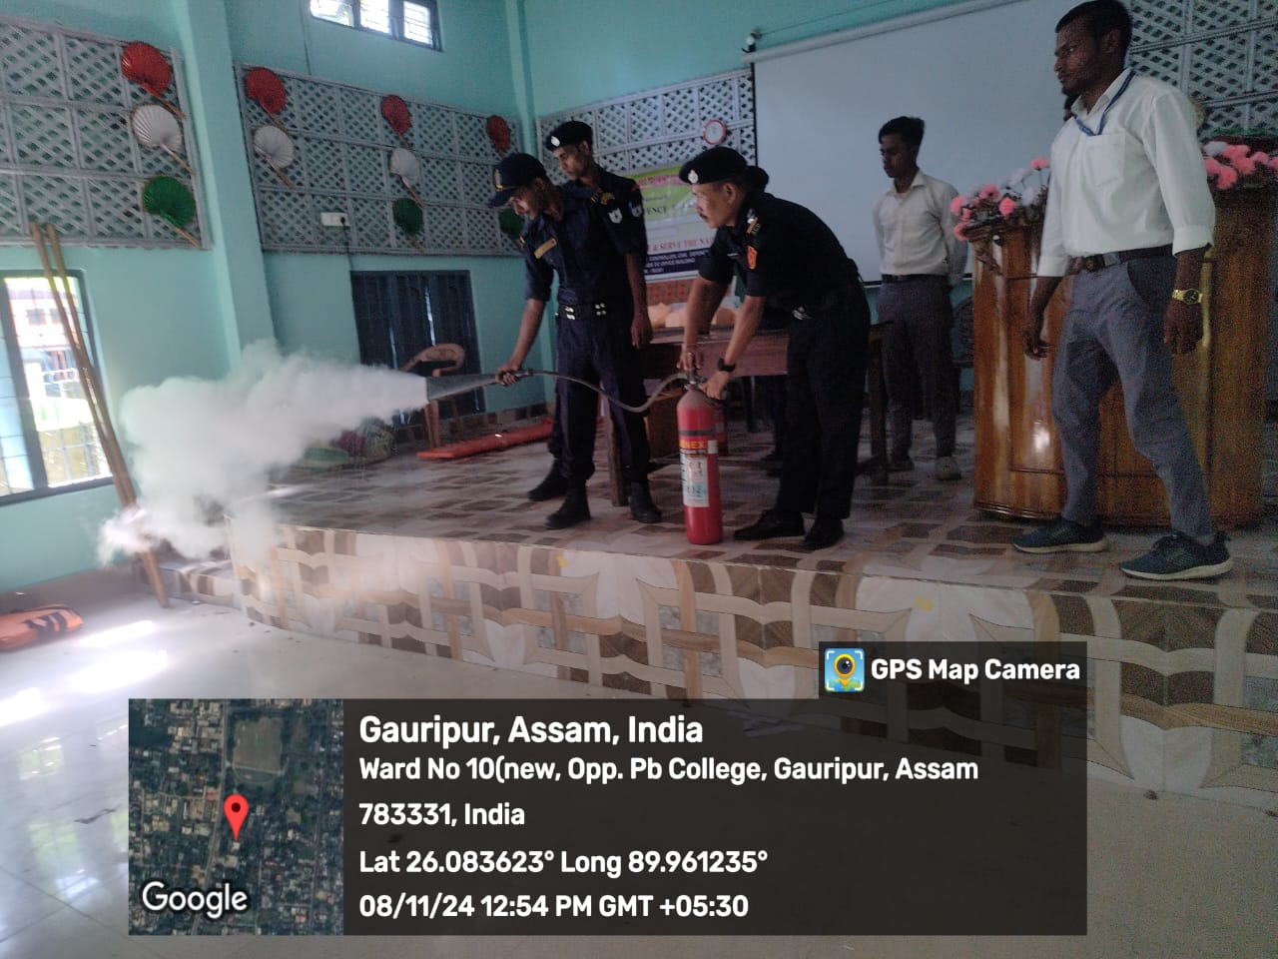
Another tip for use extinguisher while caught fire in liquid
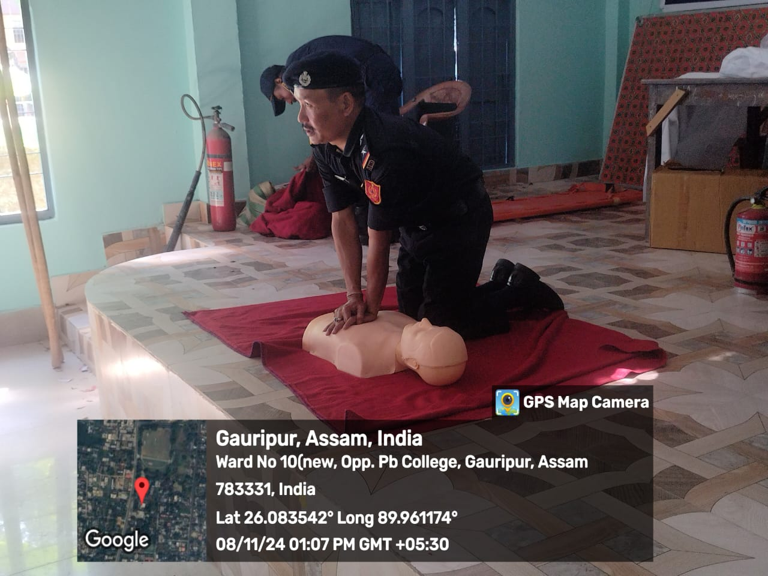
Tip for retained a heart blocked person to normal
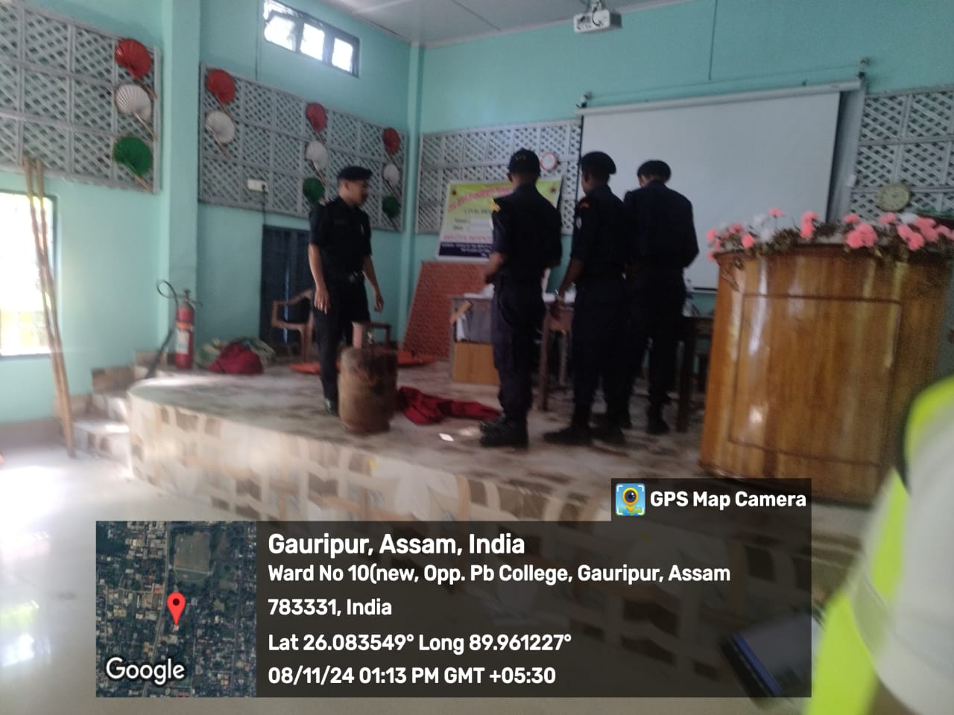
Tip for how to extinguish fire while caught in gas cylinder

Coordinator
Disaster Management Cell
P.B.College, Gauripur

