A Report
On
A Demonstration Programme of Fire Extinguisher

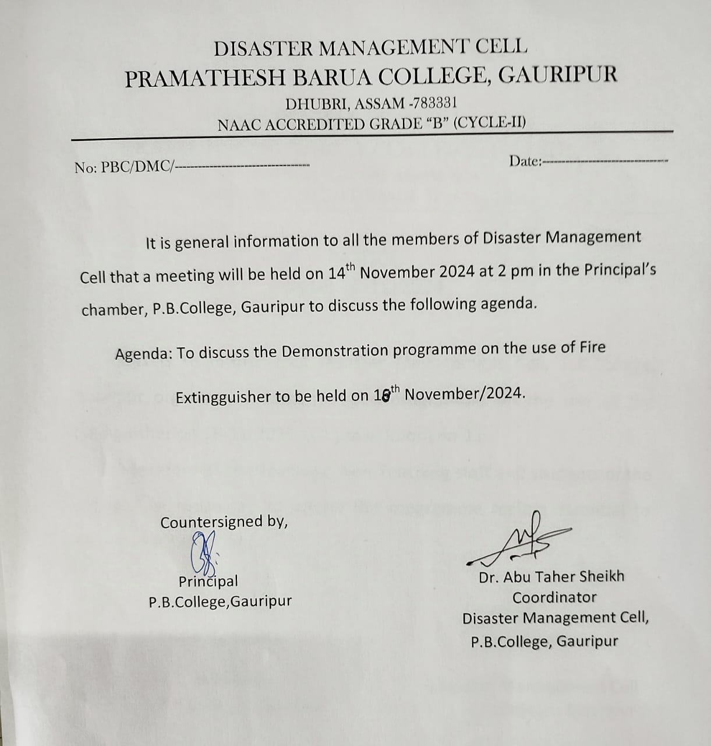
Call letter to the Members of DMC
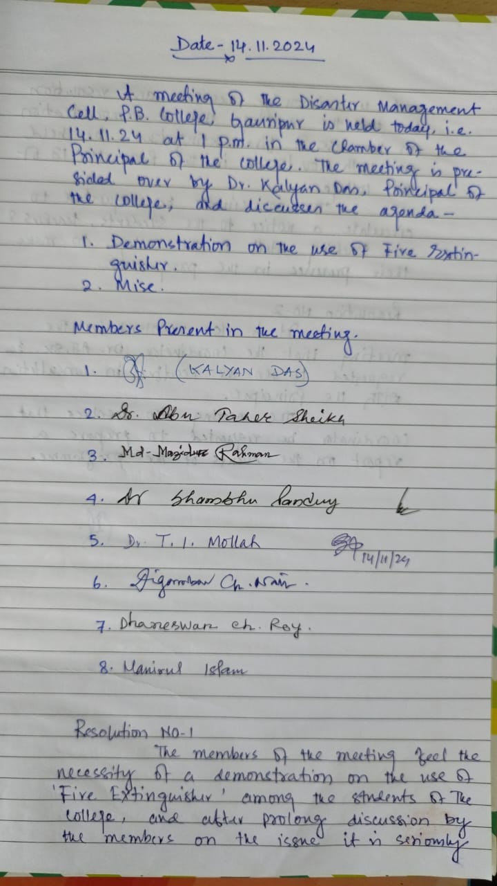
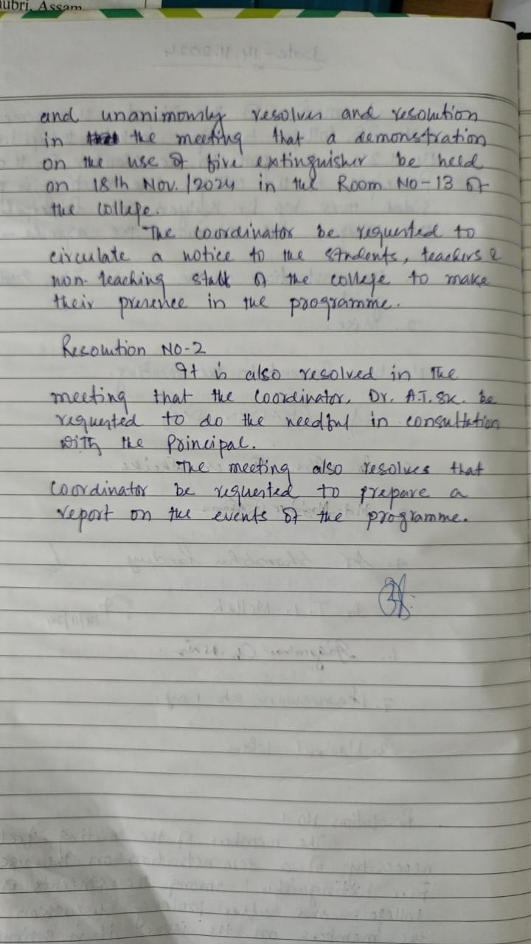
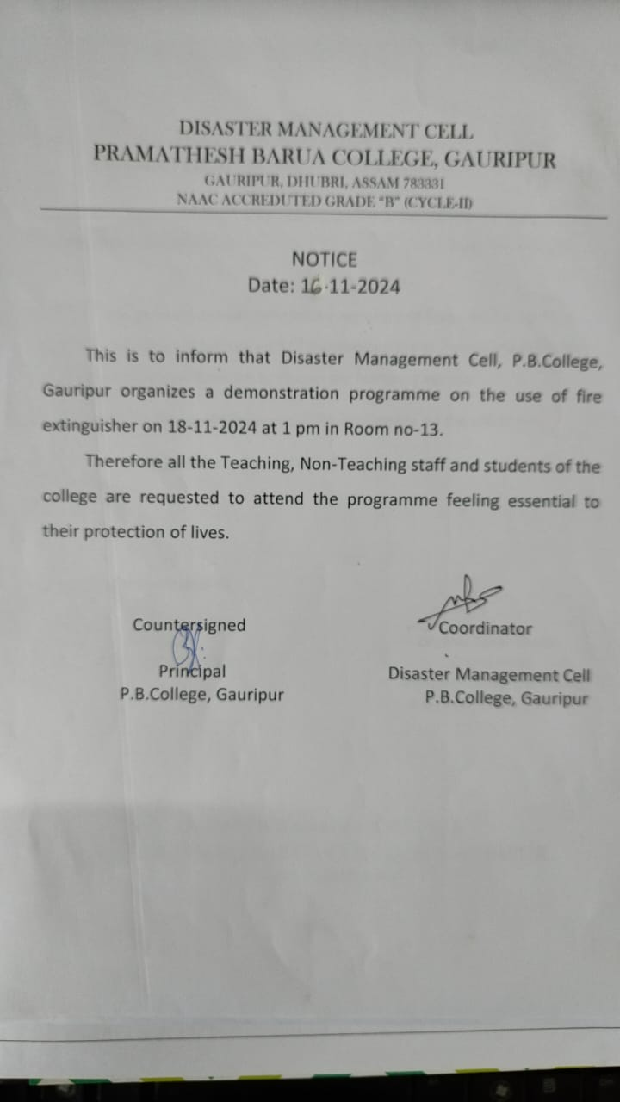
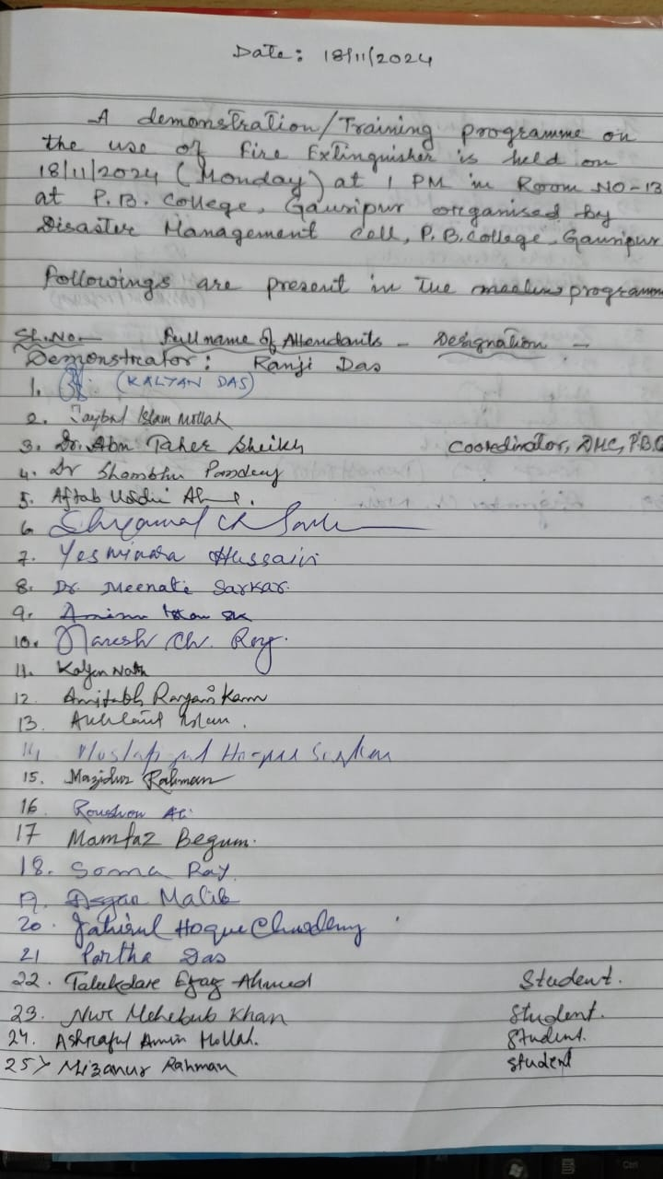

Disaster Management Cell, P. B. College, Gauripur organized a demonstration/ Training Programme on fire extinguisher on 18th November 2024 at 1 pm at Room no- 13. The programme started with the inaugural speech of Dr. Abu Taher Sheikh, Coordinator, Disaster Management Cell, P. B. College, Gauripur. The purpose of the programme was that all the Teaching, Non-Teaching staff and the students of the P.B.College, Gauripur should have the knowledge how to use the fire extinguisher at the time of caught fire.
As a quest Sri Ranaji Das, Demonstrator, delivered his valuable speech on the fire extinguisher and also instructed the College staff and the students with demonstrations how we can use and apply the extinguisher on the flame of fire. The programme has immensely benefitted the Teaching, Non- Teaching staff and the students of the college.

A few clicks of the Demonstration Programme
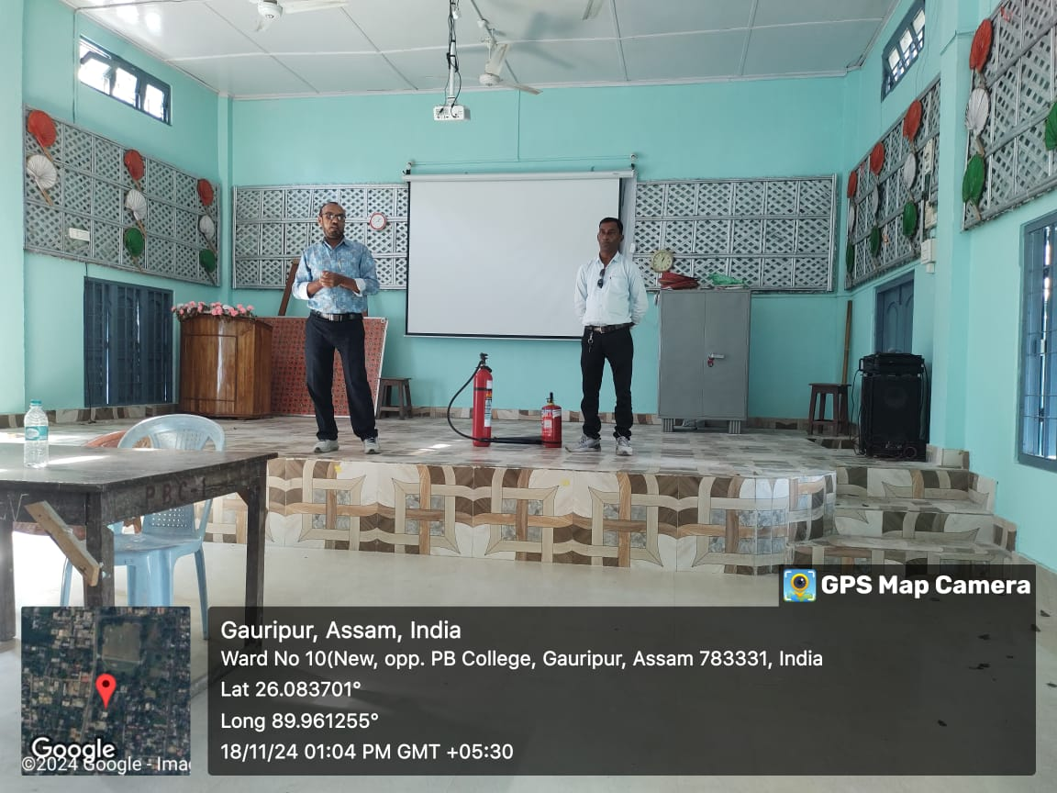
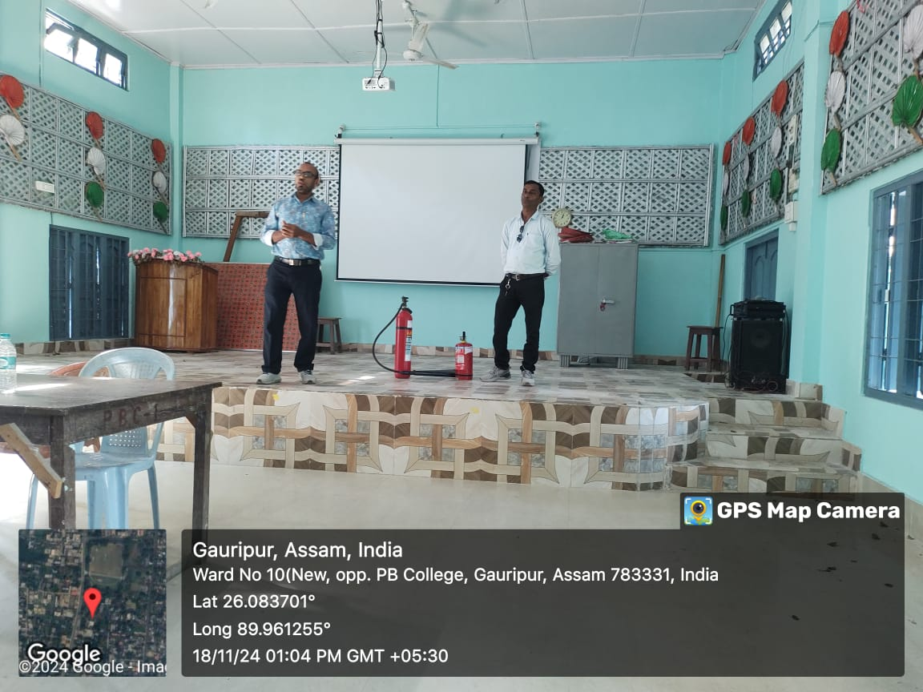
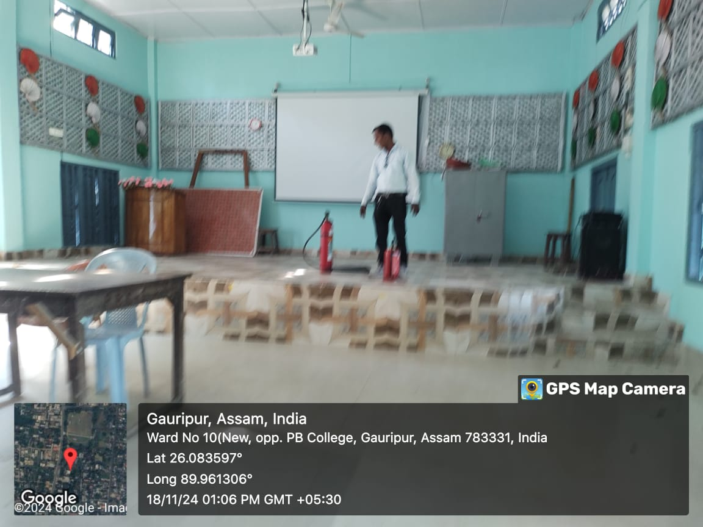

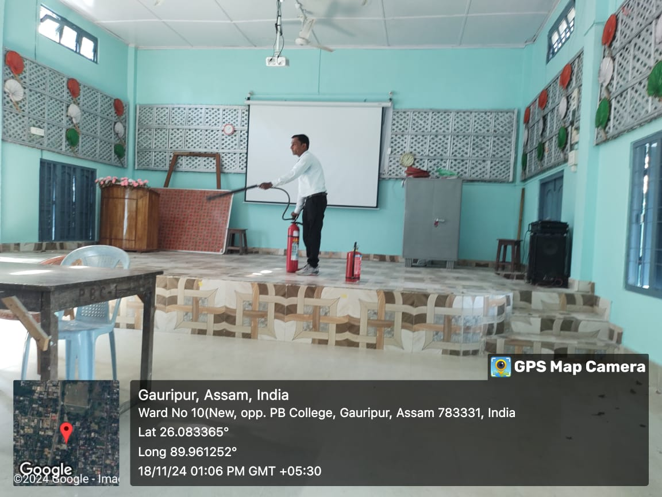
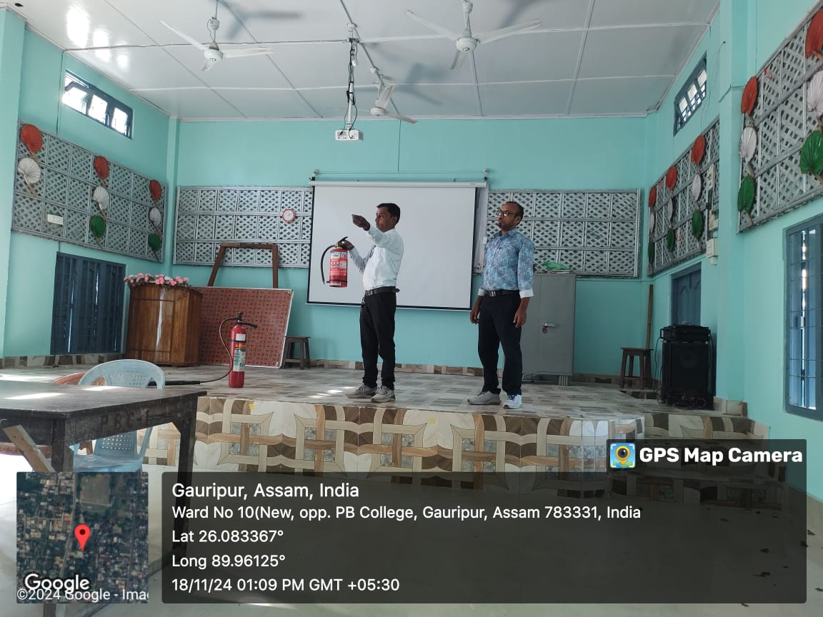
Coordinator
(Dr. ABU TAHER SHEIKH)
Diaster Management Cell
P.B.College, Gauripur

