Report of Wall Magazine Inauguration for the Department of Economics, Pramathesh Barua College

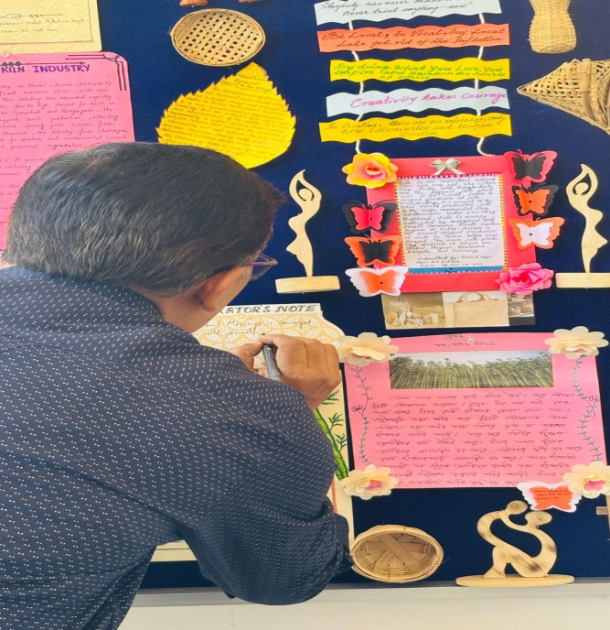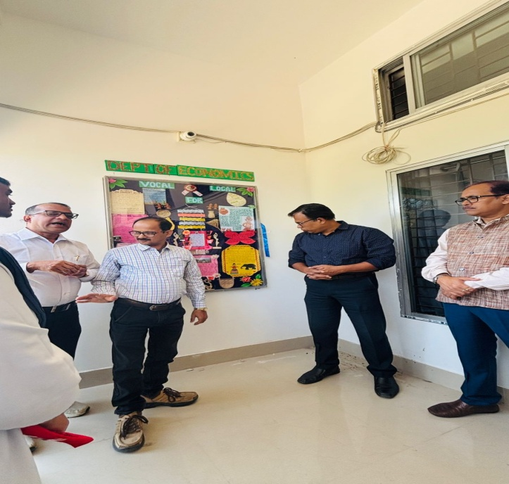
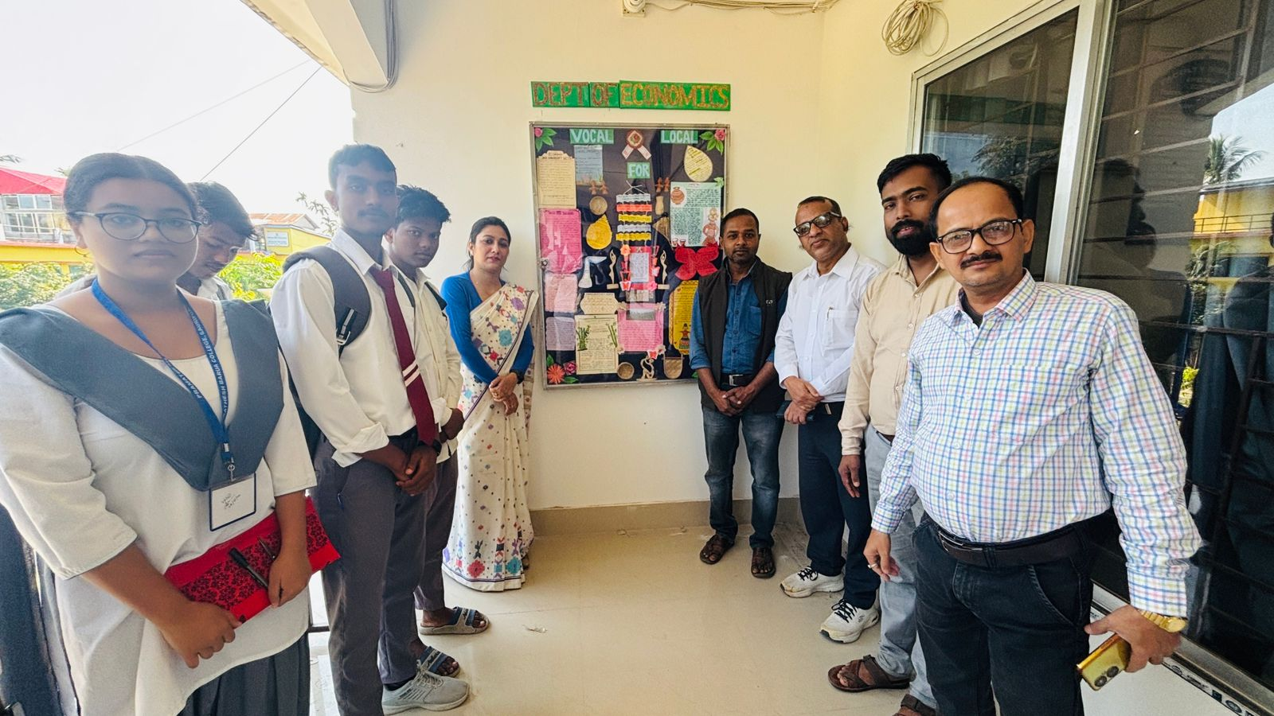
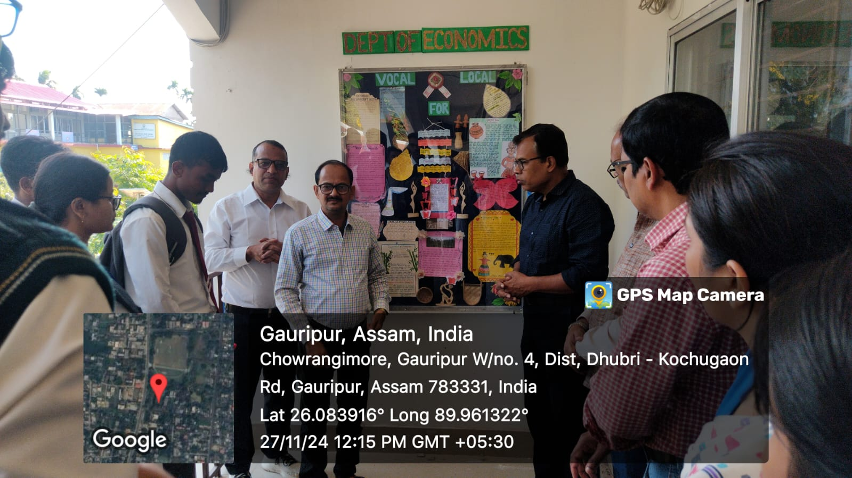

Wall Magazine for the Department of Economics, P B College, Gauripur is inaugurated by the Principal of the College on 27.11.2024 at 12.00 Noon in presence of the faculty members of the department including Dr Gopal Chandra Barman, Co-ordinator IQAC, D C Karmakar, HOD, Economics, D. Biswas, HOD Accountancy and students of the college. After the inauguration of the wall magazine, the Principal delivered a short speech regarding wall magazine. Wall Magazine is a platform where students can express themselves. It develops their creativity of writing. The theme of the Magazine is on local resource-based cottage industry.

HOD
Department of Economics

