Wall Magazine (Budhibrikhya) Opening Session
Department of Philosophy
P. B. College, Gauripur
Date: 22.11.2024
------------------------------------------

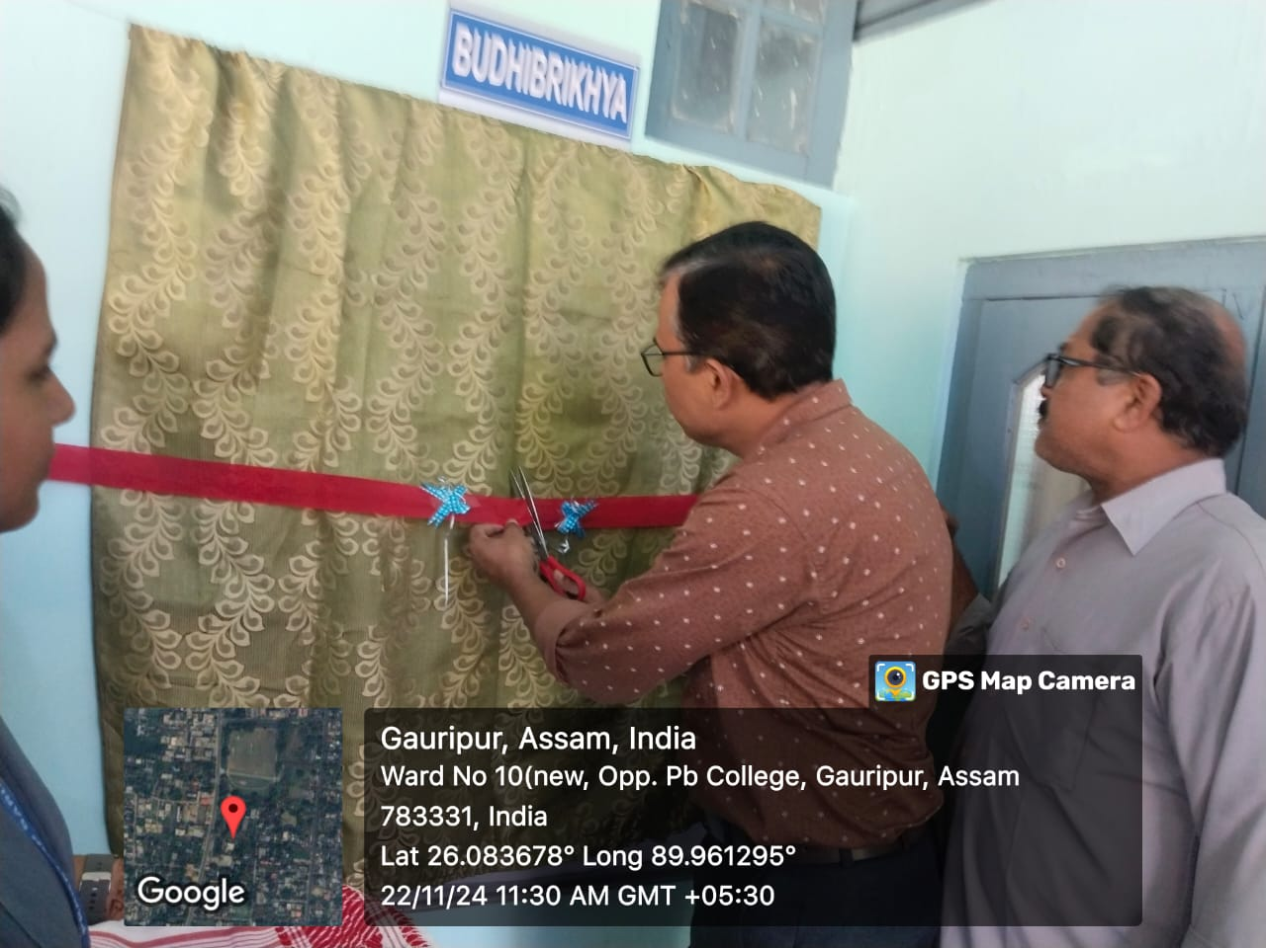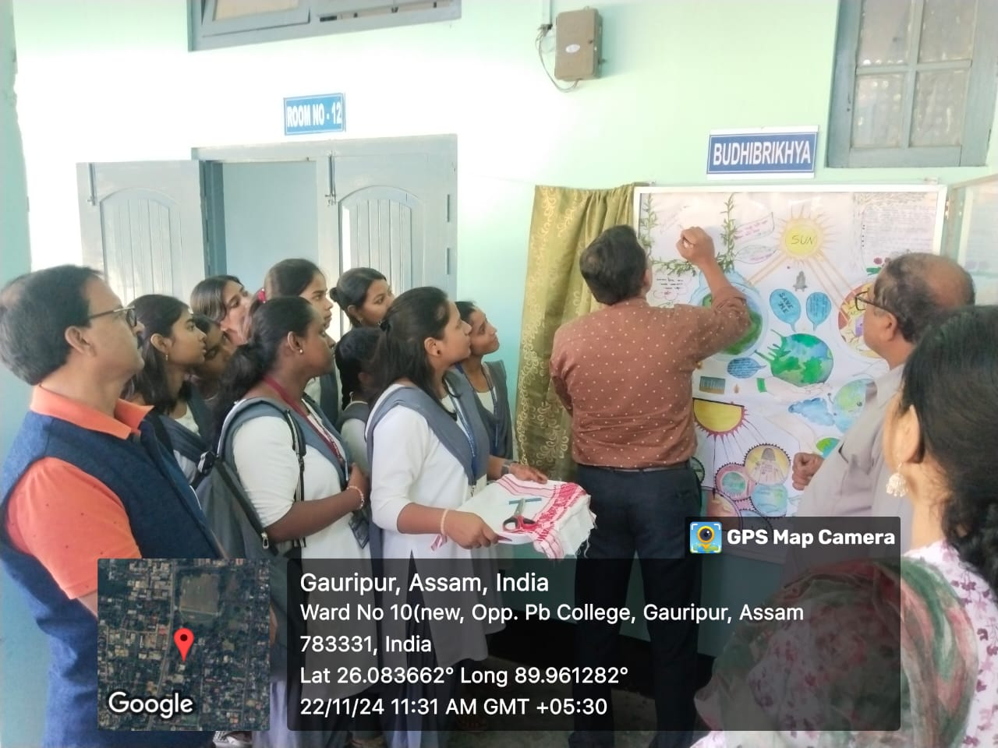

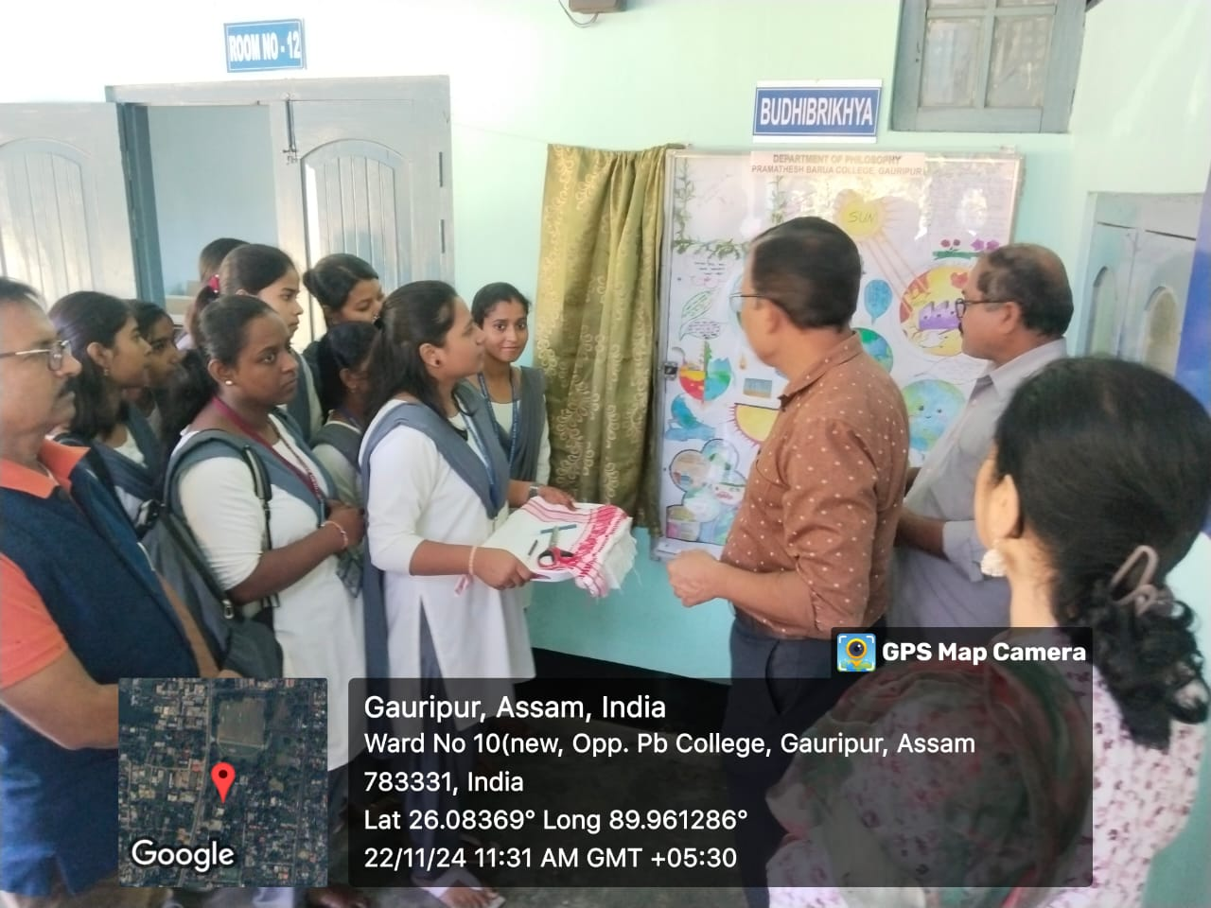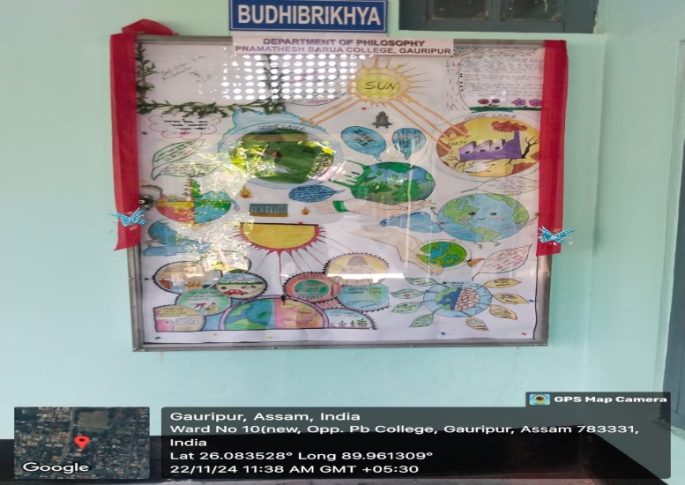
Today on 22.11.2024 the Department of Philosophy is opened its Wall Magazine (Budhibrikhya). Dr Kalyan Das, Principal, P. B. College, Gauripur opened the Wall Magazine with his encouraging short speech in connection with the concept of wall magazine in the presence departmental faculty members Mr. Digambar Ch. Nath, Associate Professor & HOD Dr Aminur Islam Sk, Associate Professor, Dr Shyamal Ch. Sarkar, Assistant Professor, invited faculty members of other department and students of the department of Philosophy, P. B. College, Gauripur. The department of Philosophy thanked to Farida Khatun, Roll No. 218, Tohmina Khatun, Roll No.199, Purabi Bala Roy, Roll No.29 and Mousumi Eyasmin, Roll No. 238 of Sem.-I for their patient and effort to bring their effort the in reality.

Department of Philosophy
P. B. College, Gauripur

