DEPARTMENT OF ASSAMESE
Pramathesh Barua College, Gauripur
PO- GAURIPUR, DIST- DHUBRI, ASSAM, PIN NO- 783331
Ref…. Date: 18-11-2024
Report on Wall Magazine-2024
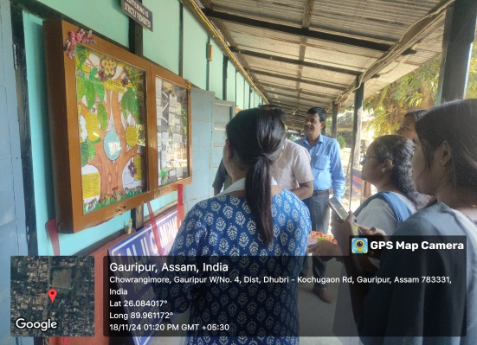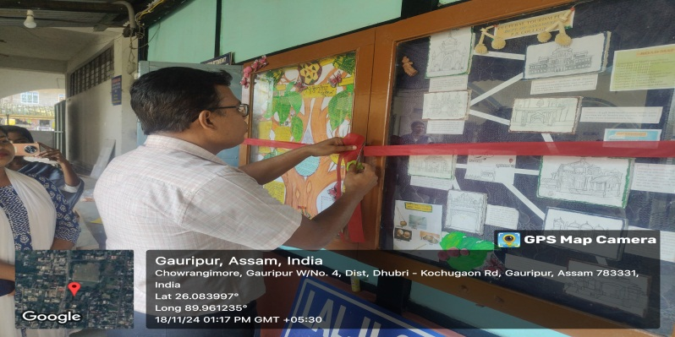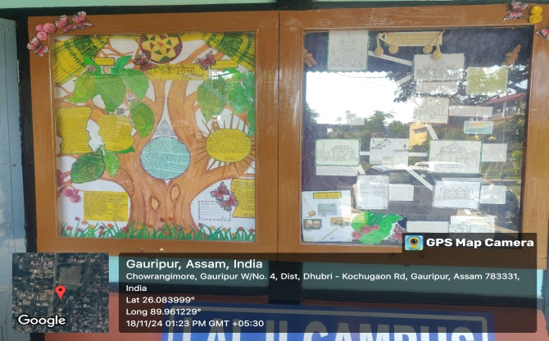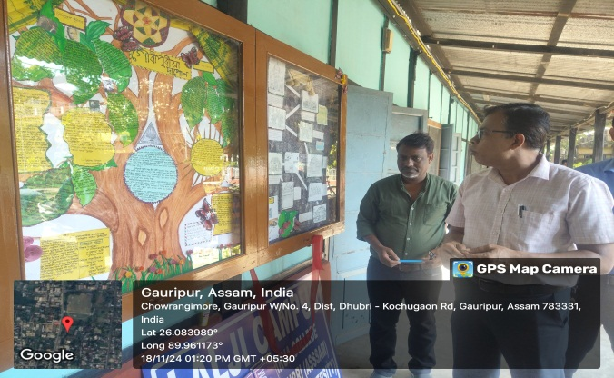

As a part of regular and participatory learning practice the department of Assamese use to publish its Wall Magazine bi-annually. Students are encouraged to collect articles and editorial responsibilities. Also they design with a theme as content demands. This issue is a joint effort of Borxa Begum, Bhumika Biswas, Muskan Yesmin and Komolesh Roy of B.A. 5th Semester. Nikumoni Das, Assistant Professor was given the responsibility of guiding the students. On 18th November the Principal of the college inaugurate the Wall Magazine in front of the faculties and Students of the college.

