Aawreness Programme by District Election Officer

In order to ensure that not a single voter is left out, the Electoral Literacy Club of P B College regularly holds awareness campaigns. As part of this, representatives of District Election Office organized an awareness campaign for new voters in P B College on 16th November, 2024.
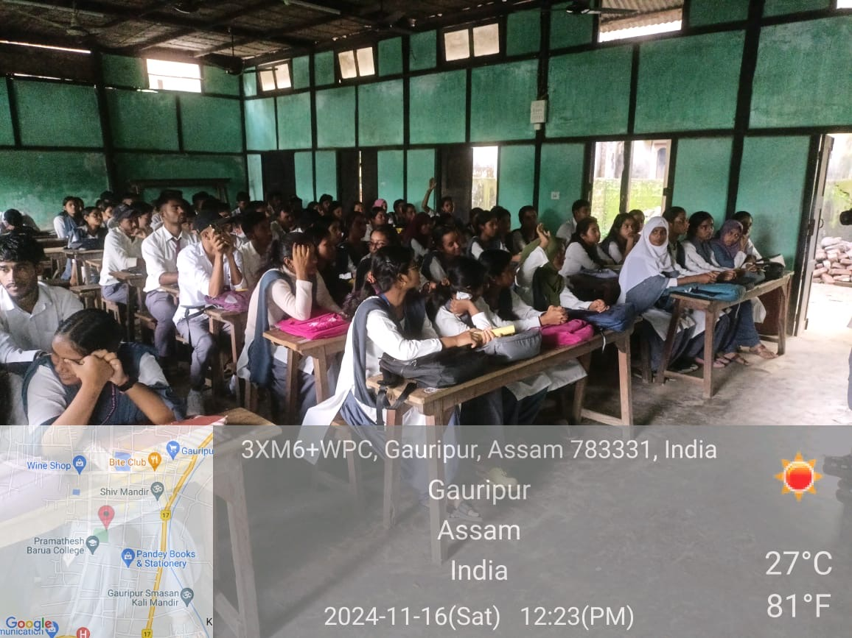
It was attended by a large number of students most of whom are potential voters. Sudarshan Roy, State Level Master Trainer, delivered his lecture on the importance of registering oneself as a new voter on time so that no eligible votes go waste. Dr Akhtarul Islam, another speaker focussed on the procedure of getting oneself registered.
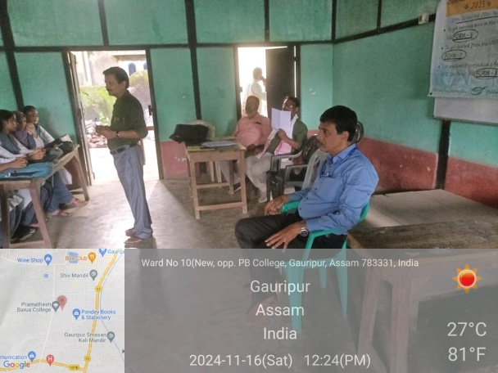
The students interacted with the speakers after the talk was delivered and their queries were answered. The students also pledged to register themselves as voters following due protocol and pledged to vote and be accountable to the Constitution. The pledge ended with the promise of students to be good citizens of the country.
