Awareness Campaign by Electoral Literacy Club

The Electoral Literacy Club of P B College regularly organizes awareness campaigns about the importance of voting as well as the registration of new voters. Along with various activities, the Club regularly organizes awareness programmes for the new voters. On 9th November, 2024, an awareness programme of the Electoral Literacy Club was held in the Digital Classroom.
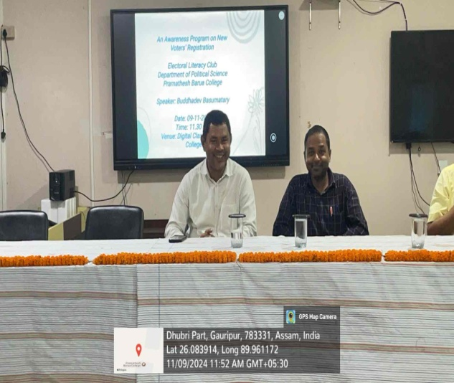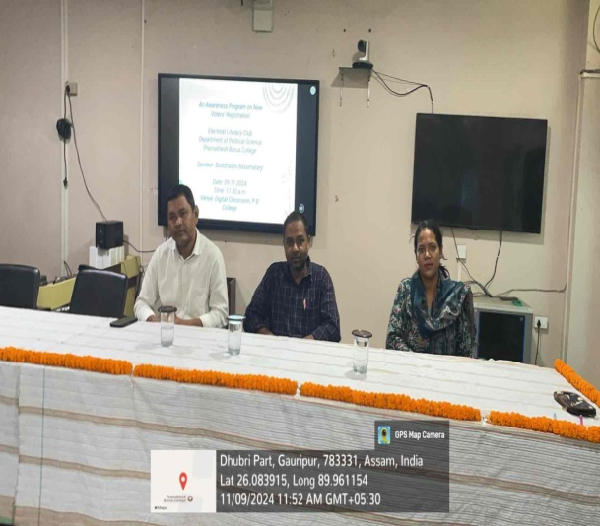
The talk was delivered by Buddhadev Basumatary, HOD, Department of Political Science who is also a nodal teacher of the Electoral Literacy Club.
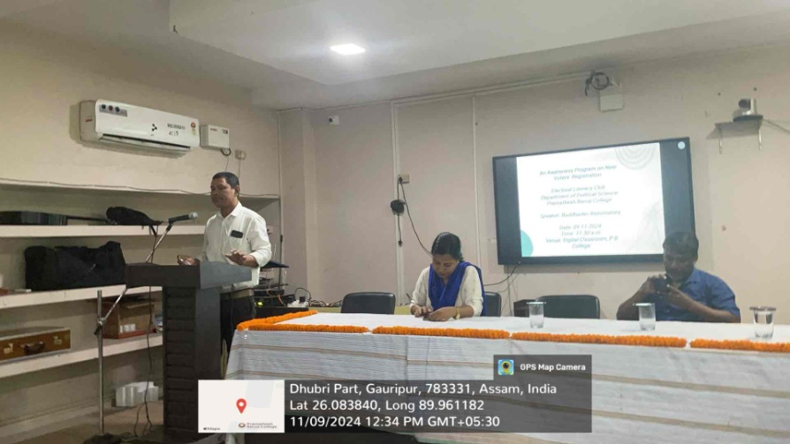
The programe was attended by around 130 students. Students who were potential new voters were given information regarding the process of registering for the upcoming voters list. The procedure was explained in details by the Nodal Teacher who also shared contact details of the District Election Officer who can be contacted for further information.
