Departmental Talk on Language

Language cannot be reduced only to its literary or cultural aspects. Language is social and political too. Languages have hierarchies. As part of the Bhaxa Xoptah Gaurav, the Department of Political Science decided to organize a talk highlighting these aspects of language on 9th November, 2024. The talk was on Revisiting the Language Movement in Assam and it focused on the role of Assamese language in shaping Assamese nationalism and Assamese identity.
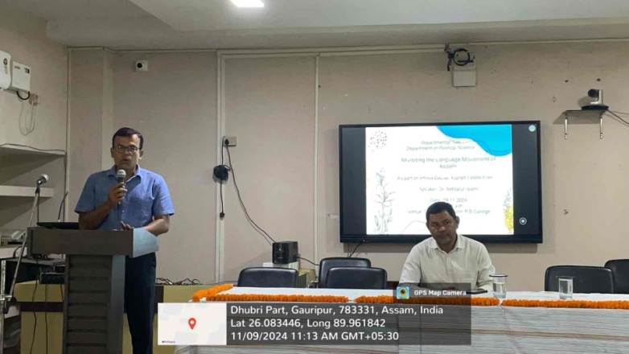
The talk was inaugurated by the Principal of P B College, Dr Kalyan Das. In his introductory speech, he emphasized that it is important to explore the struggle that went behind the establishment of Assamese as the national language and in doing so, take cognizance of the sacrifice of people who laid down their lives for the language.
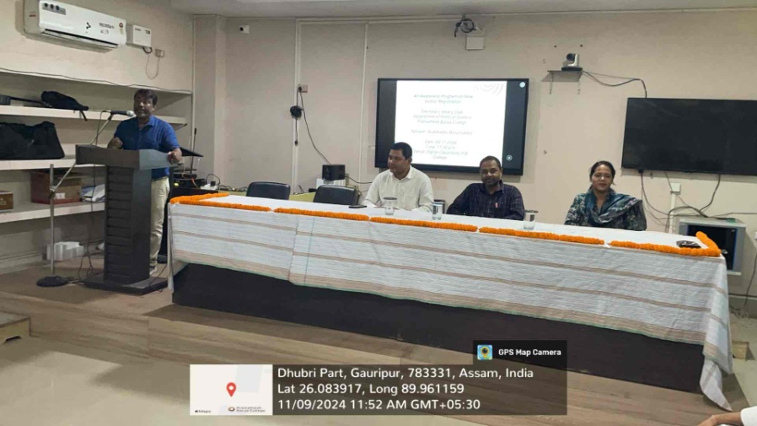
The talk was delivered by Dr Akhtarul Islam, Associate Professor and HOD, Department of Assamese, P. B College. In his detailed deliberation of 45 minutes, Dr Islam delved in the rise of Assamese as a language of the masses as opposed to languages limited to elite communities. The politics around the language was also talked about.
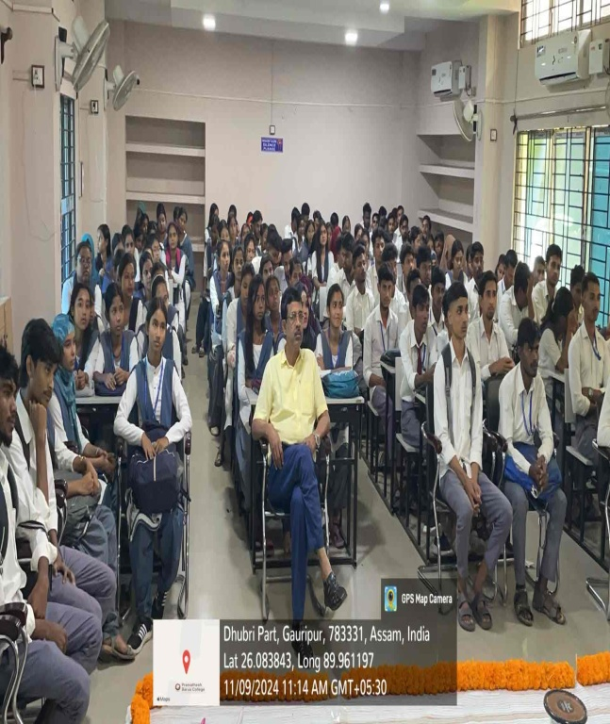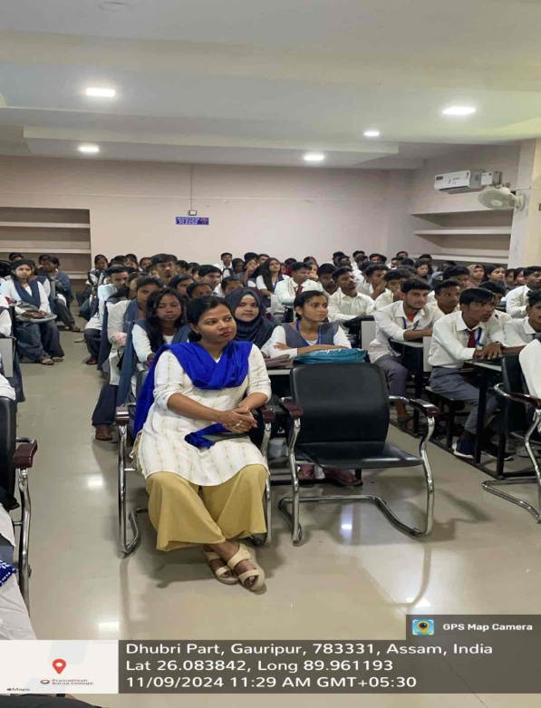
The programe was attended by close to 130 students from different departments. The students listened to the speech in rapt attention and also interacted with the speaker.

