Report
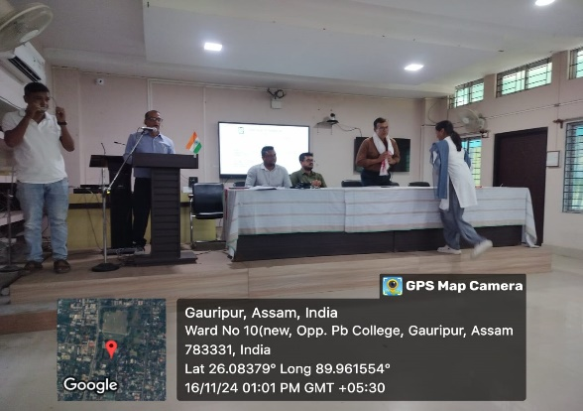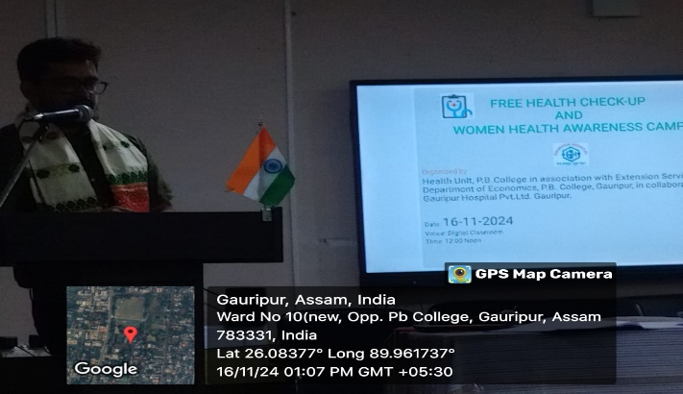
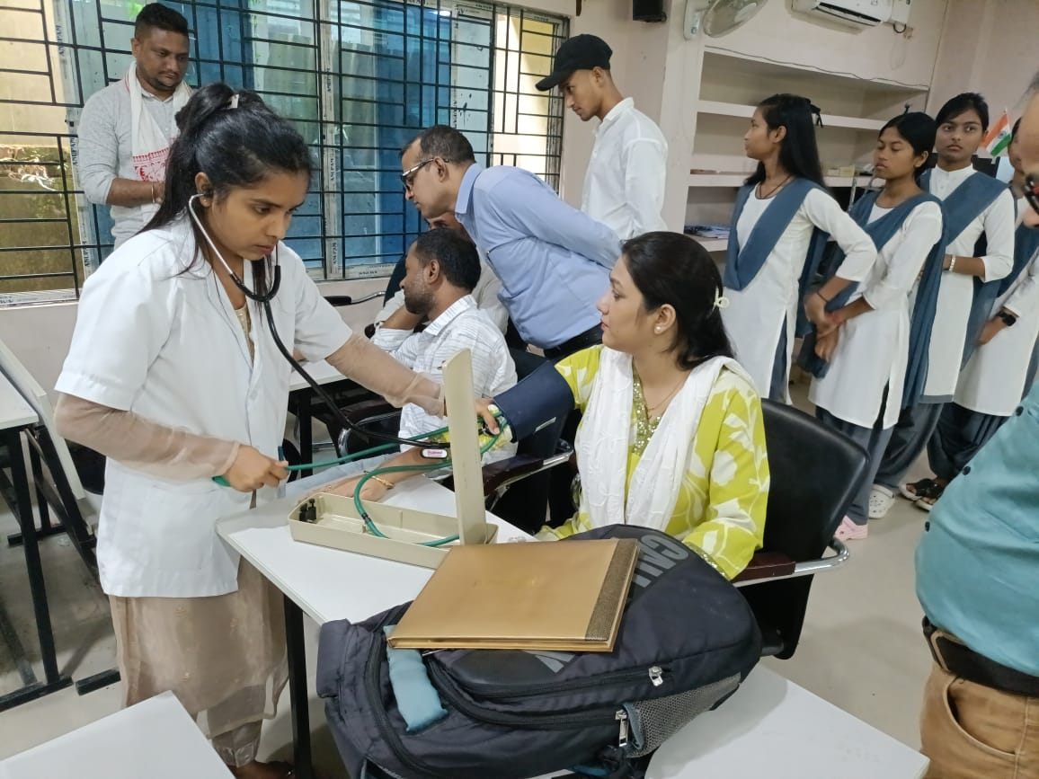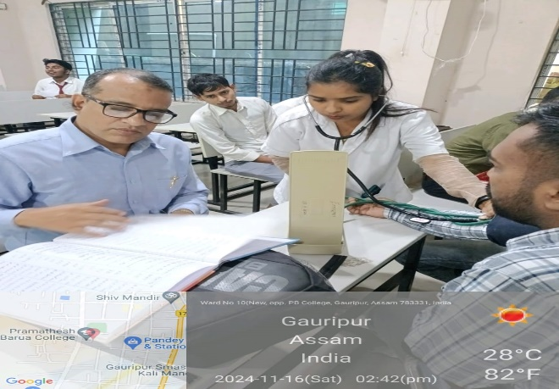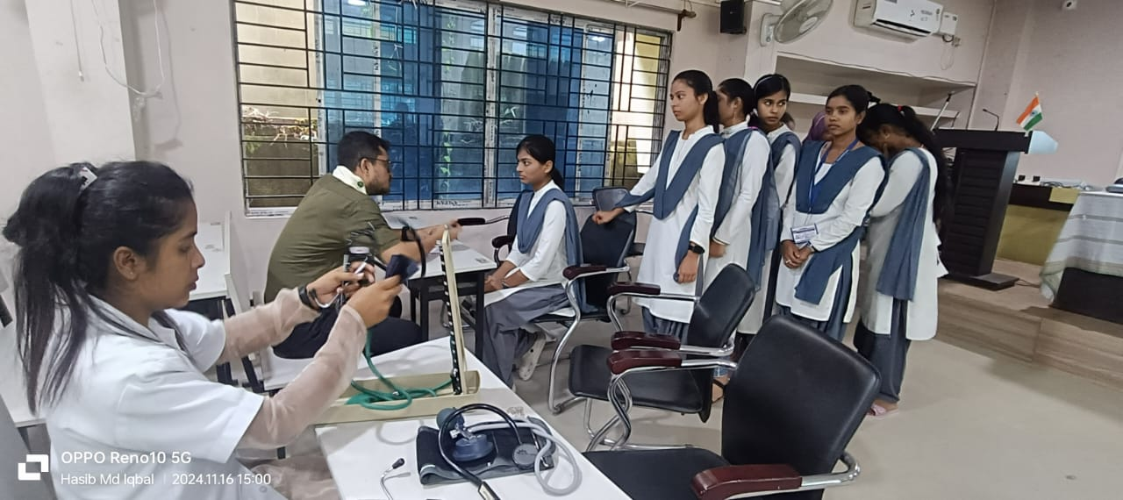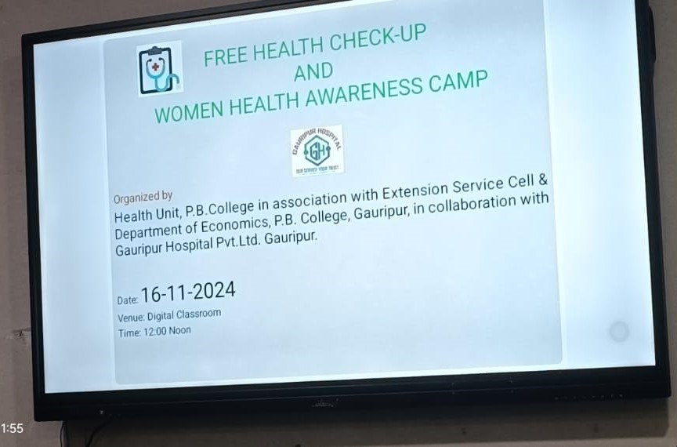
Health Unit of Pramatesh Barua College,Gauripur, organized a free Health Check-up and Women health Awareness camp in the Digital Class Room of the college on 16th Nov,2024 in association with the Extension Service Cell and Deptt of Economics of the College in Collaboration with the Gauripur Hospital Pvt Ltd, Gauripur.
Dr Kalyan Das, Principal of the College welcomed the Doctors, resource person and has given a brief speech on the importance of health and its impact on daily life.

Dr Hemanta Kakati, Managing Director, Gauripur Hospital Pvt Ltd in his motivational speech has given three main tips to change the life style of human being. In his speech, he highlighted the main health issues of women and how it can be resolved with their life style and healthy habits. Dr Kakati was supplemented by counselling with the students how to cope up with the sedentary life style diseases and get rid of them by regular exercise, yoga and healthy food habits.

Health check-up Camp was organized by Health Unit of the College as an important part of community services. This event was organized to provide the students information regarding the common health issues related with menstruation cycle, diet, blood group, blood pressure, hemoglobin, blood sugar level, appetite, eye vision, height & weight etc.

D.C Karmakar, Dr A R. Kanu, Dr A T Mollah, Mrs Mehzabeen Sultana, Mr Homang Chetri, Dr Asiqur Rahman, Hasib Md Iqbal, Convener, Health Unit of the College enthusiastically volunteered and assist the medical team in the camp.
Joydeep Rajbongshi, Executive Manager, Jasmina Khatun, ANM from Gauripur Hospital Pvt Ltd attended the camp and given their valuable service.
The voluntary service of the camp ended with the vote of thanks delivered by Dr Amitabh Ranjan Kanu, Associate professor of English department.

