Report of the Talk Programme
Department of Economics
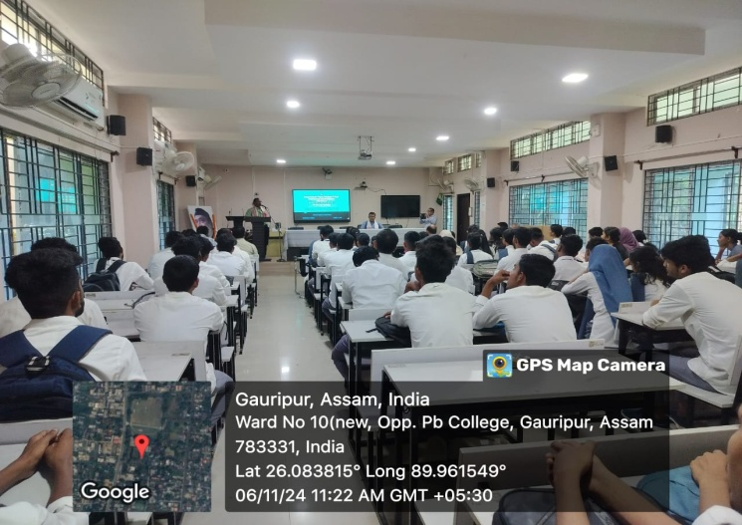
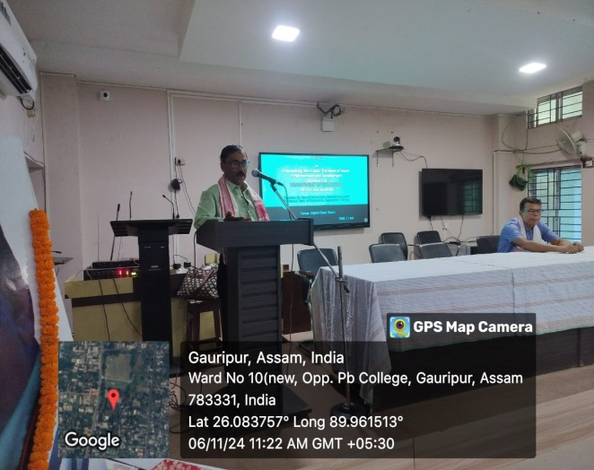

A Talk programme on “Empowering the Future: The Need of Youth Empowerment and Development” conducted by the Department of Economics, P. B. College, Gauripur on 06.11.2024 at 11.00 AM in the Digital Classroom of the College. In the programme the guest, the Principal of the College, faculty members and 64 numbers of students were present. In the programme, inaugural speech was given by the Principal Dr. Kayan Das; Purpose of the programme was given by HOD, Economics Dulal Chandra Karmakar. Lecture on the Talk programme delivered by Dr. Gour Krishna Saha, Retd. Associate Professor of Economics, Sapatgram College. In his valuable encouraging speech, Dr. Saha told the students that they have capabilities to do anything just they need strong willingness, time utilisation and perseverance. They are the future leaders of the nation. They should not misuse their time. At last, Mr. Chetri has given vote of thanks in the programme.

