DEPARTMENT OF ASSAMESE
Pramathesh Barua College, Gauripur
Dist: Dhubri, Assam, 783331.

Report on Late Amal Kr. Choudhury Memorial Lecture-2
Date: 27/08/2024

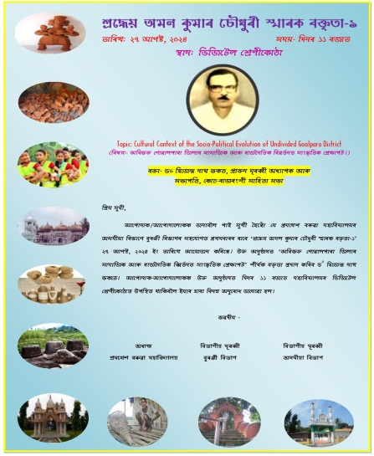
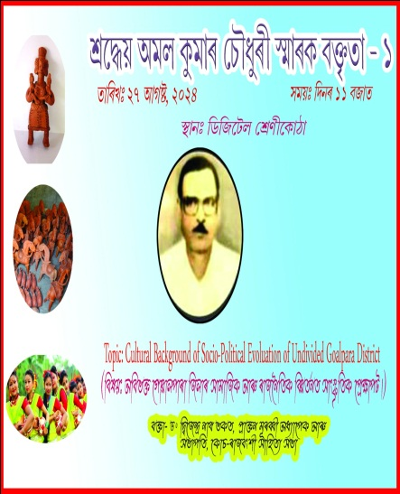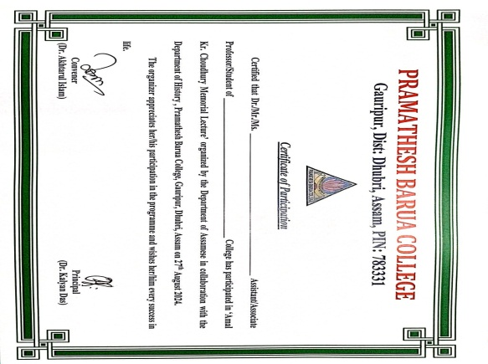
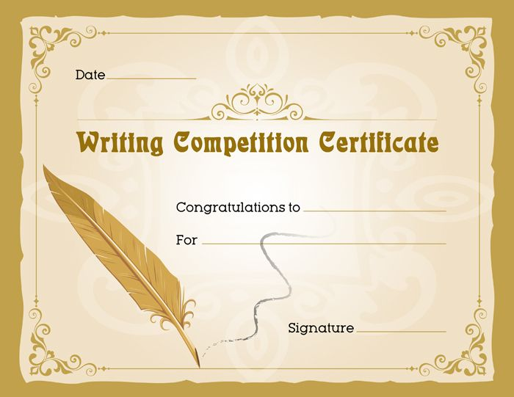
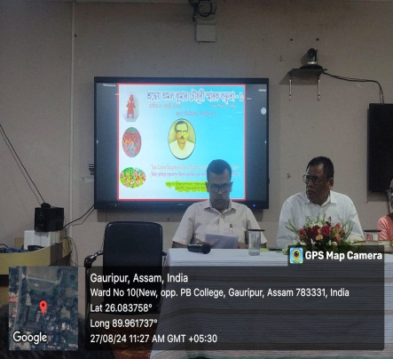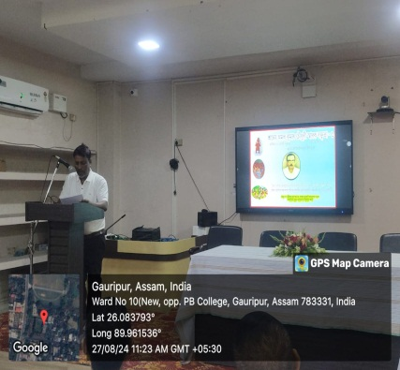
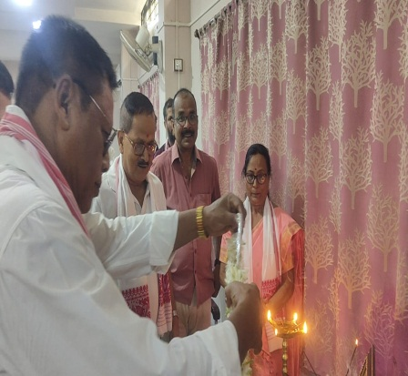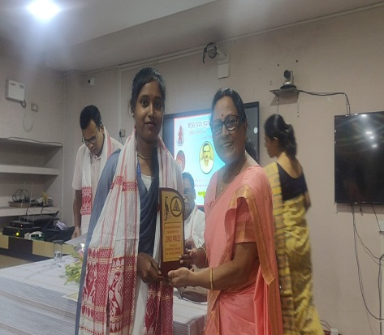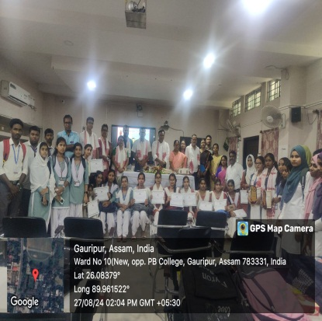
The department of Assamese, PB College has a legacy of dedicated and scholarly teaching faculties. One of the most talented and adorable former teacher of the department was late Amal Kr Choudhury. He rendered his tireless services to the department from 01/09/1965 to 08/02/1992. His sudden and untimely demise left the department with heavy loss.
The department in his memory initiated a memorial talk -1 in 2010 for which Dr. Umesh Deka, Rabindranath Tagore Professor of Gauhati University was invited to delivers a lecture on “Life and works of Sheelabhadra’’. A lot of gathering graced the occasion in the public library of Gauripur.
This year the department pursued the family members of late Amal Kr Choudhury and her elder daughter Mrs. D. D. Choudhury, HOD, History, PB College agreed for funding an amount of RS- 25000/-(Twenty Five Thousand) only to organise a ‘Memorial Lecture in her father’s name. Accordingly the department of Assamese in collaboration with the department of History, P.B.College organised the “Amal Kr Choudhury Memorial Lecture -2” inviting Dr. Dhijendra Nath Bhakat, Former HOD, Assamese, Chilarai College and President Koch Rajbongshi Sahitya Sabha on 27th April, 2024.
The department also initiated “Amal Kr Choudhury Memorial Essay Competition” for the students on ‘Tourism in Undivided Goalpara District: Problems and Possibility’.
On 27th sharp at 11 am The programme started. Dr. Akhtarul Islam, HOD, Assamese invited the guests to the Dias and described the purpose of the gathering. Dubori Dolisa Choudhury, HOD, History initiated the programme of felicitation of the guests with the help of Dr. Jyotsna Devi, Assistant Professor, Department of Assamese. Further, the distinguished guests Dr. Kalyan Das, Principal of the College, Dr. Gita Sarkar,former HOD,Assamese, P.B.College, Dr. D.N. Bhakat,speaker of the session, Dr. Umesh Das & Nitai Ch. Roy of Chilarai College, Manash Chakraborty, representative of Axom Xahitya Xobha, Nekibud Zaman of A.R College, Juin Das of Dhubri Girls College, Aluminise & students offered floral tribute to the portrait of Late Amal Kr. Choudhury.
Dr. Gita Sarkar, Former Hod, Assamese delivered a lecture on Amal Kr. Choudhury and recalled her students days where she met Late Choudhury as most adorable teacher and also she mentioned Late Choudhury’s disciplined, responsible and liveable character as colleague.
Dr. Dhijendra Nath Bhakat, the speaker of the session elaborately discussed his appointed topics ‘Cultural background of socio-political evolution of undivided Goalpara District.’ Further he handed over the written lecture to the HOD, Assamese for publication.
The HOD, Assamese declared the result of the essay competition where Barsha Begum of BA 5th semester (As Hon) secured the first position, Bhumika Biswas got second and Madhusmita Dutta of HS 1st year achieved 3rd position. Principal & guests distributed the Trophy, Certificates to the winners.
The programme was attended by the students and faculties of Pramathesh Barua College, Chilarai College, Dhubri Girls College and certificates for participants were distributed among participants of the other colleges.
Hemchandra Mili, Assistant Professor, Department of Assamese offered the vote of thanks and after a photo session the programme come to an end.
*******************************************************

