Departmental Talk

The Department of Political Science believes in ensuring an atmosphere of active academic engagement. It also believes in encouraging interdisciplinary approach to understanding politics. Literature like any other medium is not devoid of politics. Many revolutions have been strengthened by revolutionary poetry and fiction. As students of Political Science, it is important to understand how literature becomes the theatre of politics and also the harbinger of revolution.
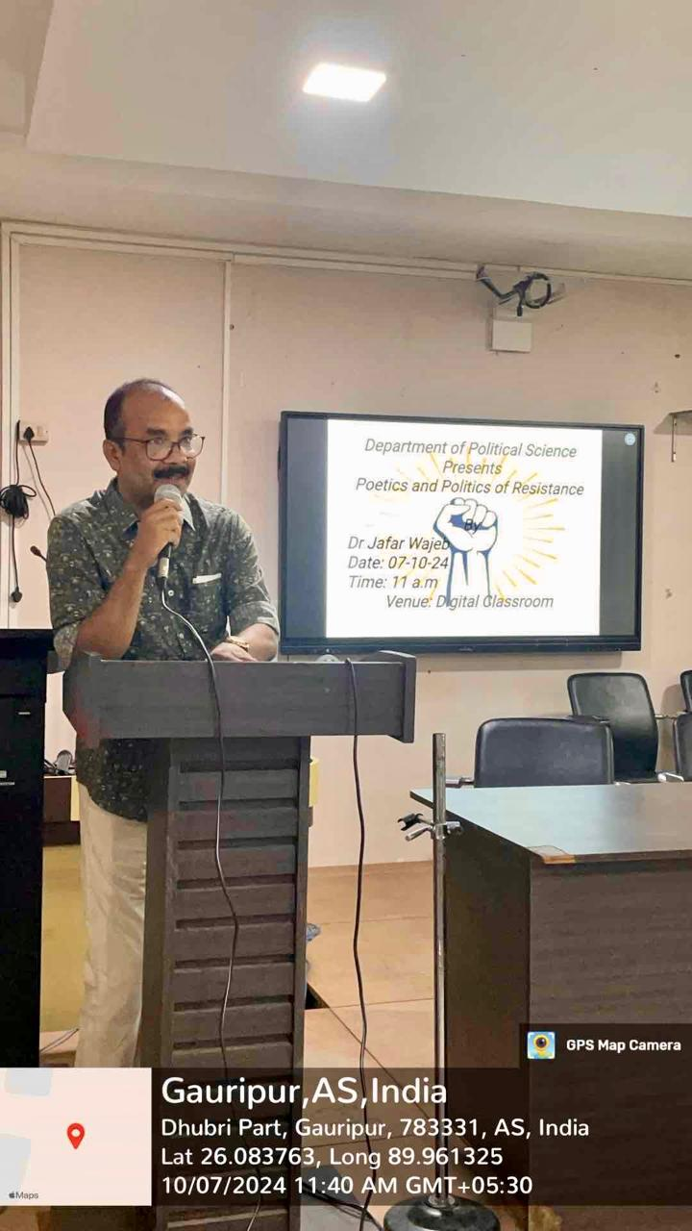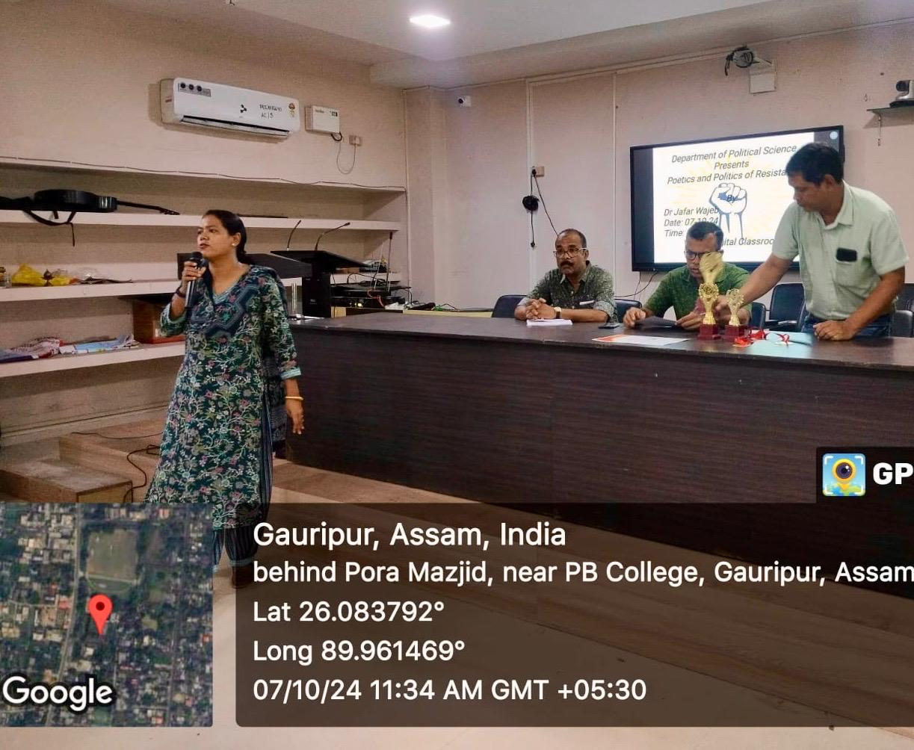
As a part of this endeavor, the department organized a talk on “Poetics and Politics of Resistance” on 07-10-2024. The talk was delivered by Dr Jafar Wajeb, Associate Professor and HOD, Department of Bengali. This was also an initiative in intra-college Faculty Exchange Program. The invigorating talk was attended by close to 80 students who listened to the presentation with in-depth attention. It was also attended by faculty members from other Departments.
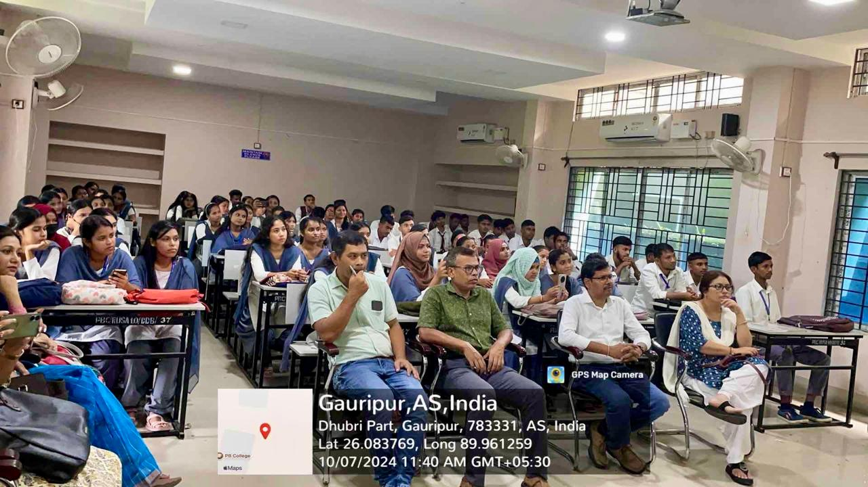
The speaker focused on the revolutionary potential of poetry. Quoting from works of noted poet Kazi Nazrul Islam, Rofique Azad and other contemporary poets, he elaborated how poets used poetry as a powerful medium to speak truth to power. Poets were also persecuted for criticizing governments and their activities. As such many were also jailed for years. Even now we have examples of literary works being banned in different countries. Many even won international awards while being in detention. The talk ended with a positive note about creative freedom.
