Freshers’ Party 2024

The Department of Political Science ensures that there is a healthy bond amongst the students. To ensure this, the Department regularly organizes various departmental programs. Like every year, this year also the Department of Political Science organized the Freshers’ Party on 24th September, 2024 at 11 a.m onwards. The aim of the party was to welcome the newly enrolled students who opted for Major in Political Science.
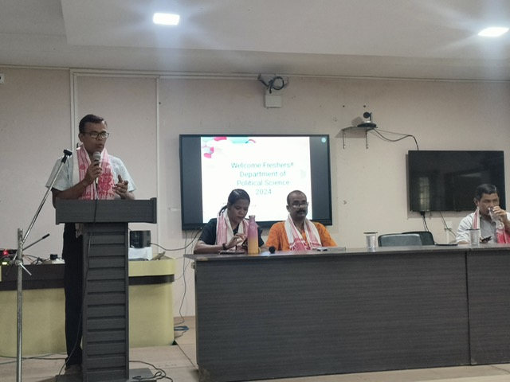
The students of 3rd Sem and 5th Sem were entrusted with the responsibility for organizing the entire program. The program was attended by the Principal of the College as well as the Academic In Charge Dr Jafar Wajeb. The program started with a few encouraging words from the Principal. It was followed by a short lecture from the Academic In Charge and a powerful piece of recitation.
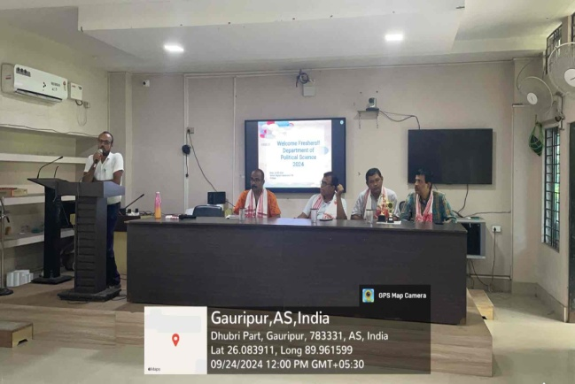
The program then went forward with the introductory session of freshers along with dance and music performances by the senior students. The newly enrolled students introduced themselves along with stating what they like to do. Many students expressed their hobbies of painting, writing and music. The performances were diverse – from recitation of self written poems to performance of songs from popular films. It also had a performance of a self composed Rabha rap song by Paulash Rabha.
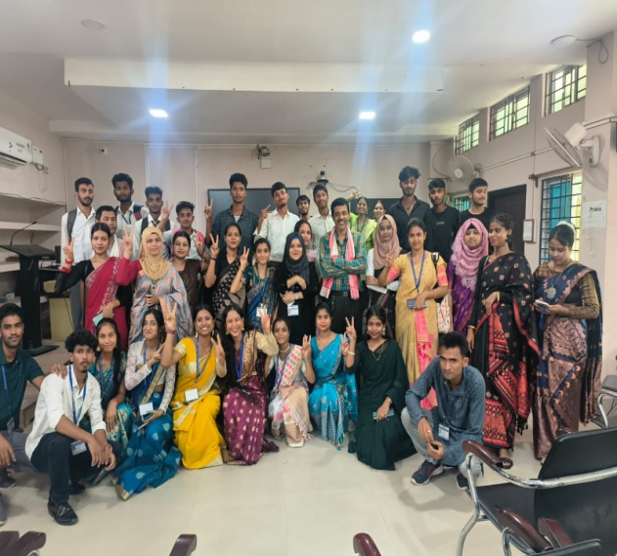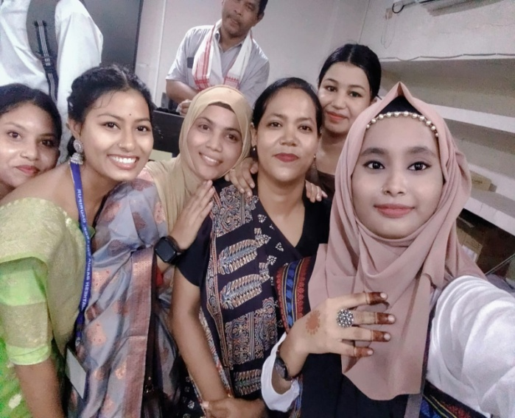
The program ended with the distribution of a light refreshment to all.

