REPORT ON THE PROGRAMME OF ESSAY & QUIZ COMPETITION 2024-25
The department of Arabic and Hindi organize Essay & Quiz competition for the students of Pramathesh Barua College, Gauripur on 19-09-2024. It is notified to the students to participate in the programme on 12-09-2024. It is also notified the Rules and Regulations for both the competitions as follows:
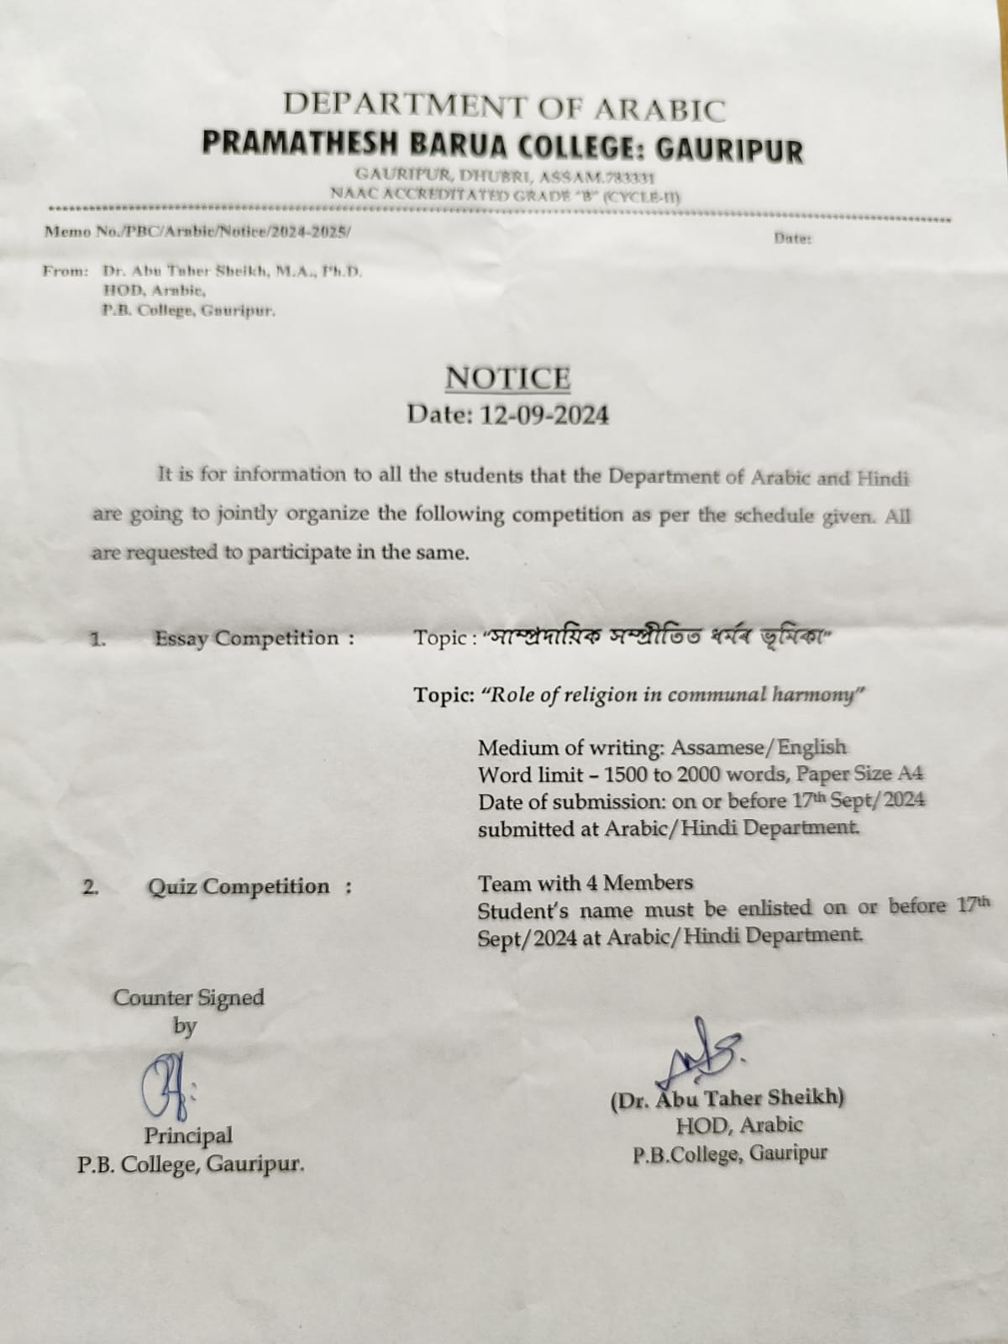
- Essay competition:
- The topic of Essay :“Role of Religion in communal harmony”
- Medium of writing : Assamese/English
- Word limit : 1500 to 2000 words
- Paper size : A4
- Date of submission : On or before 17th Sep/2024
- Submission place : Department of Arabic or Hindi

- Quiz competition:
- A group consists 4 members
- There will be 5 rounds for each group. Each round has some rules which are mentioned in following instruction
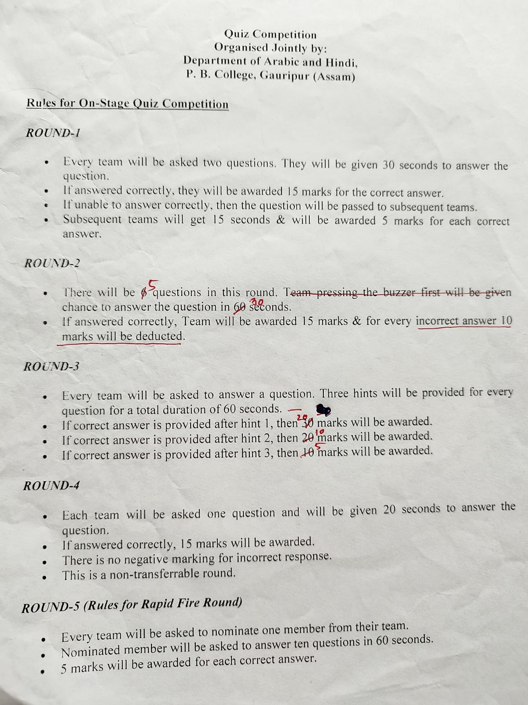

Activity 1: Essay competition: Prize distribution ceremony runned by Dr. Abu Taher Sheikh, Asstt. Prof. Deptt of Arabic…
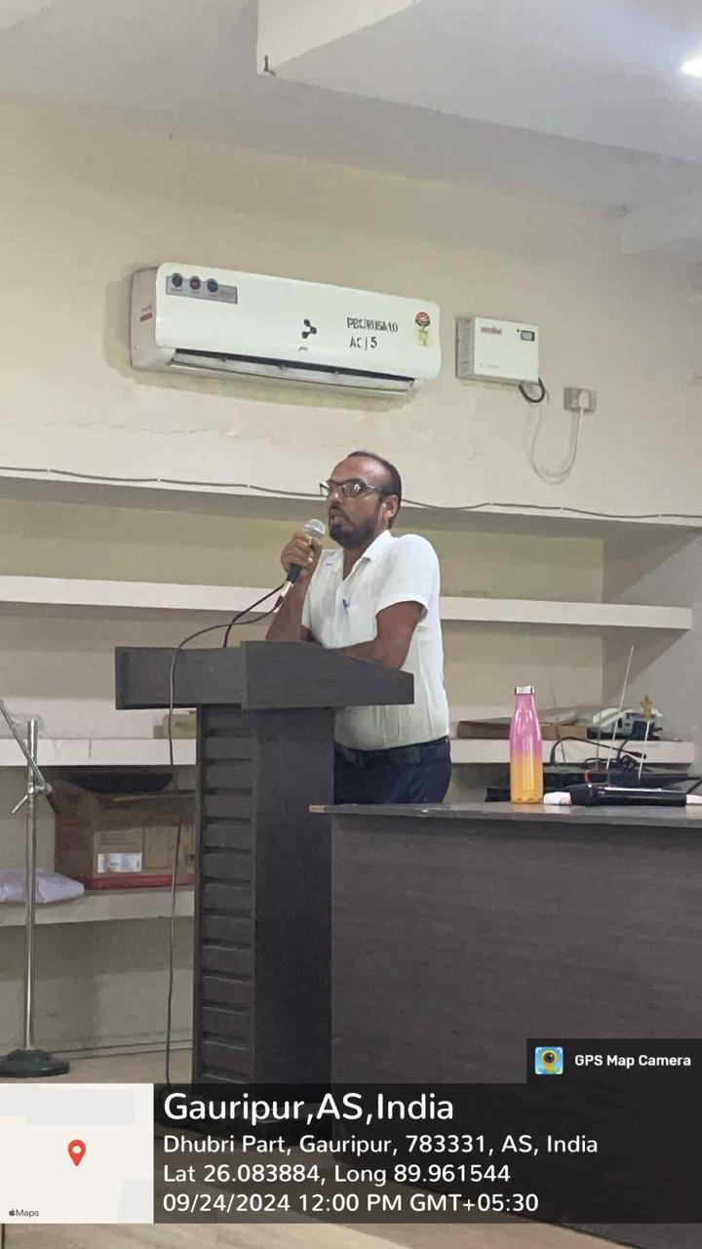
The 1st prize goes to LOTIKA NATH of BA 5th Semester bearing Roll no-0119, Major in Political Science.
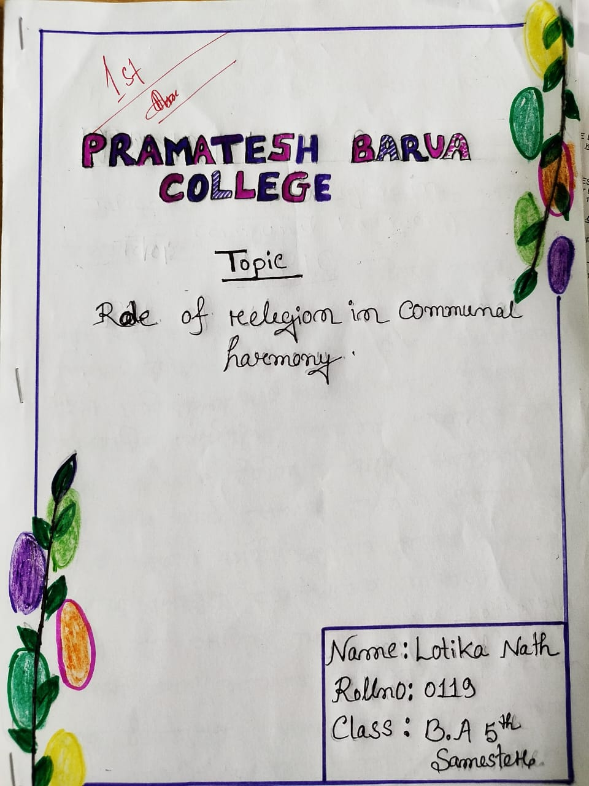

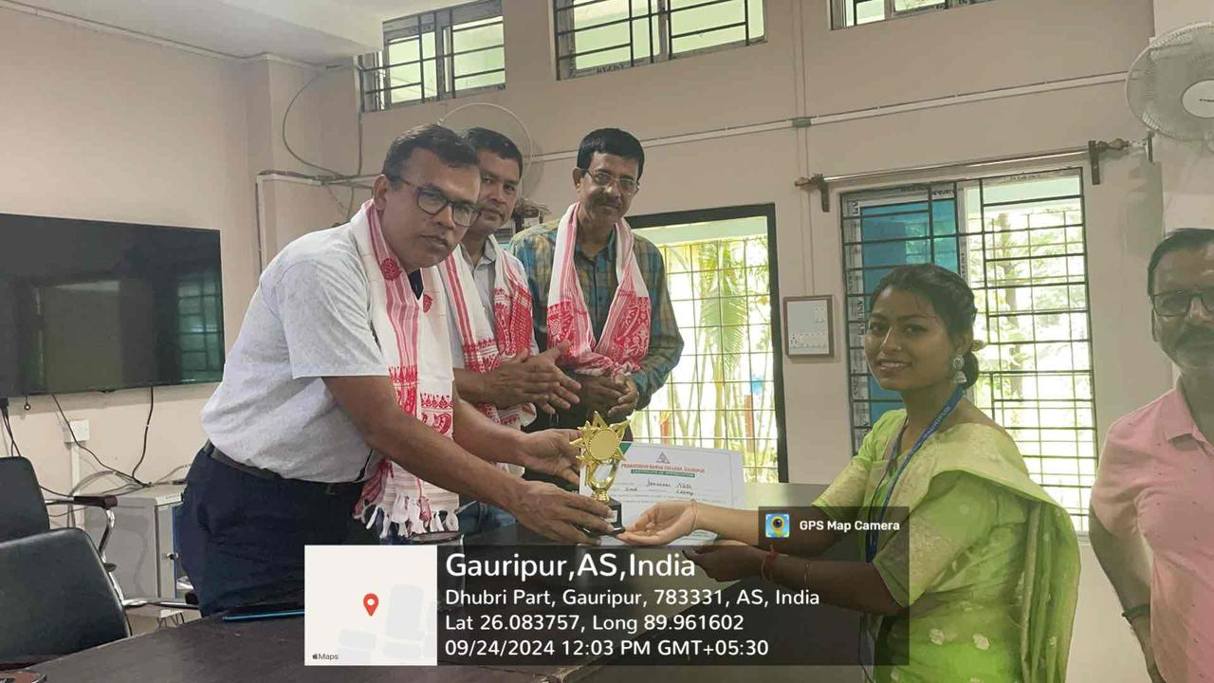
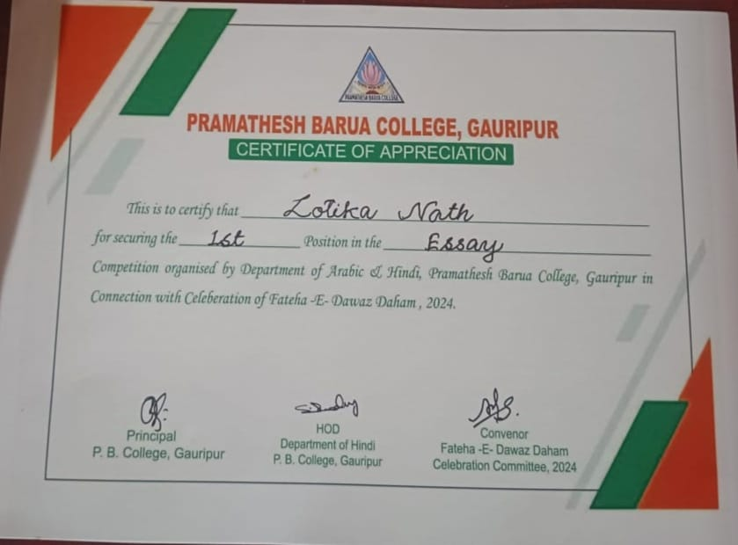

And 2nd prize goes to JONMONI NATH of BA 5th Semester bearing Roll no-0121, Major in Political Science.
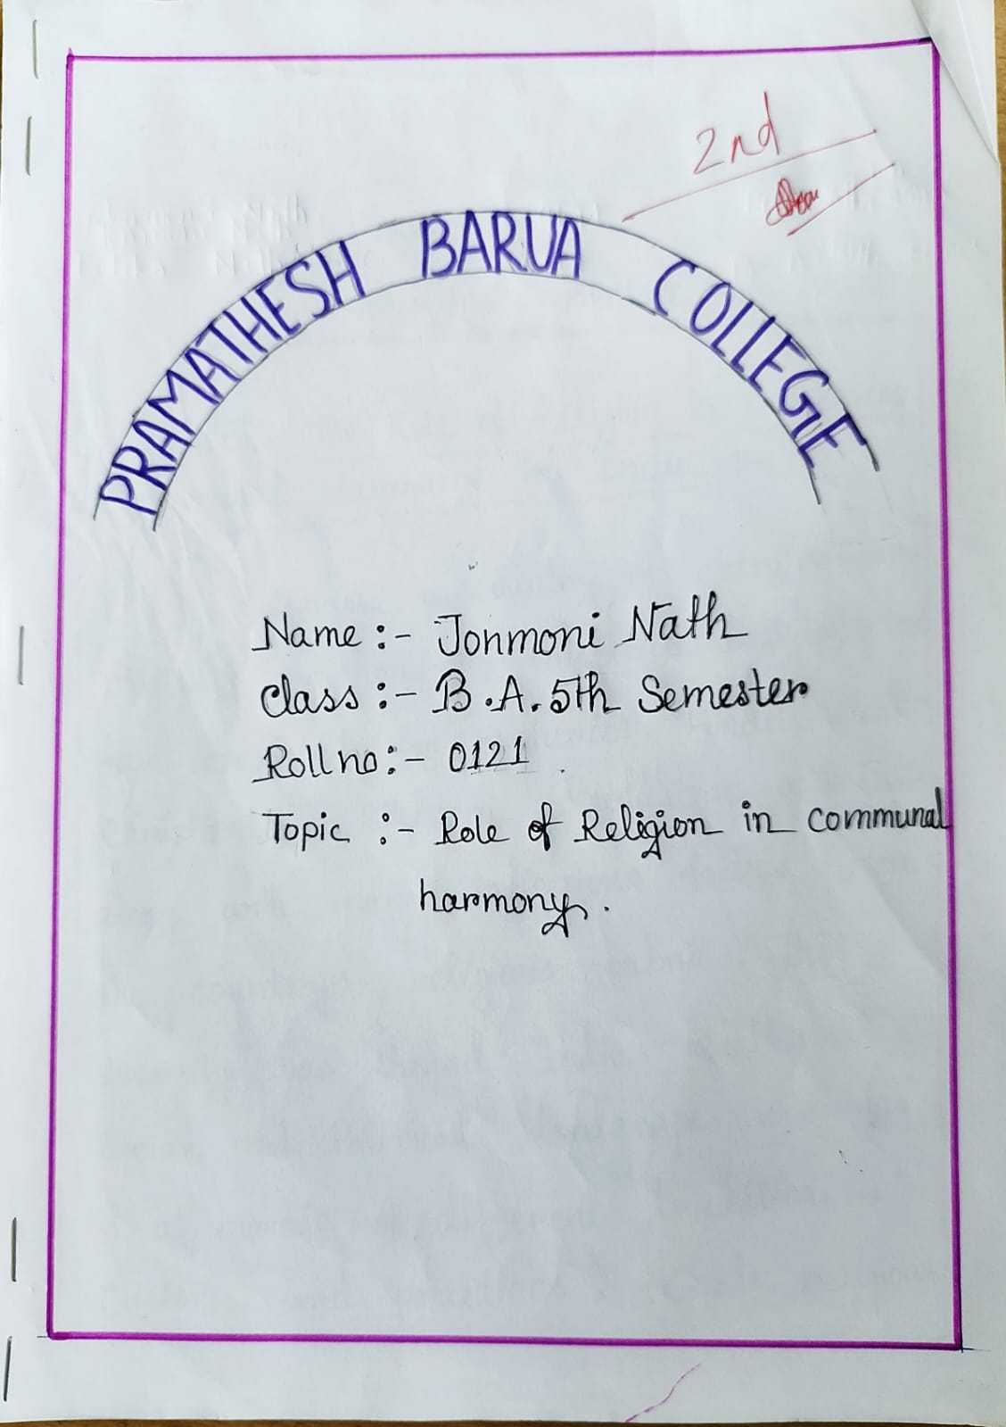
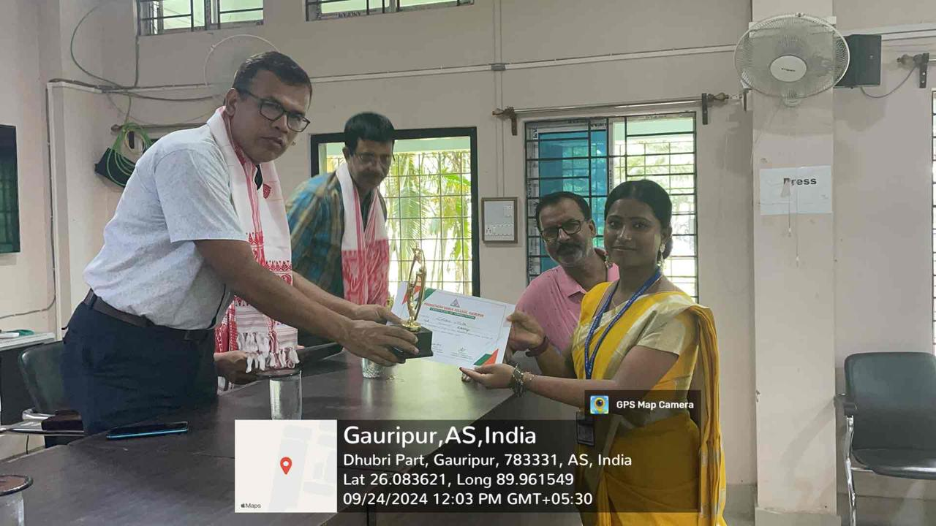
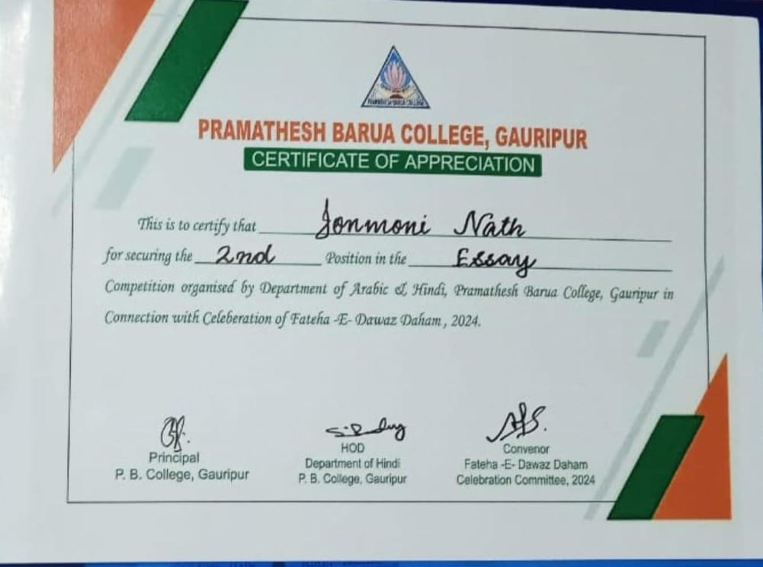

Activity 2: Quiz competition questions sample…
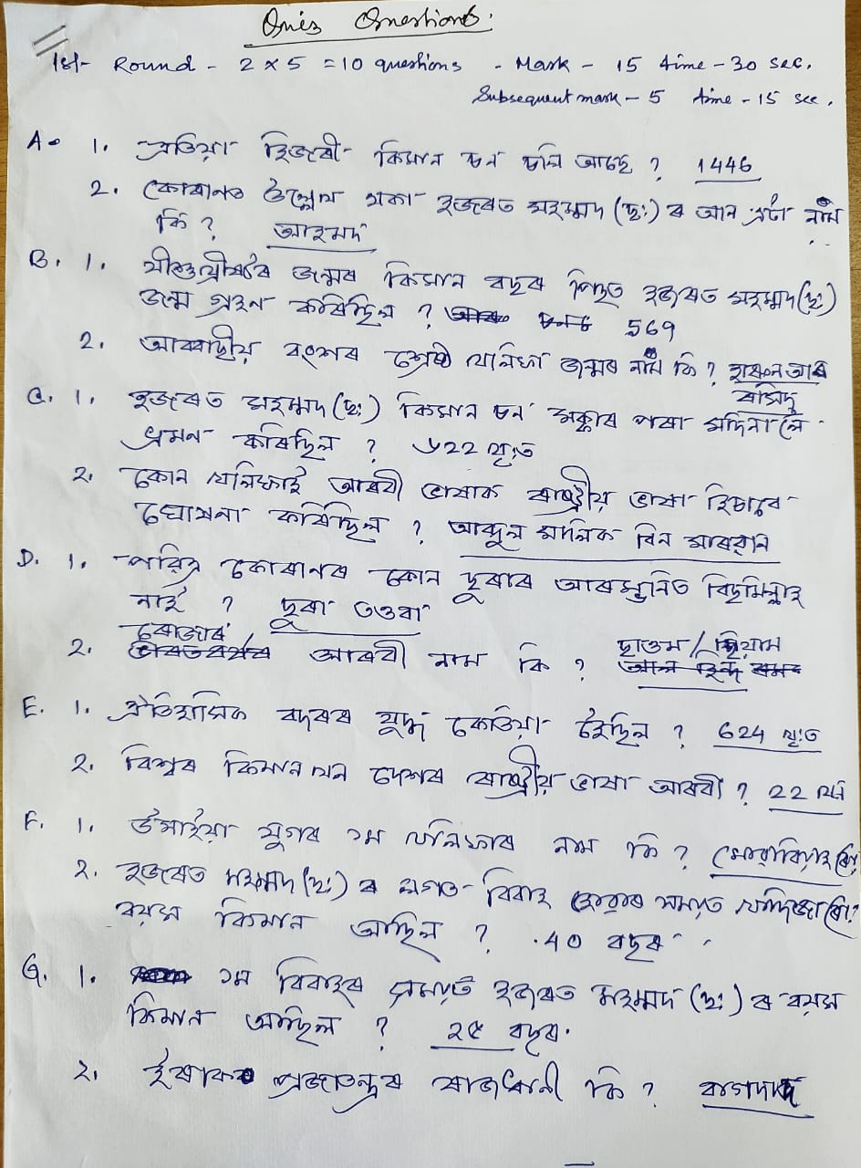
Quiz competition runned by Dr. Aminur Islam Sk, Associate Prof. Department of Philosophy….
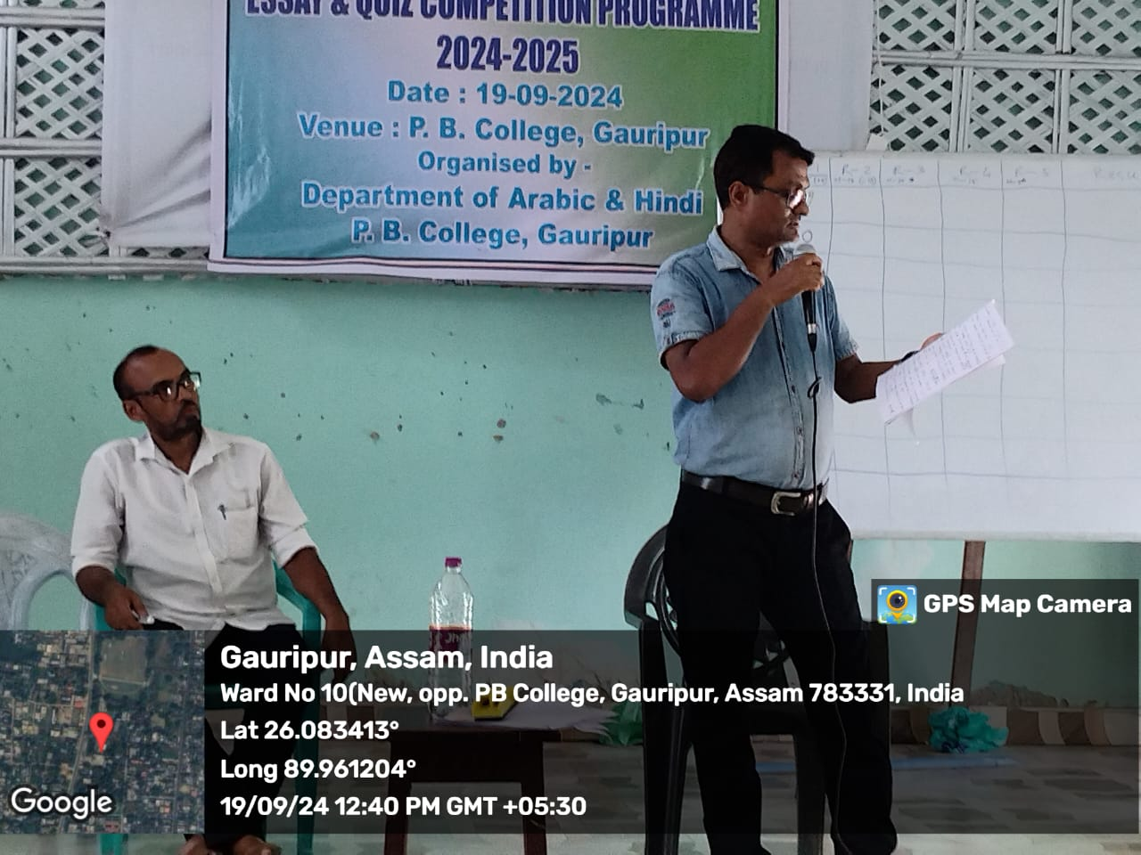
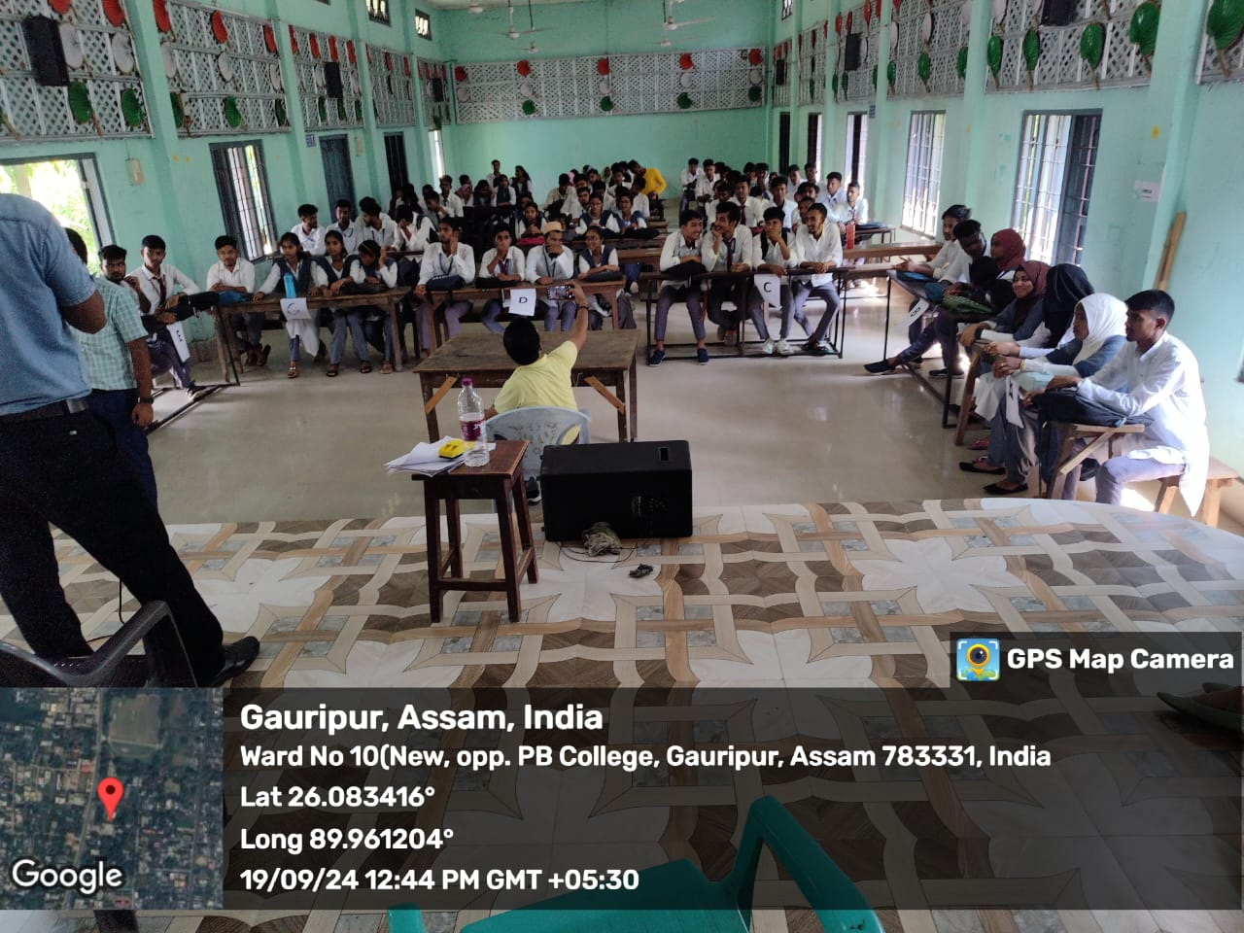

Result of Quiz Competition
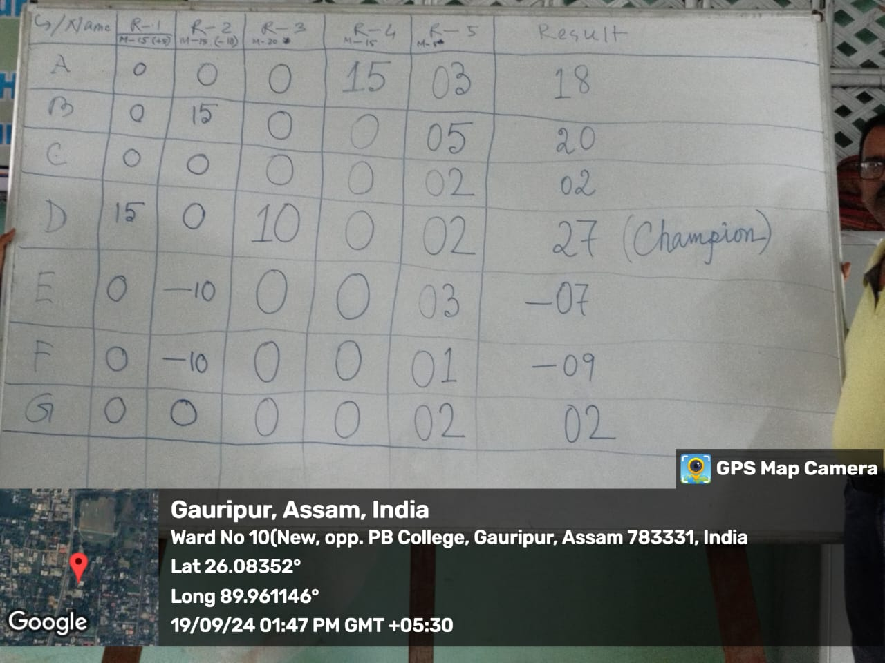

Quiz Competition Prize goes to Group D consisting of four members as follows:
- Wasim Saleh, HS 2nd year Roll-81 b. Sahinara Khatun, HS 2nd year Roll-47 c. Jiyarul Hoque, HS 2nd year Roll-56 d. Osman Goni, HS 2nd year Roll-105
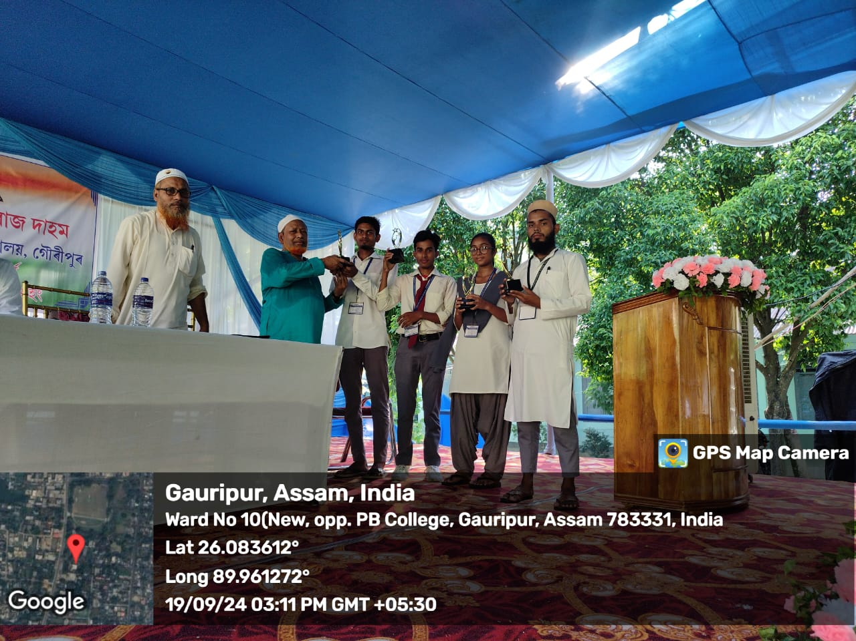

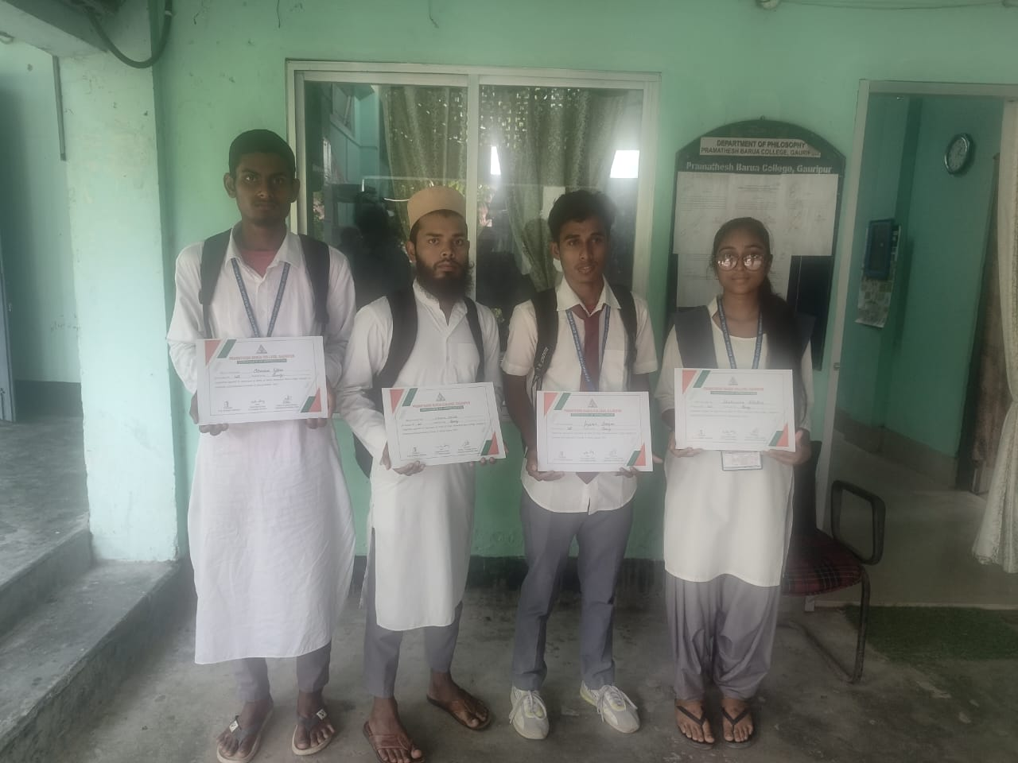
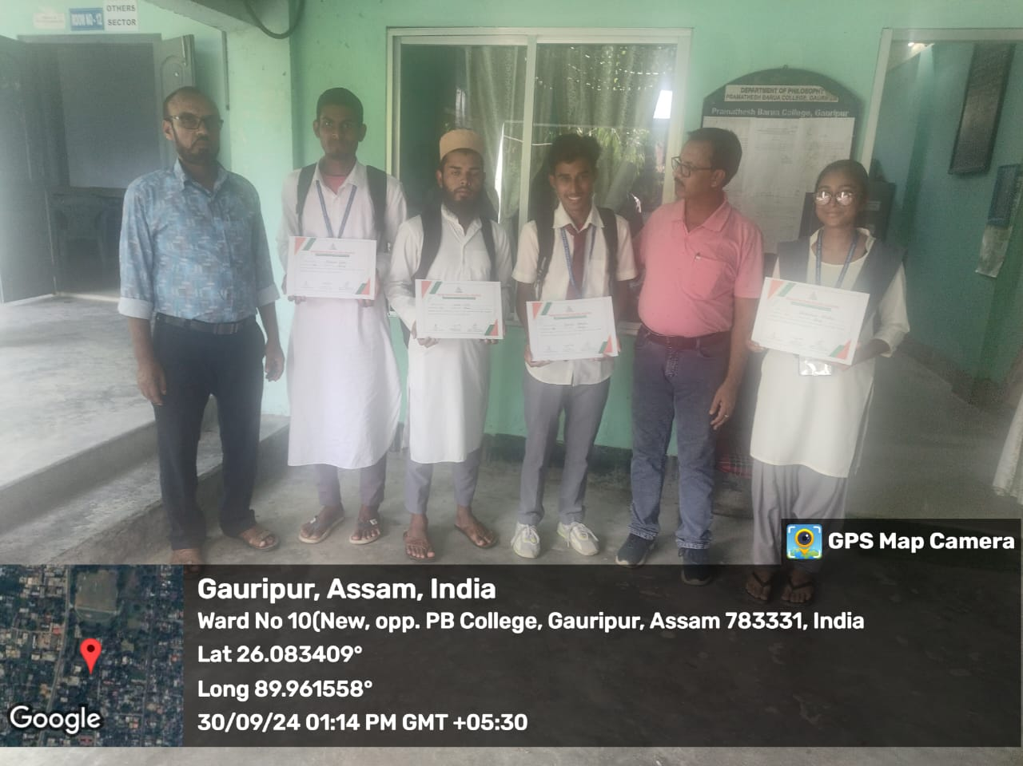

We appreciate and grateful to Dr. Aminur Islam Sk, Associate Prof. Department of Philosophy, Prof. Mehjabin Sultana, Economics Department, Prof. Enamul Mazid, Department of Mathematics, Prof. Zakir Hussain, Department of History, Prof. Hamen Das, Department of History who help us in conducting the programme and we mostly appreciate Dr.Kalyan Das, Principal, P.B.College, Gauripur who Helps us to arrange the programme smoothly. We offer thanks to our beloved students who support us to succeed the programme.
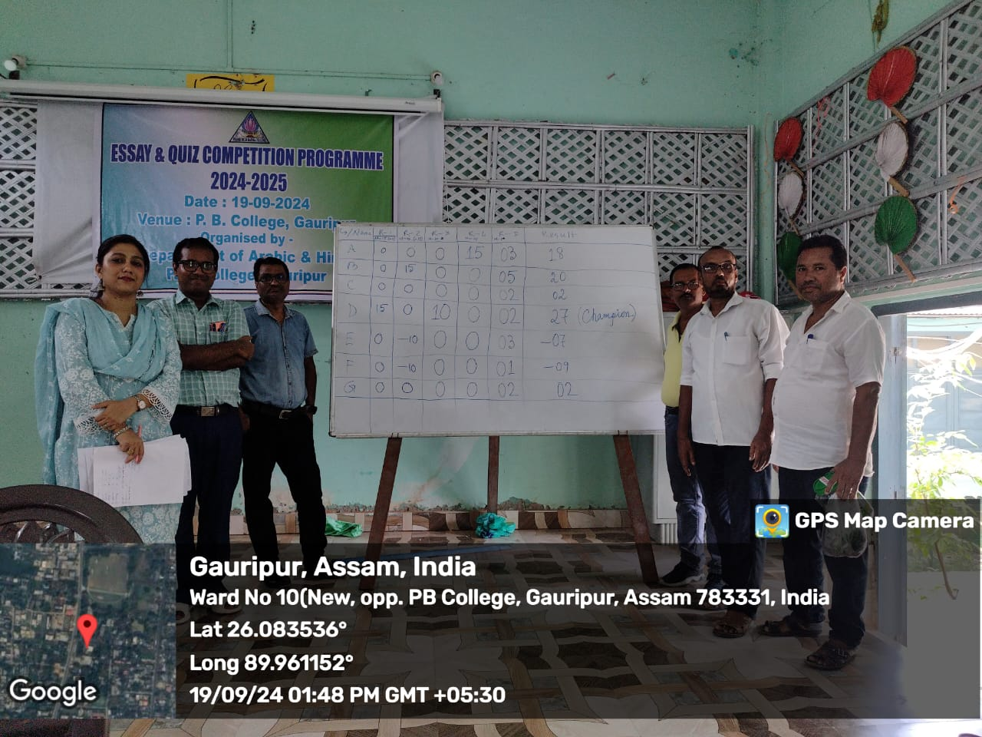
Thanking to all

Dr. Abu Taher Sheikh Dr. Shambhu Pandey
Assistant Professor Assistant Professor
Department of Arabic Department of Hindi
Promathesh Barua College, Gauripur Promathesh Barua College, Gauripur

