REPORT ON THE PROGRAMME OF FATEHA-E-DOWAZ DAHAM 2024-25

The college celebrates Fateha-e-Dowaz Daham Programme on 19-09-2024. In relation with this programme the college organizes Gazal competition, Qirat competition and speech competition on the topic “Role and Importance of Zakat in Islam”.
Activity 1: Morning Prayer for the celebration of Fateha-e-Dowaz Daham at 7:30 am in Room no-13. Photos attach herewith….
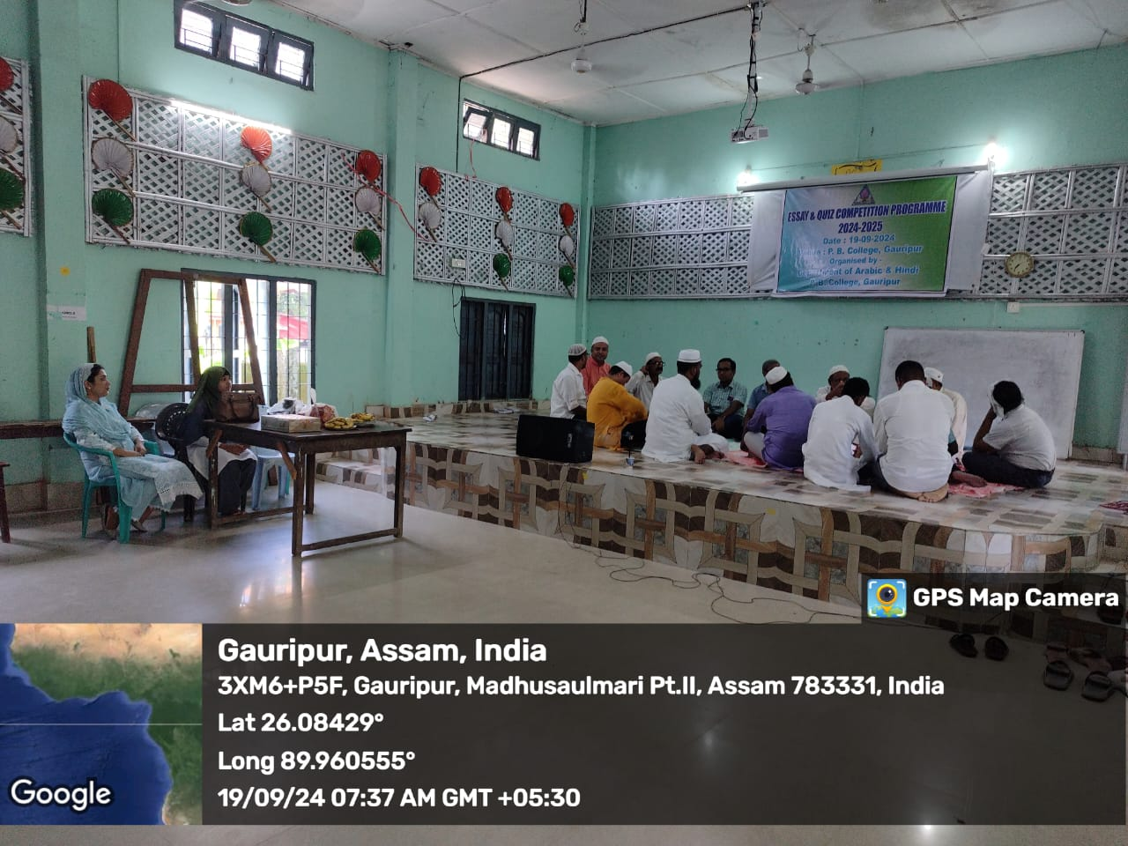
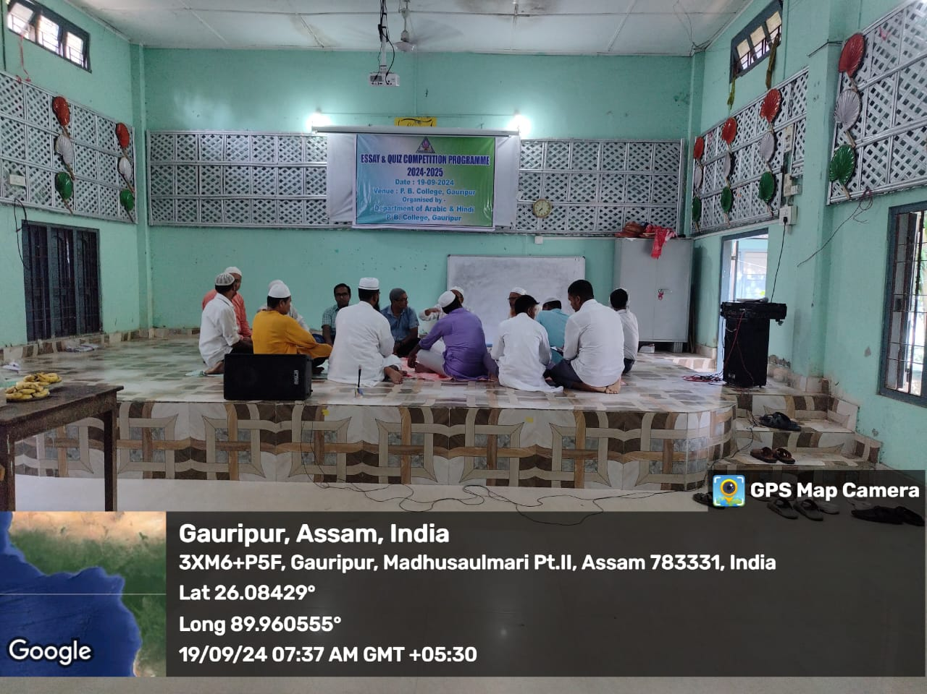

Activity 2: Qirat competition is started at 10:30 am on 19-09-2024. Photos attached herewith…
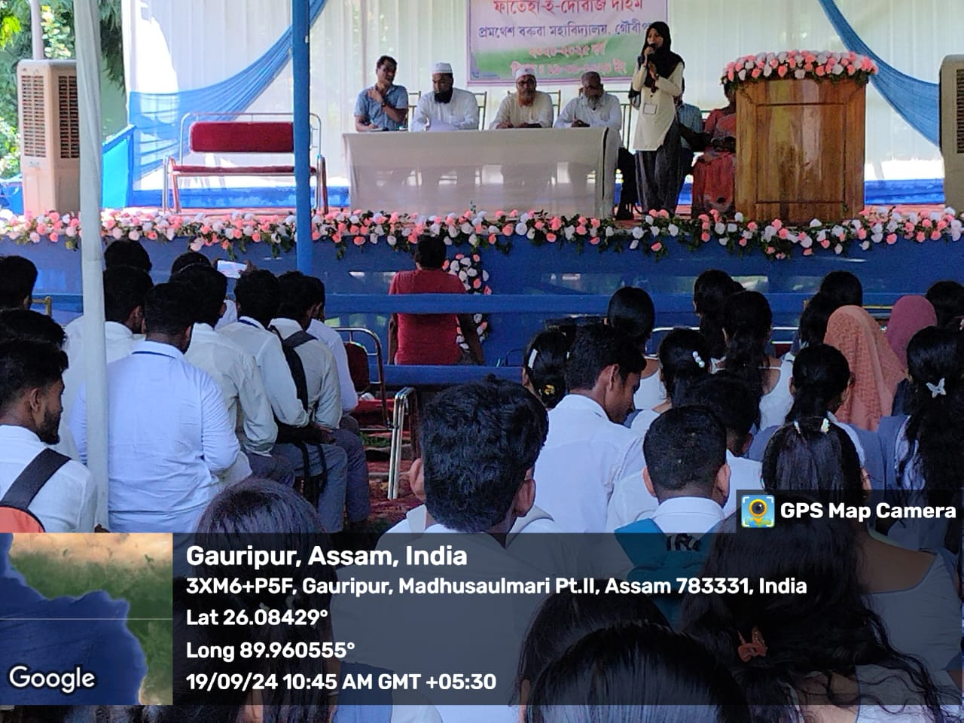
Activity 3: Gazal competition photos…
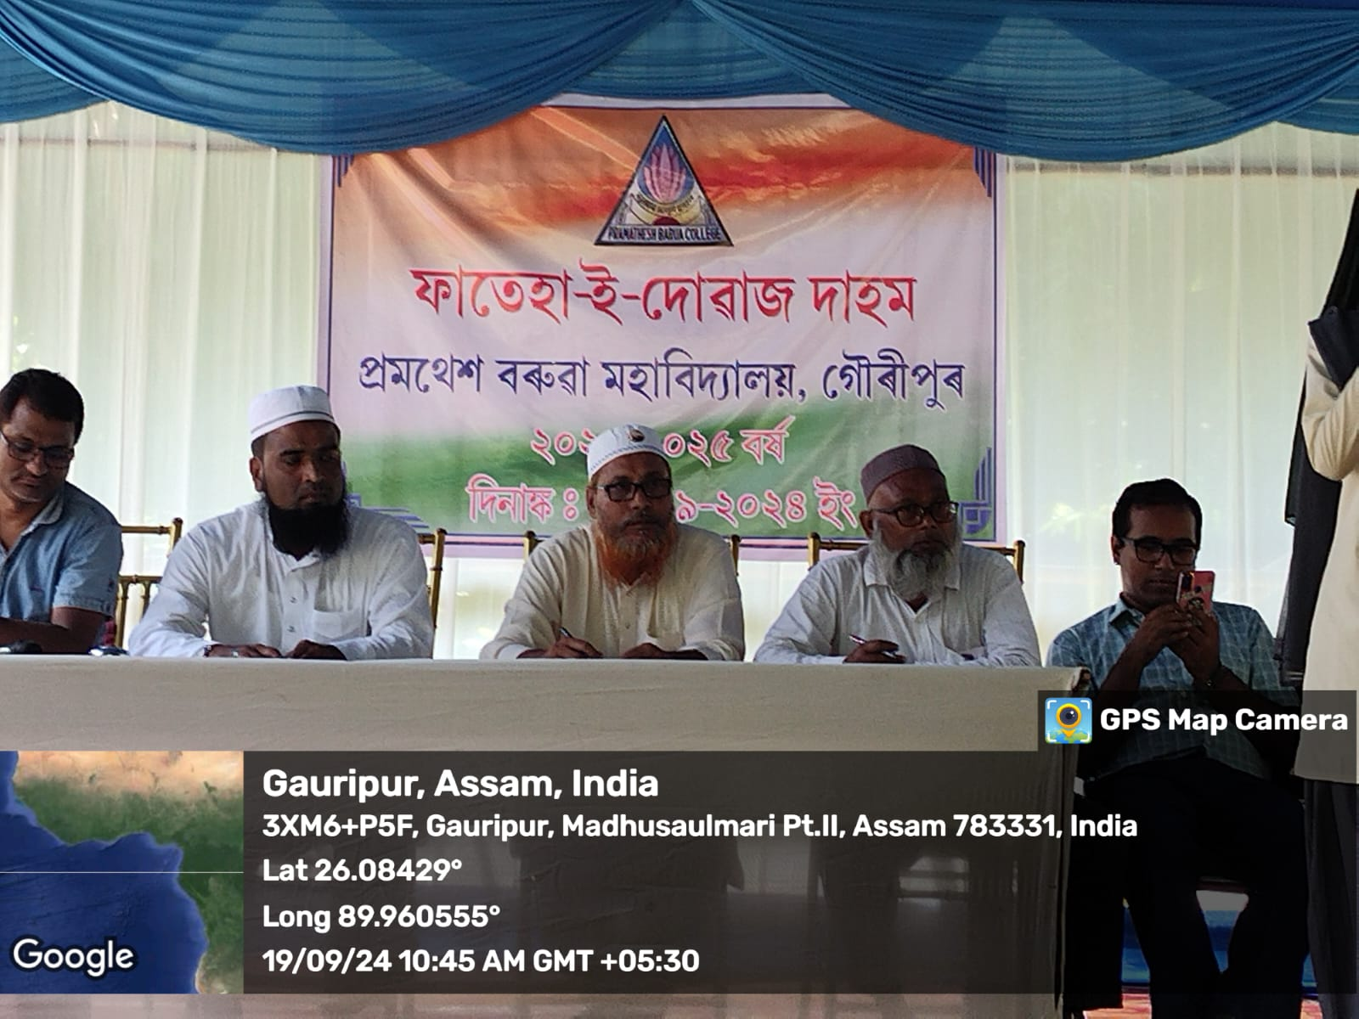

Stuudents as Audience
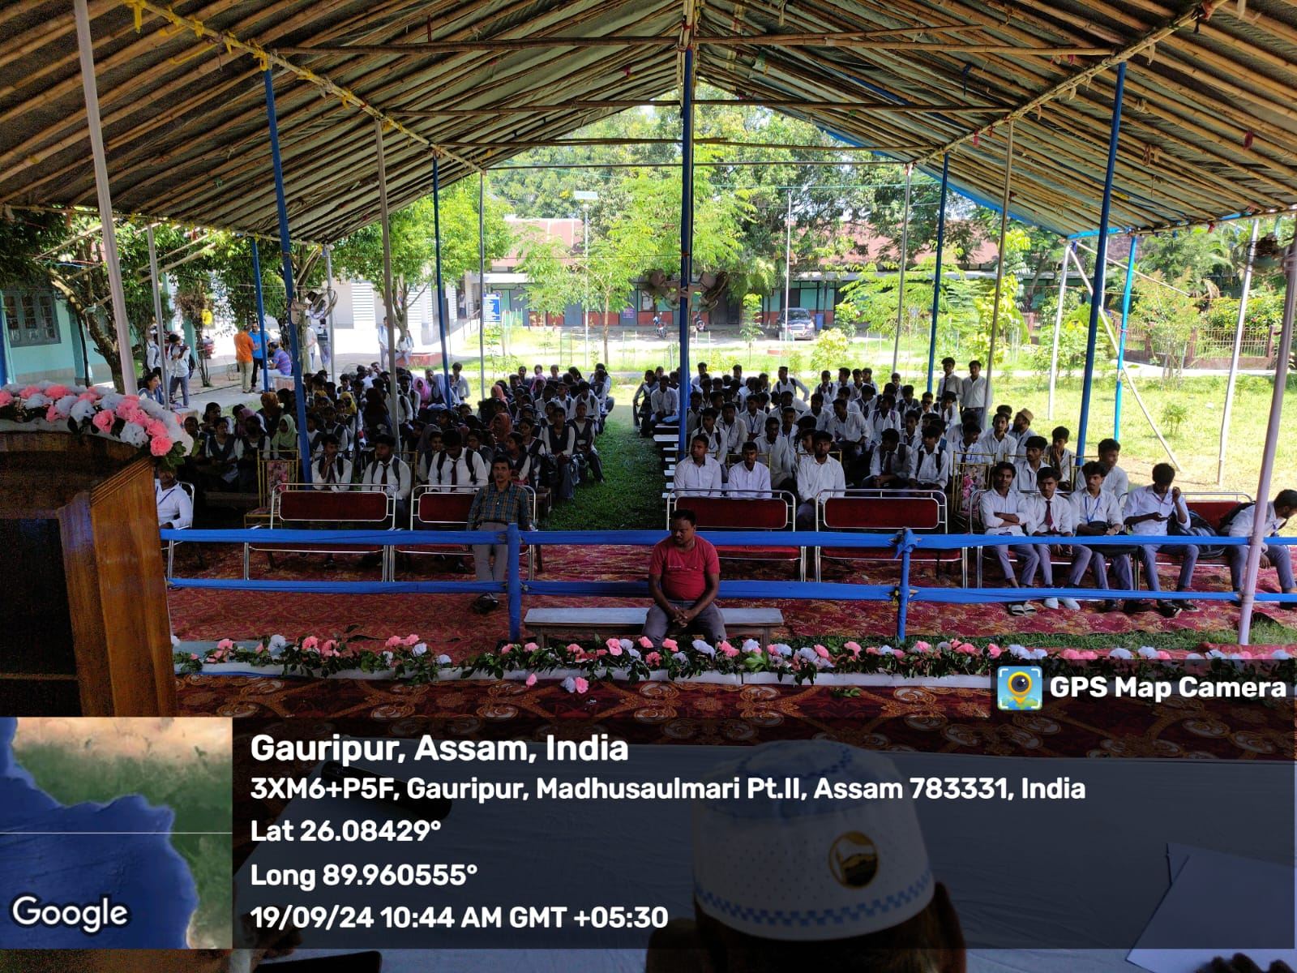

Activity 4: Speech

