DEPARTMENT OF ASSAMESE
Pramathesh Barua College, Gauripur
PO- GAURIPUR, DIST- DHUBRI, ASSAM ,PIN NO- 783331
Ref….. Date: 23-09-2024

REPORT ON FIELD TRIP FOR B.A 3RD SEM (M/M) AND SEC
Date of Visit: 21/09/2024
Place of Visit: Jinkata Rajhua Satra.
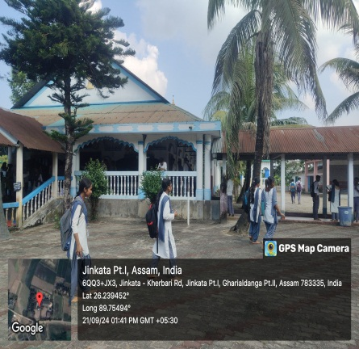
Here are some moments captured in connection of the programme
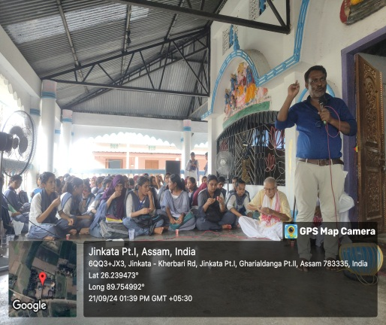
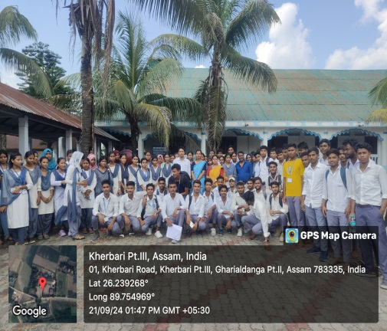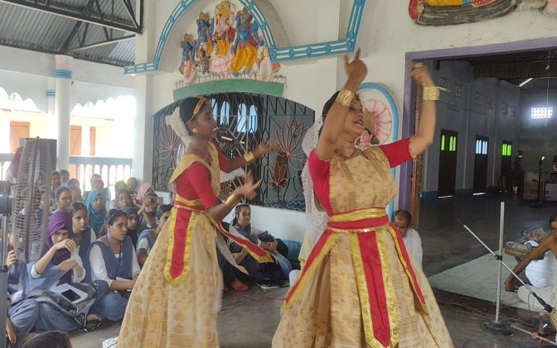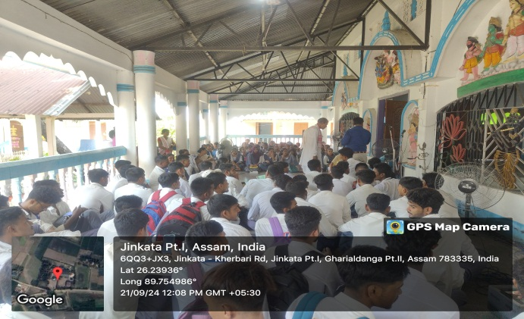
In view of experiential and participatory learning initiative the department of Assamese organised a field trip and one day workshop on ‘Satriya Dance and Performing Art of Western Assam’ in Jinkata Rajhua Satra on 21st Sep,24. Initially the Principal, P.B.College, Gauripur was sought for permission to organise the programme outside of the College campus. Having it, the management committee of ‘Jinkata Rajhua Satra’ was communicated for permission and the cultural troop of the locality was requested to perform the Satrya Dance and Goalini Nritya. The programme was aimed to accommodate the students about Satriya dance form, costumes,musical instruments as well as construction of satra like; Gurugriha, Monikut, Naamghar, Naatghar etc. Khitish Bhakat an elderly member and president of the Satra elaborately discussed different aspects of the establishment and management of the Satra and also Satriya culture of the locality. Students were asked to clarify their doubt of understanding. Mrs. Golapi Bhakat, a cultural activist of the locality elaborately discussed about the performing art of western Assam and exhibits the Goalini Nritya with her troop.
Dr.Akhtarul Islam, HOD, Assamese coordinated the programme with Dr.Jyotsna Devi,Hemchandra Mili and NikumoniDas, faculties of the department.

