World Ozone Day- 2024 Celebration Brief Report
Held at P. B. College, Gauripur, Dist. - Dhubri (Assam)
Date: 16.09.2024

The International Day for the Preservation of the Ozone Layer, more generally known as the "World Ozone Day", is celebrated on the 16th of September every year, commemorating the date on which the Montreal Protocol for the abatement of substances that deplete the Ozone Layer was signed in 1987.
As a part of the “World Ozone Day" Eco Club and Department of Philosophy, P. B. College, Gauripur organized the following activities on 16.09.2024.
Activity 1:
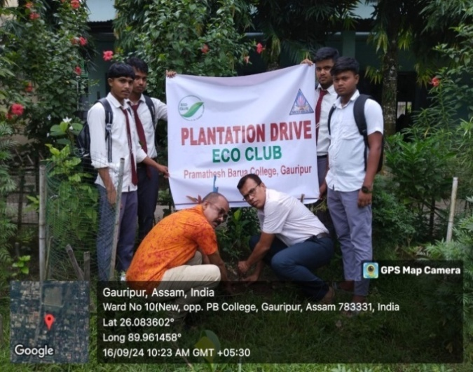
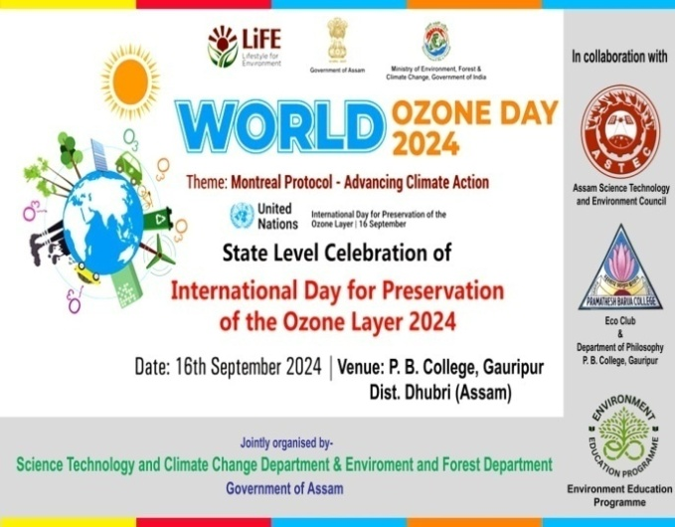
Saplings Plantation conducted in the P. B. College premises.

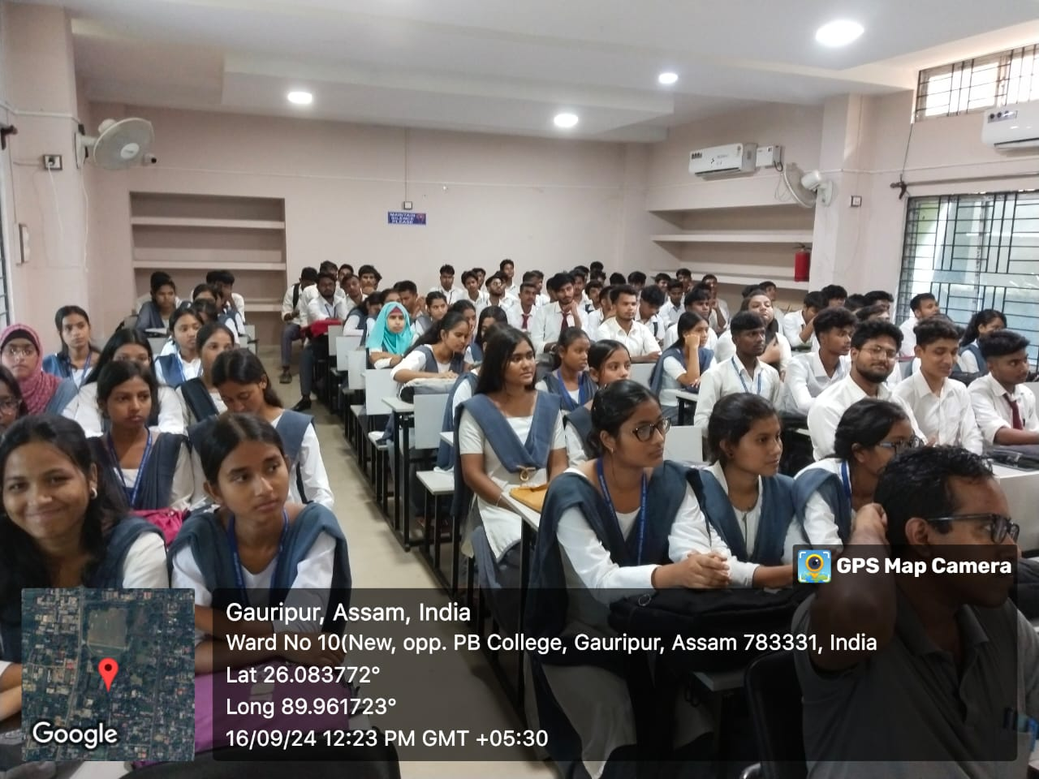

Activity 2:
Organised Posters Making and Essay Writing Competitions among the students of P. B. College, Gauripur to spread awareness about the importance of the Ozone Layer and the need to protect this fragile shield of gas.
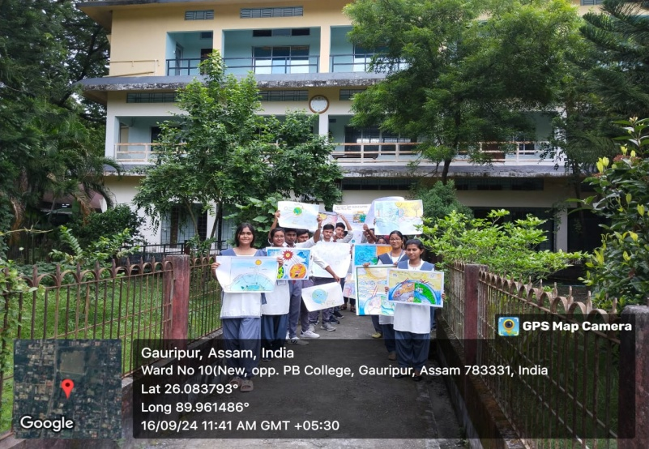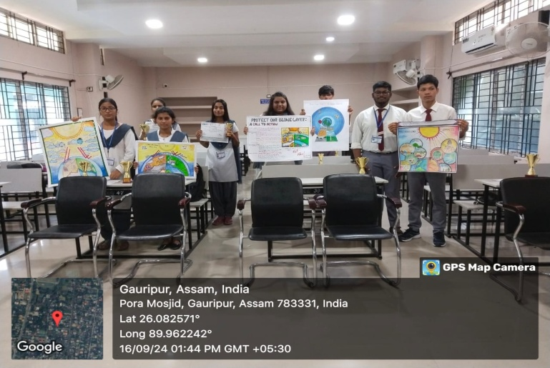
The students of HS First & Second Year and Semester-I (FYUGP) took part in the Posters Making Competitions depicting the Ozone Layer Depletion and made beautiful posters to spread awareness about the depletion of this layer and find possible solutions to preserve it. This activity helped in enhancing their psychomotor skills and creative thinking.
Students of Semester-III & V took part in the Essay Writing Competition on World Ozone Day. They discussed the depletion of the layer and the ways to preserve it. It encouraged a quiet introspection and sensitivity about their surroundings.
The Result of competitions:
Poster Making:
1st: (i) Peginal Rabha, Semester-I (FYUGP- Arts), Roll No. 53
2nd: (i) Anika Sharmila, Semester-I (FYUGP- Arts), Roll No. 197
(ii) Sulifa Rahman, Semester-I (FYUGP- Arts), Roll No. 31
3rd: (i) Palak Chirania, Semester-I (FYUGP- Arts), Roll No. 84
(ii) Karan Roy, Semester-I (FYUGP- Arts), Roll No. 56

Essay Writing:
1st: (i) Khushbu Sultana, Semester-III (FYUGP- Arts), Roll No.70
2nd: (i) Sourav Saha, Semester-V (CBCS-Com.), Roll No. 32
3rd: Jyoti Prajapati, Semester- III (FYUGP- Arts), Rol No. 59
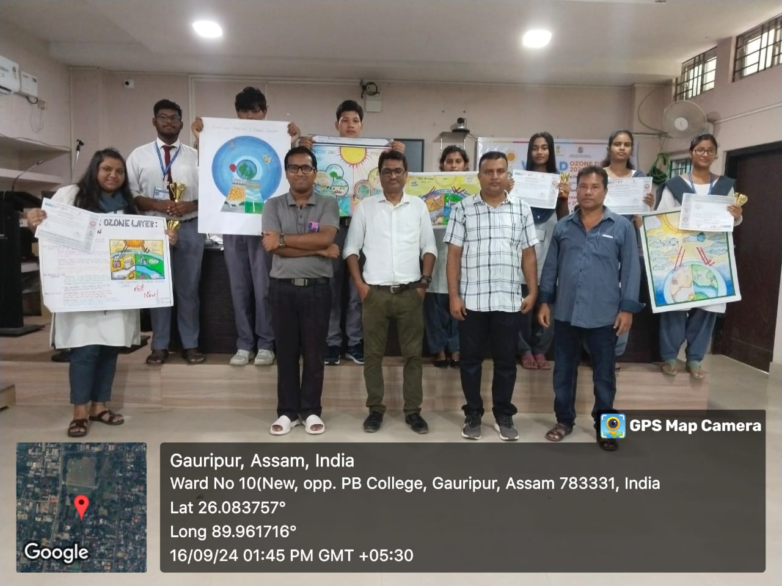
Activity 3: (Open Session)
The session is inaugurated by featuring an "Informative Animation Video of Ozone Layer Depletion."
Dr Kalyan Das, Principal, P. B. College, Gauripur has given the inaugural speech of the event.
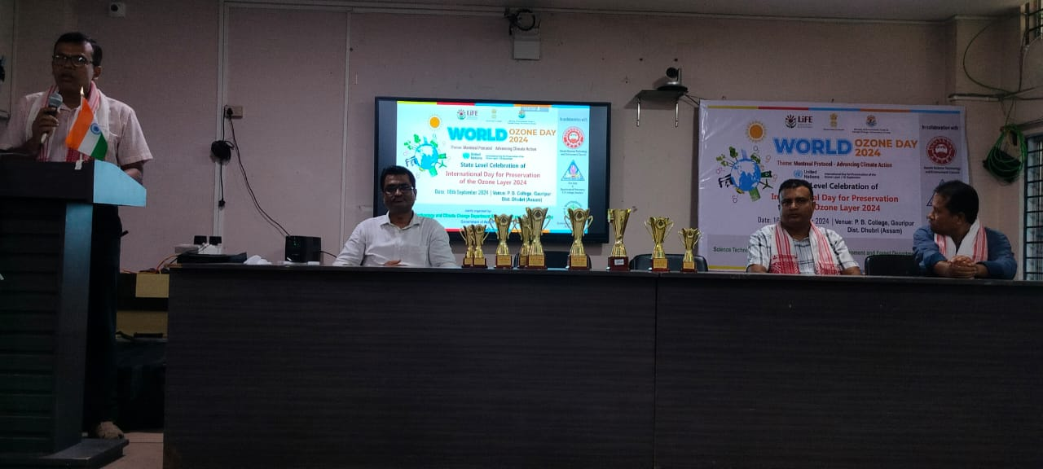
Dr Aminur Islam Sk, Coordinator and Associate Professor, Eco Club, P. B. College, Gauripur given the opening remarks of the event.
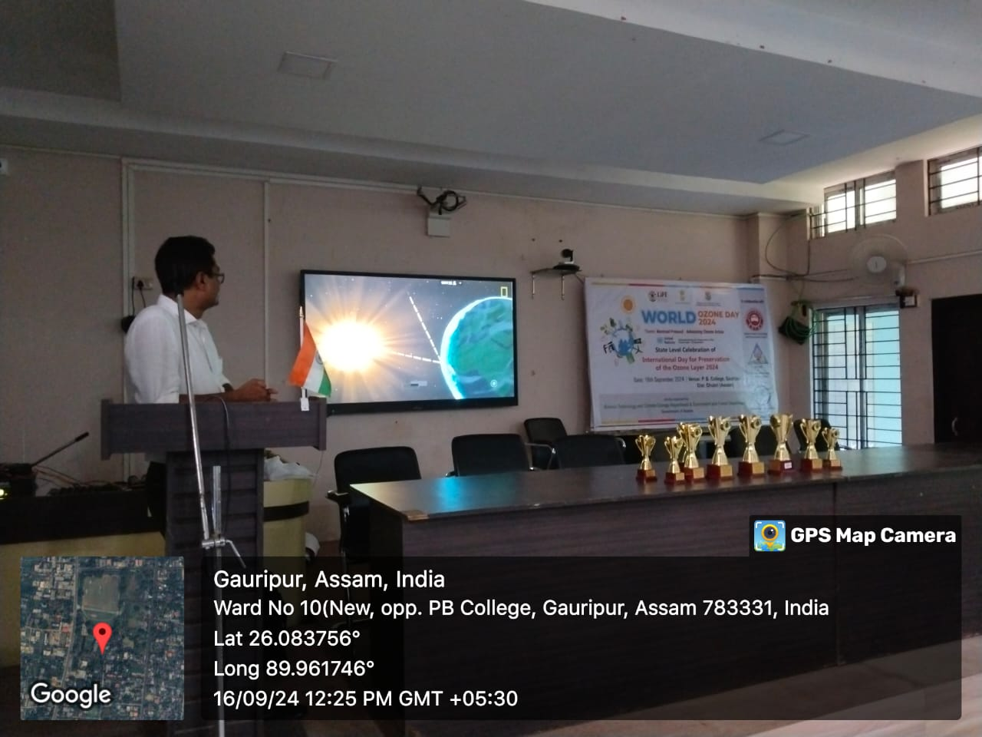
Open Session 1: On the topic "Ozone Layer Depletion, Causes, Effects and Solutions" by Dr Abu Taher Mollah, Assistant Professor, P. B. College, Gauripur.
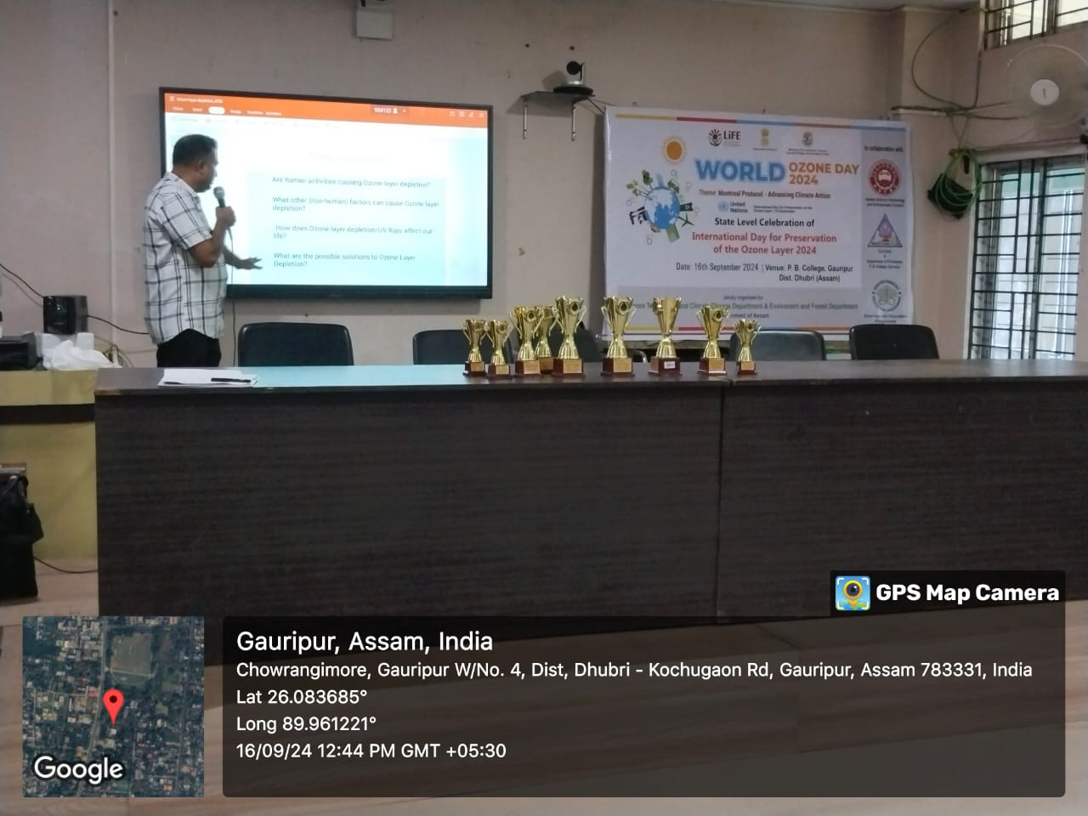

Open Session 2: On the topic "Environmental Pollution and Depletion of Ozone Layer" by Mr Enamul Mazid, Assistant Professor, P. B. College, Gauripur.
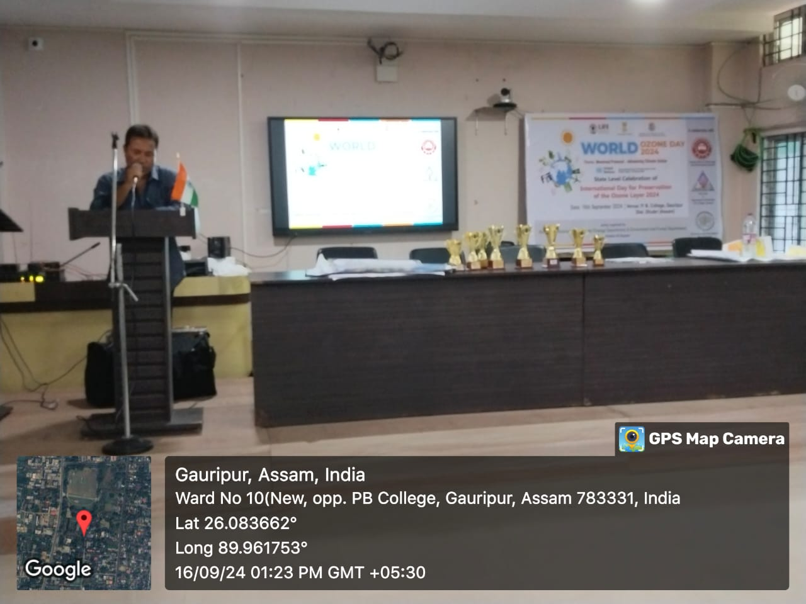
Both of the speakers discussed the importance of the Ozone layer for life on earth and the steps required for its preservation.
Activity 3: Prizes and Certificates distributed to the students who have secured their positions in the competitions.
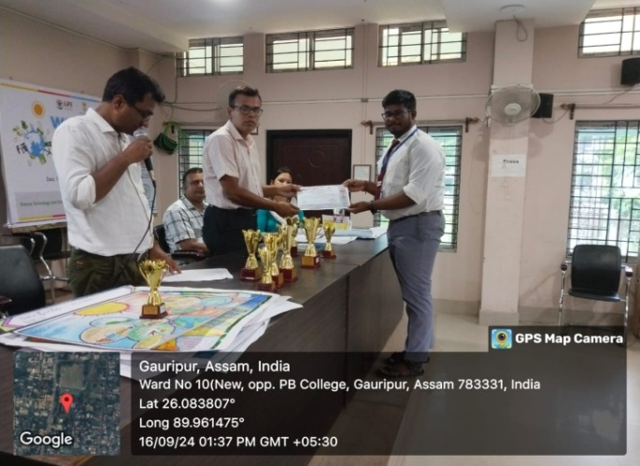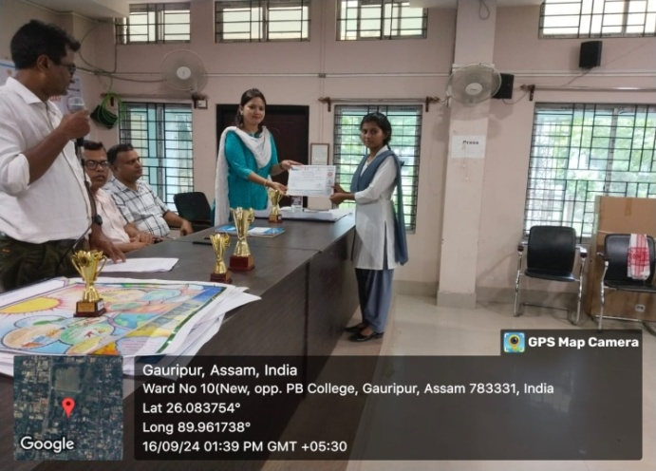
World Ozone Day was celebrated with participation (almost 100 nos.) of students and teachers of the college. At the end of the session Vote of thanks of the event was given by Dr Aminur Islam Sk, Coordinator and Associate Professor, Eco Club, P. B. College, Gauripur.
(Dr. Aminur Islam Sk)
Associate Professor cum Coordinator
Eco Club
P.B. College, Gauripur
(Dr. Kalyan Das)
Principal
P.B. College, Gauripur

