Departmental Orientation 2024-25
Department of Political Science
Date: 07-08-2024

The Department of Political Science organized a Departmental Orientation Programme on 7th August, 2024 at 10 a.m in the digital Classroom. It was attended by the students of FYUGP 1st Sem. It was attended by all the faculty members of the department of Political Science.
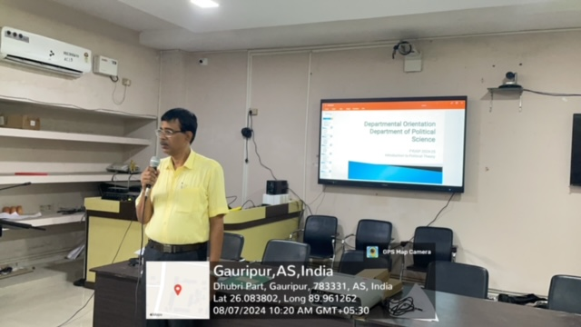
The programme started with an introduction to the course by Parvin Sultana. She stated the teachers who will be teaching the course. She elaborated the various themes included in the paper POL 01-01 Introduction to Political Theory. She also explained the evaluation method used by the Department to grade the students. Along with this, she introduced the value added course Importance of Voting offered by the Department and the Electoral Literacy Club run by the Department.
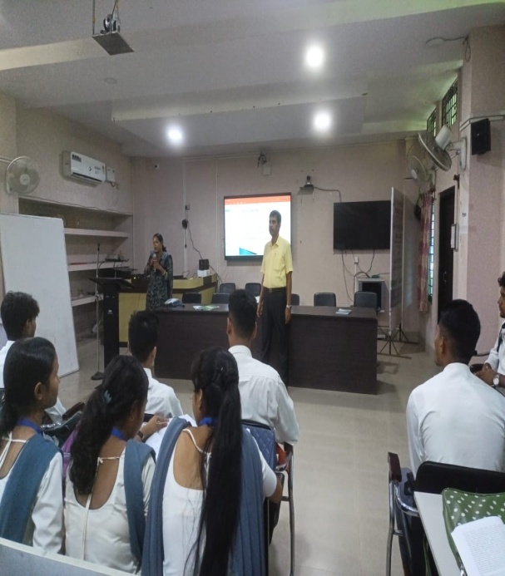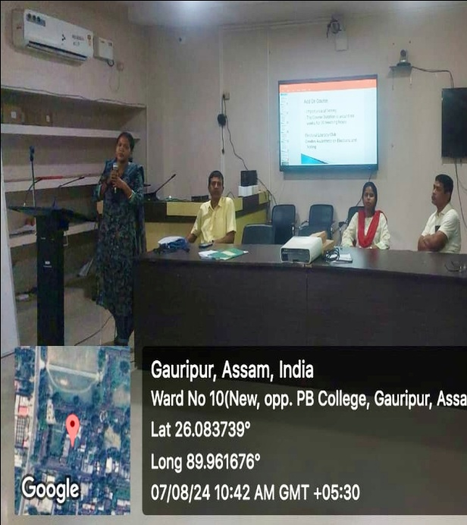

Buddhadev Basumatary, HOD, Department of Political Science spoke about the importance of following books systematically while prepearing for exams and the danger of depending solely on model question papers. Aftab Uddin Ahmed reiterated the need to attnd classes regularly and be attentive in classes.
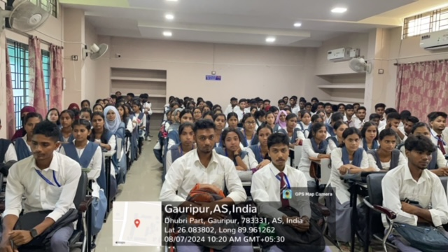

The faculty members also informed the students about the remedial and tutorial classes offered by the department to address subject related knowledge gap. The session came to an end with the teachers encouraging the students to actively participate in departmental activities and interact with the faculty members on issues related to academics or otherwise.

