ECO CLUB
PRAMATHESH BARUA COLLEGE, GAURIPUR

A brief activity report on OBSERVATION OF
World Environment Day ON 5TH JUNE-2024

Eco Club in Association with Department of Philosophy, P. B. College, Gauripur has celebrated World Environment Day on 5, June- 2024 with a couple of activities like Plantation Drive within the college campuses, Art & Extempore Speech Competition among the students of college along with the pupils of nearby schools and institutions. Certificate and Prizes distributed to the position holder in the competitions. Competitions inaugurated by Mr. Digambar Ch Nath, HOD, Department of Philosophy. The prize distribution ceremony is chaired by Dr. Kalyan Das, Principal, P. B. College, Gauripur. Vote of Thanks conveyed by Dr Aminur Islam Sk, Coordinator & Asst. Professor, Eco Club, P. B. College, Gauripur.
Sixty (60) numbers of participants (Children – 30, Youth – 20 and Teachers – 10 = 150) attended in the programme. Schools/Colleges were covered 06 numbers.
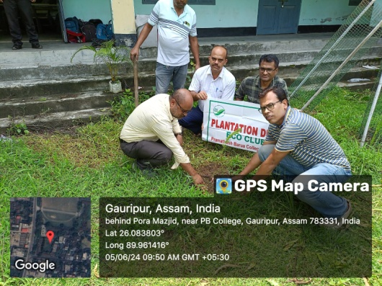 |  | 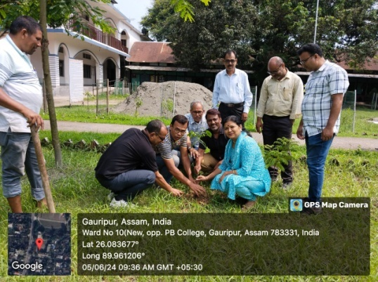
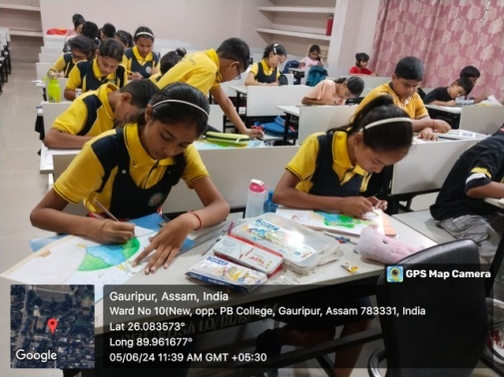 |  | 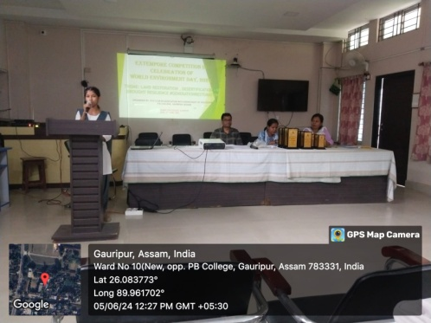
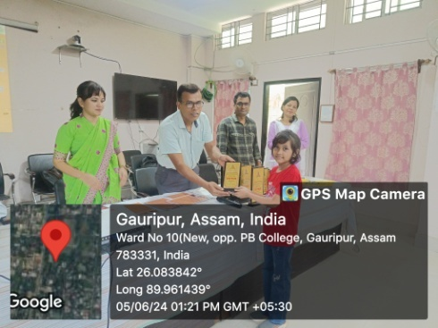 |  | 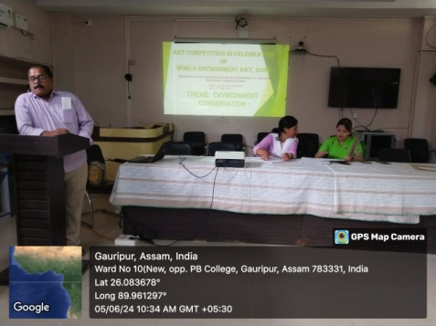
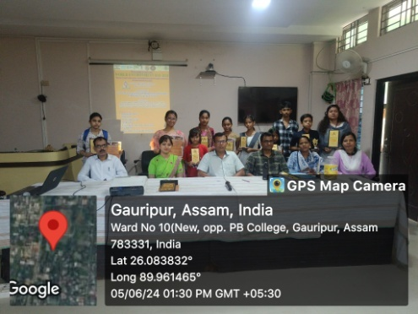 |  | 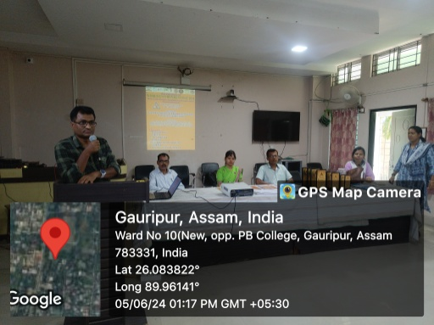

(Dr. Aminur Islam Sk)
Associate Professor & Coordinator, Eco Club
P.B. College, Gauripur
(Dr. Kalyan Das)
Principal
P.B. College, Gauripur

