An ICT based session on Methodology for Project/Dissertation Preparation
Initiative by department of Philosophy
P. B. College, Gauripur
(16.03.2023)
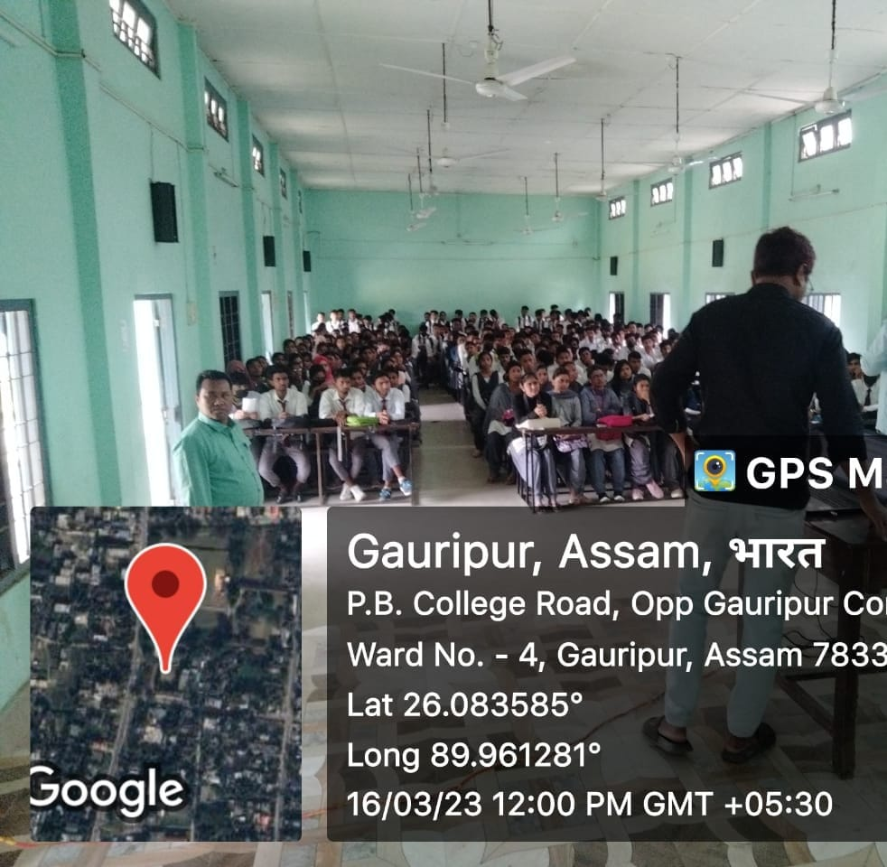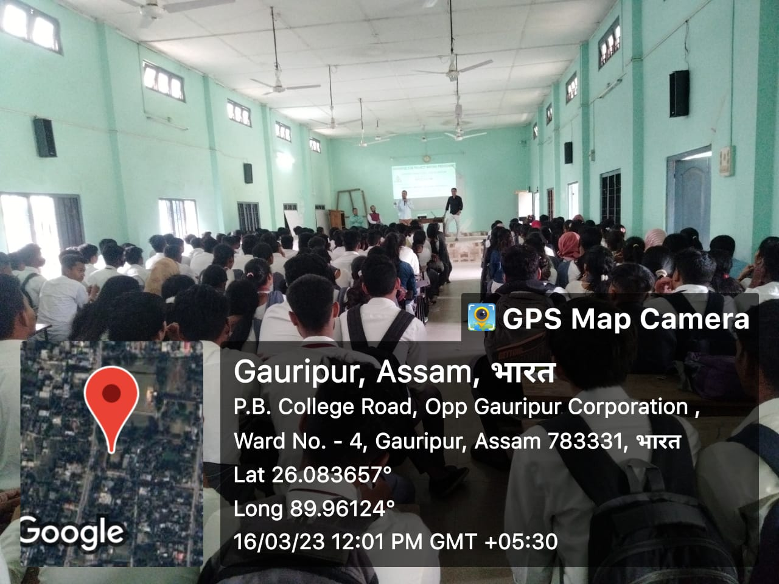
An ICT based session on Methodology for Project/Dissertation preparation class held on 16.03.2023 in the room no. 13. Dr Aminur Islam Sk in Philosophy and Dr Shambhu Pandey took session and a large number of students of different department present in the class. The session initiated by department of Philosophy, P. B. College, Gauripur. The workshop is organised by the Department of Philosophy in collaboration with Eco Club of the College.

