- Students’ satisfaction on sessional exams

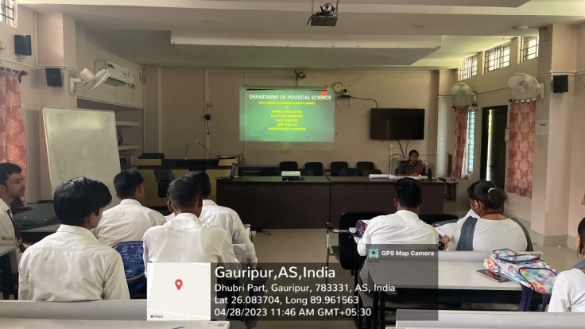

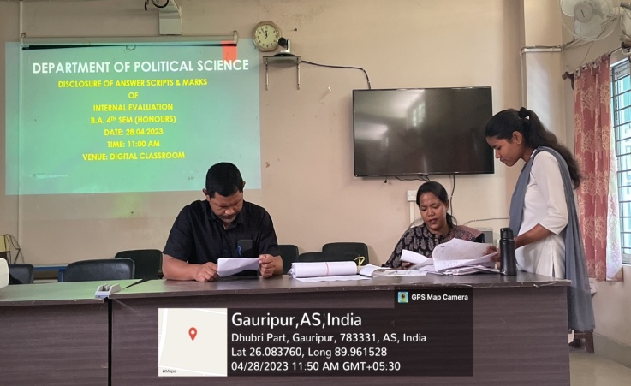

The Department believes in being transparent in its evaluation. Students are shown their sessional exams scripts and their feedback is recorded through satisfactory forms.

- Film screening as part of the Value Added Course Importance of Voting

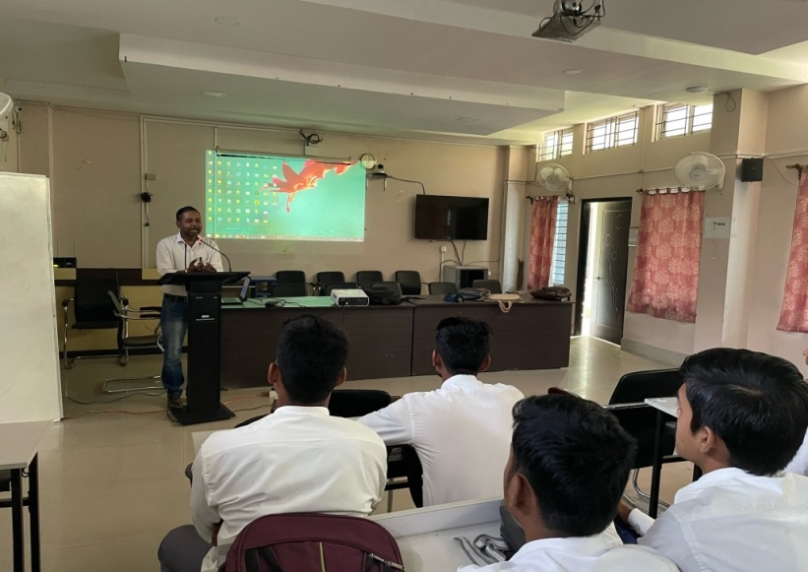

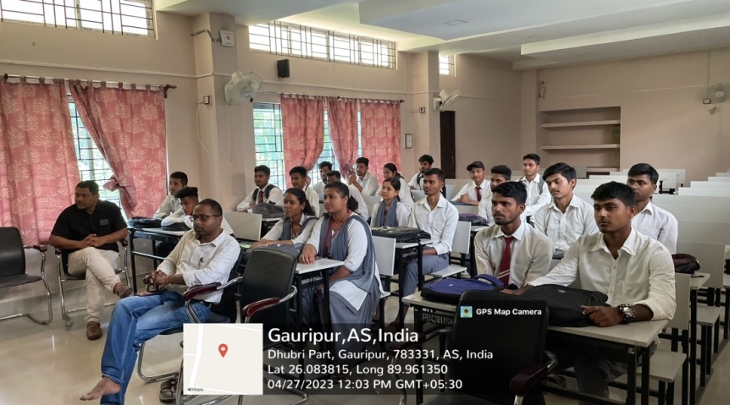

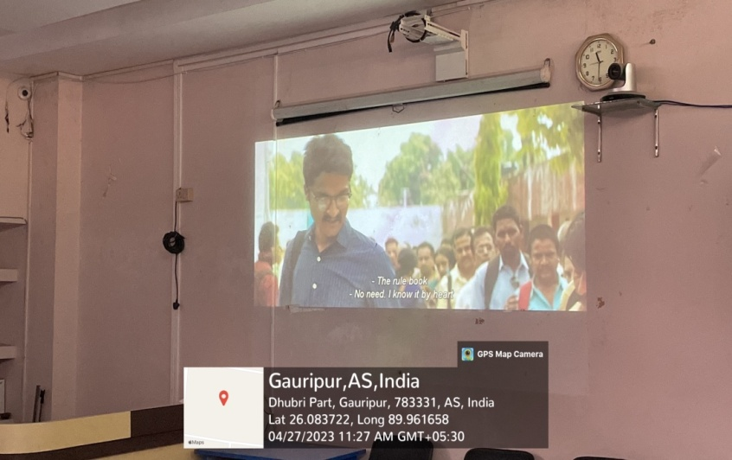

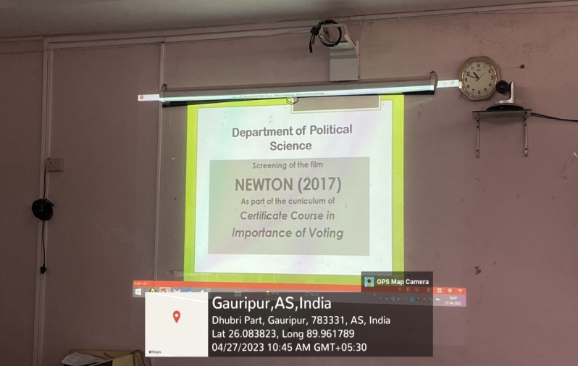

The Department engages in a multi pronged approach while teaching the students. Along with traditional mode of teaching, we use other supplementary audio-visual mode to teach students. As a part of this initiative the department screens films and documentaries. The Film Newton on Elections in the Bastar area of Chattisgarh was screened as a part of the Value Added Course Importance of Voting.

- Introductory Class of Value Added Course
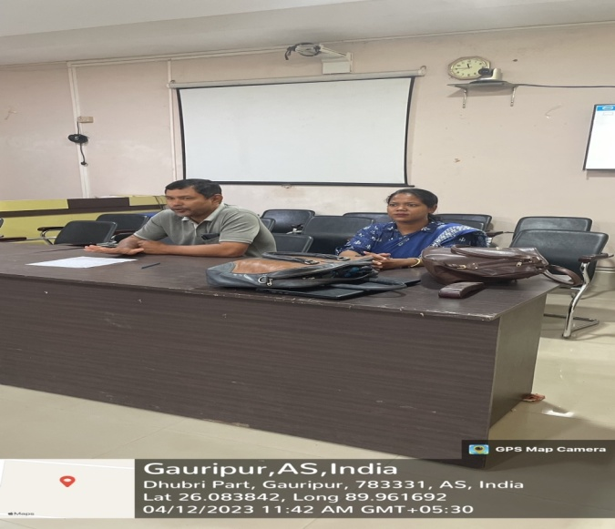

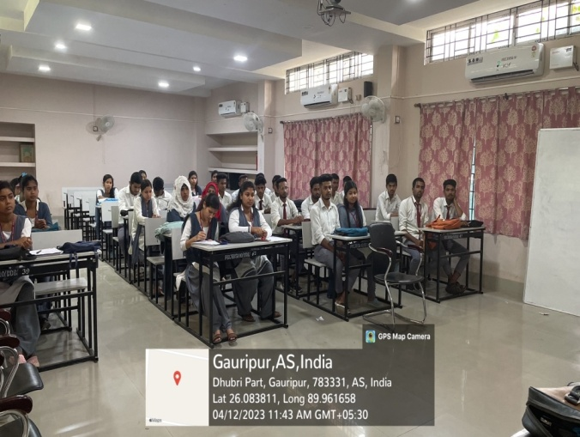
A value added course titled Importance of Voting was introduced by the Department of Political Science. Around 50 students from different departments enrolled in the course. The objective of the course is to familiarize students with the most crucial process of democracy – the elections and also inculcate a civic sense amongst the students.
- Classroom Seminar of students

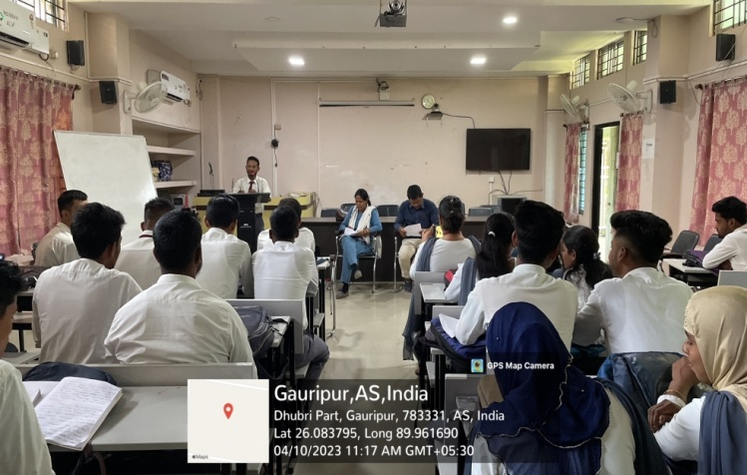

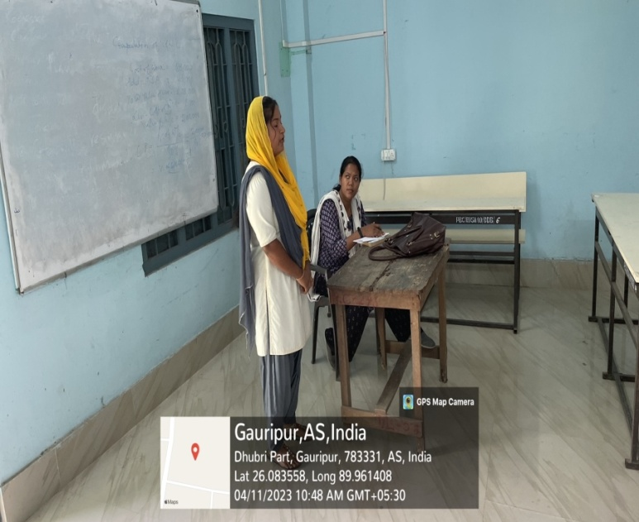
The department follows a comprehensive and continuous evaluation of the students. Along with periodical sessional exams, the department organizes regular class tests, pop quizzes as well as classroom seminars to evaluate the performance of the students. The classroom seminars also act as peer to peer teaching whereby students deliberate on various issues in front of their class mates.

- Debate on International Women’s Day on 9th March, 2023
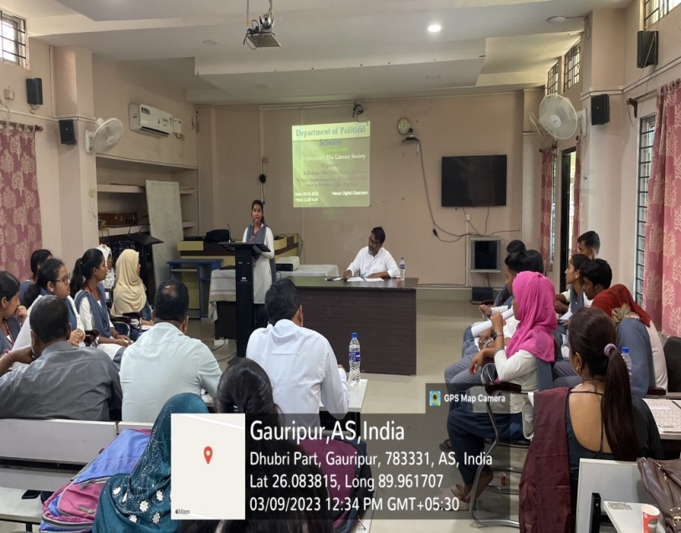

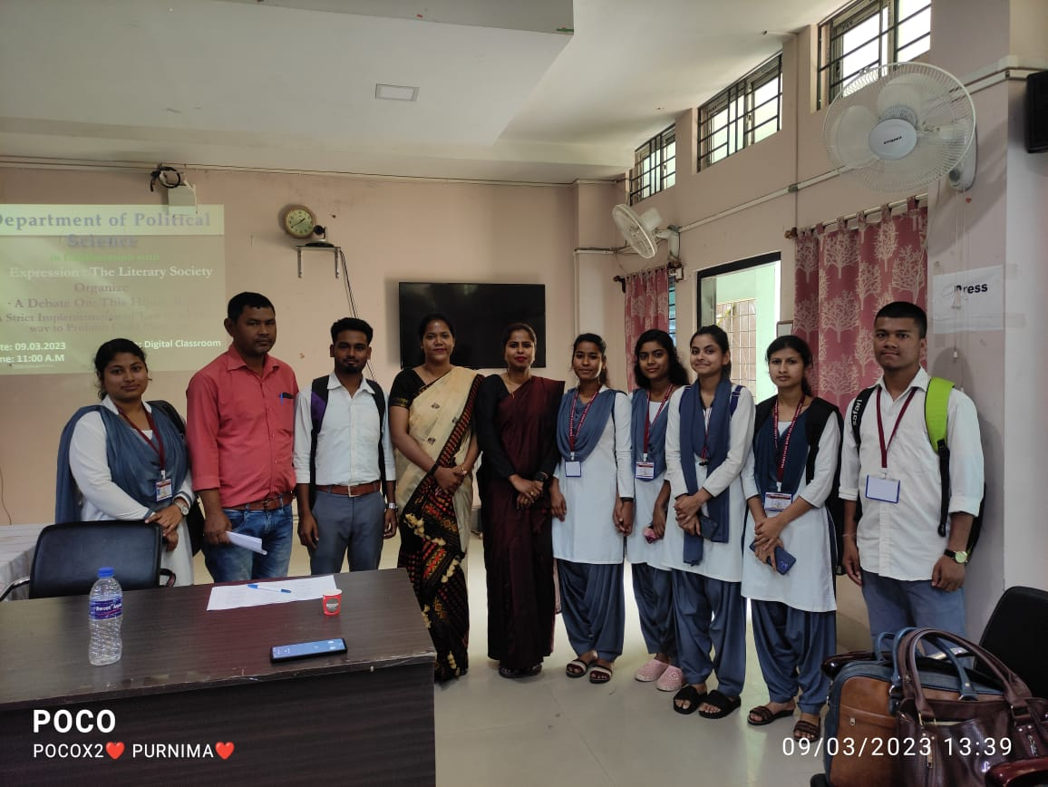

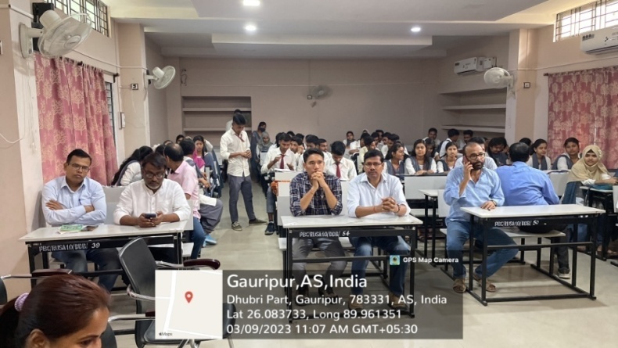
On the occasion of International Women’s Day, the Department organized a debate competition on the relevant topic of ‘This House Believes that A Strict Implementation of Law is the only way to Prohibit Child Marriage’. A large number of students participated in the debate. This debate was organized in the backdrop of the state government’s crackdown on child marriage. This was an initiative of the department to shape the opinion of students against the social vice of child marriage.
- Field visit to Gaon Panchayat
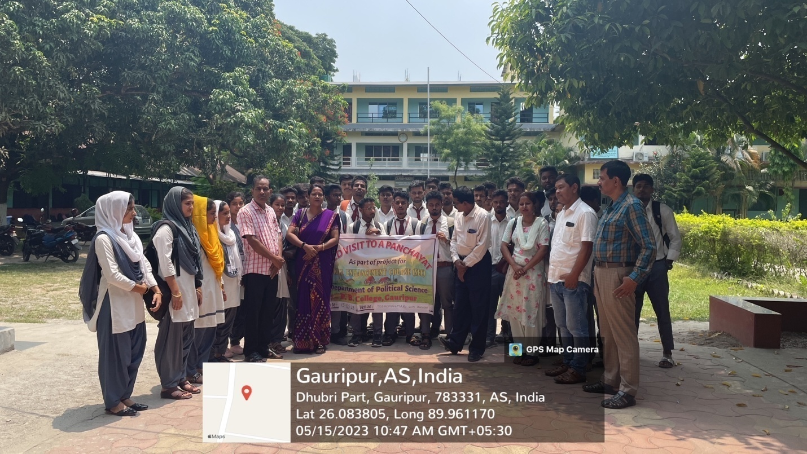

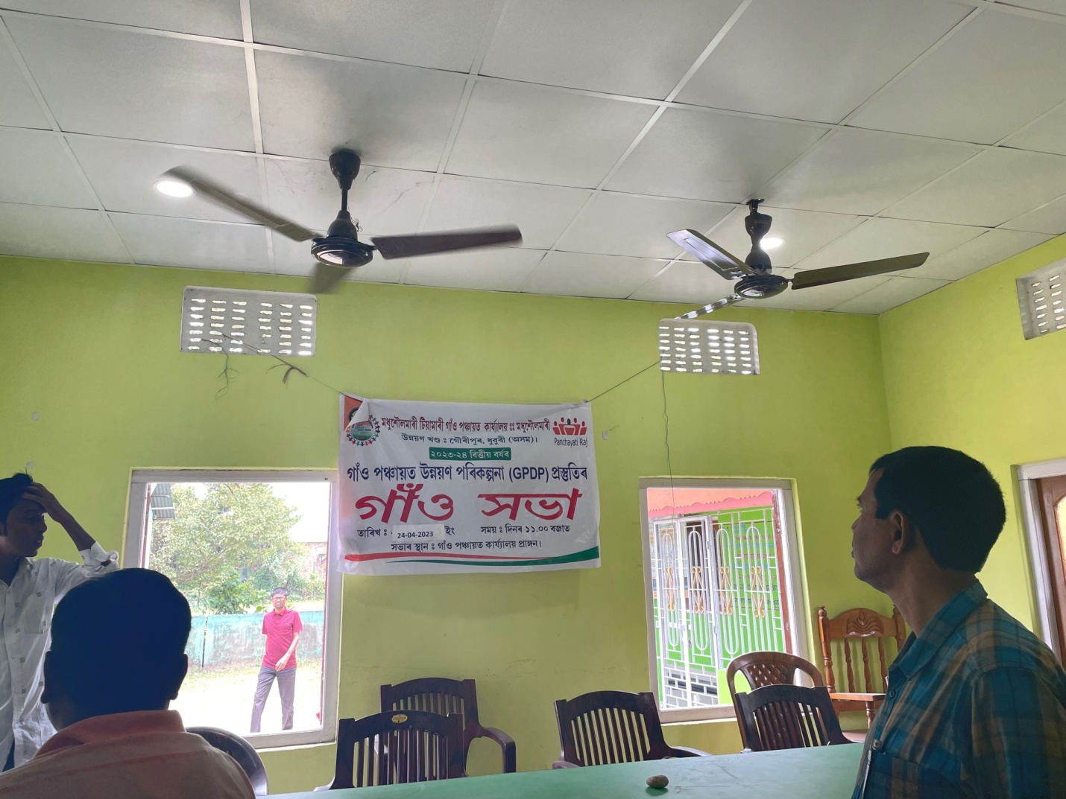

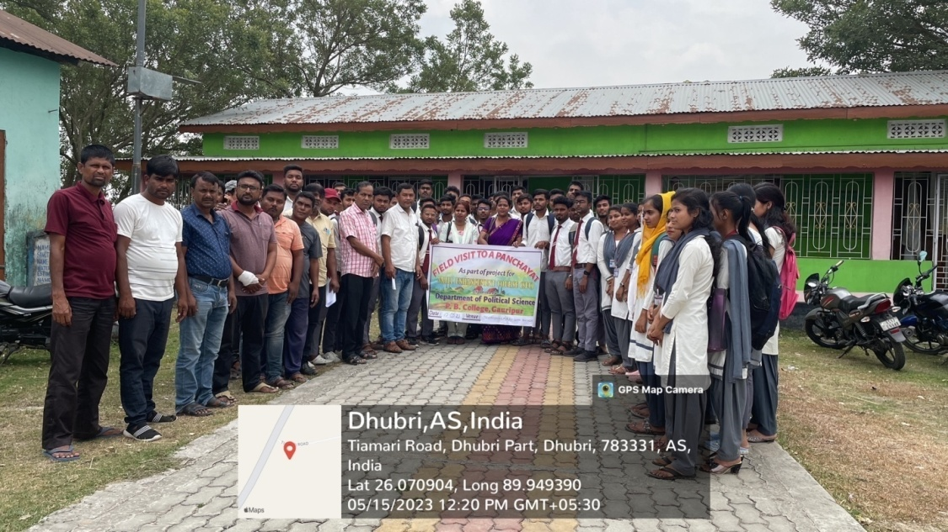
The Department offers the Skill Enhancement Course Panchayati Raj in India. As Skill Enhancement Course is meant to increase the practical knowledge of students along with theory, we took our students to the Panchayat Office of Modhushoulmari. The Panchayat office bearers elaborated the functions of PRIs. Our students were also shown certain works completed by the Panchayat. The students later wrote on the field visit and submitted a project.

- Diagnostic test 2022 held on 20th Aug, 2022

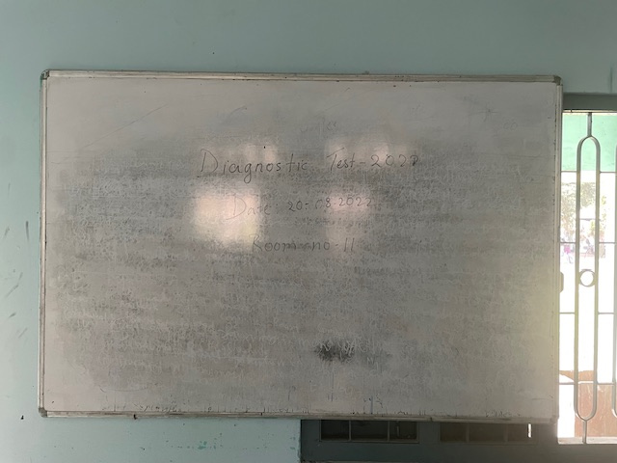

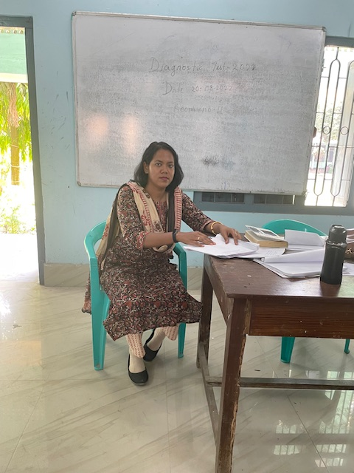

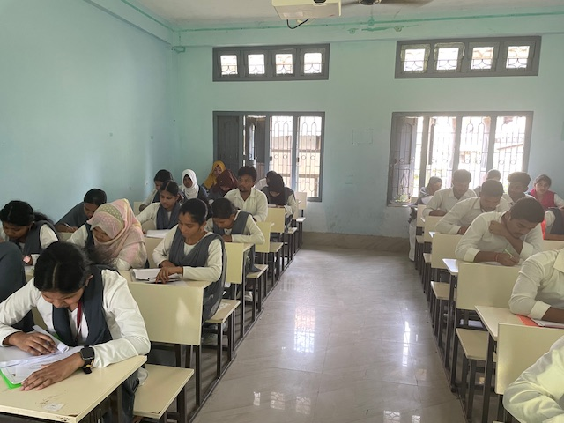

- Prize in Youth Festival
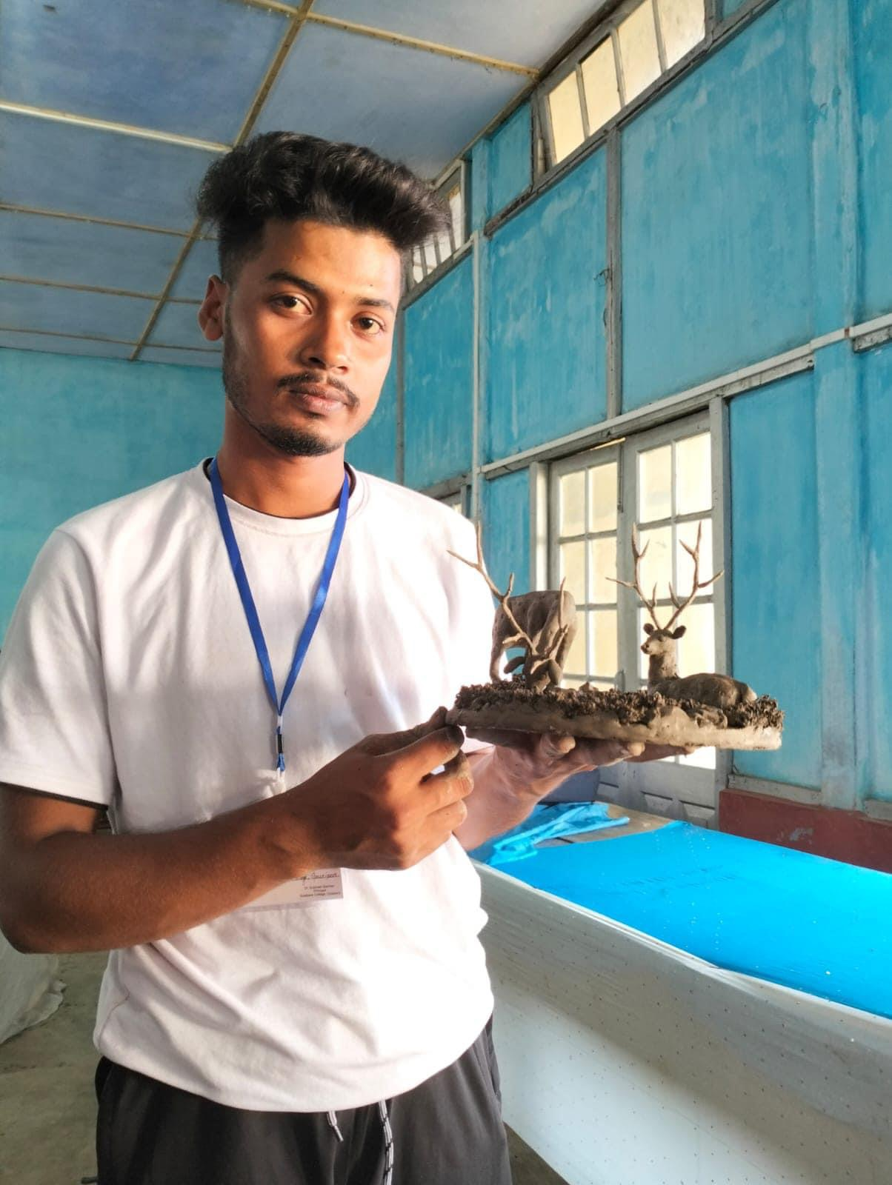

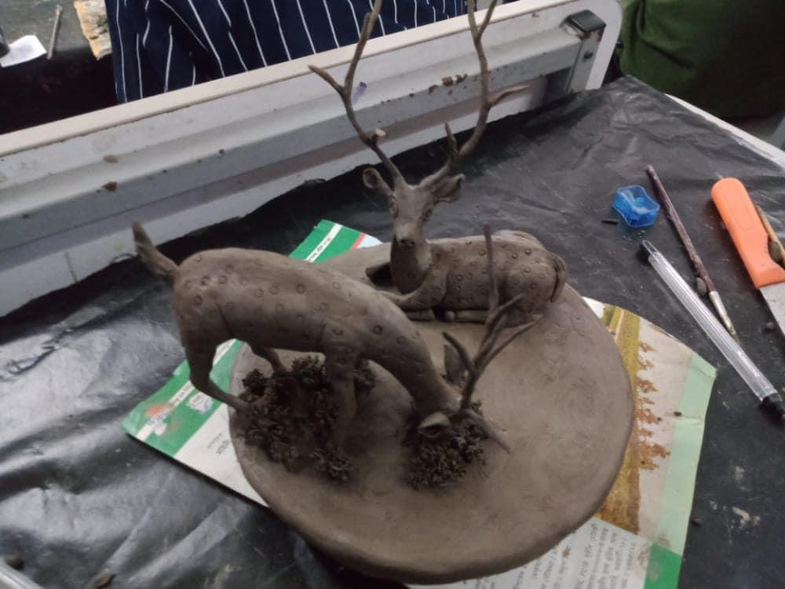
Every year our college participates in the inter college youth festival and we from the Department encourage our students to participate in different programmes. Our students participate in Debate, Quiz, Elocution, art and craft etc. In 2022-23, our student Nurnobi Sk from 3rd Sem won the first prize in Gauhati University’s clay modeling competition.

