The Department of Political Science provides regular support to the students and help them in their academic journey. Since 2021, we have started formally diagnosing our students and categorizing them as slow and advance learners on the basis of a test. After that remedial classes are provided for slow learners to help them catch up and at the same time advanced learners are groomed so that they can perform better.

- Diagnostic test of 1st Sem students on 23rd Nov, 2021

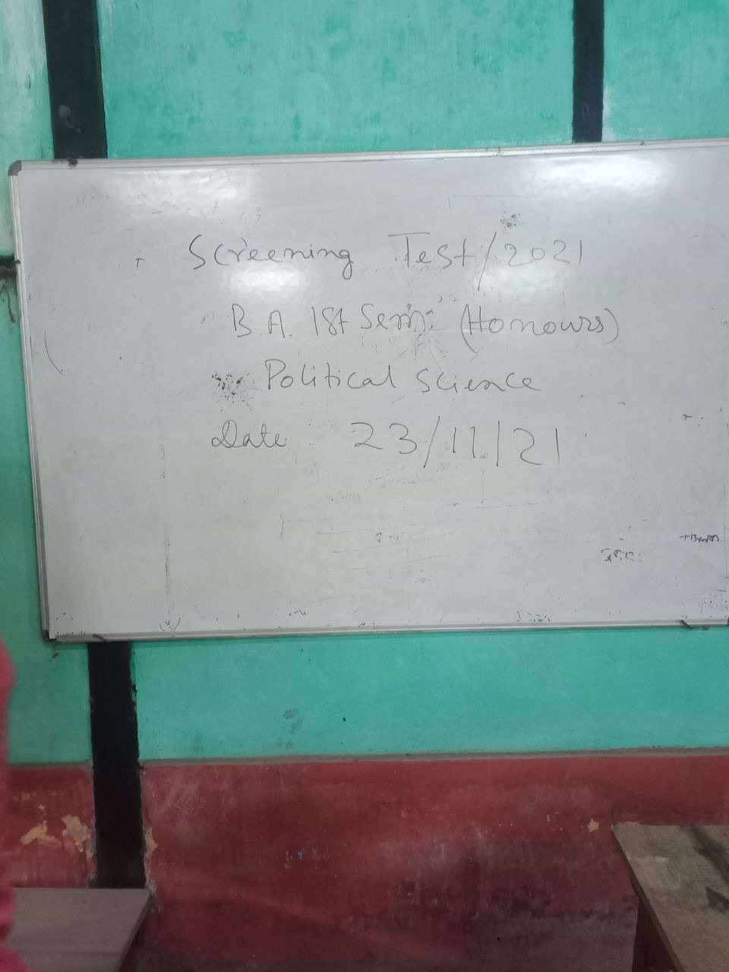

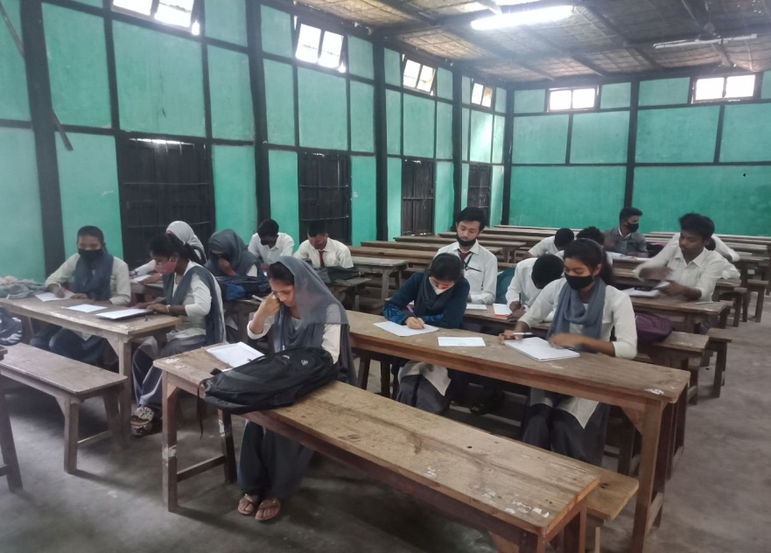

- Celebration of National Constitution Day on 26th November, 2021

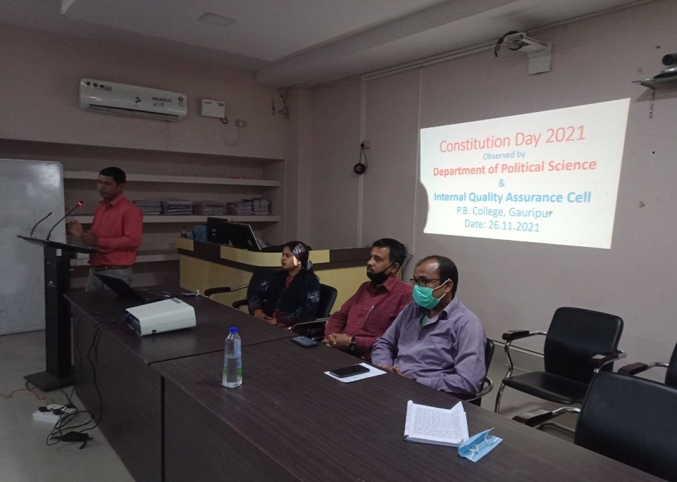

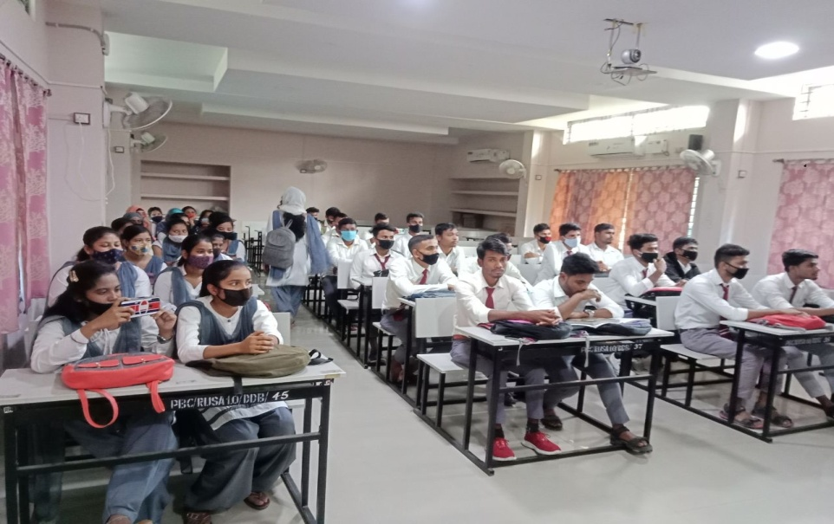

On the occasion of National Constitution Day, the Department organized a lecture on Constitutionalism and the importance of Constitution in our day to day life. The lecture was delivered by Buddhadev Basumatary, the HOD of the department of Political Science.

- Newsletter on 8th March, 2022
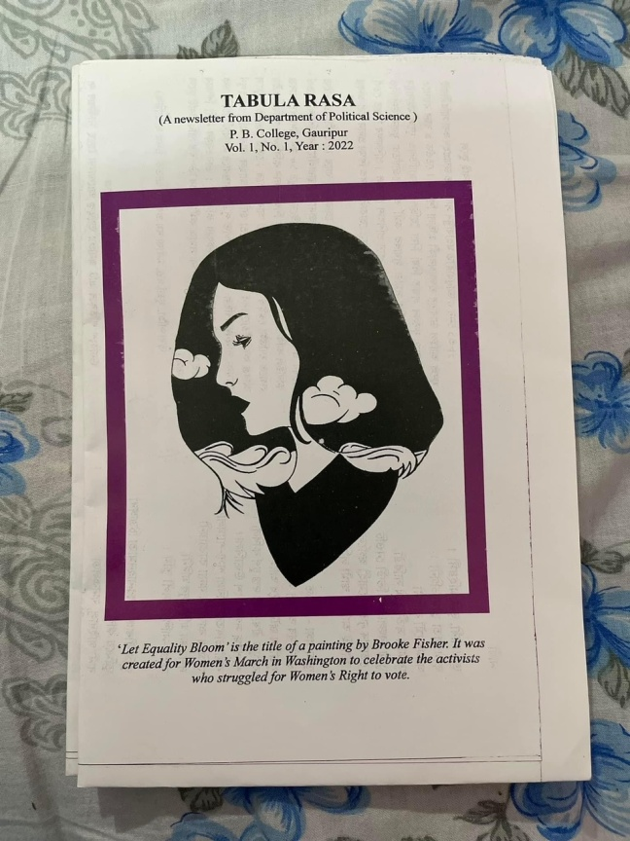

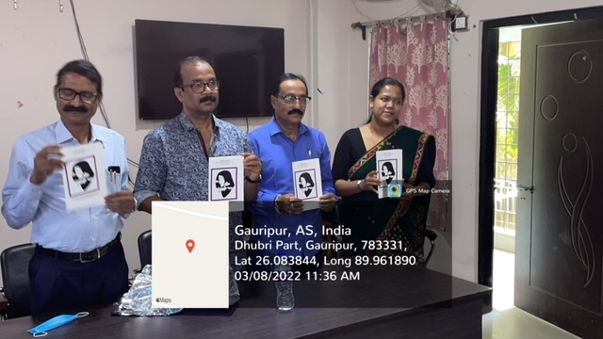

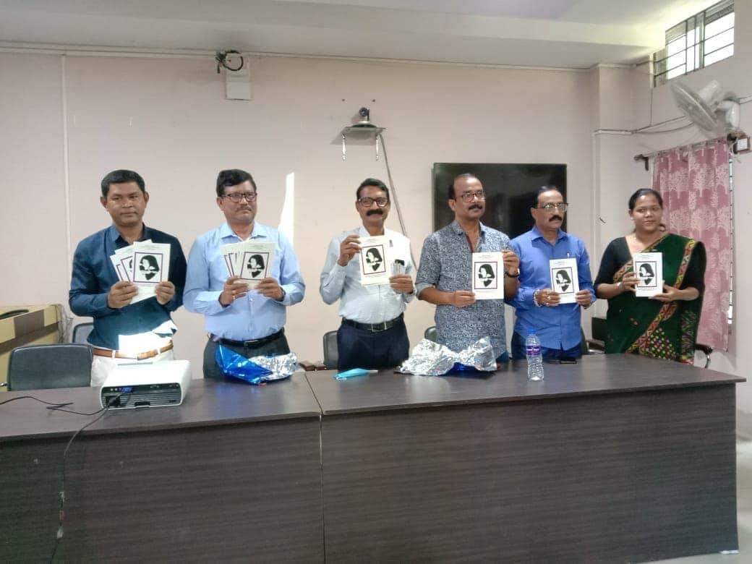

On the occasion of International Women’s Day, the Department of Political Science published the first volume of Tabula Rasa which means ‘a clean slate’, a departmental newsletter. The cover of the newsletter was a sketch by our student Roza Ali. The theme of the newsletter was gender. The students and faculty members wrote a number of articles and poems on the theme along with some informative pieces.

- Debate on National Voters Day on 25th January, 2022

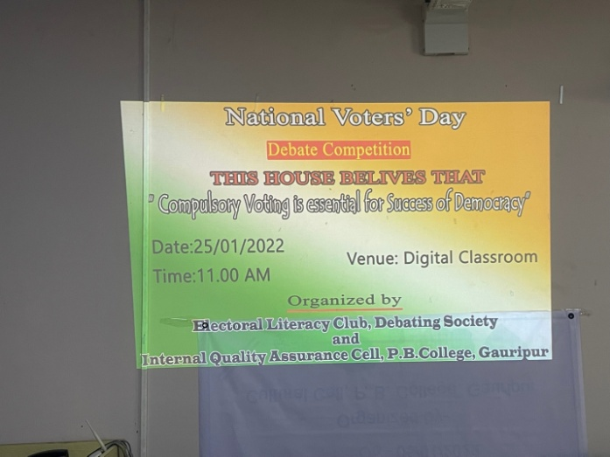

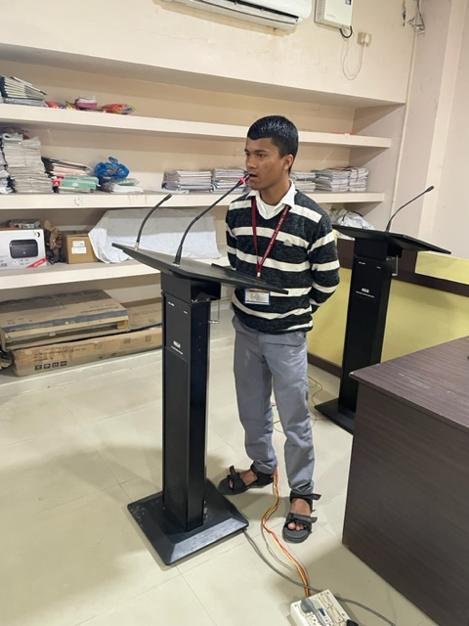

On the occasion of National Voters’ Day, the department and Electoral Literacy Club organized a debate competition on the topic “This house believes that Compulsory Voting is Essential for Success of democracy”. Students debated the pros and cons of compulsory voting giving examples of countries which opted for compulsory voting.

- Wall magazine on environment 11 June, 2022
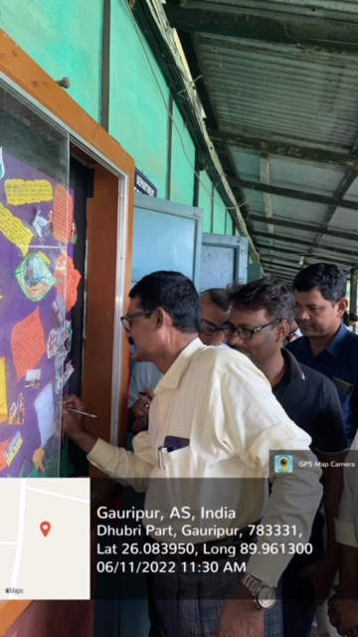
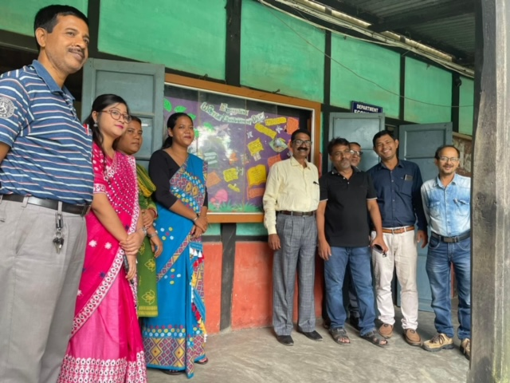

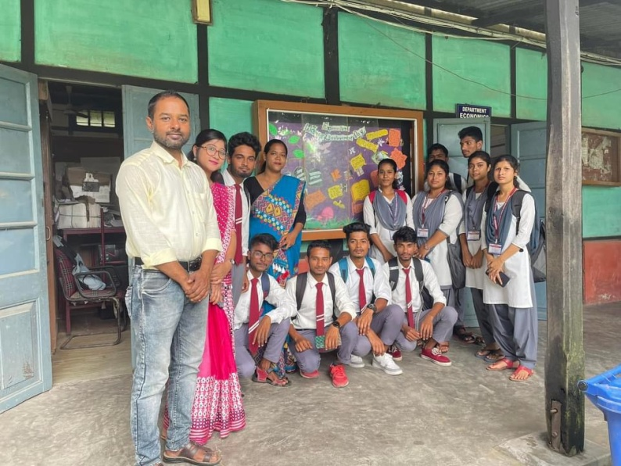

Keeping in line with World Environment Day, the department published another Wall magazine on the theme of Climate Change and Sustainable Development. The students through the wall magazine delved on the burning issues of climate change and possible green alternatives.

