The Department of Political Science celebrates a number of days related to the discipline like National Voters Day on 25th January, International Women’s Day on 8th March, Gandhi Jayanti on 2nd October and Constitution Day on 26th November. The department organizes various activities on these days to familiarize the students with the rich political legacies of our nation and inculcate in them a feeling of gratitude and pride.
- Quiz Competition on National Voters’ Day on 25th January, 2020
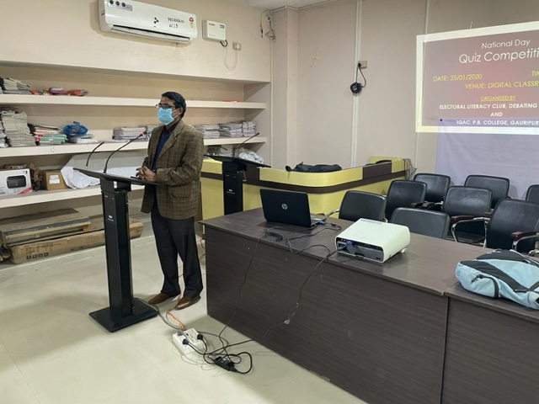
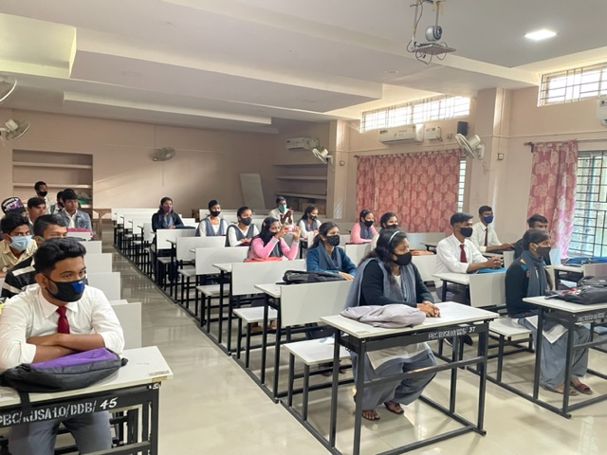
On the occasion of National Voters’ Day, the Department and Electoral Literacy Club organized a quiz competition on the theme of importance of voting and history of elections in India. Students from the department as well as other departments participated in the quiz.

- Wall magazine on the occasion of Gandhi Jayanti 2nd oct, 2019
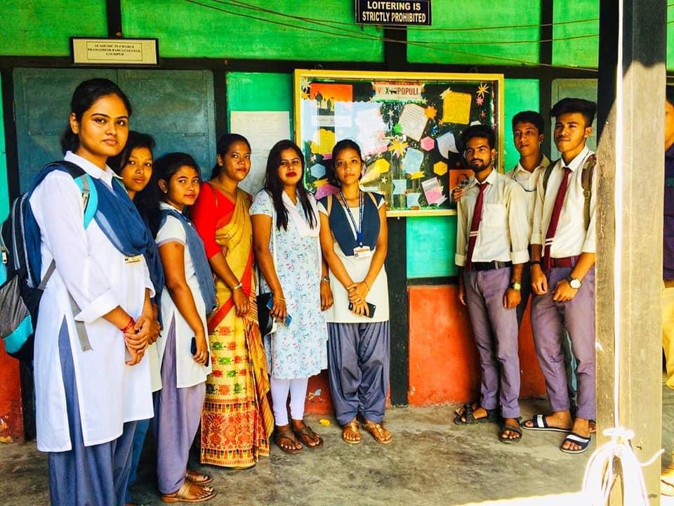

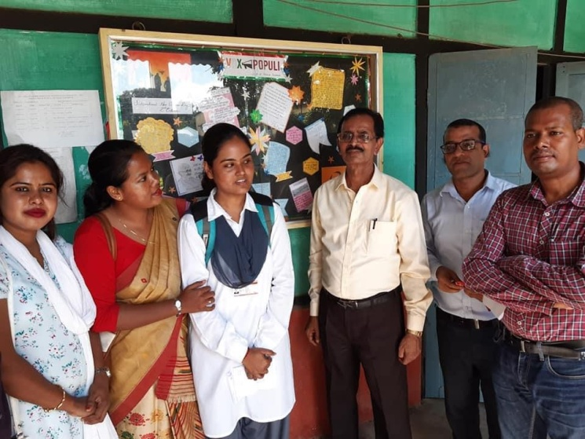

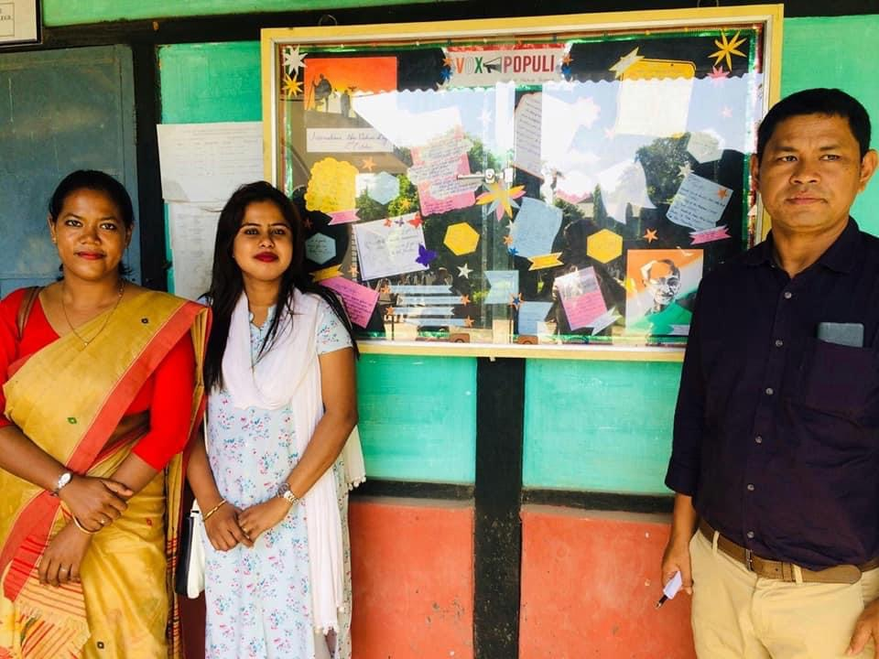
The second issue of Vox Populi was inaugurated on the occasion of Gandhi Jayanti and it was on the theme of Mahatma Gandhi’s contribution to Indian National Movement and the principles he stood for. It was inaugurated by Dr. Hanif Talukdar who was the Principal in charge.

- 11th March, 2020 Next issue of Vox Populi on Gender
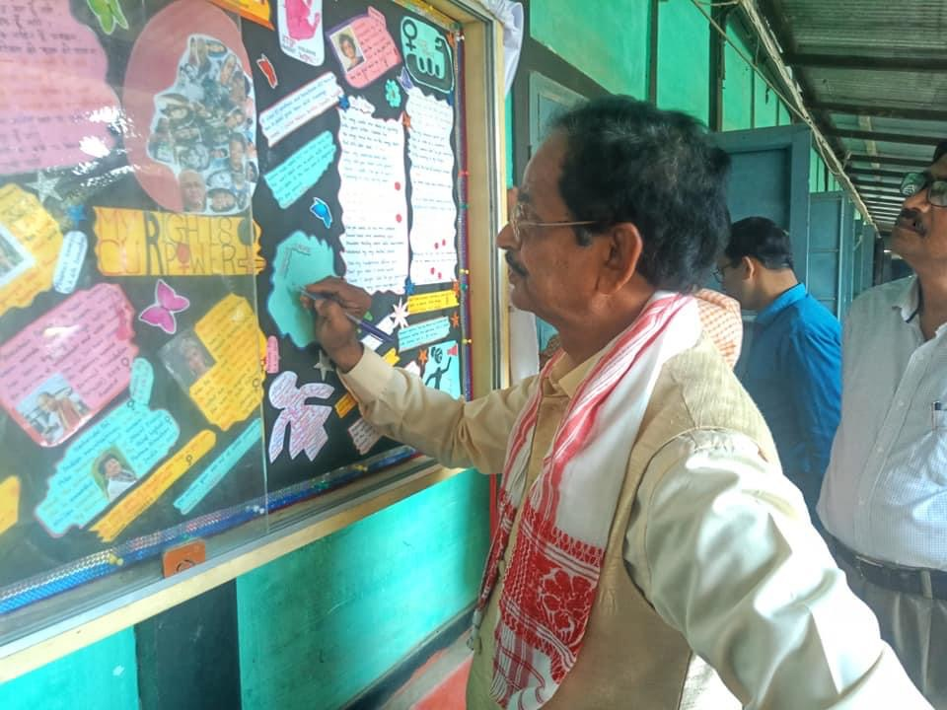

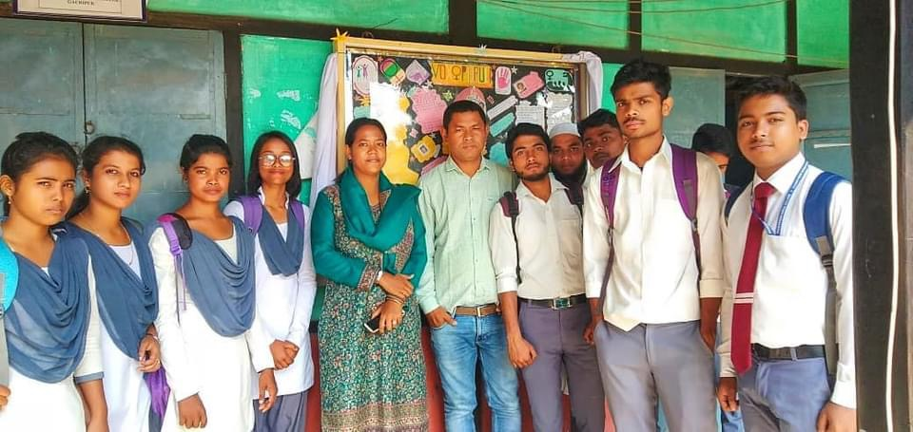

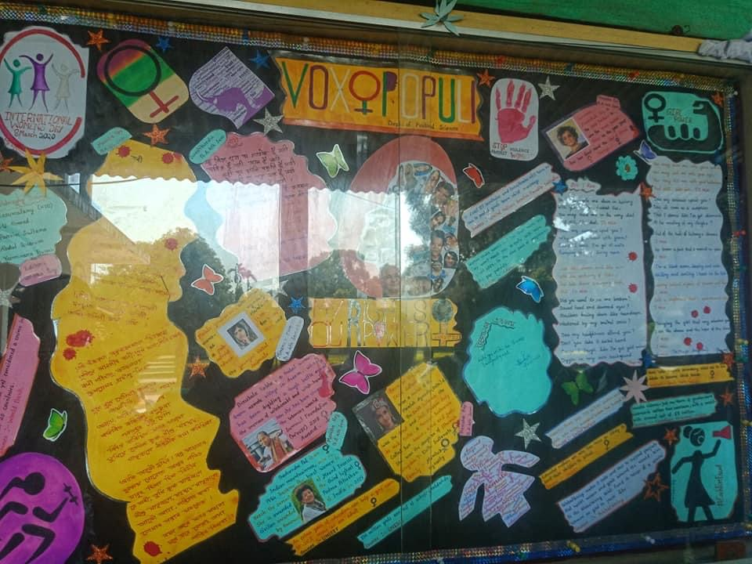
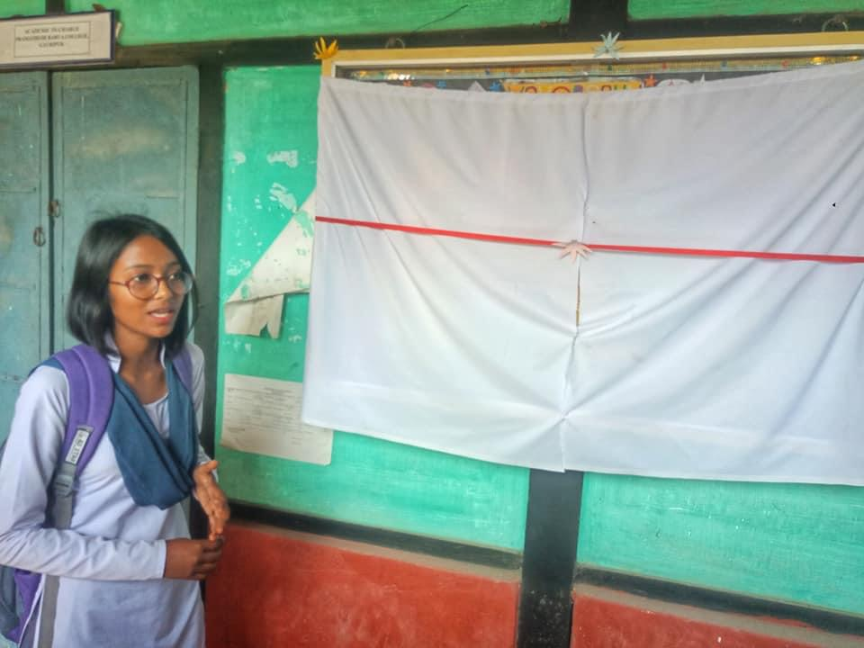

Keeping in line with the International Women’s Day, the third volume of Vox Populi was inaugurated on the theme of gender. It was edited by our student Manisha Roy and focused on the Feminist Movement. It tried to highlight ground breaking activities by women in various fields.

