The Department of Political Science believes in the holistic development of students. As such we focus on the academic as well as co-curricular participation of our students. We monitor and mentor our students regularly. The Department ensures that the students participate regularly in various activities like quiz, debate and also send our student delegates to represent the college in different programs.
- Election Quiz, March, 2019
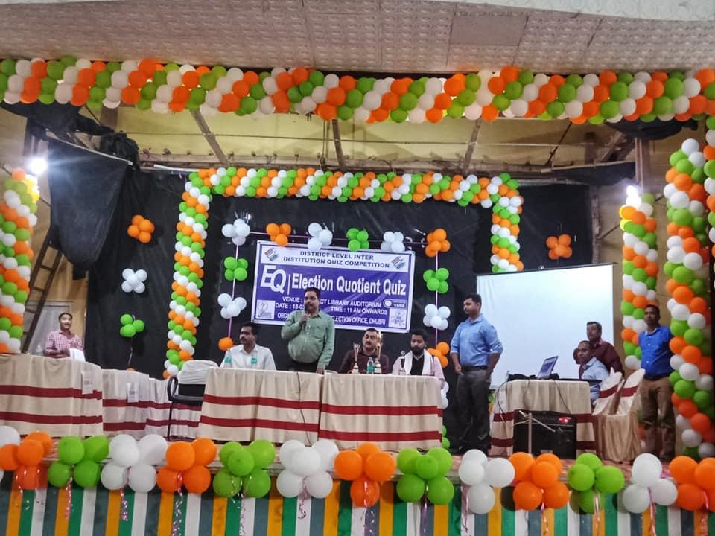

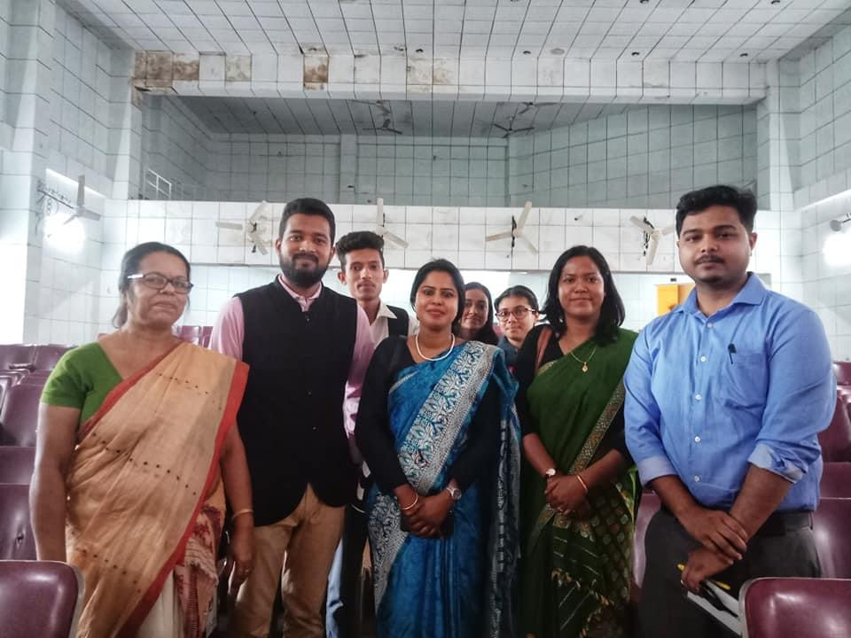
The department of Political Science organized a quiz competition through the Electoral Literacy Club in college. The winners of the competition Manisha Roy and Shabnam Khan were taken to participate at the District level quiz competition organized by District Election Office and held at District Library, Dhubri.

- First issue of Vox Populi released April, 2018
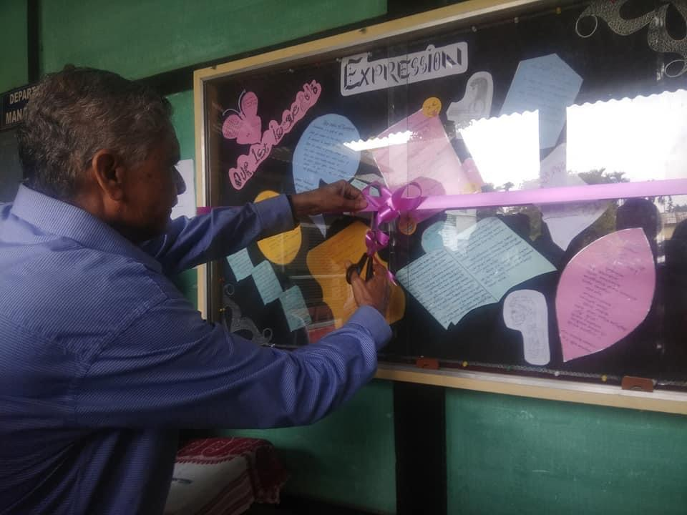

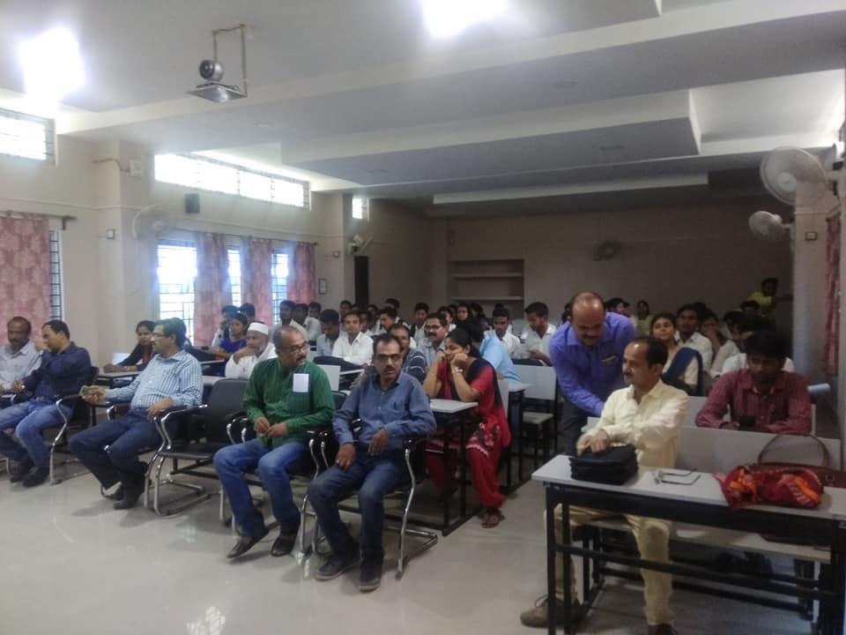

We in the Department have always worked towards teaching our students in developing a capacity to think critically and articulate their views. We encourage them to express themselves through various medium—music, poetry, art and crafts, articles etc. To ensure this the department of Political Science collaborated with the Expressions: The Literary Society of P. B College and published a wall magazine titled Vox Populi which means ‘Voice of the People’. The first issue of Vox Populi was a general issue and students wrote various poems, articles on different topics.

