EVENT: VISIT TO SANKARDEV UNIVERSITY, DHUBRI CAMPUS
Date: 02-04-2024
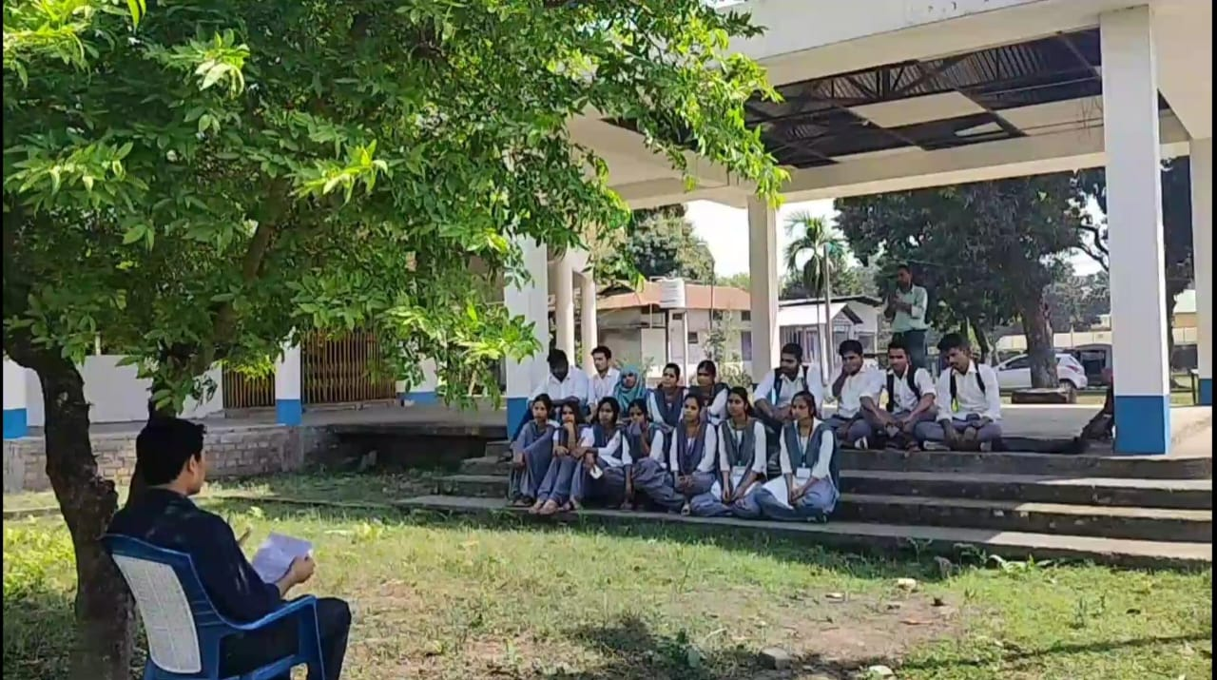
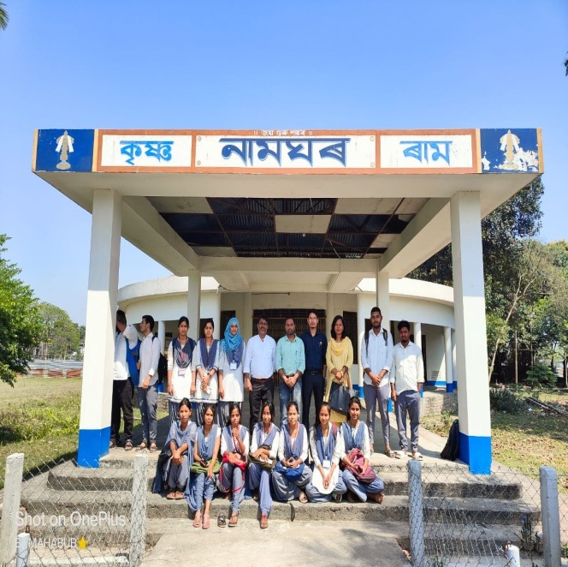
In view of influential learning and exchange views with the student of Sankardev University, Dhubri campus. The department of Assamese undertake a venture to visit the University campus at Balajan(Dumorduha). The students of sixth semester were introduced to the faculties and student of the department of Assamese of the University and exchange their views.
Later Prof. Hemchandra Mili undertakes an open class under a tree in the campus on field work methodology (which has been recorded and uploaded in the departmental YouTube channel).
The students were enthusiastic and become ambitious for obtaining higher education and the journey comes to an end after reaching college campus. The department offers thankfulness to the Principal, P.B. College for his generous support and conveyance.

