Report on Participatory Learning
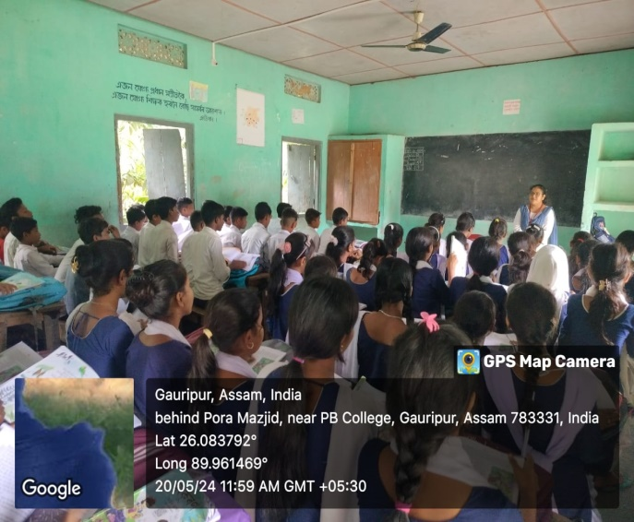
Date:20-05-2024
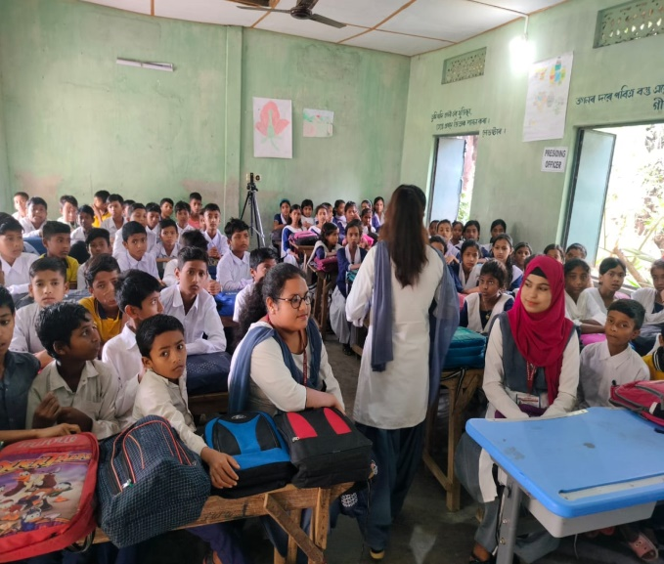
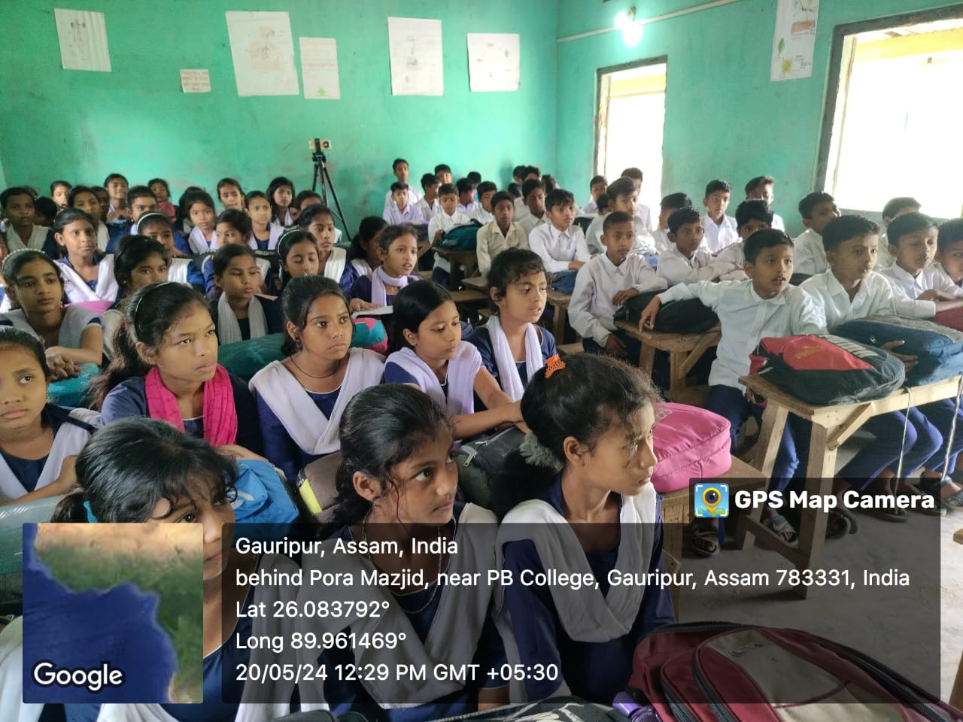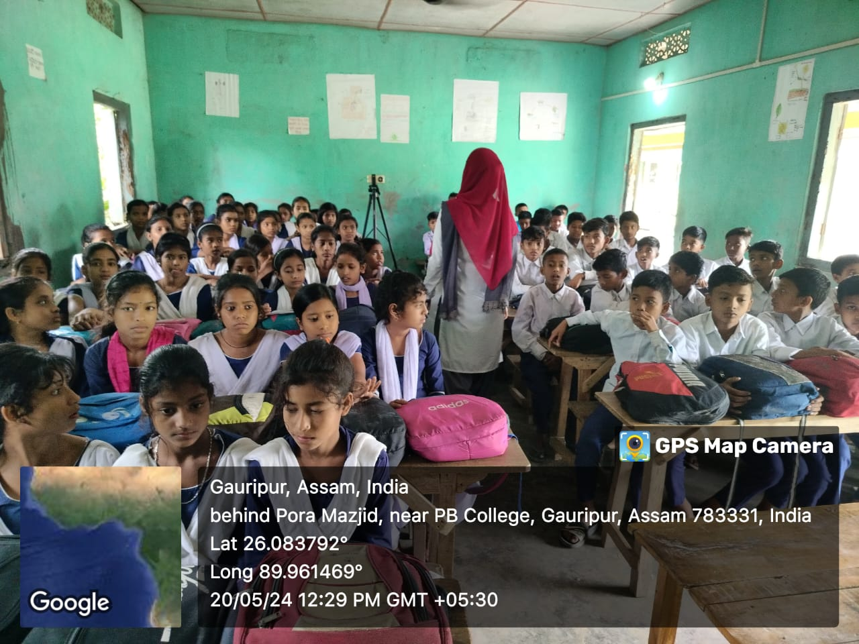
In pursuance of the participatory learning of the 4th semester honours students of the department of Assamese, Pramathesh Barua College, Gauripur,the department initiated a participatory classroom transaction for the student of Madhya Mosdhusolmari ME School. Three of the students of 4th Sem (Honours) namely Bhumika Biswas, Borsha Begum and Nurjina Yesmin were engaged to participate ad to discuss on Assamese Prose and poetry for class VI, VII & VIII syllabus.
Bhumik Biswa took a class on Assamese Poetry 'xobatotkoi Apon’ by Nabakanta Barua. She explained the literary quality of the Poem, sample question and answers and grammatical aspects of Assamese language.
Borsha Begum shared her views, understandings and critical analysis of chandra kumar Agarwals poem ‘Niyor’.
Nurjina Yesmin delivered a speech on ‘Kalika Loga Patkapur’ a literary text and analyzed the text. All Three of them engaged the students and successfully completed the class.
The teaching staff and the Head Master of the school was co-operative and wished to organise different literary competition of their own in the school and The HOD, Assamese, P.B. College assured all round cooperation from the department of Assamese, Dr. Jyotsna Devi & Prof. Hemchandra Mili accompanied the team and pioneered the programme for the student of the department.

