Event: Release of Departmental Souvenir
Date : 15-03-2021
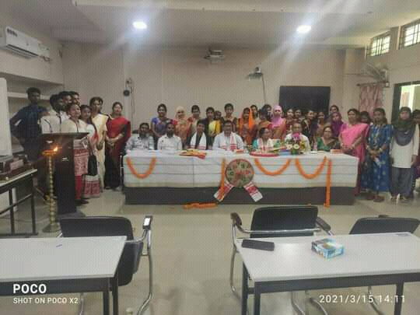
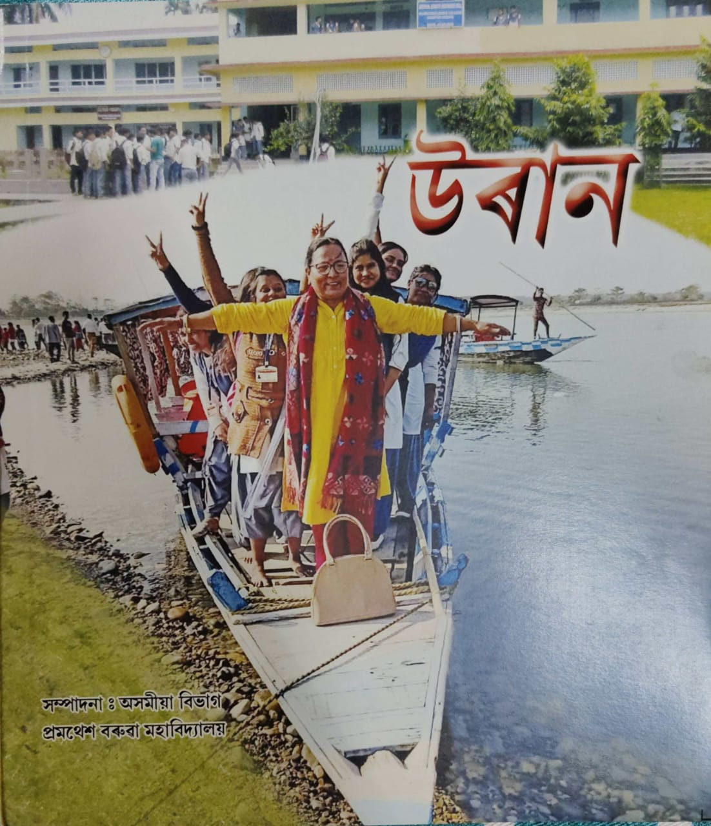

In connection with the farewell programme of former HOD and Associate Professor Dr. Gita Sarkar a departmental souvenir ‘UDAAN’ was published and inaugurated. Different stake holder of the college, ex-students wrote and expressed their reminiscence with the department as well as with Dr. Gita Sarkar. The souvenir was released by Dr. Pramathesh Bayon, Vice Principal, Bijni College.

