A talk on Sheelabhadra’s Life Philosophy and Literary Contribution
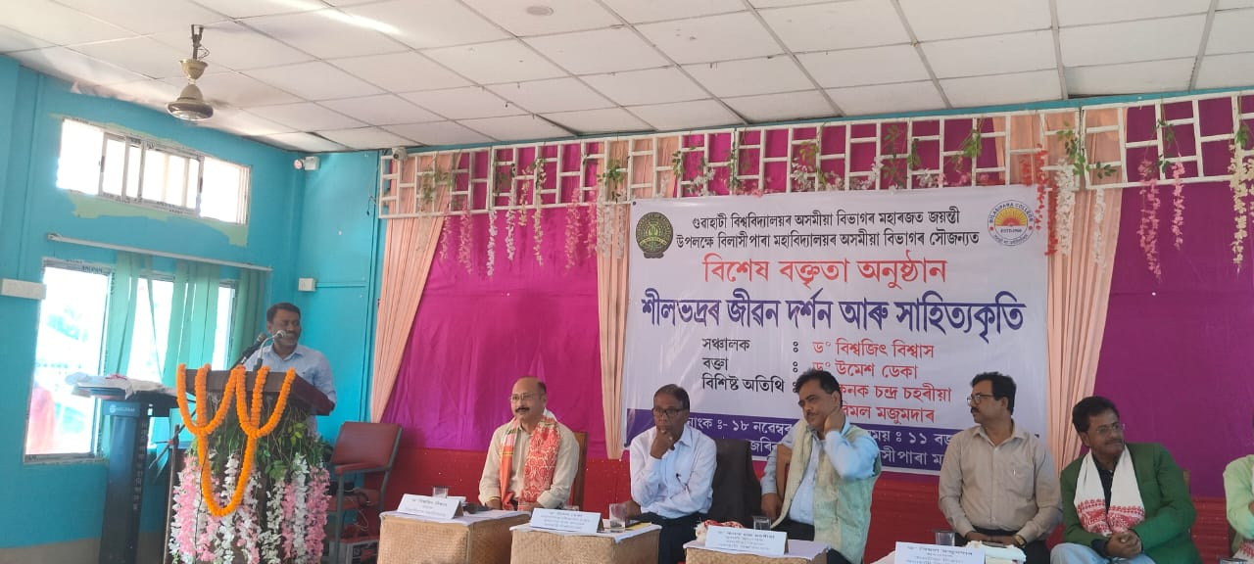
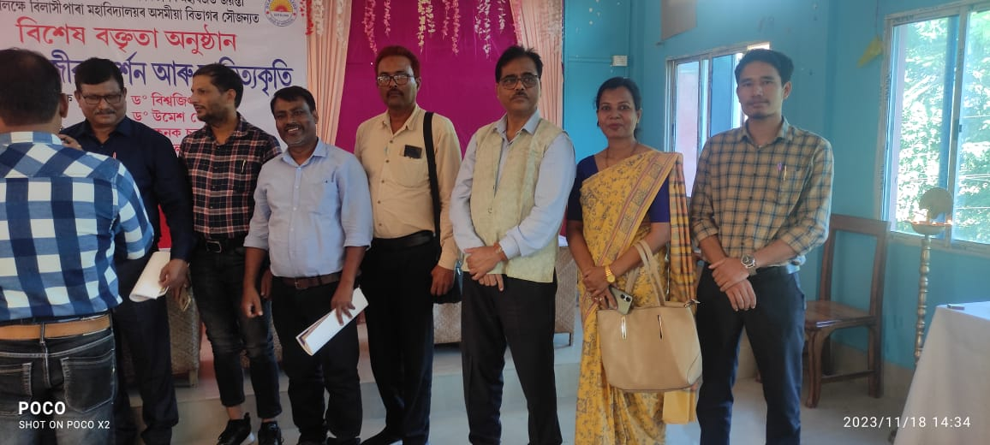
The department of Assamese, Bilashipara College organised an special talk on life philosophy and literary contribution of Reboti Mohan Choudhury alias Sheelabhadra , an eminent story teller of modern Assamese Prose (Story) literature who basically hails from Gauripur Town. In response to the invitation of the organiser, all the faculty member of the department of Assamese, P.B. College enthusiastically attended the programme.
In consonance with the platinum Jubilee of the department of Assamese, Gauhati University the programme was organised and Dr. Kanak Chaharia, HOD, Assamese and former Rabindranath Tagore professor Dr. Umesh Deka graced the occasion.
While talking about activities done in P.B.College on Sheelabhadra Dr. Akhtarul Islam informed the house that a national seminar on Sheelabhadra already been organised with the UGC grants in the department of Assamese. Also he mentioned a TRUST been constituted in the name of Sheelabhadra by the college authority and urges upon all the faculty members of Assamese department attended from different colleges of the district to take a joint venture to popularise the works of Sheelabhadra in different capacities.

