EVENT : State level Badminton competition
Date : 21-03-2022
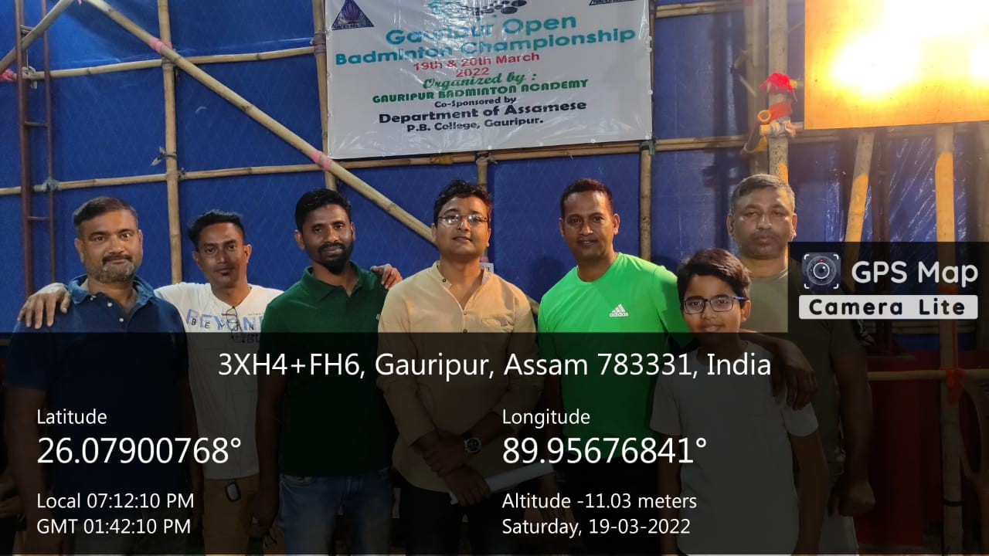
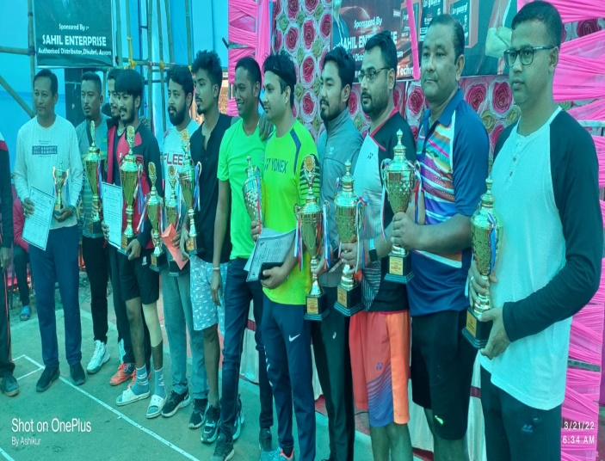

Gauripur Badminton Academy, premier institution of Gauripur which organizes different district and state level badminton competition. In response to the request of the official of the academy the Head of the department of Assamese Dr. Akhtarul Islam consented for collaboration with the institution and organised a state level Badminton competition on 21st March, 2022 in its temporary court. A huge number of team joined the competition from different district of Assam, West Bengal and West Garo hills Meghalaya.
The Competition was formally inaugurated by Dhrubajyoti Das, ADC, Dhubri and Mr. Masi Tapno, Election Officer Dhubri. In the inaugural ceremony a cultural pogramme was organised with the member of Gauripur Dance School, Gauripur.
After the competition prizes were distributed among the winners.The academy was pleased to offer a collaboration certificate to the department of Assamese.

