FACULTY EXCHANGE CLASS
Topic : Preparation of Project for Undergraduate Programme.
Teacher : Parvin Sultana, Assistant Professor,
Dept. of Pol. Science

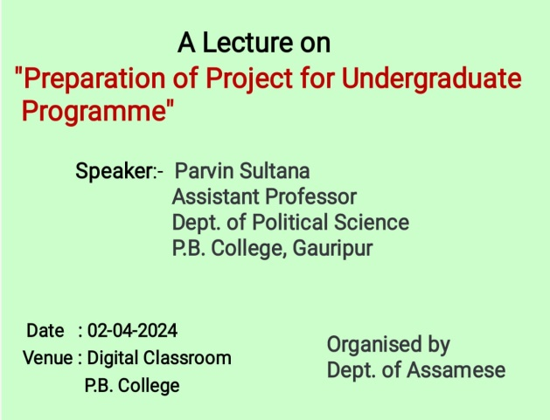
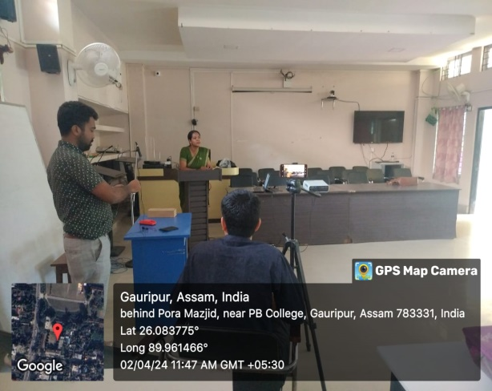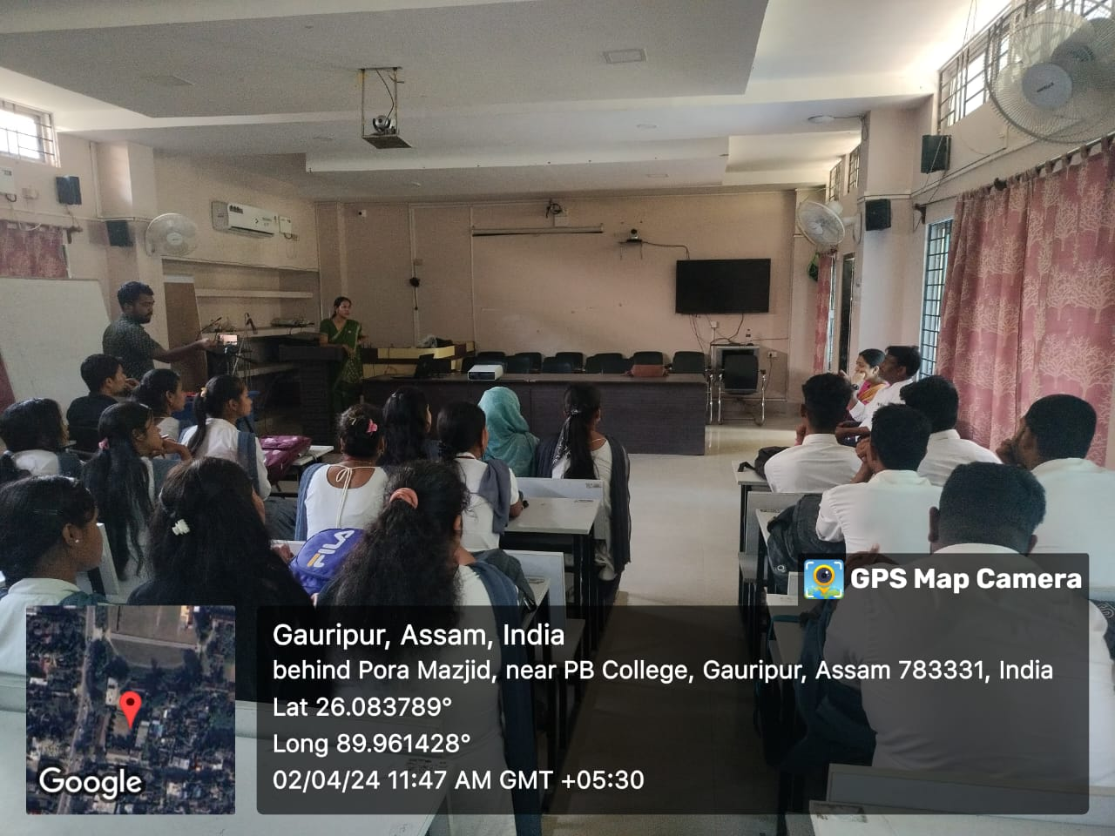

FACULTY EXCHANGE CLASS
Topic : Munshi Premchand’s Nirmala(Novel)
Teacher : Dr. Shambu Pandey, Assistant Professor,
Dept. of Hindi
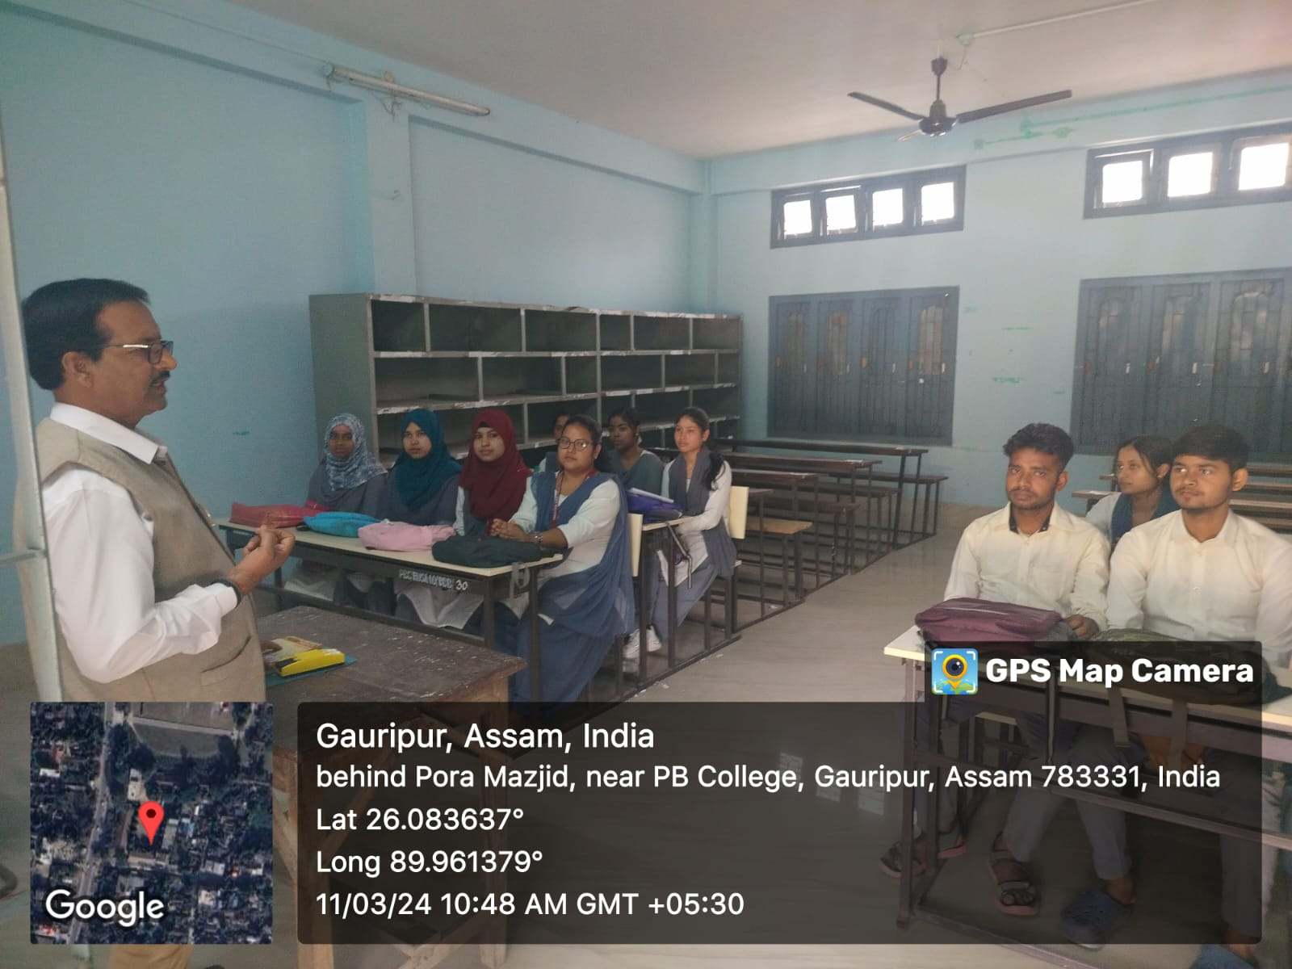
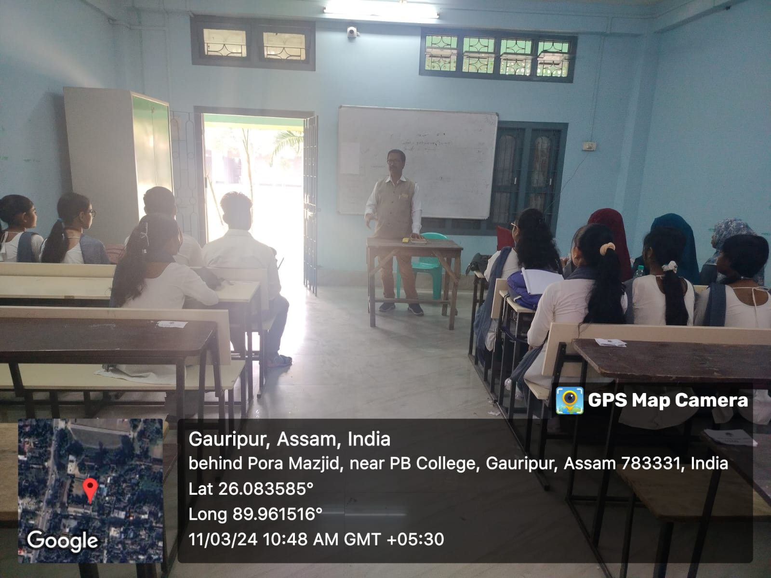

FACULTY EXCHANGE CLASS
Topic : Usha Priyamwada’s Wapsi (short story)
Teacher : Dr.Amitabh Ranjan Kanu, Assistant Professor, Dept. of English
