EVENT: Observation of International Women’s DAY
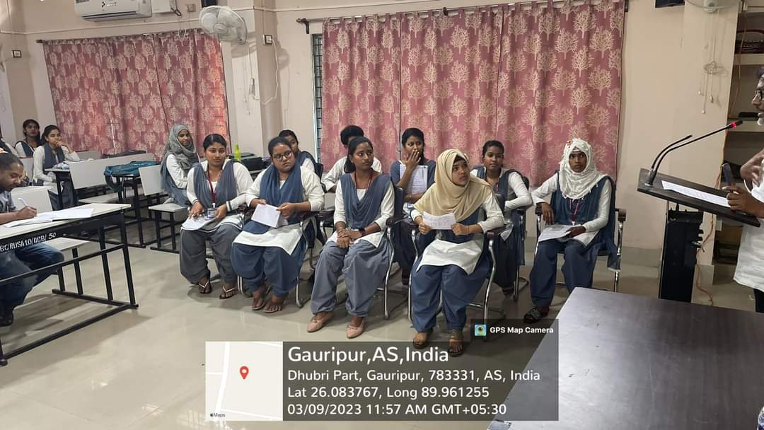
DATE:09/03/2023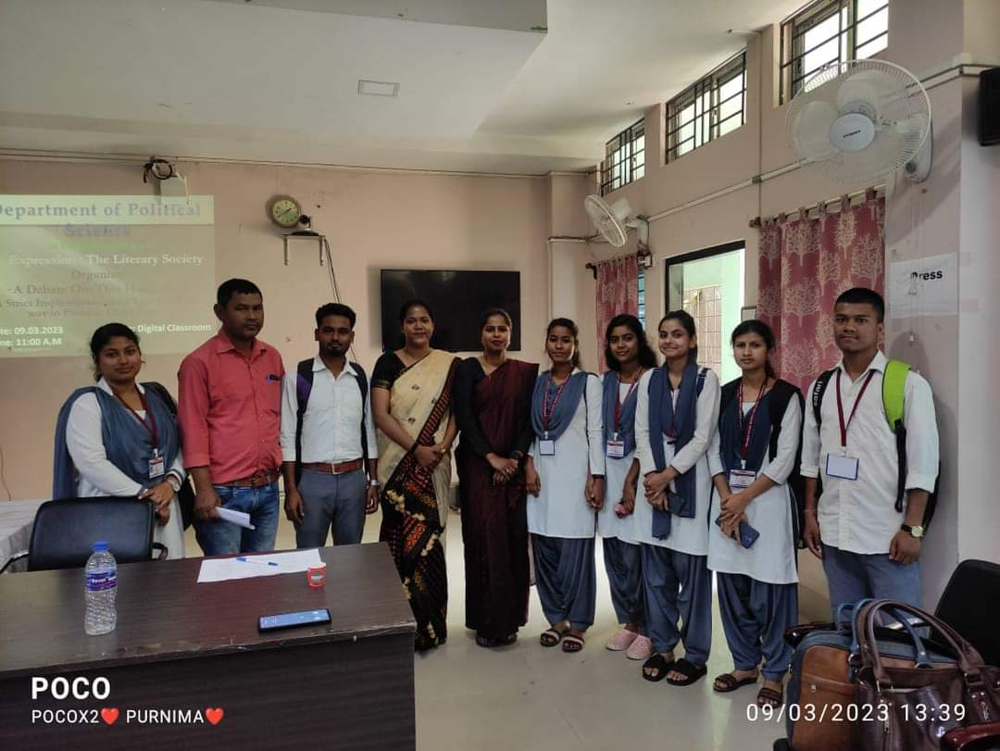
In collaboration with the department of Political Science the department observes International Women’s Day on 9th March, 23 in the digital classroom of the college. As a part of observation the department of Assamese trained there students to take part in the debate competition held on ‘According to the house making hard laws in the only solution to prevent Child Marriage. Borsha Begum, Sayeda Siddika participat as debator. Dr. Akhtarul Islam HOD, Assamese was in the chair on the debate competition.

