A brief report on Multilingual Poets Meet
Date: 14.10.2023 Time: 2 PM, Digital Classroom
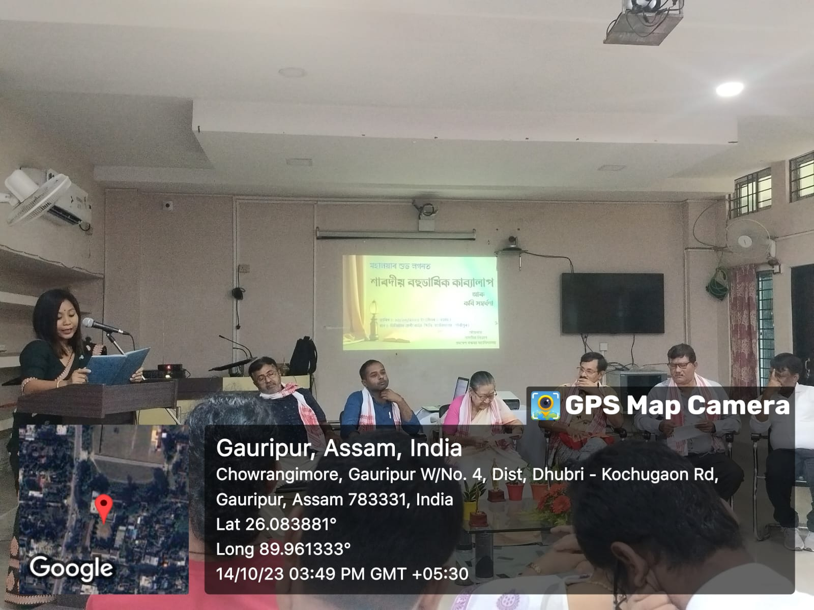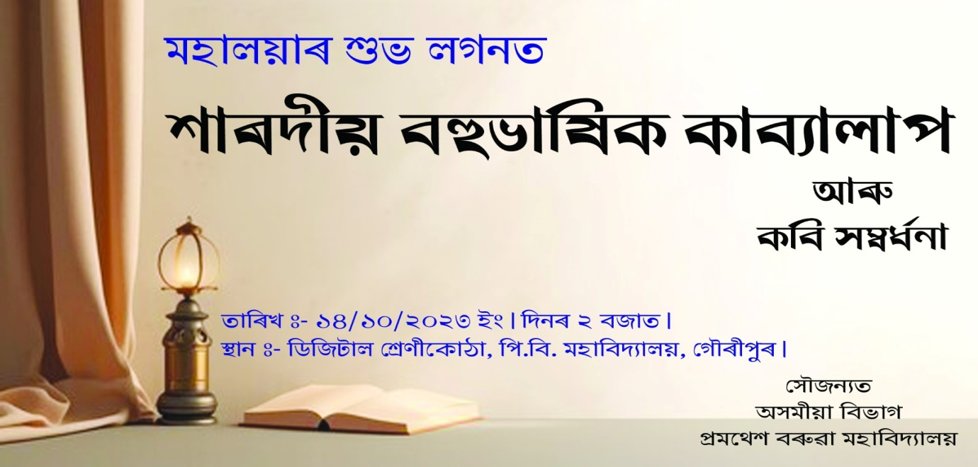

The Department of Assamese, P.B. College initiated a multilingual Poets meet on the eve of Mahalaya in The Digital Classroom of The College. A huge gathering of poets, students’, faculties and members of the civil society graced the occasion.
The Programme opened with the welcome address by The Principal of the College. A total of five no’s of Poets Mrs. Anjali Brahma, Dr. Gita Sarkar, Ohid Khan(Paris), Dr. Sibasish Chetterjee and Dr. Amitabh Ranjan Kanu were felicitated as distinguished poet of the locality. They were felicitated by the department with a fulam Gamosa, Plant and Trophy.
A good number of Poets recited their self-composed poems. Among them Mrs. Juin Das of Dhubri Girls College, Pranab Barman, Dr. GOPAL Barman of P.B. College, Dipankar Baral, Abhijit Barman, M. khanam are prominent.
After the recitation of poem Dr. Sibasish Chetterjee, Ohid Khan and Dr. D.C. Barman presents valuable deliberation on recent trends of poetry and also comments on the poems of different poets.
Dr. Jyotsna Devi offers the vote of thanks and the programme comes to an end.

