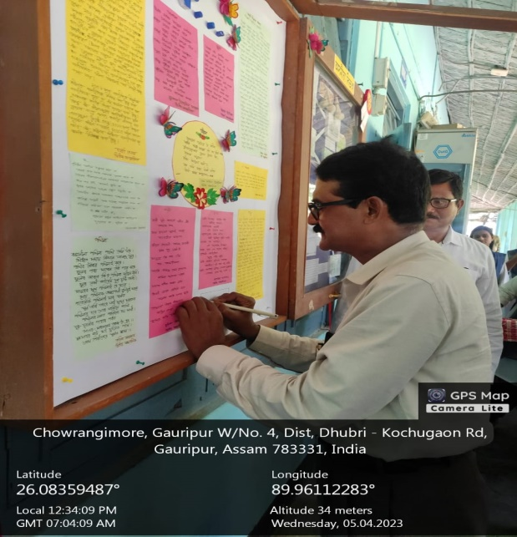
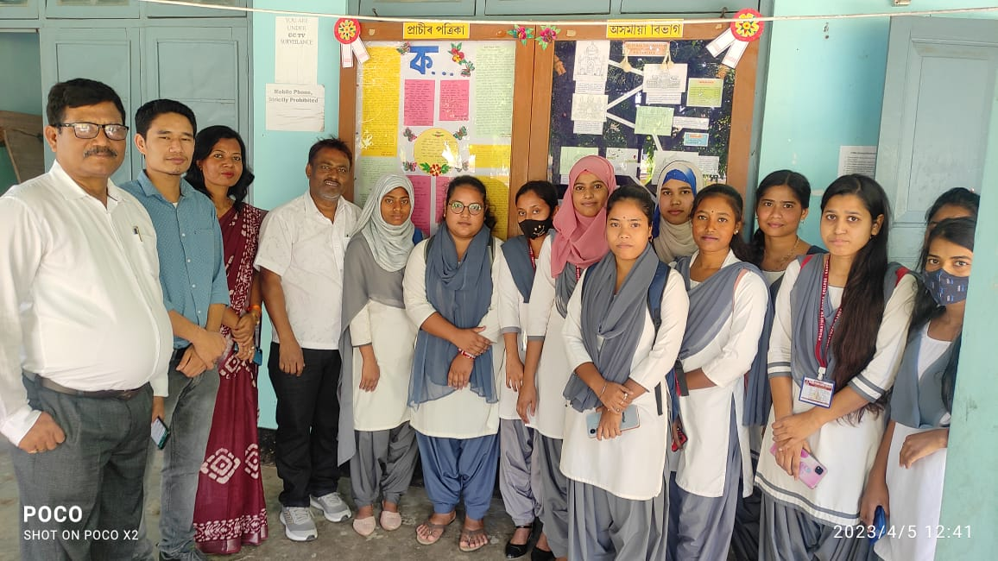
Event : Publication of Wall Magazine ‘ক’
As an regular exercise the department of Assamese published its special issue ‘ক’ and an inaugural ceremony was held at 12.30 P.M. Mr. M.R. Joddar Principal i/c of the college unveiled the Wall Magazine in front of huge gathering of faculties and students. This issue was edited by Morzina Khatun, under the guidance of Prof. Hemchandra Mili.

