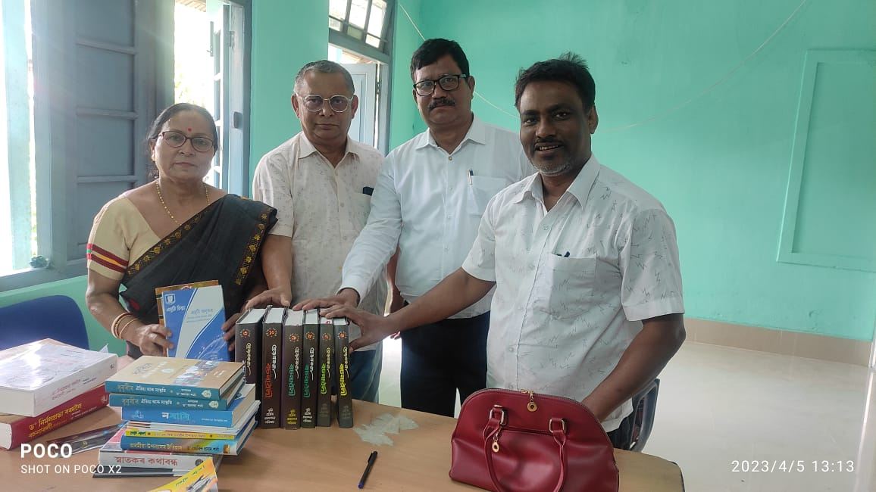
In the afternoon an informal book donation ceremony held. Dr. Gita Sarkar former HOD, Assamese were recently retired from the department donatad 27 books to the department. Dr. Pramathesh former Vice Principal of Bijni College in the donation ceremony. The departmental faculties Dr. D.C. Barman. Dr. A. Islam, Dr. J. Devi and H. mili attended the programme and offered heariest gratitude to Dr. Gita Sarkar

