Field trip to Sri Surya Pahar, Goalpara.
Date: 22 Dec, 2019
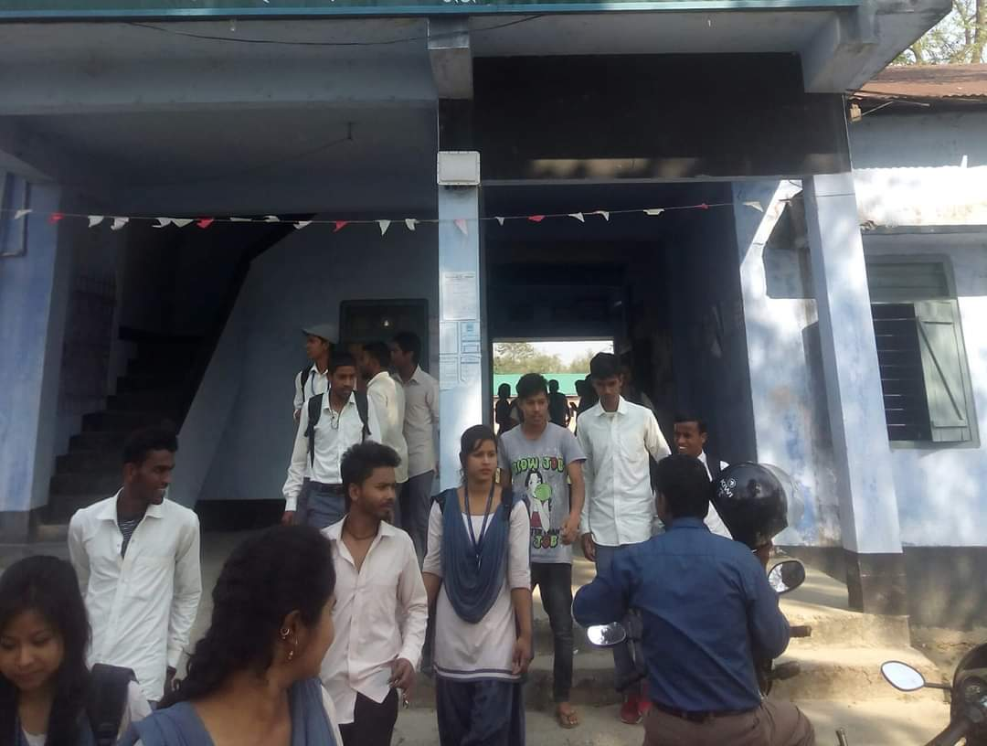
The department of Assamese, P.B. College organised a field trip to Sri Surya Pahar, Goalpara a significant and a place of archaeological importance. The site is a hilly terrain where several rock cut Shivlingas, stupas and deities of Hindu, Buddhist and Jain Pantheon are scattered in the area of about one kilometre. The site is centered on the hills of Sri Surya which is profusely filled up with Shiva Lingo’s (99999).
The students of the department were taken to the site and a lecture session was conducted by the guide from archaeology department. After sightseeing the students were asked to prepare a visit report for submission to the department within three days. All the students of the department submitted the field visit report and those were assessed by the faculties.
Dr. Gita Sarkar, Dr. D.C. Barman and Dr. Akhtarul Islam guided the students for the entire visit and evaluation process of the reports.

