A Talk On River, Culture And Humanitarian Crisis

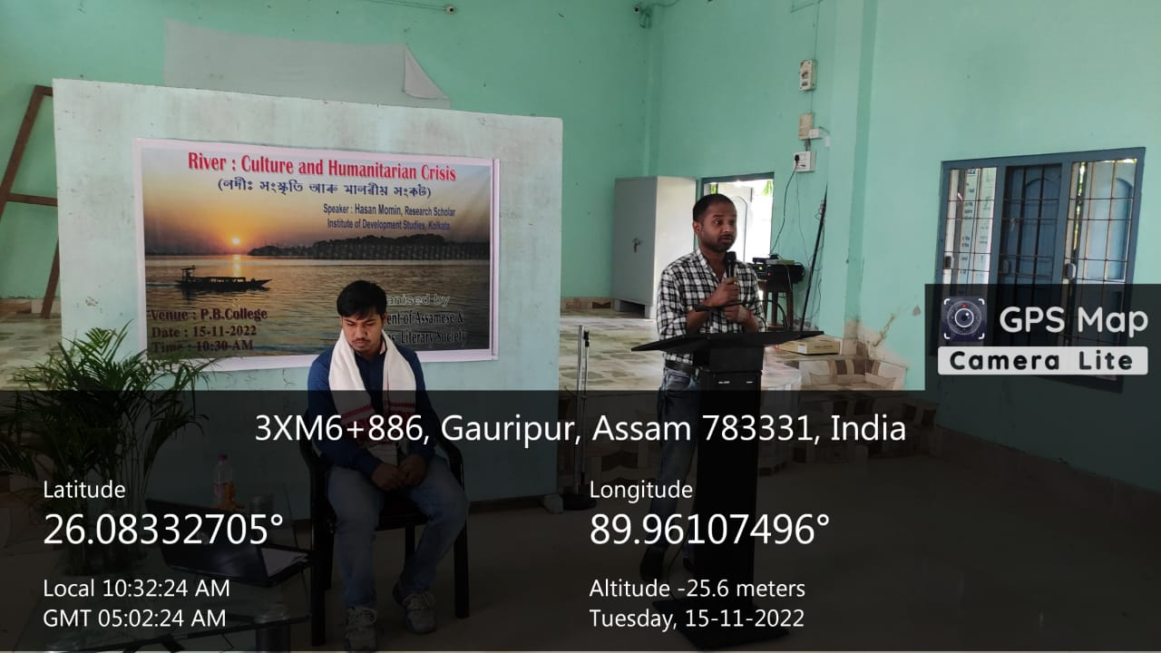
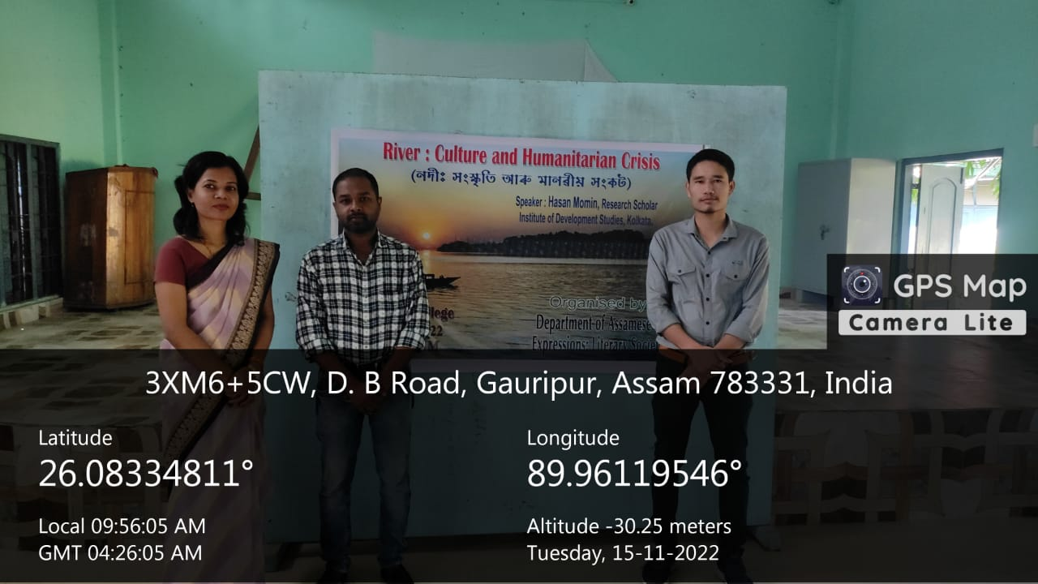
In collaboration with ‘Expression’ the literary society of the college the department organised a talk on ‘River, Culture and humanitarian crisis’. River has always been an inspiration to mankind. River has always been the source of fertility, Prosperity, transporting and transformation of life. In deed the river and riverine areas of Assam sheltered a section of people like Mymanshinghias, Nepalis etc in the pre independent era. Later on politics and policies evolved with their increasing numbers and it lead to a political dilemma in Assam.
Hassam Momin, a Research Scholar of Indian Institute of Development Studies, Kolkata perusing his research in Riverine Border Areas of Dhubri district was invited to deliver a lecture. Amitabh Ranjan Kanu, Parvin Sultana , Dr. Jyostna Devi, Hemchandra Mili, Homang Chetri and other faculties were the key organiser and huge gathering of students graced the occasion. The talk argues mean politics over riverine people and urges upon the authorities to be reasonable and lawful in term of polices and politics of the region.

