Event: Birth centenary of Lachit Barphukan

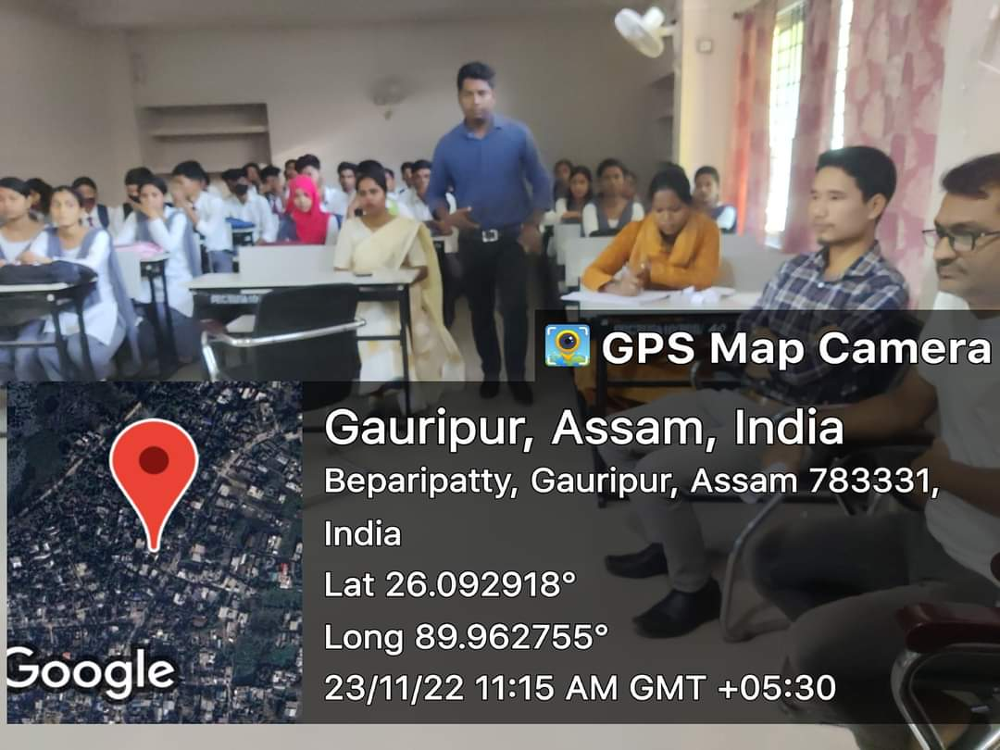

Under the initiative of the State Government, The birth centenary of Lachit Barphukan, the Hero of Assamese soliderity against Mughal invasion in Assam held in all the institutions of the district. In tune with motto of the programme the college also took active part to popularise the national hero among students. The district administration constituted a committee where Principal and HOD, Assamese, Pramathesh Barua College were kept as member. Essay competition, Debate competition and extempore speech were held in the institution. Faculties from the department of Assamese like Dr. Jyostna Devi and Hemchandra Mili lead from the front in organising all the events of Birth Centenary of Lachit Barphukan.

